DS Practical 06
  - Name: Soniya Eknath Girhe. Section: A7_B3. Roll No: 59
  - Date: 11/04/2026.

Code:
#include <stdio.h>
#include <stdlib.h>

// Define the node structure
typedef struct Node {
int data;
struct Node* left;
struct Node* right;
} Node;

// Utility to create a new node
Node* createNode(int value) {
Node* node = (Node*)malloc(sizeof(Node));
if (!node) {
printf("Memory allocation failed!\n");
exit(1);
}
node->data = value;
node->left = node->right = NULL;
return node;
}

// Iterative insert into BST
Node* insert(Node* root, int value) {
Node* newnode = createNode(value);
if (root == NULL) return newnode;

Node* parent = NULL;
Node* current = root;

while (current != NULL) {
parent = current;
if (value < current->data)
current = current->left;
else if (value > current->data)
current = current->right;
else
return root; // Ignore duplicates
}

if (value < parent->data)
parent->left = newnode;
else
parent->right = newnode;

return root;
}

// Traversals
void inorder(Node* root) {
if (!root) return;
inorder(root->left);
printf("%d ", root->data);
inorder(root->right);
}

void preorder(Node* root) {
if (!root) return;
printf("%d ", root->data);
preorder(root->left);
preorder(root->right);
}

void postorder(Node* root) {
if (!root) return;
postorder(root->left);
postorder(root->right);
printf("%d ", root->data);
}

// Count non-leaf nodes
int countNonLeaf(Node* root) {
if (!root) return 0;
if (!root->left && !root->right) return 0;
return 1 + countNonLeaf(root->left) + countNonLeaf(root->right);
}

// Compute depth (height in terms of edges)
int treeDepth(Node* root) {
if (!root) return -1;
int left = treeDepth(root->left);
int right = treeDepth(root->right);
return (left > right ? left : right) + 1;
}

int main() {
Node* root = NULL;
int n, val;

printf("Enter number of nodes: ");
scanf("%d", &n);

printf("Enter %d values:\n", n);
for (int i = 0; i < n; i++) {
scanf("%d", &val);
root = insert(root, val);
}

printf("\nInorder Traversal: ");
inorder(root);

printf("\nPreorder Traversal: ");
preorder(root);

printf("\nPostorder Traversal: ");
postorder(root);

printf("\nNon-Leaf Nodes: %d", countNonLeaf(root));
printf("\nDepth of Tree: %d\n", treeDepth(root));

return 0;
}

Output Table:
Test Case No. | Input (Nodes) | Expected Output | Actual Output
1 | 5, 3, 7, 2, 4 | Inorder: 2 3 4 5 7  Preorder: 5 3 2 4 7  Postorder: 2 4 3 7 5  Non-leaf Nodes: 2  Depth of Tree: 2 | 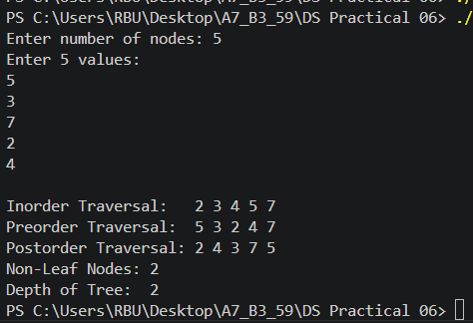
2 | 10, 5, 15 | Inorder: 5 10 15  Preorder: 10 5 15  Postorder: 5 15 10  Non-leaf Nodes: 1  Depth of Tree: 1 | 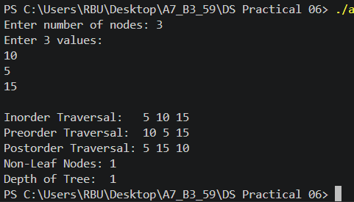
3 | 8, 4, 12, 2, 6, 10, 14 | Inorder: 2 4 6 8 10 12 14  Preorder: 8 4 2 6 12 10 14  Postorder: 2 6 4 10 14 12 8  Non-leaf Nodes: 3  Depth of Tree: 2 | 