DS Practical 07
  - Name: Soniya Eknath Girhe. Section: A7_B3. Roll No: 59
  - Date: 11/04/2026.

Code:
#include <stdio.h>
#include <stdlib.h>
#define MAX 10
int adj[MAX][MAX]; // adjacency matrix
int visited[MAX]; // visited array for DFS/BFS
int queue[MAX]; // queue for BFS
int front = -1, rear = -1;
int n; // number of vertices
// Enqueue for BFS
void enqueue(int v) {
if (rear == MAX - 1) return;
if (front == -1) front = 0;
queue[++rear] = v;}
// Dequeue for BFS
int dequeue() {
if (front == -1 || front > rear) return -1;
return queue[front++];}
// BFS traversal
void BFS(int start) {
for (int i = 0; i < n; i++) visited[i] = 0;
enqueue(start);
visited[start] = 1;
printf("BFS: ");
while (front <= rear) {
int v = dequeue();
printf("%d ", v);
for (int i = 0; i < n; i++) {
if (adj[v][i] == 1 && !visited[i]) {
enqueue(i);
visited[i] = 1;}}}
printf("\n");}// DFS traversal
void DFS(int v) {
visited[v] = 1;
printf("%d ", v);
for (int i = 0; i < n; i++) {
if (adj[v][i] == 1 && !visited[i]) {
DFS(i);}}}
// Outdegree of a node
int outdegree(int v) {
int count = 0;
for (int i = 0; i < n; i++) {
if (adj[v][i] == 1) count++; }
return count;}// Find sink nodes
void findSinkNodes() {
printf("Sink nodes: ");
for (int i = 0; i < n; i++) {
int flag = 1;
for (int j = 0; j < n; j++) {
if (adj[i][j] == 1) {
flag = 0;
break;
}
}
if (flag) printf("%d ", i);}
printf("\n");}

int main() {
int start;
printf("Enter number of vertices: ");
scanf("%d", &n);

printf("Enter adjacency matrix:\n");
for (int i = 0; i < n; i++) {
for (int j = 0; j < n; j++) {
scanf("%d", &adj[i][j]);
}
}

printf("Enter starting vertex: ");
scanf("%d", &start); // BFS
BFS(start);// DFS
for (int i = 0; i < n; i++) visited[i] = 0;
printf("DFS: ");
DFS(start);
printf("\n");
// Outdegree
printf("Outdegree of node %d = %d\n", start, outdegree(start));
// Sink nodes
findSinkNodes();

return 0;

}

Output Table:
Test  Case  No. | Input (Adjacency Matrix &amp; Start  Node) | Expected Output | Actual Output
1 | n=4  0 1 1 0  0 0 1 0  0 0 0 1  0 0 0 0  start=0 | BFS: 0 1 2 3  DFS: 0 1 2 3  Outdegree(0)=2  Sink: 3 | 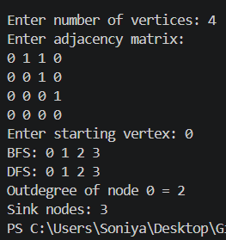
2 | n=3  0 1 0  0 0 0  1 0 0  start=0 | BFS: 0 1  DFS: 0 1  Outdegree(0)=1  Sink: 1 | 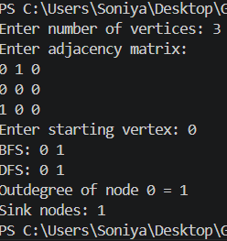
3 | n=5  0 1 0 0 0  0 0 1 0 0  0 0 0 1 0  0 0 0 0 0  0 0 0 0 0  start=0 | BFS: 0 1 2 3  DFS: 0 1 2 3  Outdegree(0)=1  Sink: 3 4 | 