DS Practical 08
Name: Soniya Eknath Girhe. Section: A7_B3. Roll No: 59
Date: 11/04/2026.

Code:
#include <stdio.h>

// Function to print array
void printArray(int arr[], int n) {
for (int i = 0; i < n; i++)
printf("%d ", arr[i]);
printf("\n");
}

// Shell Sort implementation
void shellSort(int arr[], int n) {
for (int gap = n/2; gap > 0; gap /= 2) {
for (int i = gap; i < n; i++) {
int temp = arr[i];
int j;
for (j = i; j >= gap && arr[j-gap] > temp; j -= gap) {
arr[j] = arr[j-gap];
}
arr[j] = temp;
}
}
}

// Partition function for Quick Sort
int partition(int arr[], int low, int high) {
int pivot = arr[high]; // pivot chosen as last element
int i = (low - 1);

for (int j = low; j < high; j++) {
if (arr[j] < pivot) {
i++;
// swap arr[i] and arr[j]
int temp = arr[i];
arr[i] = arr[j];
arr[j] = temp;
}
}
// swap arr[i+1] and pivot
int temp = arr[i+1];
arr[i+1] = arr[high];
arr[high] = temp;

return (i + 1);
}

// Quick Sort implementation
void quickSort(int arr[], int low, int high) {
if (low < high) {
int pi = partition(arr, low, high);

quickSort(arr, low, pi - 1);
quickSort(arr, pi + 1, high);
}
}

int main() {
int n, choice;
printf("Enter number of elements: ");
scanf("%d", &n);

int arr[n], arrCopy[n];
printf("Enter elements:\n");
for (int i = 0; i < n; i++) {
scanf("%d", &arr[i]);
arrCopy[i] = arr[i]; // copy for second sort
}

printf("\nOriginal Array: ");
printArray(arr, n);

// Shell Sort
shellSort(arr, n);
printf("Sorted Array using Shell Sort: ");
printArray(arr, n); // Quick Sort
quickSort(arrCopy, 0, n-1);
printf("Sorted Array using Quick Sort: ");
printArray(arrCopy, n);

return 0;}

Output Table:
Test Case No. | Input | Expected Output (Sorted Ascending) | Actual Output
1 | 12, 5, 8, 3, 15, 7, 3, 10, 1, 6 | 1 3 3 5 6 7 8 10 12 15 | 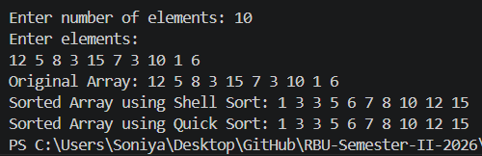
2 | 20, 18, 18, 5, 7, 2, 2, 9, 11, 14 | 2 2 5 7 9 11 14 18 18 20 | 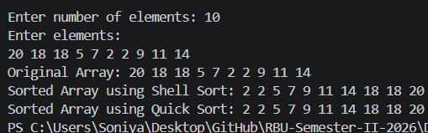
3 | 9, 4, 6, 4, 2, 8, 1, 3, 7, 5 | 1 2 3 4 4 5 6 7 8 9 | 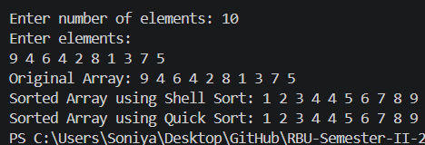
4 | 30, 25, 20, 15, 10, 5, 0, 5, 10, 15 | 0 5 5 10 10 15 15 20 25 30 | 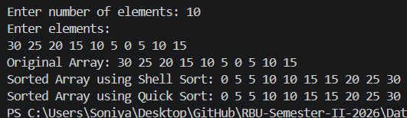
5 | 100, 50, 75, 50, 25, 75, 10, 90, 60, 30 | 10 25 30 50 50 60 75 75 90 100 | 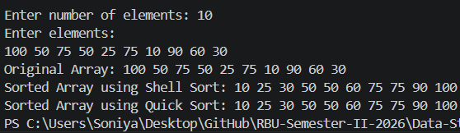
6 | 8, 8, 8, 8, 8, 8, 8, 8, 8, 8 | 8 8 8 8 8 8 8 8 8 8 | 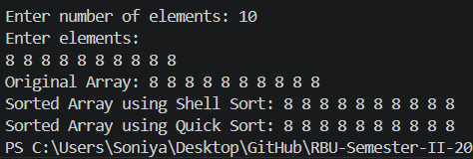
7 | 45, 23, 89, 23, 67, 12, 90, 12, 34, 56 | 12 12 23 23 34 45 56 67 89 90 | 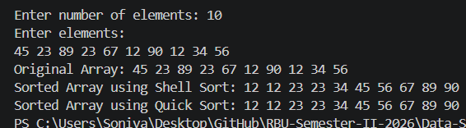
8 | 5, 1, 9, 3, 7, 2, 6, 4, 8, 0 | 0 1 2 3 4 5 6 7 8 9 | 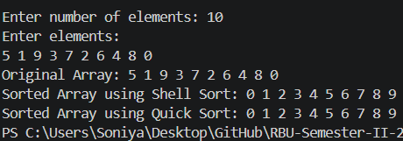
9 | 99, 1, 50, 50, 75, 25, 25, 10, 90, 60 | 1 10 25 25 50 50 60 75 90 99 | 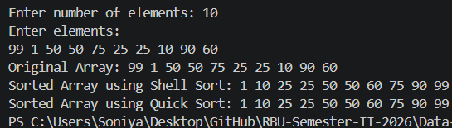
10 | 13, 27, 13, 45, 32, 27, 19, 45, 10, 5 | 5 10 13 13 19 27 27 32 45 45 | 