Practical 02

Name: Soniya Eknath Girhe.
Section: A7-B3
Roll no: 59.

Date: 16/01/2026 & 23/01/2026.

fork and vfork system call
Example 1:

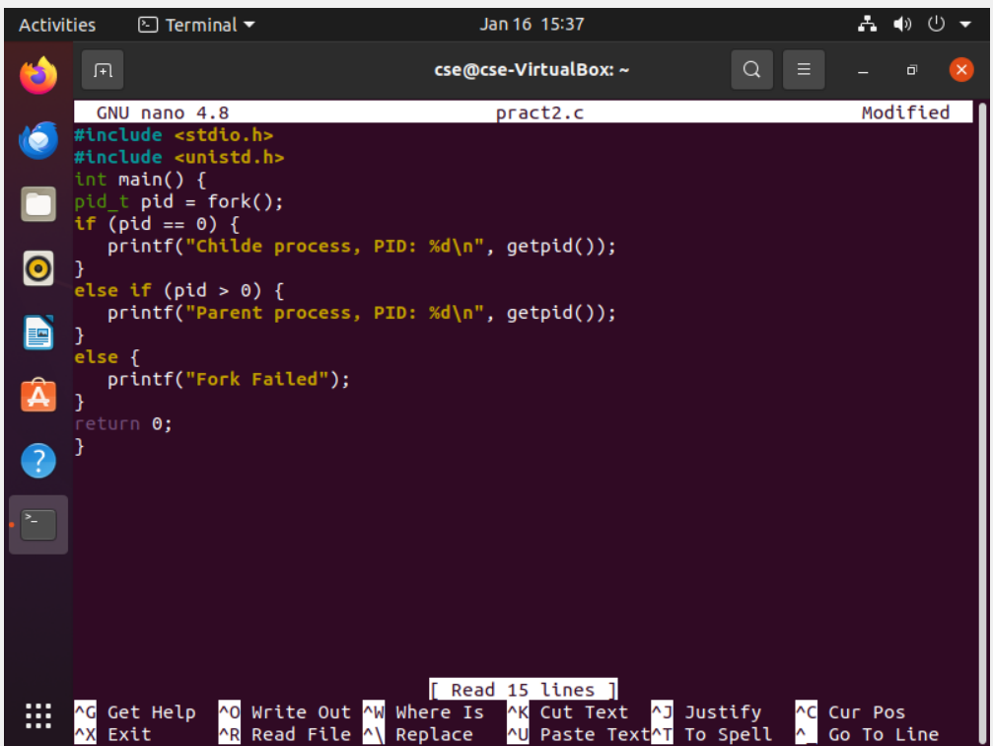

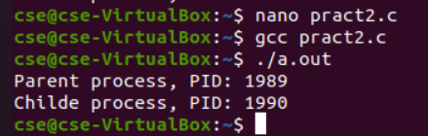

Example 2:
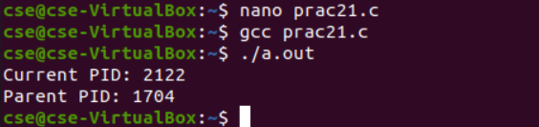
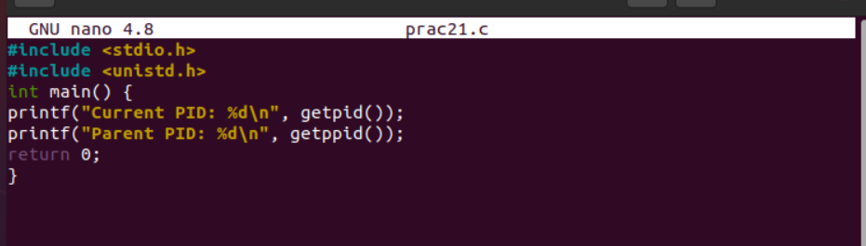
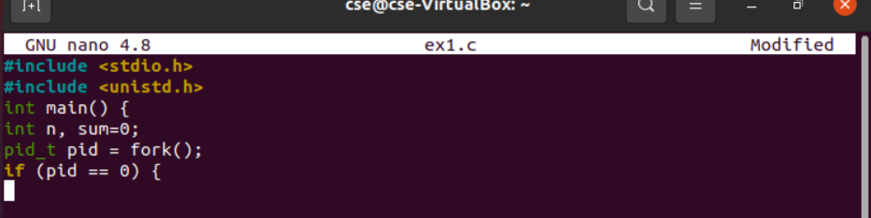

Vfork();
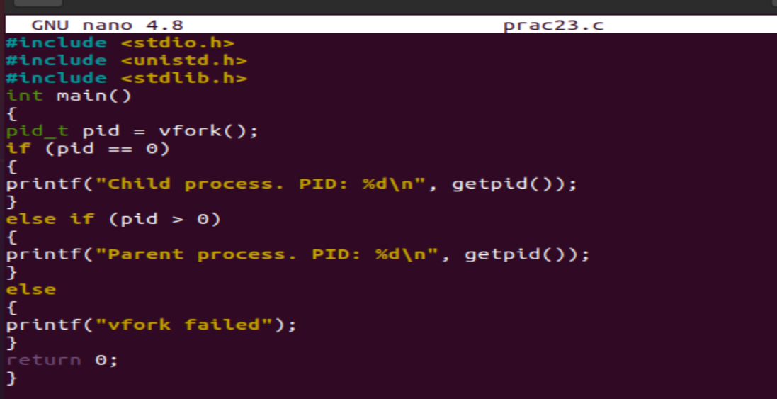
Output:
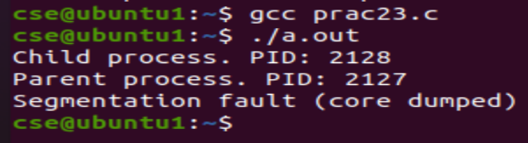

Sleep(); and wait();
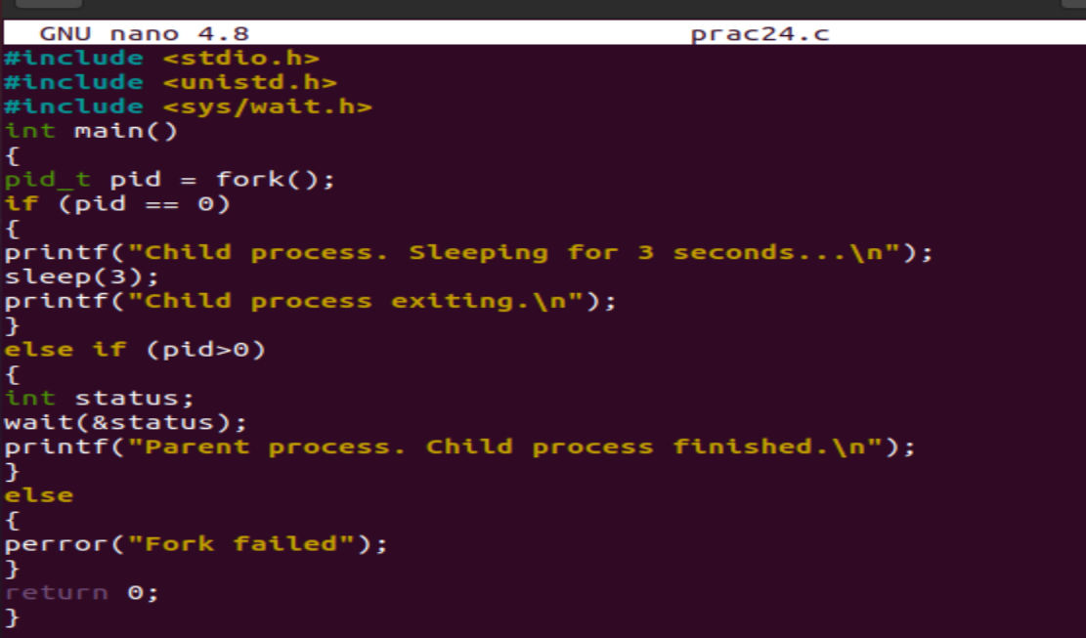
Output:
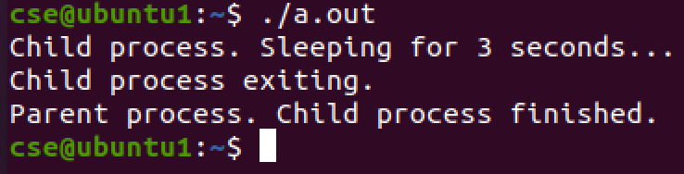

2 different program executing using EXEC
Program 1:
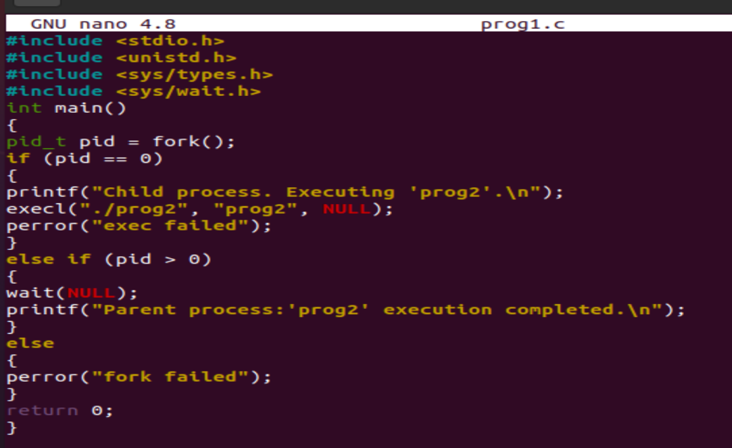
Program 2:
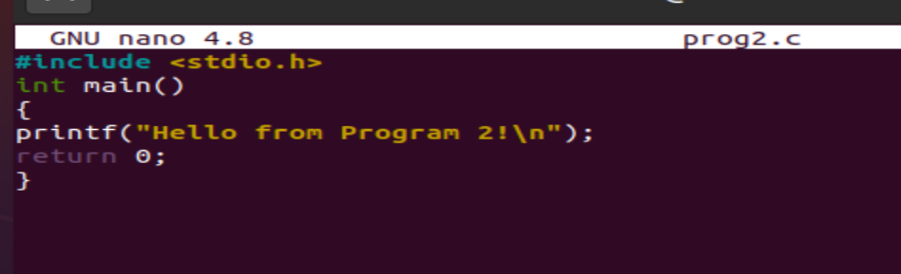
Output:
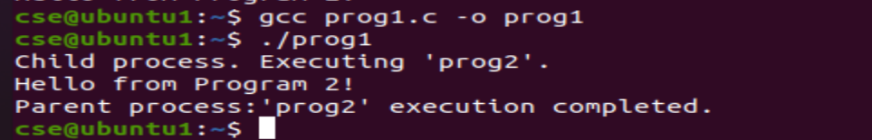

Exercise:

Write a program in C where the parent process calculates the sum of the first n natural numbers, and the child process calculates the factorial of a given number m Child process must print it's ID and parent id Parent process must wait for child process to complete its execution.
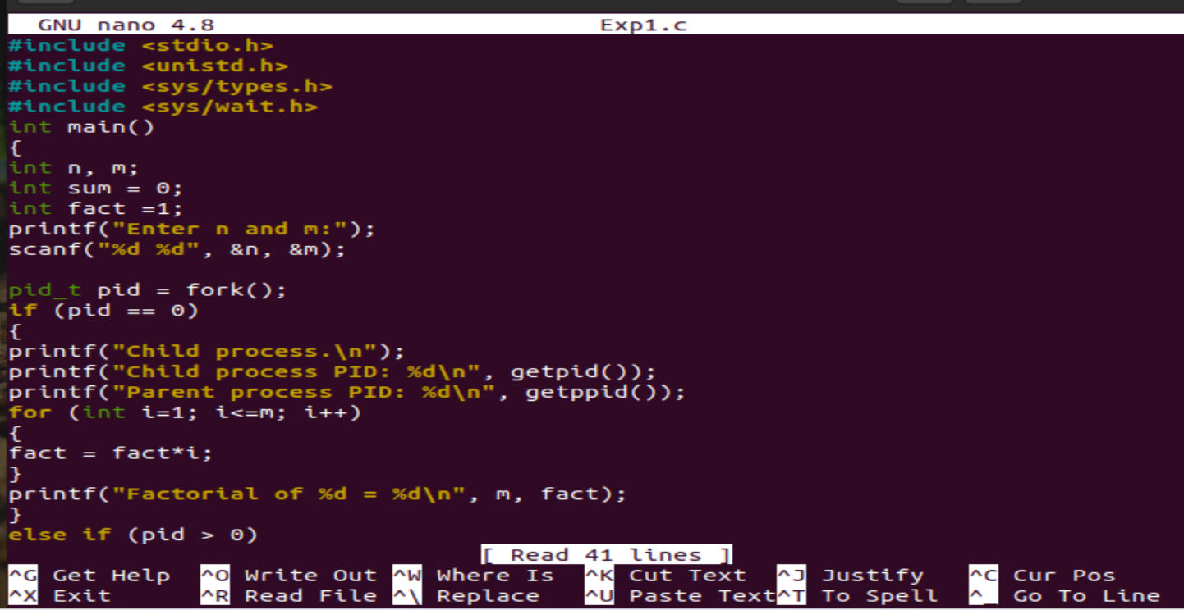
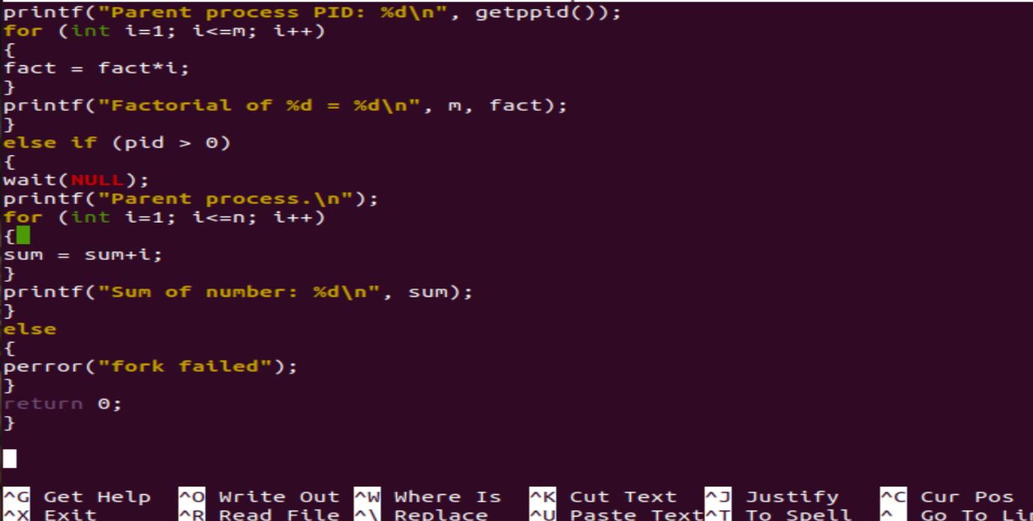
Output:

