Practical 03
  - Name: Soniya Eknath Girhe.
  - Section: A7-B3
  - Roll no: 59.
  - Date: 30/01/2026.

FCFS and SJF
- FCFS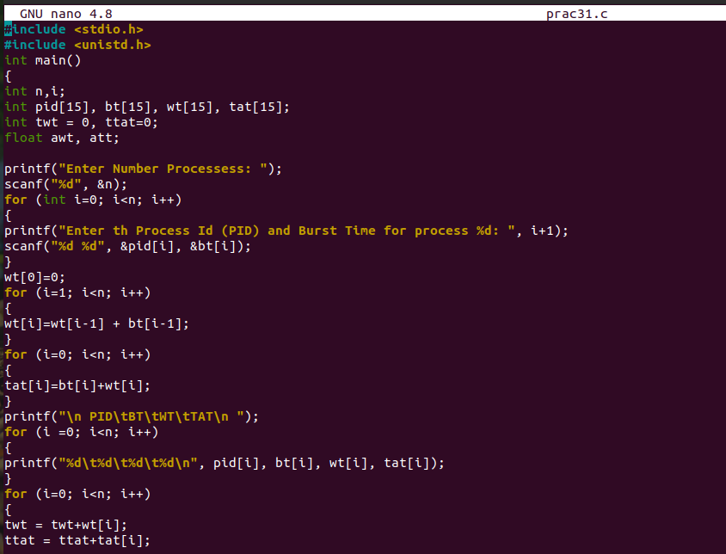
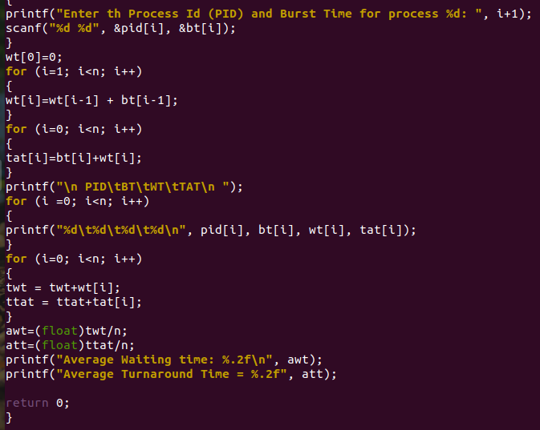
Output: 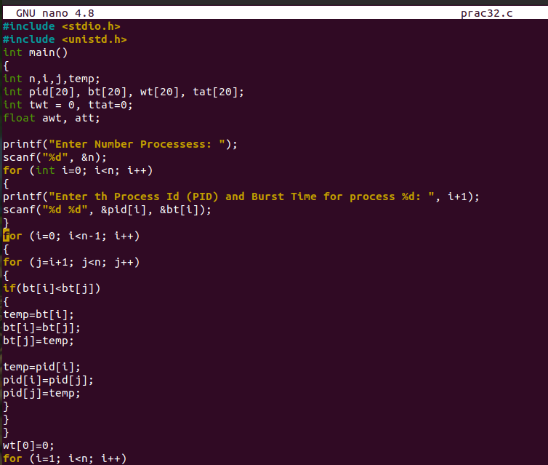
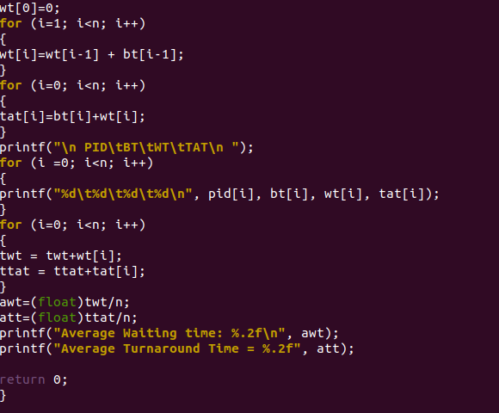
Output:
