Practical 04
  - Name: Soniya Eknath Girhe.
  - Section: A7-B3
  - Roll no: 59.
  - Date: 13/02/2026.

Process Communication

Shared Memory
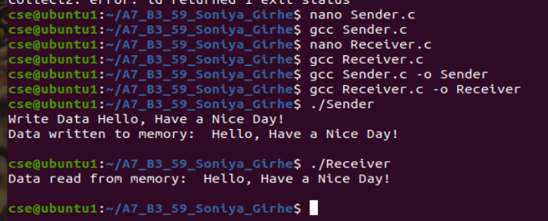
Sender.c :
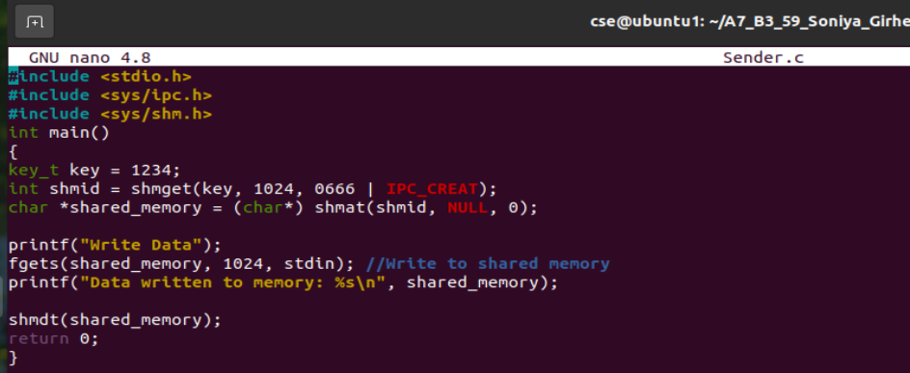
Receiver.c:
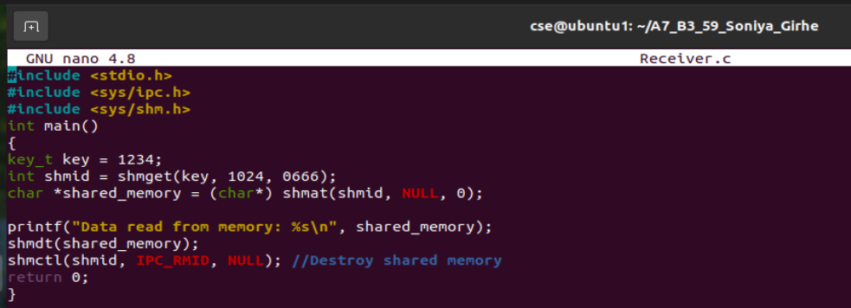

Pipe
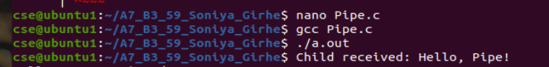

Exercises
1. Write a program where one process writes a list of integers to shared memory, and
another process reads and calculates their sum.
- Writer.c:
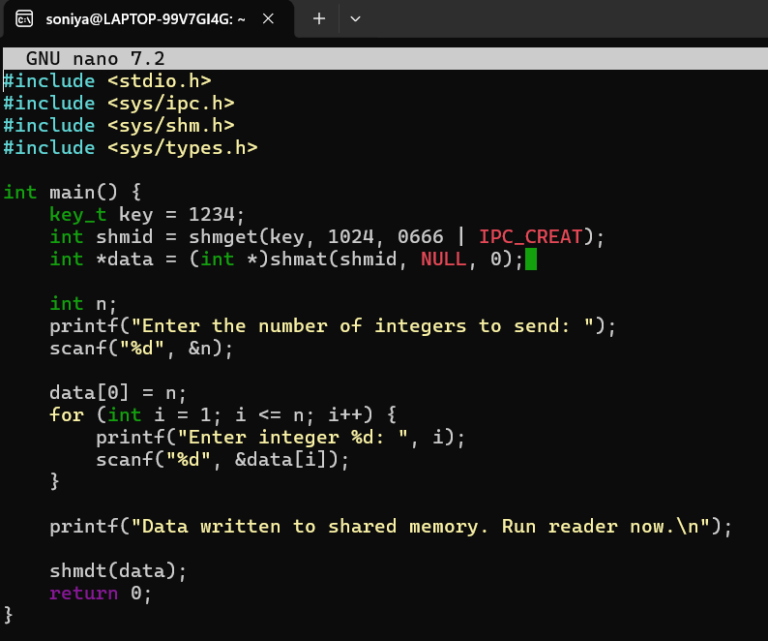

- Reader.c:

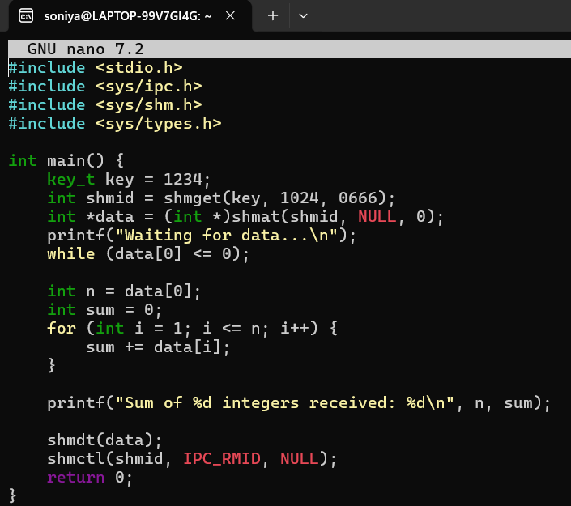
- Output:
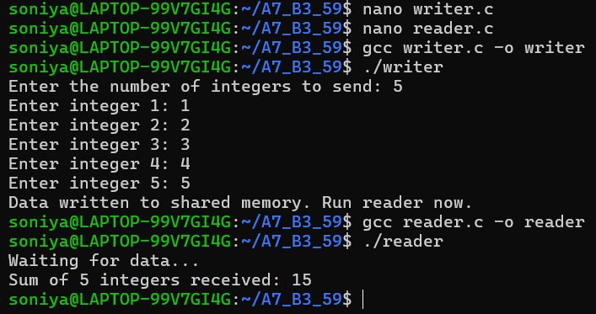

2. Create a program where the parent process sends a string through a pipe, and the child
process stores the reversed string in shared memory for the parent to read.
- Code:
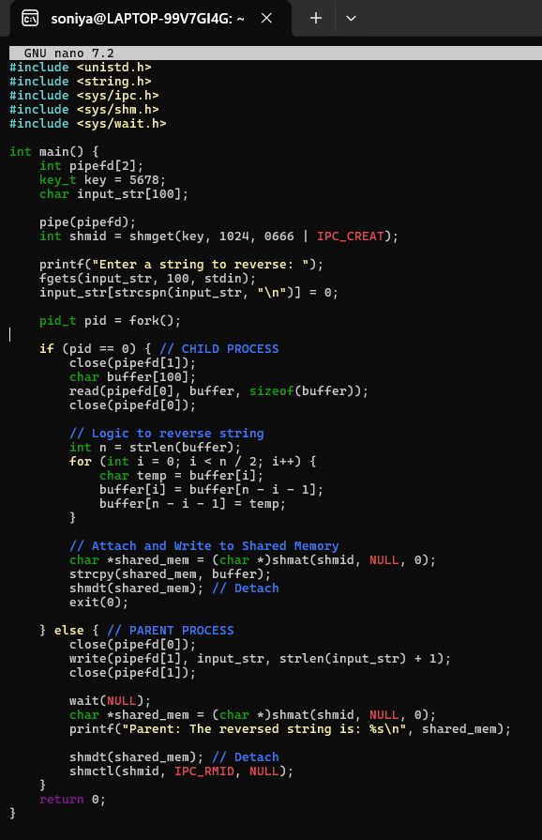
- Output: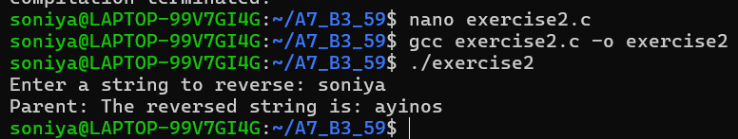
3. Modify the pipe example to implement a two-way communication system between the
parent and child processes.
- Code:
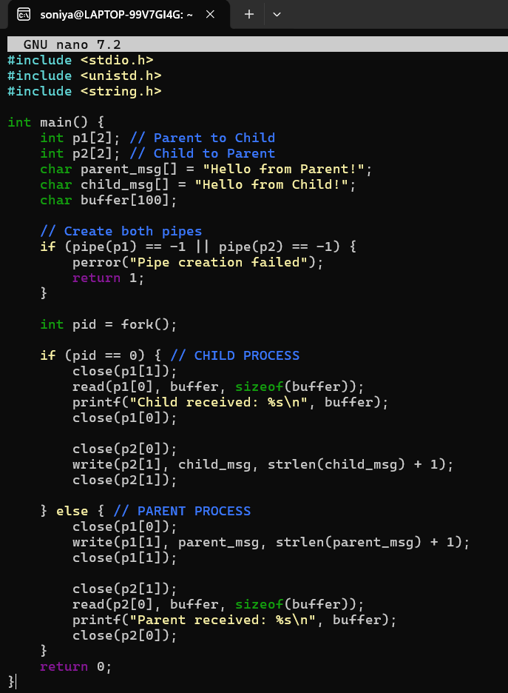
- Output:
