Practical 06
  - Name: Soniya Eknath Girhe.
  - Section: A7-B3.
  - Roll no: 59.
  - Date: 20/02/2026.

Banker Algorithm
Printing Need matrix from Allocation matrix and maximum matrix
Code: 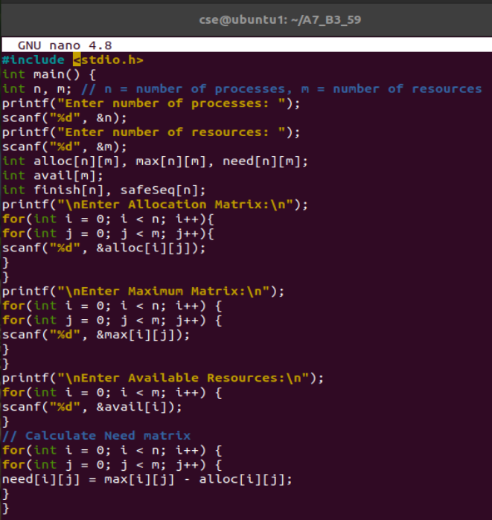
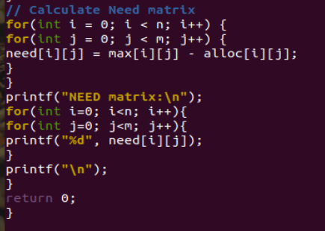
Output:
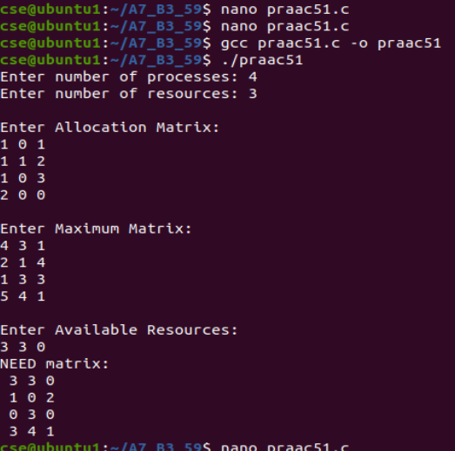
Next code:
