OS Practical 08
  - Name: Soniya Eknath Girhe. Sec_Batch_RollNo: A7_B3_59.
  - Date: 10/04/2026.

1.FCFS

Code:
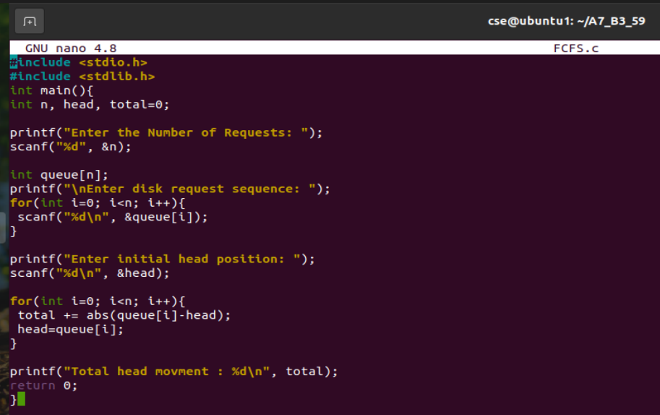

Output:
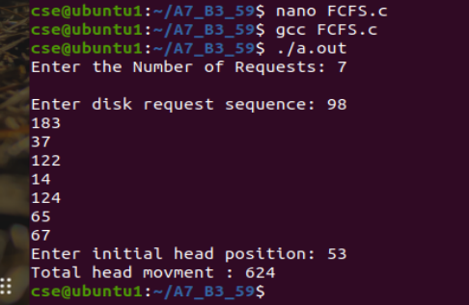

2. SSTF

Code:
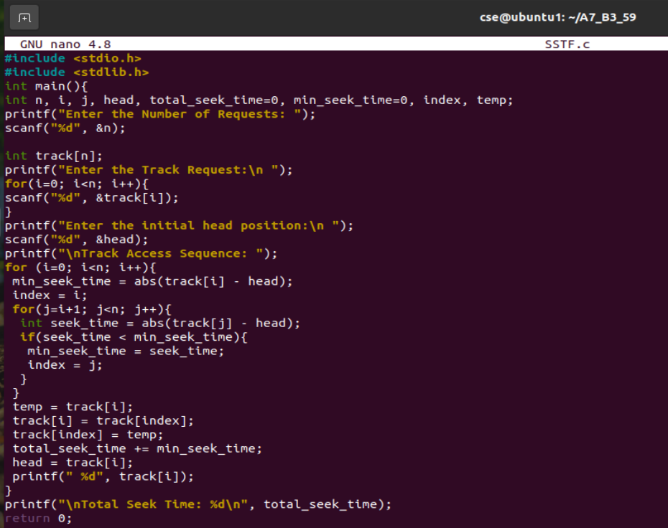
Output:
