Practical 04
  - Name: Soniya Eknath Girhe. Section: A7-B3. Roll no: 59.
  - Date: 13/02/2026.

Producer-Consumer using Semaphores and Mutex
Code:
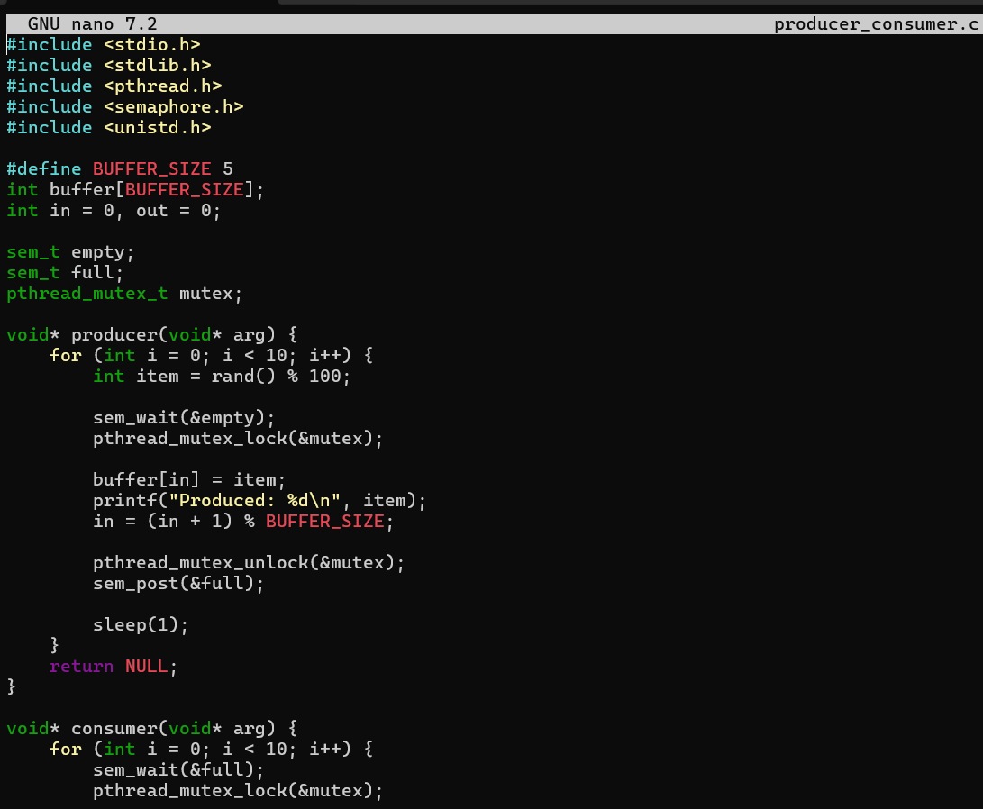
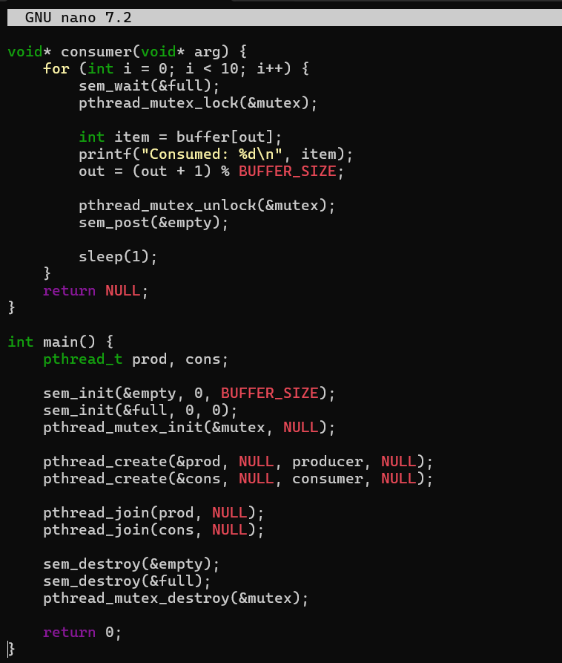
Output:

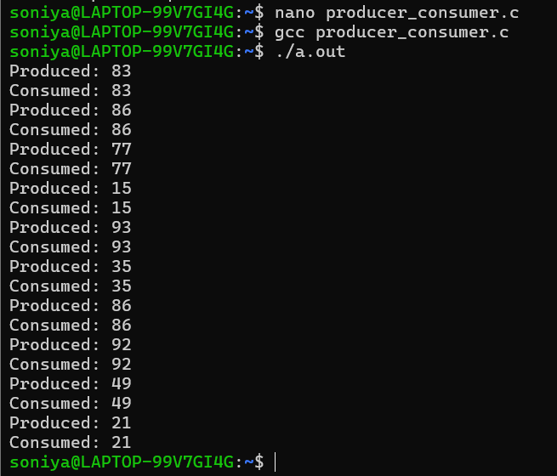

Exercise: Dining Philosophers Problem
Code:
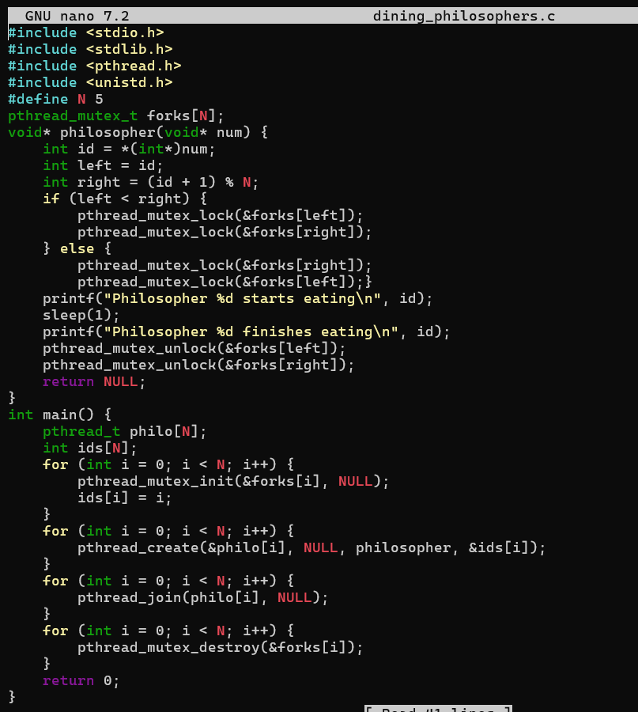
Output:
