OS Practical 07
  - Name: Soniya Eknath Girhe. Section_Batch_RollNo: A7_B3_59.

FIFO (First-In-First-Out):
Code:
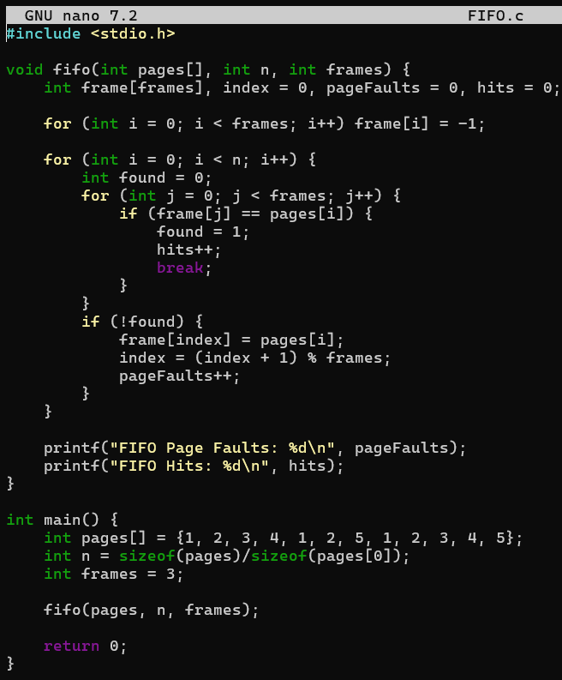
Output:
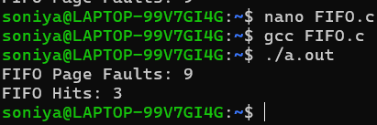

LRU (Least Recently Used):
Code:

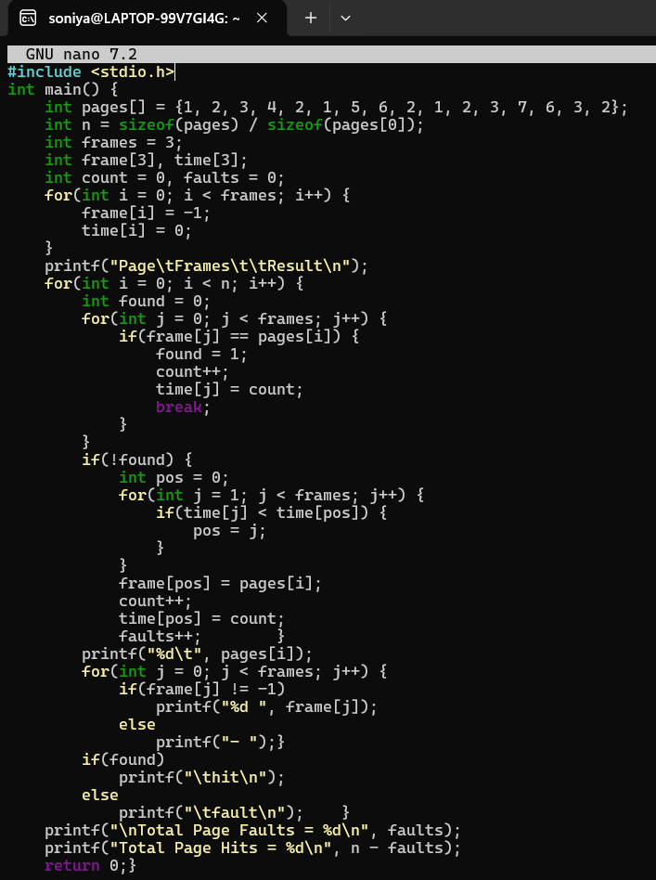
Output:
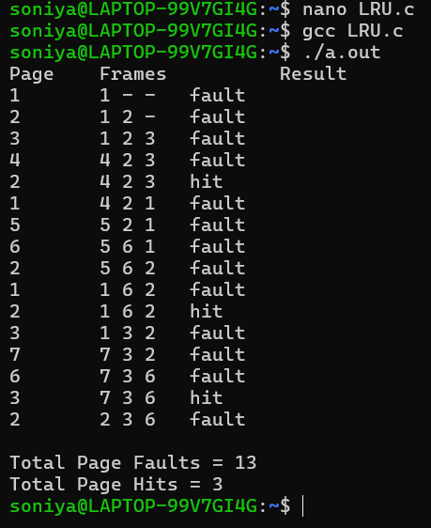

Exercise:
Q1. Consider a page reference string 1, 3, 0, 3, 5, 6 with 3-page frames. Find the
number of page faults &amp; Page Hit? Use FIFO algorithm.
Code:
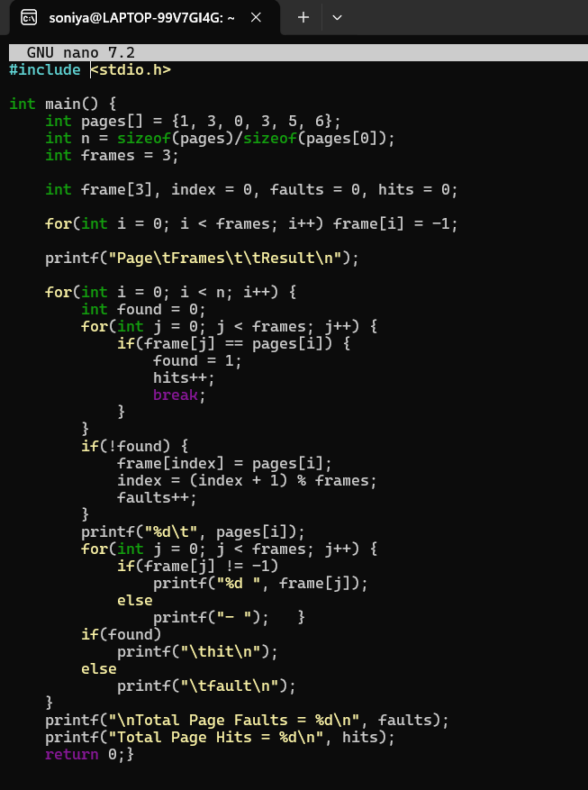
Output:
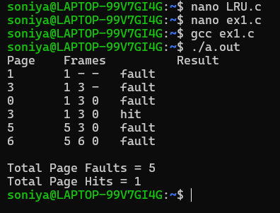
Q2. Consider a reference string 1, 2, 1, 0, 3, 0, 4, 2, 4. We have 3 empty
memory locations available. Find the number of page hits and page faults? Use
LRU algorithm.
Code:
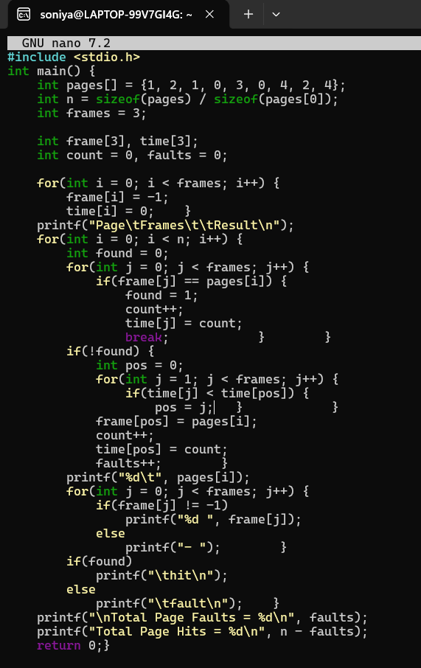
Output:
