PakWheels Car MarketplaceObject-Oriented Programming — Assignment 2
| [Company address]

Name = DEEPA KATARIA
Roll no = 25k-0131

[Year]

1. Project Overview
This project is a C++ console application that simulates a vehicle marketplace similar to PakWheels. Users can register as Buyers, Sellers, or Admins; list Cars and Bikes; search and filter listings; and perform moderation actions.
Assignment 2 extends Assignment 1 by adding all five advanced OOP features:
- Inheritance (12 relationships)
- Polymorphism — function overloading and virtual overriding
- Abstraction — 4 abstract classes with header files
- Operator Overloading — 10+ operators across classes
- Friend Functions and Friend Classes

2. File Structure

File | Type | Purpose
IDisplayable.h | Header (.h) | Abstract interface — forces display()
ISearchable.h | Header (.h) | Abstract interface — forces matchesSearch()
IRatable.h | Header (.h) | Abstract interface — forces rating methods
ITransactable.h | Header (.h) | Abstract interface — forces price/availability
main.cpp | Source (.cpp) | All class implementations + main()

3. Inheritance
The system implements 12 clearly justified inheritance relationships across two hierarchies.

3.1 User Hierarchy
# | Relationship | Type | Justification
1 | User → Buyer | Single | A Buyer IS-A User with extra budget and favorites
2 | User → Seller | Single | A Seller IS-A User who manages listings
3 | User → Admin | Single | An Admin IS-A User with moderation powers
4 | User → IDisplayable | Interface | User must be displayable for the dashboard
5 | Seller → IRatable | Interface | Sellers receive ratings — Buyers do not

3.2 Vehicle Hierarchy
# | Relationship | Type | Justification
6 | Vehicle → Car | Single | Car IS-A Vehicle with doors/fuel/colour
7 | Vehicle → Bike | Single | Bike IS-A Vehicle with engineCC/bikeType
8 | Vehicle → IDisplayable | Interface | Every vehicle must be printable
9 | Vehicle → ISearchable | Interface | Marketplace searches vehicles by keyword
10 | Vehicle → ITransactable | Interface | Vehicles have a price and availability flag

3.3 Listing & Marketplace
# | Relationship | Type | Justification
11 | Listing → IDisplayable, ISearchable, ITransactable | Multiple interface | Listing wraps a Vehicle and must be searchable and buyable
12 | Marketplace uses User* / Listing* arrays | Composition + poly | Holds heterogeneous objects through base pointers

3.4 Code Snippet — Inheritance declaration
Vehicle inherits THREE abstract interfaces
class Vehicle : public IDisplayable,
public ISearchable,
public ITransactable { ... };

Seller inherits User AND IRatable (multiple inheritance)
class Seller : public User, public IRatable { ... };

4. Polymorphism

4.1 Function Overriding (Runtime Polymorphism)
The display() method is declared virtual in IDisplayable and overridden in every concrete class. The Marketplace iterates an array of User* or Listing* and calls display() — C++ resolves the correct version at runtime through the vtable.

Class | display() output
Buyer | [BUYER] Ali | ali@gmail.com | Karachi
Seller | [SELLER] Ahmed | AutoWorld | Lahore | Rating: 4.5
Admin | [ADMIN] Usman | Role: Moderator | Platform: PakWheels
Car | [CAR] Toyota Corolla | Year: 2020 | Price: PKR 3500000 ...
Bike | [BIKE] Yamaha YBR125 | Year: 2022 | Price: PKR 290000 ...

4.2 Function Overloading (Compile-time Polymorphism)
displayDetails() is overloaded three times in both Car and Bike — same name, different parameter lists.

Signature | Behaviour
displayDetails() | Calls display() — full details
displayDetails(bool showPrice) | Shows or hides the price field
displayDetails(string format) | "short" = brand+model+year only; else full

5. Abstraction
Four separate header files define pure-virtual interfaces. Each file is an independent compilation unit exposing only the contract — no implementation details leak out.

5.1 IDisplayable.h
Forces every entity (User, Vehicle, Listing) to implement display(). The Marketplace loops through base pointers and calls display() without knowing the concrete type. File location: IDisplayable.h
CODE :
class IDisplayable {
public:
virtual void display() const = 0;
virtual ~IDisplayable() {}
};

5.2 ISearchable.h
Guarantees any searchable object exposes matchesSearch(keyword). The Marketplace's search loop calls this on Listing objects which internally delegate to Vehicle. File location: ISearchable.h

Code :
class ISearchable {
public:
virtual bool matchesSearch(const string& keyword) const = 0;
virtual ~ISearchable() {}
};

5.3 IRatable.h
Decouples the rating contract from Seller. Any future entity (e.g. a Dealership class) can be rated without modifying Seller. File location: IRatable.h
Code:

class IRatable {
public:
virtual float getrating() const = 0;
virtual void updateRating(float r) = 0;
virtual ~IRatable() {}
};

5.4 ITransactable.h
Any buyable item must expose getPrice(), getTitle(), and isAvailable(). Buyer::canAfford() accepts an ITransactable& so it works for Cars, Bikes, and any future listing type. File location: ITransactable.h

CODE :
class ITransactable {
public:
virtual float getPrice() const = 0;
virtual string getTitle() const = 0;
virtual bool isAvailable() const = 0;
virtual ~ITransactable() {}
};

5.5 Why User and Vehicle are also abstract
User has display() = 0 — a raw User object cannot exist, only Buyer/Seller/Admin. Vehicle has display() = 0 — only Car or Bike can be instantiated. This prevents accidentally creating meaningless base objects.

6. Operator Overloading
At least 10 operators are overloaded across different classes. Member operators use the implicit this pointer; global (friend) operators appear outside the class.

# | Operator | Class | Member / Global | Reason
1 | == | User | Member | Compare users by unique ID
2 | != | User | Member | Complement of ==
3 | << | User | Global friend | Stream output: cout << someUser
4 | >> | User | Global friend | Stream input: cin >> someUser
5 | == | Vehicle | Member | Brand+model+year equality check
6 | < | Vehicle | Member | Price comparison for sorting
7 | > | Vehicle | Member | Price comparison (complement)
8 | + | Vehicle | Member | Bundle price: car + bike
9 | << | Listing | Global friend | One-line listing summary
10 | == | Listing | Member | Compare by listing ID
11 | < | Listing | Member | Compare by asking price
12 | << | Seller | Global friend | Seller summary with rating
13 | == | Seller | Member | Same company + location
14 | += | Buyer | Member | buyer += listingID shorthand
15 | += | Marketplace | Member | market += &listing shorthand

6.1 Member operator example

CODE :
Vehicle::operator+ — bundle price calculation
float operator+(const Vehicle& other) const {
return price + other.price;
}
// Usage:
float bundle = c1 + bk1; // PKR 3,790,000

6.2 Global friend operator example

CODE :
Declared inside Listing:
friend ostream& operator<<(ostream& os, const Listing& l);

Defined outside all classes:
ostream& operator<<(ostream& os, const Listing& l) {
os << "Listing #" << l.listingID
<< " [" << l.status << "] PKR " << l.askingPrice;
return os;

7. Friend Functions & Friend Classes
Friend declarations allow trusted outside entities to access private data. They are used only where the alternative would be adding a public getter just for one use-case — which would break encapsulation more than a targeted friend.

# | Friend Entity | Granted to | What it accesses | Why it's needed
1 | operator<<(ostream, User) | Global function | protected name, email | Stream output needs private fields; adding getters for every field would pollute the API
2 | operator<<(ostream, Listing) | Global function | private listingID, status, askingPrice | Same reason — one targeted friend is cleaner than three new getters
3 | operator<<(ostream, Seller) | Global function | private rating, companyName | Displays seller info without exposing all Seller internals
4 | compareListings(a, b) | Global function | private askingPrice of Listing | A standalone sort utility that does not belong inside any class
5 | class Admin | Buyer | private favCount, favorites[] | Admin must audit a buyer's list for moderation — not a general-purpose getter

7.1 Friend class code snippet

CODE :
Inside Buyer class:
friend class Admin; Admin can read favCount + favorites[]

Admin uses the access:
void auditBuyerFavorites(const Buyer& b) const {
cout << "[AUDIT] " << b.name << " favorites: ";
for (int i = 0; i < b.favCount; i++)
cout << b.favorites[i] << " ";
}

7.2 Global friend function code snippet

CODE :
// Inside Seller class:
friend bool topRatedSeller(const Seller& a, const Seller& b);

// Defined globally — compares private rating fields:
bool topRatedSeller(const Seller& a, const Seller& b) {
return a.rating > b.rating;
}

8. UML Class Diagram
The UML class diagram below represents all classes, their relationships, and the four abstract interfaces. Dashed arrows indicate interface implementation (realisation). Solid arrows with hollow heads indicate inheritance. Composition is shown with filled diamonds.
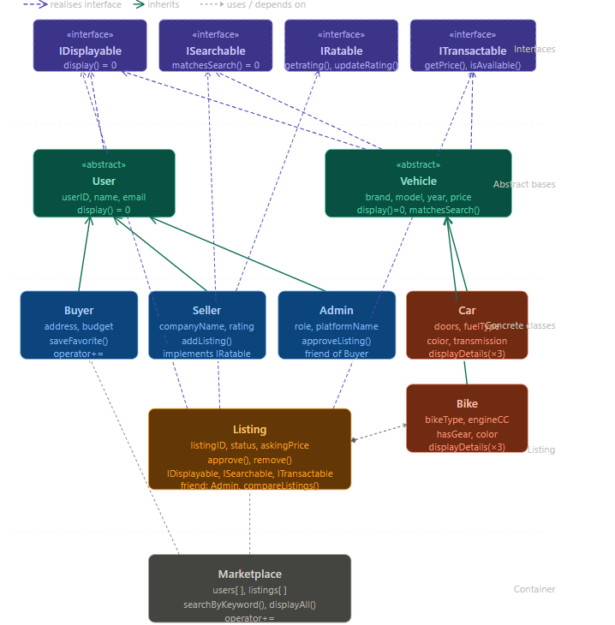

Recommended tool: draw.io (free). Use the following layout:
- Top row: IDisplayable · ISearchable · IRatable · ITransactable (interfaces, dashed border)
- Middle row: User (abstract) on left, Vehicle (abstract) on right
- Bottom of User: Buyer · Seller · Admin
- Bottom of Vehicle: Car · Bike
- Listing in centre — composition arrow to Vehicle*, realisation arrows to all 3 interfaces
- Marketplace at bottom — aggregation arrows to User* and Listing*

9. Sample Program Output

