IRIS CLASSIFICATION USING MACHINE LEARNING
- Objective
The objective of this project is to build a machine learning classification model that predicts the species of an iris flower using its sepal length, sepal width, petal length, and petal width measurements.
- Dataset Description
Dataset Name: Iris Classification Dataset
Features:
• Sepal Length
• Sepal Width
• Petal Length
• Petal Width
Target Variable:
• Species
The dataset contains three classes of iris flowers:
• Iris-setosa
• Iris-versicolor
• Iris-virginica
- Exploratory Data Analysis (EDA)
The dataset was loaded using Pandas and analyzed to understand its structure and characteristics.
The following operations were performed:
• Displayed the first few rows using df.head()
• Examined dataset information using df.info()
• Generated statistical summaries using df.describe()
• Checked for missing values using df.isnull().sum()
• Counted the number of samples in each class using value_counts()
Findings:
• No missing values were found.
• The dataset is clean and balanced.
• The flower species show clear separation based on petal and sepal measurements.
- Data Visualization
The following visualizations were created:
- Histogram
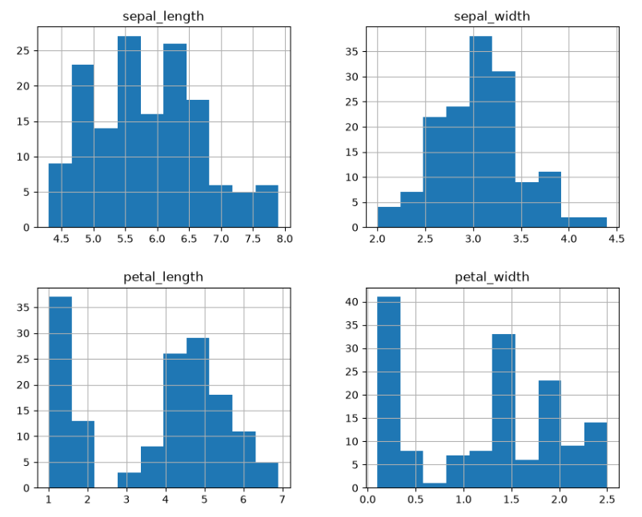
- Box Plot
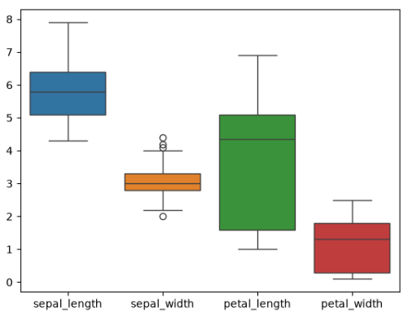
- Pair Plot
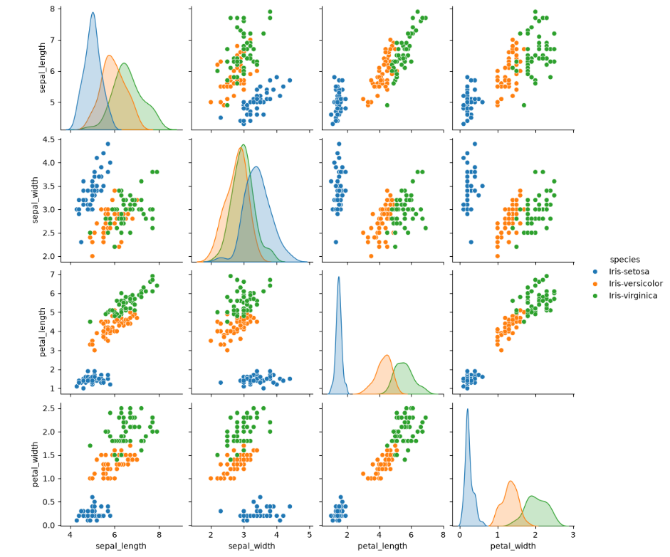
- Scatter Plot
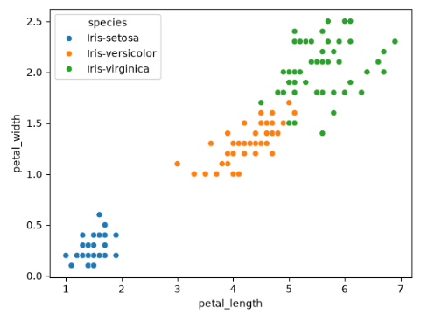
Observations:
The visualizations indicate that petal length and petal width are highly useful features for distinguishing between iris species.
- Data Preprocessing
The following preprocessing steps were performed:
• Feature variables were separated from the target variable.
• Species labels were encoded into numerical values using LabelEncoder.
• The dataset was split into training and testing sets using train_test_split().
• Training data: 80%
• Testing data: 20%
- Model Training
Three machine learning algorithms were trained and evaluated:
- K-Nearest Neighbors (KNN)
- Logistic Regression
- Decision Tree Classifier
- Model Evaluation
Accuracy Comparison:
Model | Accuracy
KNN | 100%
Logistic Regression | 100%
Decision Tree | 100%
Confusion Matrix:
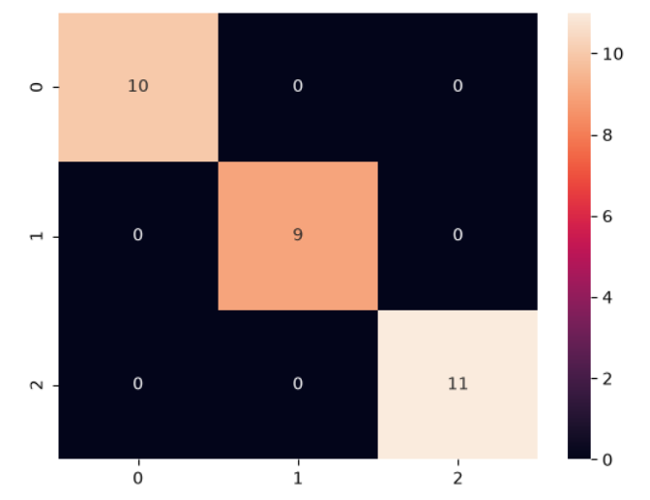
Classification Report:
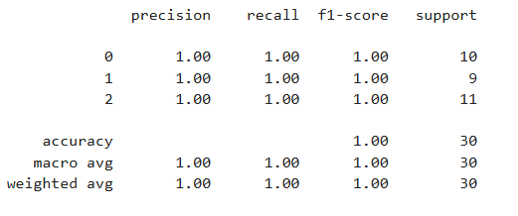
- Model Saving
The best-performing model was saved using Joblib.
File Name:
best_model.pkl
This model can be loaded later and used for making predictions on new iris flower measurements.
- Conclusion
The Iris Classification project was successfully completed using three machine learning algorithms: K-Nearest Neighbors, Logistic Regression, and Decision Tree.
Exploratory Data Analysis and visualization techniques were used to understand the dataset and identify important features.
All three models achieved 100% accuracy on the test dataset. Since all models performed equally well, KNN was selected as the final model and saved for future use.
The trained model can accurately classify iris flowers based on their sepal and petal measurements.

