EdgeFlow Simulator Installation and Usage Manual
Python Socket Programming Mini Project Tutorial
Kumar Shivam Registration Number 25MCMC34

Project Overview
EdgeFlow Simulator is a classroom implementation of a distributed edge system inspired by Cloudflare Workers. It runs one dispatcher, two independent cache nodes, an origin server, and a command-line client. The included demonstration starts the services, sends requests, stops one edge node, verifies failover, and closes every child process.

System Requirements
- Windows 10 or Windows 11.
- Python 3.10 or later available as python from Command Prompt or PowerShell.
- No internet connection and no third-party Python packages are required.
- Local ports 8800, 8801, 8802, and 8900 available for the automatic demo.

Folder Contents
File | Purpose
common.py | JSON message framing, size validation, and client connection helper.
origin_server.py | Authoritative content service.
edge_server.py | TTL cache node and statistics.
dispatcher.py | Round-robin routing, health checks, and failover.
client.py | Manual request client.
demo.py | Complete repeatable demonstration.
test_system.py | Five automated integration tests.
generate_evidence.py | Re-runs the evidence scenarios and prepares execution pages.
run_demo.bat | Double-click launcher for the automatic demonstration.

Quick Start
- Extract the final ZIP file to a writable folder.
- Open the source_code folder.
- Double-click run_demo.bat, or open a terminal in the folder and run python demo.py.
- Wait for DEMO RESULT PASS. The script closes the servers automatically.
- Run python -m unittest -v test_system.py to verify all five integration tests.

Automatic Demonstration
The demo uses ports 8800, 8801, 8802, and 8900 so that it does not conflict with common local development services. It creates service logs in the execution_logs folder. The expected sequence is two healthy nodes, two initial cache misses, a repeated cache hit, one simulated edge failure, successful service through the surviving edge, and a structured error for a missing resource.
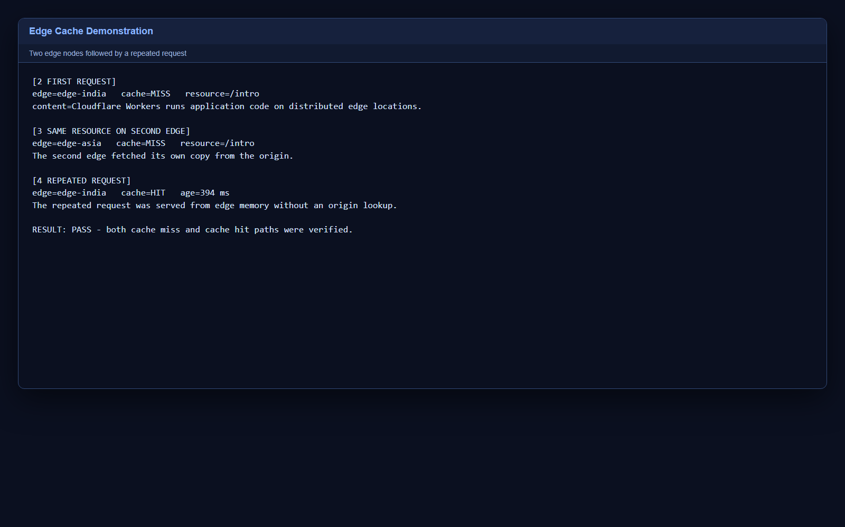
Figure 1 Verified cache miss and cache hit execution

Manual Execution
Open five terminals in the source_code folder. Run the following commands in order and keep the first four terminals open.
python origin_server.py --port 9000
python edge_server.py --name edge-india --port 8001 --ttl 30
python edge_server.py --name edge-asia --port 8002 --ttl 30
python dispatcher.py --port 8000 --node edge-india:127.0.0.1:8001 --node edge-asia:127.0.0.1:8002
python client.py /intro --repeat 3

Manual Failover Demonstration
- Confirm that both edge terminals are running.
- Press Ctrl C in the edge-india terminal to simulate a partial failure.
- Run python client.py /architecture in the client terminal.
- Observe served_by edge-asia in the response.
- Restart edge-india if you want to restore the original two-node setup.
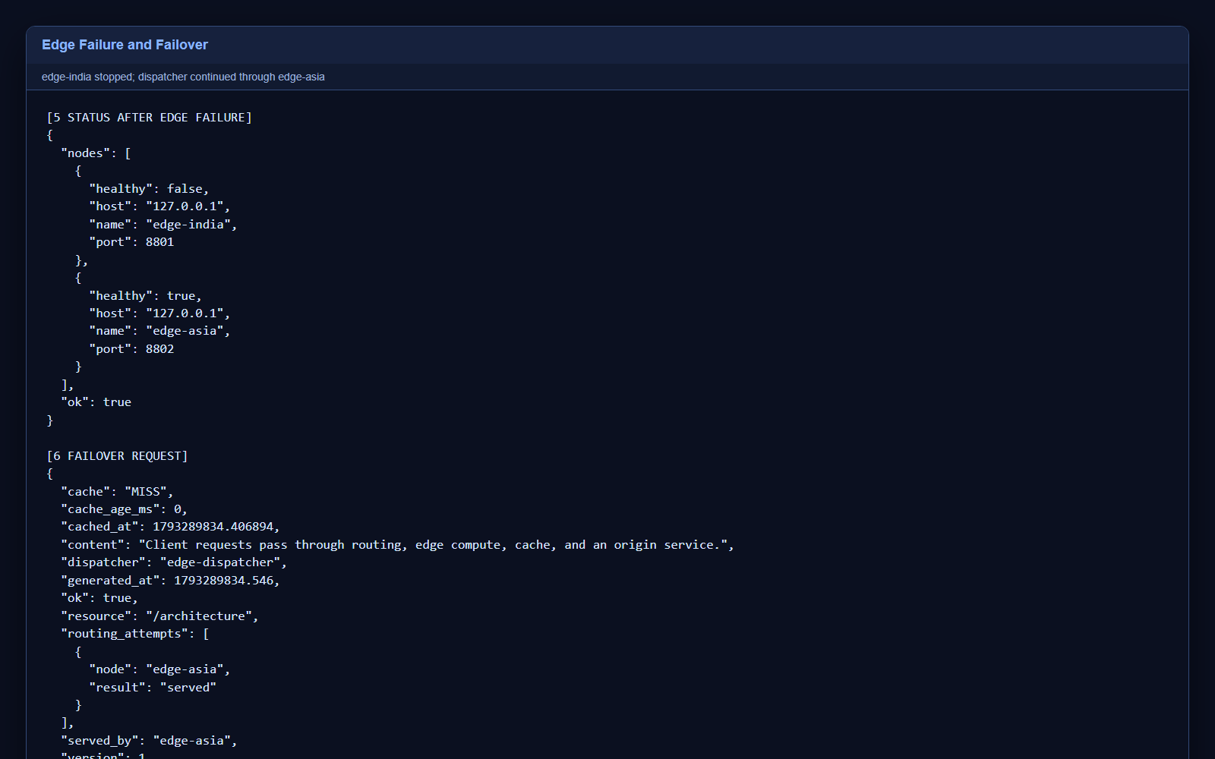
Figure 2 Verified health change and successful failover

Client Options
Option | Example | Meaning
resource | client.py /concepts | Path requested from the system.
--host | --host 127.0.0.1 | Dispatcher address.
--port | --port 8000 | Dispatcher port.
--repeat | --repeat 5 | Number of requests.
--delay | --delay 0.5 | Seconds between repeated requests.

Automated Tests
Run the following command from source_code: python -m unittest -v test_system.py. The tests start isolated services on ports 8100, 8101, 8102, and 9100. They verify initial node health, cache miss followed by hit, dispatcher routing, continued service after edge shutdown, and the not_found error path.
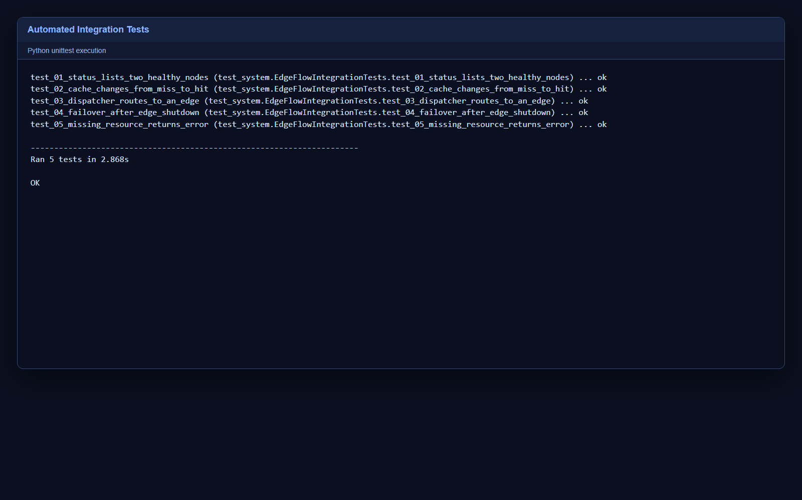
Figure 3 Five integration tests completed successfully

Expected Outputs
Scenario | Important fields
First access on an edge | cache MISS and served_by edge name
Repeated access on same edge | cache HIT and cache_age_ms greater than or equal to zero
Initial status | Both node health values true
After stopping one edge | Stopped node false and surviving node true
Failover request | ok true and served_by surviving edge
Unknown path | ok false and error not_found

Troubleshooting
Problem | Cause | Solution
python is not recognized | Python is not installed or not on PATH. | Install Python 3.10+ and enable Add Python to PATH.
Address already in use | Another program is using a required port. | Close the other program or change matching ports in all commands.
Connection refused | A required server has not started. | Start origin, edges, and dispatcher before the client.
Origin error | Origin server is stopped. | Restart origin_server.py and repeat the request.
Stale content | The edge entry has not expired. | Wait for TTL expiry, restart the edge, or use a shorter --ttl.
Firewall prompt | Windows is asking about Python network access. | For this localhost project, allow only private network access if required by local policy.

Demonstration Explanation
- Round robin: consecutive requests begin with different edge nodes.
- Caching: the first request populates a node cache; the repeated request is a hit.
- Fault tolerance: the dispatcher skips a failed edge and continues through a healthy edge.
- Concurrency: threaded servers can handle more than one connection at a time.
- Eventual consistency: each edge may keep an older origin version until its TTL expires.

Viva Preparation
Question | Short answer
Why use a dispatcher? | It hides edge selection, checks health, and provides failover.
Why can cached data become stale? | Each edge keeps a value until its TTL expires.
What happens if every edge stops? | The dispatcher returns no_edge_available.
Why add a newline after JSON? | TCP has no message boundaries, so the newline marks the end.
How is this related to Cloudflare Workers? | Both place request processing before the origin and distribute work across edge locations.
What is simplified? | The project omits global Anycast routing, V8 isolates, TLS, and production storage services.

Completion Checklist
- Run demo.py and confirm DEMO RESULT PASS.
- Run the five integration tests and confirm OK.
- Keep the source_code, execution_screenshots, documents, and presentation folders inside the final ZIP.
- Read the architecture and algorithms documents before the individualized Minor III test.

