When Does a Learned Waypoint Handoff Help?
Teacher Sensitivity and Embedded NMPC Distillation
Anonymous Submission
Abstract—Distilling nonlinear model predictive control (NMPC) into a compact policy removes online optimization from resource-constrained robots but moves the two-waypoint handoff into the student interface. We first test whether changing only the next waypoint changes the teacher's first command at fixed current-state anchors. 130/236 (55.1%) pre-switch anchors and 163/264 (61.7%) post-switch controls passed the existing useful-and-directional rule; the reported medians are 0.568 and 0.734, respectively. We then compare Hard selection, Joint MLP, Scalar Gate, and Lightweight Attention as four end-to-end current-state architecture bundles. The fixed evaluation contains four routes and three independently trained checkpoints per architecture, giving 12 crossed route-checkpoint cells per architecture. Completion counts are 10/12, 11/12, 12/12, and 12/12 for Hard, Joint MLP, Scalar Gate, and Lightweight Attention respectively. PLACEHOLDER—FINAL RESULT: insert handoff failures, recalculated peak-jump median [min,max] with n_valid/12, and deadline misses/1,000 from the same frozen cell table. Under the fixed deadline-completion-failure-jump hierarchy, [NAME THE DESCRIPTIVE LEADER OR REPORT UNRESOLVED].
Index Terms—model predictive control, policy distillation, hybrid autonomy, waypoint handoff, embedded control
I. INTRODUCTION  NMPC provides predictive dynamics, finite-horizon objectives, and constraints, but repeated online optimization can exceed the compute budget of FTC-class hardware. A compact student can imitate the teacher's first receding-horizon command. Our question is narrower than proposing a new attention method: how should a current-state student combine one current and one next waypoint at the handoff?  The planner supplies current-cycle features x_t, current waypoint g1, next waypoint g2, and phase z_t. No stacked lagged frames or recurrent state are used. Hard keeps the classical switch; Joint MLP is the existing learned-fusion baseline; Scalar Gate learns a one-coordinate relaxation; and Lightweight Attention learns a 1-by-2 current-state-to-waypoint interaction.  The evaluation follows a sensitivity-first order. If the teacher command does not respond to g2 before the switch, the labels cannot supervise genuine look-ahead. We therefore audit the teacher first, compare all four architecture bundles second, and report embedded cost third.  A. Contributions  - a frozen-anchor counterfactual test of local next-waypoint sensitivity in the teacher's first command;  - a common-contract comparison of four complete current-state handoff bundles; and  - a fixed-suite closed-loop and target-device report covering failure, jump, completion, latency, and capacity. | B. Relation to Prior Work  Neural MPC approximations move computation offline but do not automatically inherit teacher feasibility, stability, constraint, or safety guarantees [1]–[4]. Offline imitation also faces closed-loop distribution shift [5], so held-out regression error alone does not establish control behavior.  Attention has coupled state and planning context in driving and navigation [6], [7], while TransformerMPC and TransMPC target solver acceleration or explicit control-sequence generation [8], [9]. Our student is the embedded controller and uses standard scaled dot-product attention [10] only as one compact interface bundle. We claim neither a new attention primitive nor a new MPC solver.  Command-conditioned imitation and hybrid navigation also combine learned policies with classical cues [11], [12]. Our contribution is the ordered diagnostic: verify teacher sensitivity before spending model capacity, then expose the closed-loop and embedded tradeoff among four interfaces.  C. Reviewable Claim  For this tested teacher, robot task, and sparse two-waypoint regime, a teacher-side sensitivity audit followed by a complete four-bundle fixed-suite comparison can reveal whether relaxing a classical waypoint switch improves observed closed-loop/deployment outcomes. Results are descriptive for four fixed routes. We do not claim route-population superiority, sim-to-real transfer, or causal attribution to one operator.  PLACEHOLDER—DEFINE — State whether z_t is a binary switch or a continuous progress feature, and use that same definition in code, figure, and text.

II. DOES THE TEACHER FIRST ACTION DEPEND ON G2?  At each fixed anchor, the factual and counterfactual solves restore the same current state, g1, z_t, objective, constraints, warm start, initial guess, solver settings, and seed. Only g2 changes. The deployed target is the teacher's first command:  u*t = pi_NMPC(x_t, g1, g2, z_t), u*t in R^(D_u).  d_i = ||D^(-1)(u*i,cf - u*i,f)||2.  A pair is valid only when both solves pass frozen status, feasibility, and residual checks. It is useful and directional only when d_i exceeds the finalized declared/actuator/repeat floor and its projection on the frozen direction exceeds the directional threshold. This tests local first-action sensitivity, not formal identifiability.  PLACEHOLDER—SMALL AUDIT — Restore three representative factual snapshots and solve each five times. With the saved factual reference, report 15 repeat-vs-reference distances, max, and p95. If every distance is exactly zero, report max = p95 = 0; otherwise investigate and include repeat max in the useful floor.  TABLE I  FROZEN NEXT-WAYPOINT COUNTERFACTUAL TEST  Region N Median difference / IQR Useful + directional  Pre-switch 236 0.568 / [0.155, 2.252] 130/236 (55.1%)  Post-switch control 264 0.734 / [0.225, 3.465] 163/264 (61.7%) | III. CONTROLLED HANDOFF INTERFACES  All students receive current-cycle x_t, g1, g2, and z_t and predict the same normalized command. Dataset split, targets, normalization, training budget, checkpoint rule, and paired evaluation are shared. Three independently trained checkpoints are used per architecture; they are training replicates, not condition seeds.  Hard deterministically selects the phase-active waypoint. Joint MLP is the existing learned-fusion architecture already in the project and is one of the four models. Scalar Gate blends phase-ordered active and next waypoint embeddings. Lightweight Attention uses one current-state query, two waypoint keys/values, and a 1-by-2 map.  c_gate = (1-alpha_t)e_active + alpha_t e_next,  A_t = softmax(Q_t K_F^T / sqrt(d)), A_t in R^(1x2).  A. Fairness and Attribution  Information, supervision, and evaluation are matched, but decoder paths, capacity, parameter count, and latency differ. Therefore the experiment compares four end-to-end architecture bundles. It cannot isolate attention, gating, or another operator as the causal source of a difference.  B. Fixed Descriptive Decision Rule  A model is eligible only if its preselected export has zero deadline misses among exactly 1,000 retained calls. Among eligible models, maximize completion; if tied, minimize handoff failures; if still tied, minimize median peak jump only on all 12 valid cells or exactly the same matched cells. Otherwise report unresolved.

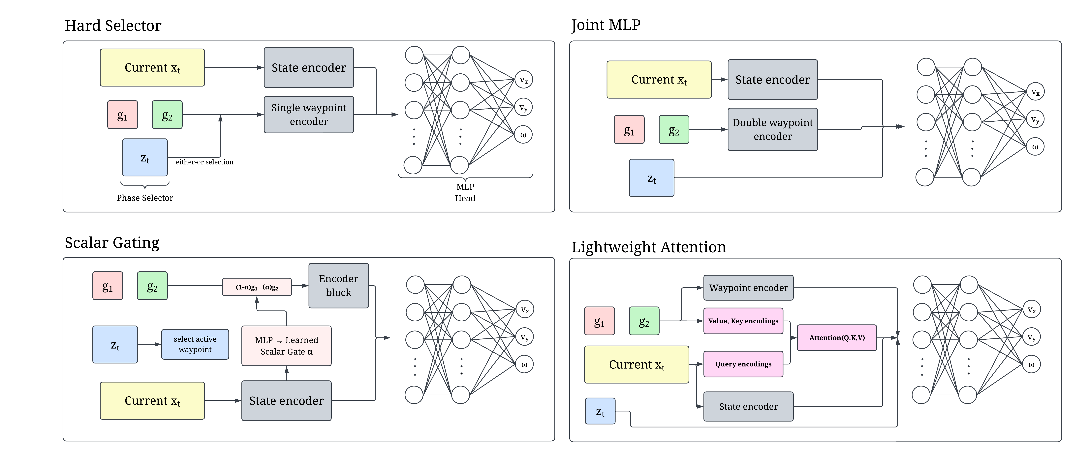
Fig. 1. Sensitivity-first evaluation and four current-state handoff bundles. Joint MLP is the existing learned-fusion baseline; dashed paths are diagnostics. The comparison is bundle-level, not operator-causal.

IV. PAIRED CLOSED-LOOP AND DEPLOYMENT EVALUATION  We use four fixed routes—straight pass-through, sharp turn/S-curve, closely spaced waypoints, and stop-and-hold—and three independently trained checkpoints per architecture. This produces 12 crossed route-checkpoint cells per architecture and 48 cells in total. The 12 cells are not 12 independent route samples.  A. Protocol Boundary  [DECLARE DETERMINISTIC SIMULATION/SCRIPTED BENCH, OR PHYSICAL DEMONSTRATION/REPEATED EXECUTION.] All 12 planned cells remain in the handoff-failure denominator. Timeout, collision, fallback, or numerical termination counts as failure/nonattempt. Completion requires the shared ordered-waypoint, terminal-pose/hold, timeout, collision, fallback, and numerical rules to pass.  Peak jump is the maximum consecutive normalized change of the final applied command in the frozen handoff window, including the transition into its first frame. Compute consecutive differences on the full sorted rollout before selecting window transitions. Report median [min,max], n_valid/12, and every missing reason. | B. Reproducibility Boundary  The supplement must report robot/teacher dynamics; NMPC horizon, objective, constraints, solver, and tolerances; dataset and route-disjoint split counts; loss, optimizer, budget, checkpoint rule, and architecture dimensions; and the M1 anchor/counterfactual rule. Bind exact configs, model/evaluator hashes, and all 48 architecture-route-checkpoint keys.  Latency uses one common checkpoint ID selected before the final comparison. After 200 warm-ups, retain exactly 1,000 timed calls for each architecture on the same device/runtime/thread/power/thermal configuration. Report p50, p95, maximum, and misses/1,000 using one frozen deadline rule.  PLACEHOLDER—DOMAIN — If these are deterministic simulator/scripted-bench runs, say so. If they are one-off physical runs, call them demonstrations; a physical reliability claim requires execution repeats and balanced/interleaved order.

TABLE II
PAIRED HANDOFF AND DEPLOYMENT RESULTS
Architecture | Params / file size | Handoff failures  k/12 | Median control jump (m/s)/ [min, max] | Completion  k/12 | Cross-track error RMSE (m) | Latency p50/p95;  misses/1000
Hard | 138,355 / 153 KB | 2/12 | 0.405 [0.281, 0.869] | 10/12 | 0.147 | 0.3068/0.4180; 0/1000
Joint MLP | 121,683 / 148 KB | 0/12 | 0.343 [0.270, 0.750] | 11/12 | 0.142 | 0.2097/0.3042; 0/1000
Scalar Gate | 138,420 / 497 KB | 0/12 | 0.354 [0.282, 0.869] | 12/12 | 0.150 | 0.3806/0.4754; 0/1000
Lightweight Attention | 269,351 / 1.061 MB | 0/12 | 0.296 [0.259, 0.711] | 12/12 | 0.13799058 | 0.6020/0.7338; 0/1000
†The uploaded jump values are averages under an earlier definition; preserve them for audit but do not relabel them as medians. Recompute FINAL as median [min,max], n_valid/12 from the 12 raw cells.
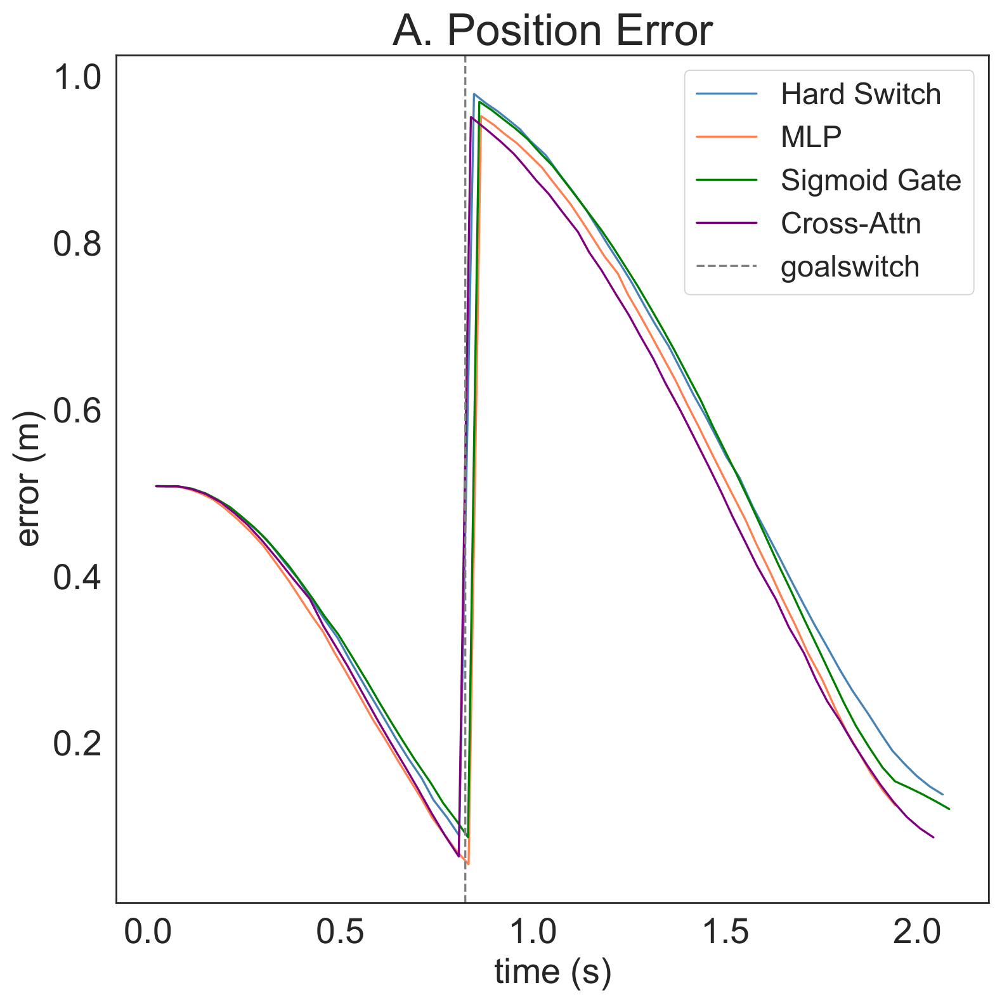  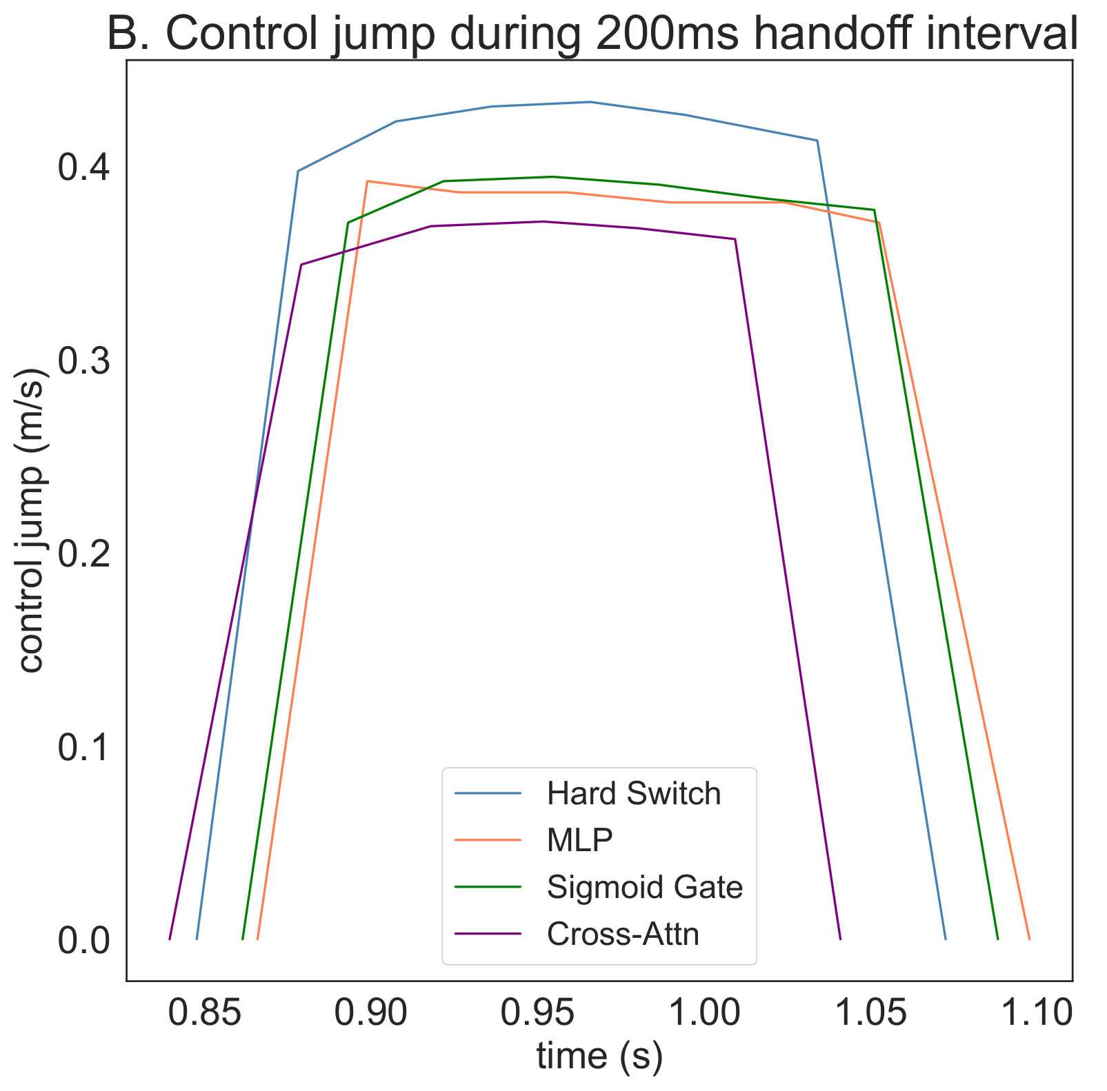  Fig. 2. PLACEHOLDER—FINAL DATA. Panel A: the same rule-selected route and display checkpoint for all four bundles. Panel B should neutrally expose the four-architecture fixed-suite jump evidence (route-level lines and/or all checkpoint cells). Keep the prespecified four-route Gate–Hard diagnostic in the supplement.  C. Figure Selection  Select the trace using Hard alone: compute each route's mean over its three checkpoints and choose the route nearest the median of the four Hard route means; break ties by route ID. Do not inspect other architecture labels during selection. Use the same axes, progress window, and checkpoint ID for all models. | D. Result and Failure Audit  PLACEHOLDER—FINAL RESULT — From the validated 48-row sheet, write one paragraph naming all four completion/failure results, the matched-cell peak-jump ordering, and deadline eligibility. Apply the fixed hierarchy and state either one descriptive leader or unresolved.  Add a compact failure taxonomy in the supplement: architecture, route, checkpoint, failure type, and where it occurred. The current Joint MLP pattern—0/12 handoff failures but 11/12 completion—can be valid if one rollout fails after handoff; the recorded reason makes this interpretable rather than suspicious.  E. Deployment  CURRENT V2 DATA: Joint MLP has the lowest reported p50/p95 latency (0.2097/0.3042 ms); Lightweight Attention has the highest (0.6020/0.7338 ms). These are measured latencies, while 5 ms is the policy deadline. Do not state that all models meet the deadline until all four miss counts are verified.  F. Minimal Statistical Contract  Closed-loop summaries are descriptive for a fixed crossed suite. Do not add an anchor-level CI, treat controller frames as samples, or call the 12 cells independent routes. Gate–Hard M7 is reported only if all 12 matched cells per model have valid peak jumps; otherwise report it unavailable with missing reasons and no imputation.

V. DISCUSSION  A. What the Teacher Audit Establishes  M1 asks whether the first NMPC action is locally sensitive to g2 at selected current-state anchors. A positive result is necessary evidence that the next waypoint exists in the supervision, but it does not prove that a student learned the intended mechanism or that every state depends on g2.  B. What the Architecture Test Establishes  The four-model suite compares complete implementations: a classical phase rule, the existing Joint MLP fusion, one learned scalar relaxation, and a lightweight query-to-waypoint interaction. Any observed advantage belongs to the complete bundle because decoder paths and capacities differ.  PLACEHOLDER—EVIDENCE-DEPENDENT — Insert the final bounded interpretation. Example sentence structure only—not a result: ‘[MODEL] was the descriptive leader under the fixed hierarchy in this tested suite, while [MODEL] retained the lower latency/size cost.’ Fill only with verified Table II values.  C. Why This Matters for Hybrid Autonomy  The interface determines which classical coordinates remain explicit and which decisions become learned. Waypoint handoff is a small case where the availability of teacher information can be checked before comparing capacity. The engineering lesson is therefore sensitivity-first: diagnose supervision, then spend complexity only when the closed-loop evidence justifies its embedded cost. | D. Limitations  The study covers one mecanum-robot task family, one teacher, two sparse waypoints, current-cycle features, four fixed routes, and three trained checkpoints per architecture. It supports a fixed-suite workshop result, not broad reliability, route-population inference, operator causality, or statistical superiority. Offline imitation also does not preserve NMPC feasibility, stability, constraints, or safety guarantees.  E. Reproducibility and Traceability  The abstract, Tables I–II, Fig. 2, discussion, and conclusion must be generated from or checked against one frozen master sheet and manifest. The supplement binds all cells to route/checkpoint IDs, model and evaluator hashes, output order/scales, missing/failure reasons, and the exact timing configuration.  F. Future Work  A later controlled study can add an output-connected temporal-history encoder while holding current features, waypoints, phase, routes, training settings, and evaluation fixed. The present paper makes no positive or negative claim about using temporal history correctly.  VI. CONCLUSION  We treat waypoint handoff as a sensitivity-first architecture-comparison problem rather than assuming that a richer student is better. A frozen teacher counterfactual measures local next-waypoint sensitivity; four current-state handoff bundles are then evaluated under one closed-loop and embedded contract.  PLACEHOLDER—COPY EXACTLY — Insert the same final evidence sentence used in the abstract and Results. It must match Table II, the valid-cell rule, and the deadline hierarchy word for word in substance.  The bounded design rule is to preserve classical structure when it suffices, relax its low-dimensional handoff coordinate when paired evidence supports doing so, and pay for richer fusion only when its observed closed-loop benefit justifies deployment cost.

REFERENCES
[1] D. Q. Mayne, J. B. Rawlings, C. V. Rao, and P. O. M. Scokaert, "Constrained model predictive control: Stability and optimality," Automatica, vol. 36, no. 6, pp. 789-814, 2000.
[2] L. Hewing, K. P. Wabersich, M. Menner, and M. N. Zeilinger, "Learning-based model predictive control: Toward safe learning in control," Annu. Rev. Control Robot. Auton. Syst., vol. 3, pp. 269-296, 2020.
[3] B. Karg and S. Lucia, "Efficient representation and approximation of model predictive control laws via deep learning," IEEE Trans. Cybern., vol. 50, no. 9, pp. 3866-3878, 2020.
[4] M. Hertneck, J. Kohler, S. Trimpe, and F. Allgower, "Learning an approximate model predictive controller with guarantees," IEEE Control Syst. Lett., vol. 2, no. 3, pp. 543-548, 2018.
[5] S. Ross, G. Gordon, and D. Bagnell, "A reduction of imitation learning and structured prediction to no-regret online learning," in Proc. AISTATS, 2011, pp. 627-635.
[6] D. Li, E. Javanmardi, N. Bao, and M. Tsukada, "Cross-attention enhanced imitation learning for end-to-end autonomous driving in unprotected turns," in Proc. ICEA, 2024, pp. 81-86.
[7] X. Xiao et al., "Learning model predictive controllers with real-time attention for real-world navigation," in Proc. CoRL, PMLR 205, 2023, pp. 1708-1721.
[8] V. Zinage, A. Khalil, and E. Bakolas, "TransformerMPC: Accelerating model predictive control via Transformers," arXiv:2409.09266, 2024.
[9] S. Wu et al., "TransMPC: Transformer-based explicit MPC with variable prediction horizon," arXiv:2509.07381, 2025.
[10] A. Vaswani et al., "Attention is all you need," in Adv. Neural Inf. Process. Syst., vol. 30, 2017.
[11] F. Codevilla, M. Muller, A. Lopez, V. Koltun, and A. Dosovitskiy, "End-to-end driving via conditional imitation learning," in Proc. IEEE ICRA, 2018, pp. 4693-4700.
[12] S. Dey, A. Sadek, G. Monaci, B. Chidlovskii, and C. Wolf, "Learning whom to trust in navigation: Dynamically switching between classical and neural planning," in Proc. IEEE/RSJ IROS, 2023, pp. 5235-5242.

