**Convention Structure**

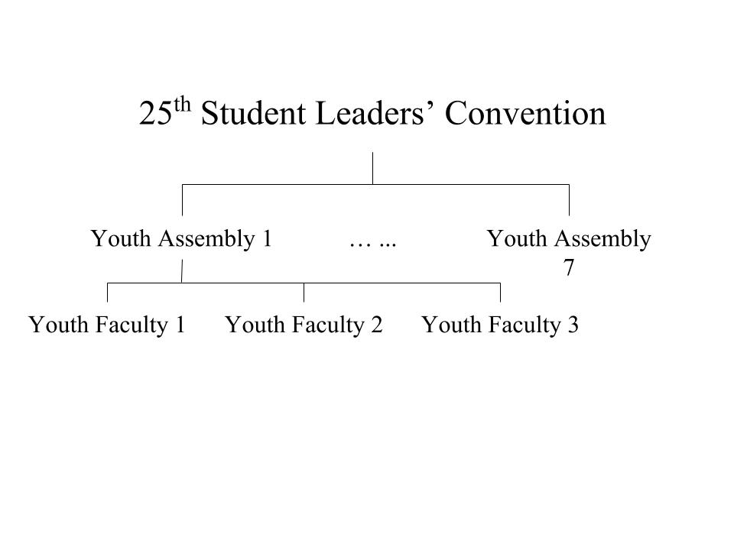

Participants will be grouped into Youth Faculties (YFs) that each forms part of a larger Youth Assembly (YA). For the 25th SLC, there are seven different YAs, each comprising three separate YFs. Each YA is allocated a subtopic pertaining to the main topic of Education. Thereafter, each YF will focus on a facet of this subtopic before coming together and sharing their ideas.

An individual YF is managed by two Facilitators, who will report to their respective Head Facilitators in charge of the YA.

**The Crossroads**

Crossroads would take a similar approach to a simulation of a story where Delegates have to consider different scenarios open to the stakeholders. The audience would then be allowed to choose how the story flows, thus engaging the audience in the skit. At the end of the story, the YFs would be presenting the various consequences that could have resulted if the audience were to pick a different option, hence allowing the audience to have greater insight into the issue.

**Exhibition**

The Exhibition aims to allow the Delegates to showcase the research they have conducted based on the Thought Process and raise awareness of their topics through research.

Delegates would be grouped accordingly to their YFs and each YF would be given a booth to present solutions to their subtopics, and other forms of research they had done, to the judges.

During the Gallery Walk, Delegates would be allowed to move according to the exhibition movement plan and are free to give constructive feedback pertaining to the solutions of other YF subtopics. Concurrently, Concepts members would act as judges and grade the YF booths based on a given set of rubrics.

**Thought Process**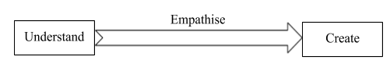

In relation to the topic for the 25th SLC’s Hwa Chong Lecture — “Education”, the SLC Thought Process seeks to incorporate the elements of the past, present and future into the work and discussion process of the Convention itself, while imparting delegates with the necessary knowledge required for them to come up with feasible solutions to combat the problems faced.

*More information about the Thought Process can be found in the eBooklet.*

**Why:** Every solution has flaws within it which has to be addressed. It is by addressing these flaws that can enable solution to be further improved upon. Thus, it is hoped that through The Crossroads, Participants will be able to come up with an improved solution which can tackle the various perspectives of the issue at hand as well as deal with the intended or unintended consequences of the solution.

**Purpose:** To provide an engaging platform for the Delegates to discuss on their allocated issues.Through acting out their ideas and sharing their different perspectives, we hope that they can identify the flaws in each other’s ideas and formulate a better solution as a group.