CSCI927 · SERVICE MODELLING DELIVERABLE
City Parking Management Center
BSRL Specifications, BPMN Process Models
and Semantic Effect Annotations
Deliverable scope: Two service descriptions, two BPMN collaboration models, immediate effect annotations for every modelled task, and cumulative effect scenarios for the principal normal and exceptional paths.

Prepared by Member E
ServiceUniverse · commit a8b222d
August 2026

1. Modelling Basis and Scope
This package translates the implemented ServiceUniverse parking capability into the three modelling artefacts required by the course. It describes the Public Parking Availability Service, the Parking Billing and Payment Service, and their observable behaviour through the shared API Gateway.
Implementation baseline: The specifications are traced to the OpenAPI contracts, FastAPI services, independent SQLite repositories, pricing rule and frozen process-activity dictionary at commit a8b222d. Sixteen targeted parking tests pass locally; the only reported warning is an upstream TestClient deprecation warning.

Artefact | Course basis | Applied interpretation
BSRL | Service Modelling, slides 4-10 | Goal, conditions, assumptions, inputs/outputs, resources, key steps, QoS, delivery and contractual factors.
BPMN | Business Process Modelling and Management | Events, tasks, exclusive gateways, pools/lanes, sequence flows, message flows, data objects and error paths.
Semantic annotation | Semantic Processes and Services, slides 8-24 | Business objects, immediate effects on tasks, cumulative effects, scenario labels and mutually exclusive paths.

1.1 Notation
Predicates use lower-case names and variables: l = parking lot, r = request, s = parking session, c = citizen, v = vehicle, f = parking fee, p = payment, n = available-space value, t = time, a = monetary amount. The symbol ¬ denotes negation and ∧ denotes conjunction. Effects describe the state immediately after successful completion unless an exceptional result is stated.

2. BSRL - Public Parking Availability Service
Service description | Public Parking Availability Service (service slug: parking-availability; implementation type: selected microservice).
Goal | Achieve an accurate, queryable representation of current public parking capacity and permit a validated availability update. The goal is satisfied when the consumer receives either the current ParkingLot resource(s) or an explicit contract-defined error without unintended data mutation.
Preconditions | The service and its independent store are available. For a single-lot query or update, lot_id is supplied. For an update, available_spaces is an integer greater than or equal to zero; the parking lot exists; and available_spaces does not exceed total_spaces.
Postconditions | List/query returns current ParkingLot data with a derived availability_status. A valid update persists available_spaces and a UTC updated_at value, then returns the updated resource. Invalid or unknown requests return a stable error and leave stored availability unchanged.
Assumptions | The upstream operator or sensor provides a truthful occupancy value. total_spaces is authoritative. All exchanged timestamps use ISO 8601/UTC. The prototype does not reserve spaces and does not infer occupancy from Parking Billing.
Resources | FastAPI service; independent SQLite parking_lots table; SQLAlchemy repository; service-specific Dockerfile; OpenAPI contract; API Gateway router; service-specific frontend page.

2.1 Inputs and Outputs
Operation | Input | Success output | Exceptional output
List parking lots | No body | 200; array of ParkingLot resources | 422 for malformed request metadata if applicable
Get parking lot | lot_id: path string | 200; one ParkingLot resource | 404 PARKING_LOT_NOT_FOUND
Update availability | lot_id; JSON available_spaces: integer >= 0 | 200; persisted ParkingLot resource | 404 PARKING_LOT_NOT_FOUND; 409 AVAILABILITY_EXCEEDS_CAPACITY; 422 VALIDATION_ERROR

2.2 Key Steps
Step | Activity | Result
1 | Receive and route the HTTP request through the Gateway. | The operation and target lot are identified.
2 | Validate path/body data and the relevant business constraints. | Only contract-valid requests continue.
3 | Read the parking_lots store or persist the requested availability update. | A current or updated ParkingLot entity is obtained.
4 | Derive availability_status from available_spaces and total_spaces. | full if n = 0; limited if 0 < n <= max(5, floor(total/10)); otherwise available.
5 | Return a typed JSON resource or stable error response. | The consumer receives an explicit outcome.

2.3 QoS, Delivery and Contractual Factors
Factor | Constraint
Data integrity | 0 <= available_spaces <= total_spaces. A rejected update performs no mutation.
Freshness | Every successful update replaces updated_at with the current UTC service time.
Determinism | The same valid PATCH value produces the same availability value and derived status; GET operations are read-only.
Availability semantics | The service publishes /health and is independently deployable on default port 8301.
Delivery schedule | Synchronous request/response; one terminal response per accepted HTTP request.
Contract | REST/JSON under /api/v1; snake_case fields; explicit 200/404/409/422 outcomes; no cross-service database access.
Penalty | Not applicable in the course prototype; contract violations are represented by HTTP errors rather than financial penalties.

2.4 Operation and Data Invariants
Invariant | Model/implementation consequence
Capacity bound | No successful state can satisfy available_spaces < 0 or available_spaces > total_spaces.
Derived status | availability_status is computed from the persisted space count and is not stored independently.
Isolation | Parking Availability owns parking_lots and does not read the Parking Billing database.
Update semantics | PATCH sets an explicit count rather than incrementing/decrementing it, making the classroom demonstration repeatable.

3. BPMN - Public Parking Availability
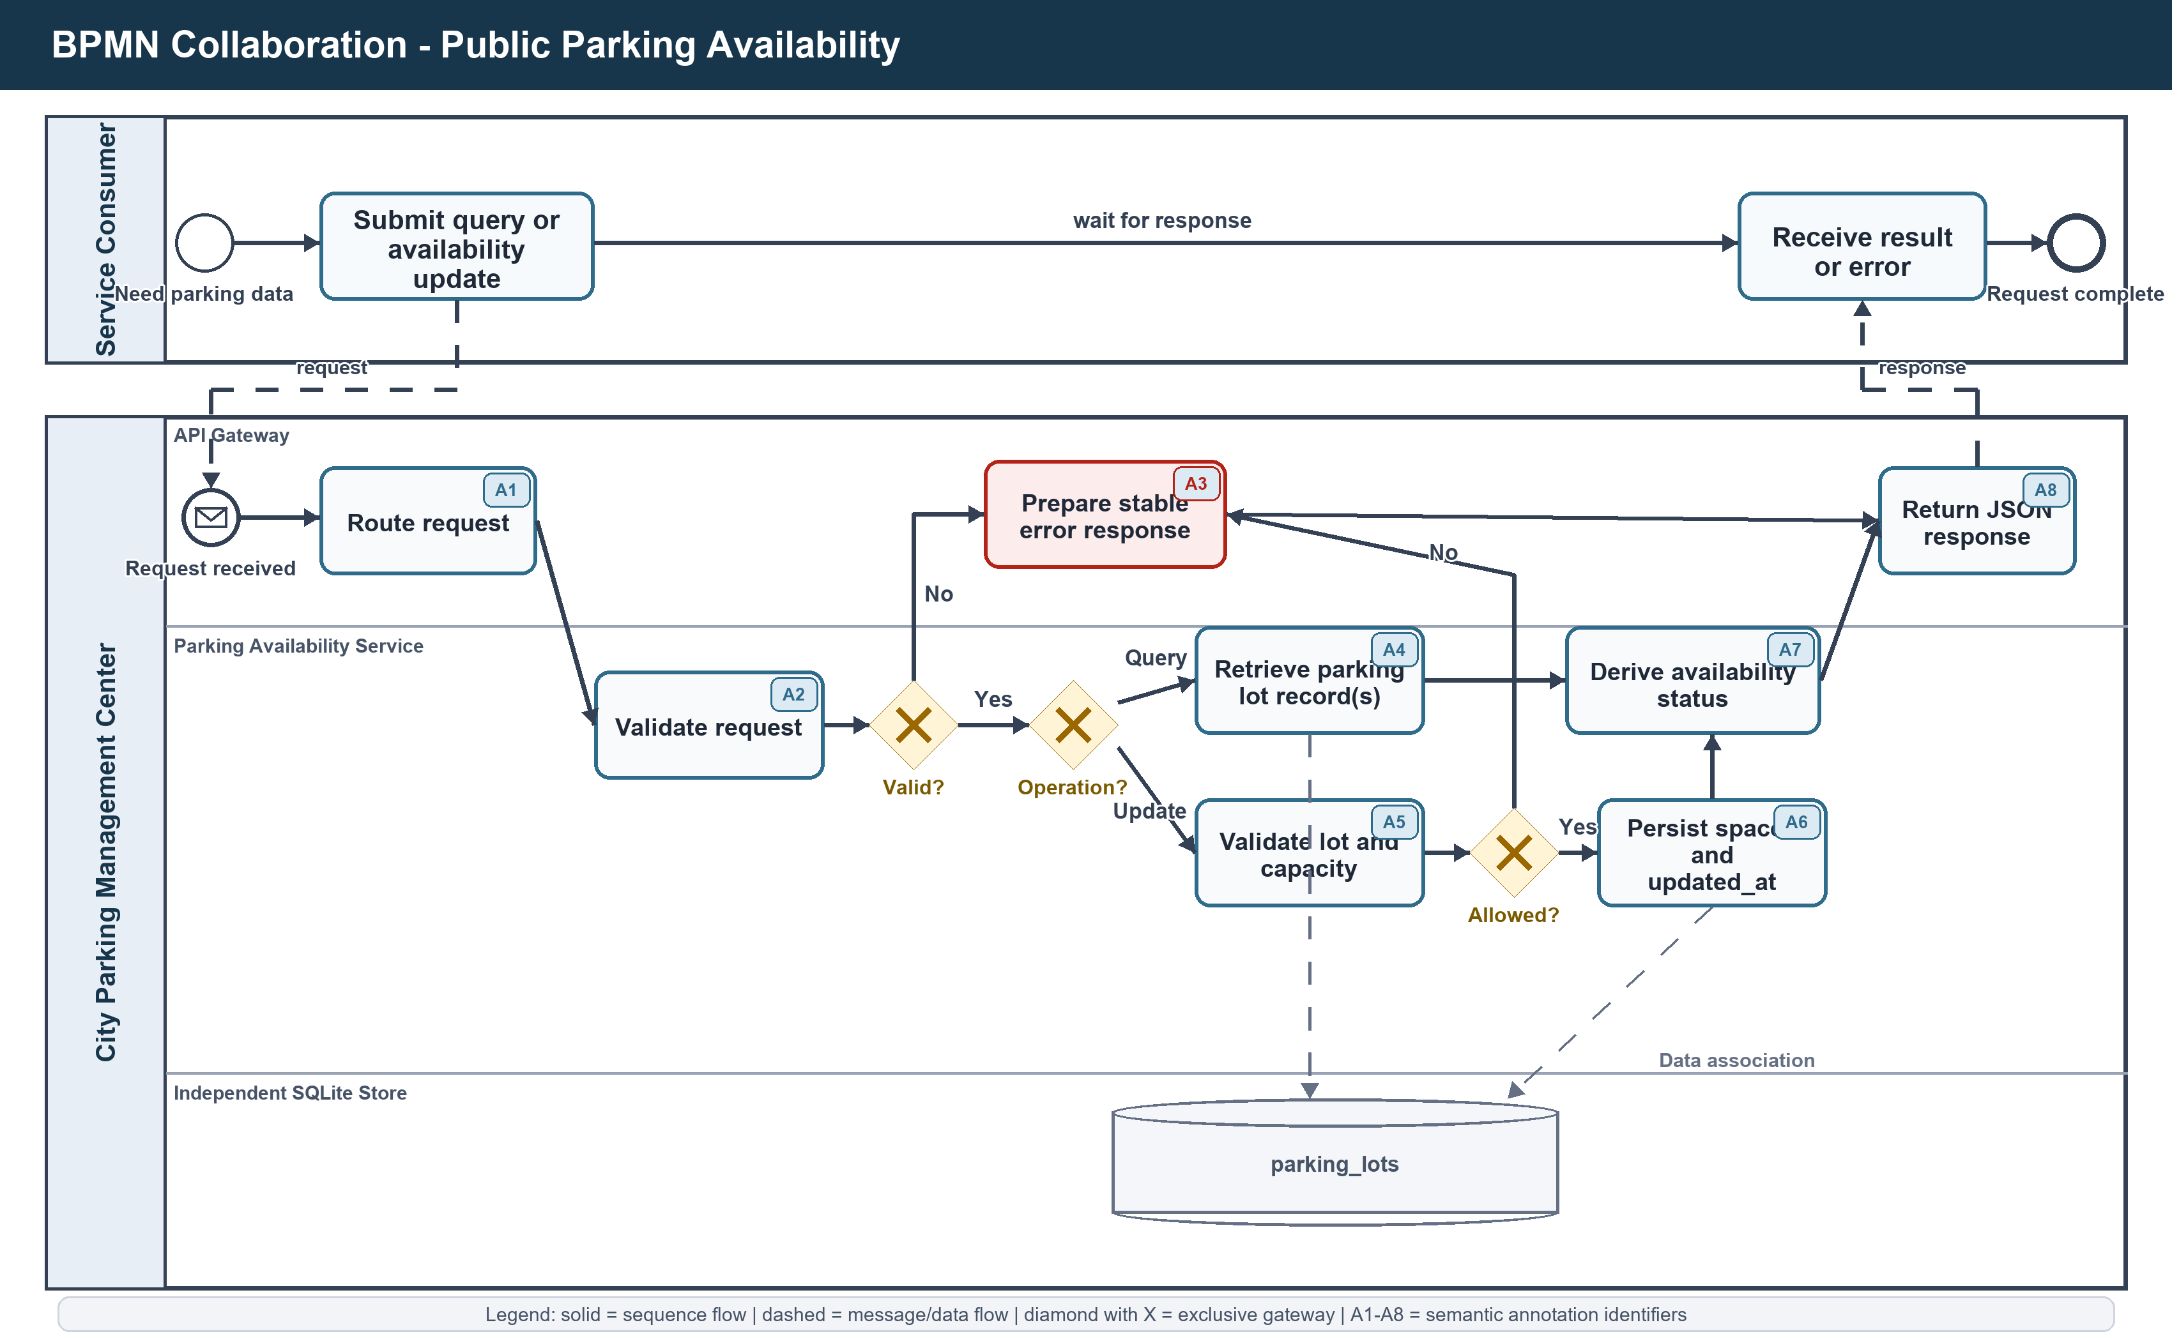
Figure 1. Collaboration model for querying and updating parking availability. A1-A8 link the BPMN tasks to Section 4.2.

4. Semantic Effect Annotations - Availability

4.1 Business Objects and Background Knowledge
Object | Variable | Relevant states and relationships
ParkingLot | l | known(l), totalSpaces(l,m), availableSpaces(l,n), availabilityStatus(l,status), updatedAt(l,t)
AvailabilityRequest | r | received(r), valid(r), queryRequest(r), updateRequest(r,n), targets(r,l), rejected(r,reason)
AvailabilityResponse | q | responseFor(q,r), contains(q,l), successful(q), errorResponse(q,code), delivered(q)

Background knowledge BK-A full(l) <-> availableSpaces(l,0); limited(l) <-> 0 < availableSpaces(l,n) <= max(5,floor(totalSpaces(l)/10)); available(l) <-> availableSpaces(l,n) > max(5,floor(totalSpaces(l)/10)); mutuallyExclusive(full,limited,available)

4.2 Immediate Effects
ID | BPMN task | Immediate effect assertion
A1 | Route request | received(r) ∧ routedTo(r,parkingAvailabilityService)
A2 | Validate request | valid(r) OR rejected(r,validationError)
A3 | Prepare stable error response | errorResponse(q,code) ∧ responseFor(q,r) ∧ ¬dataMutated(r)
A4 | Retrieve parking lot record(s) | retrieved(l) ∧ contains(q,l) ∧ reflectsStoredState(q,l)
A5 | Validate lot and capacity | known(l) ∧ 0 <= n <= totalSpaces(l) OR rejected(r,notFoundOrCapacity)
A6 | Persist spaces and updated_at | availableSpaces(l,n) ∧ updatedAt(l,t) ∧ persisted(l)
A7 | Derive availability status | availabilityStatus(l,status) ∧ status ∈ {available,limited,full}
A8 | Return JSON response | delivered(q) ∧ responseFor(q,r) ∧ (successful(q) OR errorResponse(q,code))

4.3 Cumulative Effect Scenarios
Scenario AV-Q (successful query) <A1,A2,A4,A7,A8> : received(r) ∧ valid(r) ∧ retrieved(l) ∧ availabilityStatus(l,status) ∧ delivered(q) ∧ successful(q)

Scenario AV-U (successful update) <A1,A2,A5,A6,A7,A8> : valid(r) ∧ known(l) ∧ availableSpaces(l,n) ∧ updatedAt(l,t) ∧ persisted(l) ∧ availabilityStatus(l,status) ∧ delivered(q)

Scenario AV-E (rejected request) <A1,A2,A3,A8> or <A1,A2,A5,A3,A8> : rejected(r,reason) ∧ errorResponse(q,code) ∧ ¬dataMutated(r) ∧ delivered(q)

Exclude sets: AV-Q, AV-U and AV-E are mutually exclusive terminal scenarios for one request. For an update request, the successful AV-U label excludes AV-E; an unknown lot or invalid capacity selects AV-E and excludes AV-U.

5. BSRL - Parking Billing and Payment Service
Service description | Parking Billing and Payment Service (service slug: parking-billing; implementation type: business service).
Goal | Track a vehicle parking session from entry to exit, calculate the payable fee according to the published tariff, accept an eligible payment, and expose an auditable event sequence.
Preconditions | Create: citizen_id, vehicle_plate and parking_lot_id are valid and the vehicle has no active session. End: the session exists, is active and ended_at is later than started_at. Pay: the session exists, is completed/unpaid and payment_method is card or digital_wallet.
Postconditions | Create produces active/not_due. End records ended_at and duration, calculates amount_minor, and produces completed/unpaid. Payment creates a completed ParkingPayment and produces completed/paid. Every successful state-changing operation records the corresponding frozen activity event.
Assumptions | Timestamps are trusted UTC values; the currency is AUD; the parking lot identifier is supplied by the caller; prototype payment confirmation is synchronous and does not call an external card acquirer; simulated Reject Payment events are analysis data, not runtime payment-provider responses.
Resources | FastAPI service; independent SQLite sessions/payments/events tables; SQLAlchemy repository; pricing component; OpenAPI contract; Gateway router; frontend page; deterministic event-log generator and activity dictionary.

5.1 Inputs and Outputs
Operation | Input | Success output | Exceptional output
Create session | citizen_id; vehicle_plate; parking_lot_id; optional started_at | 201; active/not_due ParkingSession | 409 ACTIVE_SESSION_EXISTS; 422 VALIDATION_ERROR
List/get session | optional citizen_id/status filters or session_id | 200; session list or resource | 404 PARKING_SESSION_NOT_FOUND
End session | session_id; optional ended_at | 200; completed/unpaid session with duration and amount | 404 not found; 409 already ended; 400 invalid end time
Create payment | session_id; card or digital_wallet | 201; completed ParkingPayment and paid session | 404 not found; 409 not billable/already paid
Get payment/events | payment_id or session_id | 200; payment or ordered ProcessEvent list | 404 resource not found

5.2 Key Steps and Fee Rule
Step | Frozen activity | State/result
1 | Register Parking Entry | Create session: active/not_due.
2 | Close Parking Session | Record exit and duration; transition to completed.
3 | Calculate Parking Fee | Set amount_minor and payment_status = unpaid.
4 | Initiate Payment | Start payment for an ended, unpaid session.
5 | Confirm Payment | Create payment; set payment_status = paid.
5E | Reject Payment | Simulated exceptional analysis path; session remains unpaid.

Pricing duration_minutes = max(1, ceil((ended_at - started_at)/60 seconds)); billed_hours = ceil(duration_minutes/60); amount_minor = min(billed_hours * 400, 4000); currency = AUD

5.3 QoS, Delivery and Contractual Factors
Factor | Constraint
State integrity | At most one active session per normalized vehicle plate; allowed lifecycle is active/not_due -> completed/unpaid -> completed/paid.
Monetary integrity | Amounts use integer minor units; currency is AUD; rate is 400 cents per started hour; cap is 4000 cents per session.
Temporal integrity | ended_at > started_at; duration is rounded up to at least one minute; timestamps are UTC.
Idempotency protection | A completed session cannot be ended again and a paid session cannot be paid again.
Auditability | Runtime normal-path events use case_id = session_id, lifecycle = complete and the frozen activity names.
Delivery schedule | Synchronous request/response. Optional omitted timestamps are replaced with current UTC service time.
Contract | REST/JSON under /api/v1; independent storage; default service port 8302; stable 200/201/400/404/409/422 outcomes.
Penalty | Not applicable in the prototype; invalid transitions are rejected and do not create a valid payment.

5.4 Process Event Contract
Field | Runtime meaning | Required value/relationship
case_id | One process instance | Equals the parking session_id.
activity | Completed business activity | Uses the frozen six-name activity dictionary.
timestamp | Completion time | ISO 8601 UTC and ordered within a case.
resource | Executing participant | parking-billing-service for runtime events.
lifecycle/outcome | Event completion and result | lifecycle = complete; runtime normal path outcome = success.
cost/duration/status | Analytical payload | Populated when relevant to fee, duration or lifecycle state.

6. BPMN - Parking Billing and Payment
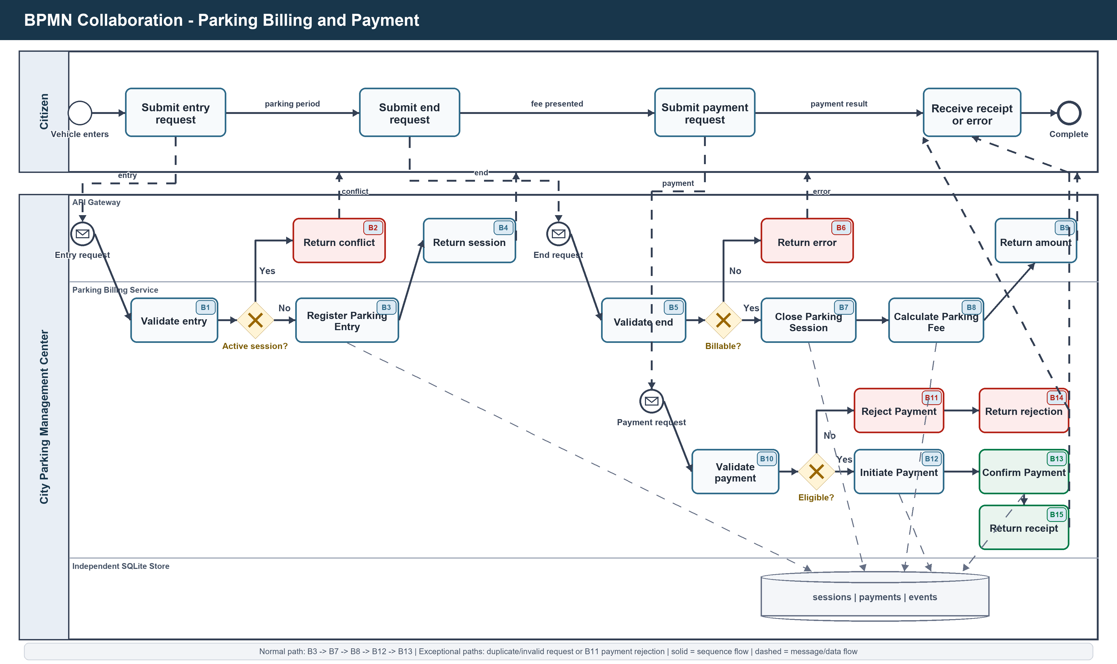
Figure 2. Billing collaboration model. B3/B7/B8/B12/B13 match the frozen normal-path event vocabulary; B11 is the simulated payment-failure activity.

7. Semantic Effect Annotations - Billing

7.1 Business Objects and Background Knowledge
Object | Variable | Relevant states and relationships
ParkingSession | s | active(s), completed(s), notDue(s), unpaid(s), paid(s), forVehicle(s,v), ownedBy(s,c), atLot(s,l), duration(s,d)
ParkingFee | f | calculated(f), feeFor(f,s), amount(f,a), currency(f,AUD)
ParkingPayment | p | initiated(p), completedPayment(p), rejectedPayment(p), paysFor(p,s), method(p,m), paidAt(p,t)
ProcessEvent | e | eventFor(e,s), activity(e,name), lifecycle(e,complete), outcome(e,result)

Background knowledge BK-B active(s) -> notDue(s); completed(s) -> ¬active(s); paid(s) -> completed(s) ∧ ¬unpaid(s); completedPayment(p) -> paysFor(p,s) ∧ paid(s); rejectedPayment(p) -> unpaid(s); paid(s) and unpaid(s) are mutually exclusive

7.2 Immediate Effects
ID | BPMN task | Immediate effect assertion
B1 | Validate entry | validEntry(r) OR rejected(r,validationOrDuplicate)
B2 | Return conflict | errorResponse(q,ACTIVE_SESSION_EXISTS) ∧ ¬sessionCreated(r)
B3 | Register Parking Entry | active(s) ∧ notDue(s) ∧ forVehicle(s,v) ∧ ownedBy(s,c) ∧ atLot(s,l) ∧ event(activity=Register Parking Entry)
B4 | Return session | delivered(q) ∧ contains(q,s)
B5 | Validate end | validEnd(r,s,t) OR rejected(r,notFoundAlreadyEndedOrInvalidTime)
B6 | Return error | errorResponse(q,code) ∧ ¬sessionEnded(r)
B7 | Close Parking Session | completed(s) ∧ ¬active(s) ∧ endedAt(s,t) ∧ duration(s,d) ∧ event(activity=Close Parking Session)
B8 | Calculate Parking Fee | calculated(f) ∧ feeFor(f,s) ∧ amount(f,a) ∧ currency(f,AUD) ∧ unpaid(s) ∧ event(activity=Calculate Parking Fee)
B9 | Return amount | delivered(q) ∧ contains(q,s) ∧ exposes(q,a,AUD)
B10 | Validate payment | eligible(s,p) OR rejected(r,notBillableOrAlreadyPaid)
B11 | Reject Payment | rejectedPayment(p) ∧ paysFor(p,s) ∧ unpaid(s) ∧ event(activity=Reject Payment)
B12 | Initiate Payment | initiated(p) ∧ paysFor(p,s) ∧ method(p,m) ∧ event(activity=Initiate Payment)
B13 | Confirm Payment | completedPayment(p) ∧ paid(s) ∧ ¬unpaid(s) ∧ paidAt(p,t) ∧ event(activity=Confirm Payment)
B14 | Return rejection | delivered(q) ∧ errorResponse(q,paymentRejected)
B15 | Return receipt | delivered(q) ∧ contains(q,p) ∧ successful(q)

7.3 Cumulative Effect Scenarios
Scenario PB-A (still active) <B1,B3,B4> : active(s) ∧ notDue(s) ∧ forVehicle(s,v) ∧ ownedBy(s,c) ∧ atLot(s,l)

Scenario PB-U (ended and unpaid) <B1,B3,B4,B5,B7,B8,B9> : completed(s) ∧ ¬active(s) ∧ duration(s,d) ∧ calculated(f) ∧ amount(f,a) ∧ currency(f,AUD) ∧ unpaid(s)

Scenario PB-P (paid normal path) <B1,B3,B4,B5,B7,B8,B9,B10,B12,B13,B15> : completed(s) ∧ completedPayment(p) ∧ paysFor(p,s) ∧ paid(s) ∧ ¬unpaid(s) ∧ delivered(receipt)

Scenario PB-R (payment rejected) <B1,B3,B4,B5,B7,B8,B9,B10,B11,B14> : completed(s) ∧ rejectedPayment(p) ∧ unpaid(s) ∧ ¬paid(s) ∧ delivered(rejection)

Scenario PB-E (request/state error) <B1,B2> OR <B5,B6> OR <B10,B14> : errorResponse(q,code) ∧ delivered(q) ∧ noInvalidTransitionApplied(r)

Exclude sets: PB-P excludes PB-R and PB-E for the same payment attempt. PB-R excludes PB-P. PB-A is a prefix state, not a contradiction: it remains current until a valid end request extends the case to PB-U; PB-U remains current until a valid payment extends it to PB-P or the simulated failure produces PB-R.

8. Traceability and Acceptance Evidence
Requirement | BSRL/BPMN evidence | Implementation evidence
List and query parking lots | Availability BSRL operations; Figure 1 query branch; AV-Q | GET /api/v1/parking-lots and GET /api/v1/parking-lots/{lot_id}
Repeatable availability update | Availability update conditions; Figure 1 update branch; AV-U/AV-E | PATCH /api/v1/parking-lots/{lot_id}/availability; SQLite persistence
Selected microservice | Availability resource/QoS factors | Independent Dockerfile, dependency file, SQLite store, /health, port 8301
Create/query session | Billing BSRL; Figure 2 entry stage; PB-A | POST/GET parking-sessions; duplicate-active guard
End and calculate | Billing key steps; B7-B9; PB-U | End endpoint; ceiling-hour AUD 4.00 tariff; AUD 40.00 cap
Eligible payment | B10-B15; PB-P/PB-R | POST parking-payments; completed/unpaid eligibility; duplicate-payment guard
Process-event handoff | Frozen task names in Figure 2 and semantic effects | events endpoint, activity_dictionary.json and deterministic simulated CSV generator

Acceptance conclusion: The two service descriptions, two collaboration diagrams and their semantic annotations are consistent with the implemented contracts and state transitions. They are suitable for insertion into the team Master Report, subject only to the team's final document numbering and visual style.

9. References
[1] CSCI927, Subject Introduction - SOC Preliminaries, lecture slides.
[2] CSCI927, Service Modelling, especially the Business Service Representation Language structure and service modelling exercise.
[3] CSCI927, Business Process Modelling and Management, BPMN elements, swimlanes, message flows, gateways, data objects and exception handling.
[4] CSCI927, Semantic Processes and Services, immediate/cumulative effect annotations, effect scenarios and exclude sets.
[5] ServiceUniverse repository, commit a8b222d: parking OpenAPI contracts, service implementations, repositories, pricing rule, tests and activity dictionary.

