**R Programming CA 2**

**12215949**

**SUDHARSAN B**

**Roll No: 25**

**Question 1**

View(Titanic)

data <-data.frame(Titanic)

data

library(sqldf)

**ii)**

da <- sqldf("select count(*) from data where Survived=='No'")

dat <- sqldf("select count(*) from data where Survived=='Yes'")

dead_count <- da$count

dead_count

alive_count <- dat$count

alive_count

ratio <- dead_count/alive_count

ratio

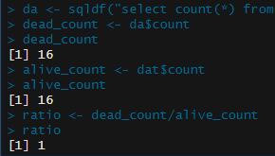

**i)**

families <- (data$Class)

four_familes <- levels(families)

four_familes

# 3x3 matrix

mat1 <- matrix(c(1:9),nrow=3,ncol=3)

mat2 <- matrix(c(2:10),nrow=3,ncol=3)

mat1

mat2

**Question 2**

**iv)**

# with using sql query function

first <- sqldf("select mpg from mt where gear > 3 and cyl > 3")

first

library(dplyr)

?dplyr

**ii)**

ans <-subset(mt,cyl>3,gear>3)

ans

ans1 <- ans$mpg

ans1



?dplyr

library(dplyr)

**i)**

ans2 <- filter(mt,gear>3 & cyl>3)

ans2 <- ans2$mpg

ans2



**iii)**

ans3 <- mt %>%

subset(gear>3 & cyl >3)

ans4 <- ans3$mpg

ans4

