**R Programming (Activity)**

12215949

Sudharsan B

25

K22G

**ACTIVITY 1**

* Filtering the data using the library ‘dplyr’ R version 4.3.3

**Code**

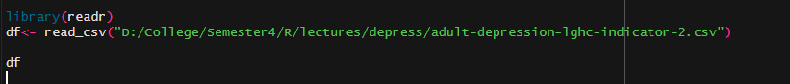

**Result**

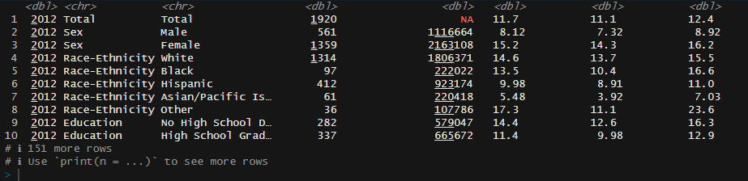

**ACTIVITY 2**

* Adding the filter using dpyrl library and ‘%>%’ is called as pipe
* Filter is year should has to be 2012 and the Strata attribute should be ‘Education’

**Code**

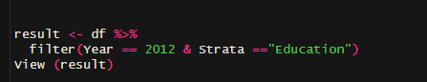

This is the final result which we got by filtering the data

**Activity 3**

* Lets exclude the missing data which is present in the data using na.exclude() method

Earlier

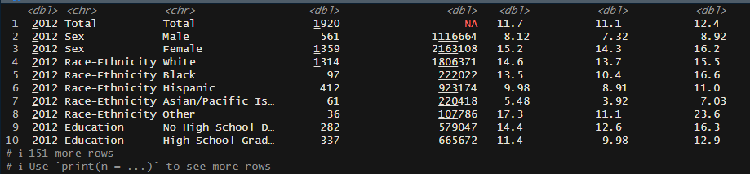

**Code**

na.exclude(df)

**Activity 4**

* Let’s find the percentage of missing data was present in our data
* Using visualization tool library visdat

**Code**

Library(visdat)

vis_miss(df)

