程序设计基础（实验九）
学号： 姓名： 专业：
1.目的：熟练掌握在vc环境下类的建立。
2 题目：

（1）定义圆类，完成面积的求解；定义圆柱体类，其中一数据成员为圆类，要求编写函数完成圆柱体体积和表面积的求解。
（2）定义stack类，完成栈功能的实现，包括push函数、pop函数、构造函数（完成空间的分配）、析构函数（完成空间的释放），添加断点，。
（3）类的建立与访问，添加私有成员number，添加静态私有成员obj_num
要求1：在构造函数中初始化number的值，生成对象obj1，并利用函数返回私有成员number的值
要求2:利用obj_num统计对象的个数，生成两个对象，利用函数读取obj_num的值
要求3：利用new函数生成该类的对象，调用delete函数进行删除，观察该过程是否调用了构造函数和析构函数（截图说明）

3 程序结果贴图（注意标明对应题号和进行简短说明）
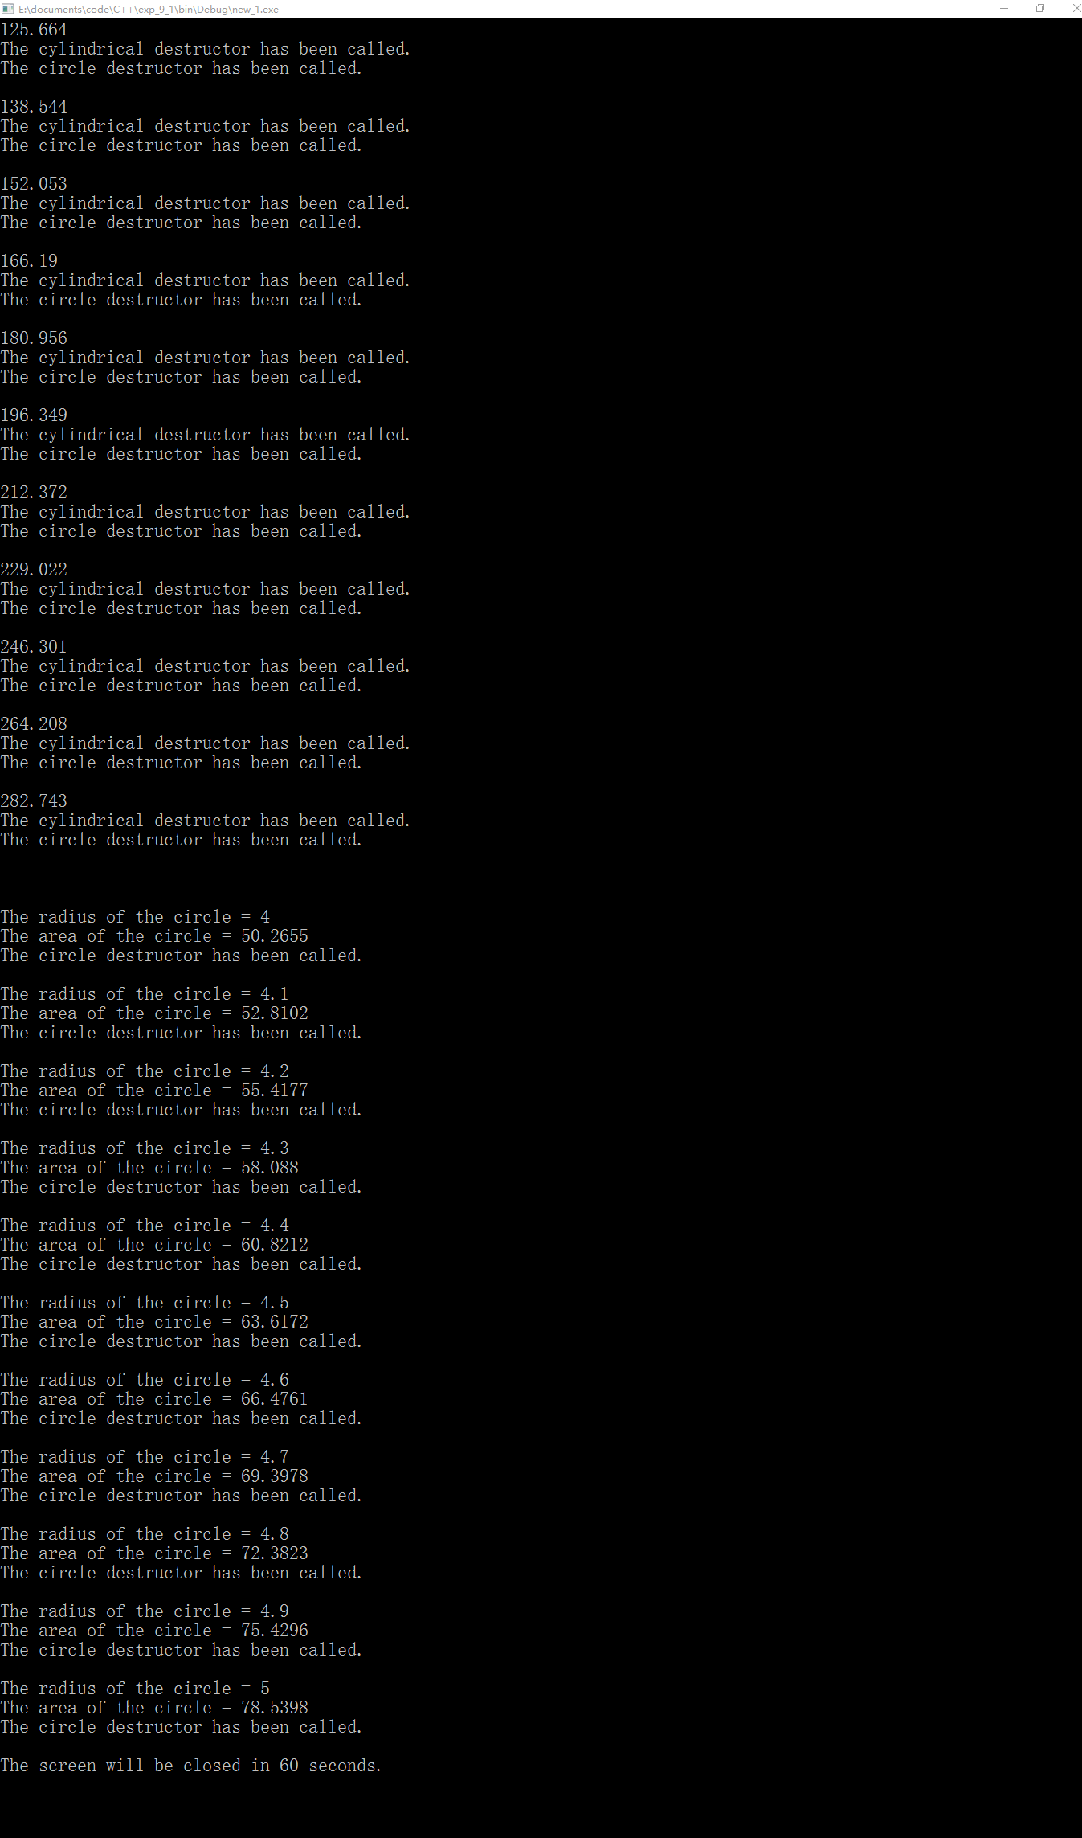
图一 题目（1）程序运行截图

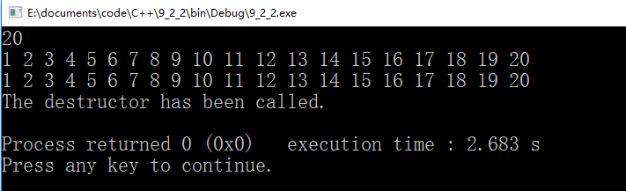
图二 题目（2）程序运行截图

obj1.number = 3
Now obj_num = 1

obj2.number = 4355776
Now obj_num = 2

obj3.number = 0
Now obj_num = 3

obj4.number = 6
Now obj_num = 4

The destructor has been called.
Now obj_num = 3
***********************************************************
obj5.number = 19
Now obj_num = 4

The destructor has been called.
obj6.number = 20
Now obj_num = 4

The destructor has been called.
obj7.number = 21
Now obj_num = 4

The destructor has been called.
obj8.number = 22
Now obj_num = 4

The destructor has been called.
obj9.number = 23
Now obj_num = 4

The destructor has been called.
obj10.number = 24
Now obj_num = 4

The destructor has been called.
obj11.number = 25
Now obj_num = 4

The destructor has been called.
obj12.number = 26
Now obj_num = 4

The destructor has been called.
obj13.number = 27
Now obj_num = 4

The destructor has been called.
obj14.number = 28
Now obj_num = 4

The destructor has been called.
obj15.number = 29
Now obj_num = 4

The destructor has been called.
obj16.number = 30
Now obj_num = 4

The destructor has been called.
obj17.number = 31
Now obj_num = 4

The destructor has been called.
obj18.number = 32
Now obj_num = 4

The destructor has been called.
obj19.number = 33
Now obj_num = 4

The destructor has been called.
obj20.number = 34
Now obj_num = 4

The destructor has been called.
obj21.number = 35
Now obj_num = 4

The destructor has been called.
obj22.number = 36
Now obj_num = 4

The destructor has been called.
obj23.number = 37
Now obj_num = 4

The destructor has been called.
obj24.number = 38
Now obj_num = 4

The destructor has been called.
***********************************************************
obj25.number = 26
Now obj_num = 4

obj26.number = 27
Now obj_num = 5

obj27.number = 28
Now obj_num = 6

obj28.number = 29
Now obj_num = 7

obj29.number = 30
Now obj_num = 8

obj30.number = 31
Now obj_num = 9

obj31.number = 32
Now obj_num = 10

obj32.number = 33
Now obj_num = 11

obj33.number = 34
Now obj_num = 12

obj34.number = 35
Now obj_num = 13

obj35.number = 36
Now obj_num = 14

obj36.number = 37
Now obj_num = 15

obj37.number = 38
Now obj_num = 16

obj38.number = 39
Now obj_num = 17

obj39.number = 40
Now obj_num = 18

obj40.number = 41
Now obj_num = 19

obj41.number = 42
Now obj_num = 20

obj42.number = 43
Now obj_num = 21

obj43.number = 44
Now obj_num = 22

obj44.number = 45
Now obj_num = 23

***********************************************************
obj45.number = 29
The destructor has been called.
Now obj_num = 23

obj46.number = 30
The destructor has been called.
Now obj_num = 23

obj47.number = 31
The destructor has been called.
Now obj_num = 23

obj48.number = 32
The destructor has been called.
Now obj_num = 23

obj49.number = 33
The destructor has been called.
Now obj_num = 23

obj50.number = 34
The destructor has been called.
Now obj_num = 23

obj51.number = 35
The destructor has been called.
Now obj_num = 23

obj52.number = 36
The destructor has been called.
Now obj_num = 23

obj53.number = 37
The destructor has been called.
Now obj_num = 23

obj54.number = 38
The destructor has been called.
Now obj_num = 23

obj55.number = 39
The destructor has been called.
Now obj_num = 23

obj56.number = 40
The destructor has been called.
Now obj_num = 23

obj57.number = 41
The destructor has been called.
Now obj_num = 23

obj58.number = 42
The destructor has been called.
Now obj_num = 23

obj59.number = 43
The destructor has been called.
Now obj_num = 23

obj60.number = 44
The destructor has been called.
Now obj_num = 23

obj61.number = 45
The destructor has been called.
Now obj_num = 23

obj62.number = 46
The destructor has been called.
Now obj_num = 23

obj63.number = 47
The destructor has been called.
Now obj_num = 23

obj64.number = 48
The destructor has been called.
Now obj_num = 23

The screen will be closed in 60 seconds.
题目（3）程序输出数据
4 编程过程中碰到的问题及总结

5 附源代码：
//题目（1）源代码：
// _circle.h: interface for the _circle class.
//
//////////////////////////////////////////////////////////////////////

#if !defined(AFX__CIRCLE_H__F43D814D_EC95_4C34_9227_24B6BA7742F3__INCLUDED_)
#define AFX__CIRCLE_H__F43D814D_EC95_4C34_9227_24B6BA7742F3__INCLUDED_

#if _MSC_VER > 1000
#pragma once
#endif // _MSC_VER > 1000

class _circle
{
public:
_circle(double);
~_circle();
double area();
void display();
private:
double r,s;
};

#endif // !defined(AFX__CIRCLE_H__F43D814D_EC95_4C34_9227_24B6BA7742F3__INCLUDED_)
// _circle.cpp: implementation of the _circle class.
//
//////////////////////////////////////////////////////////////////////

#include "_circle.h"
#include <iostream>
#define _pi 3.1415926

//////////////////////////////////////////////////////////////////////
// Construction/Destruction
//////////////////////////////////////////////////////////////////////

_circle::_circle(double R)
{
r=R;
s=_circle::area();
}

_circle::~_circle()
{
std::cout<<"The circle destructor has been called."<<std::endl;
}

double _circle::area()
{
return _pi*r*r;
}

void _circle::display()
{
std::cout<<"The radius of the circle = "<<r<<std::endl<<"The area of the circle = "<<s<<std::endl;
}
//_cylindrical.h
#ifndef _CYLINDRICAL_H_INCLUDED
#define _CYLINDRICAL_H_INCLUDED
#include "_circle.h"
#include "iostream"

class _cylindrical
{
public:
_cylindrical(double r=0.0,double _height=0.0);
~_cylindrical();;
double volume();
void display();
private:
_circle circle;
double h,_volume;
};

#endif // _CYLINDRICAL_H_INCLUDED

//_cylindrical.cpp
#include "_cylindrical.h"

_cylindrical::_cylindrical(double r,double _height):circle(r)
{
h=_height;
_volume=_cylindrical::volume();
}

_cylindrical::~_cylindrical()
{
std::cout<<"The cylindrical destructor has been called."<<std::endl;
}

double _cylindrical::volume()
{
return circle.area()*h;
}

void _cylindrical::display()
{
std::cout<<_volume<<std::endl;
}
//test.cpp
#include "_cylindrical.h"
#include <cstdio>
#include <windows.h>

int main()
{
freopen("x1.out","w",stdout);
for(float i=1.0;i<=3.0;i+=0.1)
{
{
_cylindrical a(i,10);
a.display();
}
std::cout<<std::endl;
}
std::cout<<std::endl;
for(float i=3.0;i<=5.0;i+=0.1)
{
_circle b(i);
std::cout<<std::endl;
b.display();
}
std::cout<<"\nThe screen will be closed in 60 seconds.\n";
Sleep(1000*60);
return 0;
}

//题目（2）源代码：
//_stack.h
#ifndef _STACK_H_INCLUDED
#define _STACK_H_INCLUDED
#include <iostream>

typedef int DataType;

class _stack
{
public:
_stack();
~_stack();
bool _is_empty()const;
bool _is_full()const;
bool push(const DataType& data);
bool pop(DataType& data);
void _top();
private:
enum{maxn=10};
DataType num[maxn];
DataType top;
};

#endif // _STACK_H_INCLUDED
//_stack.cpp
#include "_stack.h"

_stack::_stack()
{
top=0;
}

bool _stack::_is_empty()const
{
return top==0;
}

bool _stack::_is_full()const
{
return top==maxn;
}

bool _stack::push(const DataType& data)
{
if(top<maxn)
{
num[top++]=data;
return true;
}
else
return false;
}

bool _stack::pop(DataType& data)
{
if(top>0)
{
data=num[--top];
return true;
}
return false;
}

void _stack::_top()
{
for(int i=0;i<10;i++)
std::cout<<num[i]<<" ";
}

_stack::~_stack()
{
delete []num;
std::cout<<std::endl<<"The destructor has been called."<<std::endl;
//std::cout<<num<<std::endl;
}
//test.cpp
#include "_stack.h"

int main()
{
_stack st;
for(int i=0;i<10;i++)
st.push(i+1);
st._top();
for(int i=0;i<10;i++)
st.pop(i);
//std::cout<<std::endl;
//st._top();
//st.~_stack();
//st._top();
return 0;
}

//题目（3）源代码：
//version 1,succeed
#include <iostream>
#include <cstdio>
#include <windows.h>

using namespace std;

class exp3
{
public:
exp3(int);
exp3(const exp3&){++obj_num;};
~exp3();
static int get_obj_num();
int get_number();
private:
static int obj_num;
int number;
};

int exp3::obj_num =0; //这里的int不能少

exp3::exp3(int n)
{
number=n;
++obj_num;
}

exp3::~exp3()
{
--obj_num;
cout<<"The destructor has been called."<<endl;
}

int exp3::get_number()
{
return number;
}

int exp3::get_obj_num()
{
return obj_num;
}

int main()
{
freopen("x1.out","w",stdout);
exp3 obj1(3);
cout<<"obj1.number = "<<obj1.get_number()<<endl;
cout<<"Now obj_num = "<<exp3::get_obj_num()<<endl;
cout<<endl;

exp3 obj2(obj1);
cout<<"obj2.number = "<<obj2.get_number()<<endl;
cout<<"Now obj_num = "<<exp3::get_obj_num() <<endl;
cout<<endl;

exp3 obj3=obj1;
cout<<"obj3.number = "<<obj3.get_number()<<endl;
cout<<"Now obj_num = "<<exp3::get_obj_num()<<endl;
cout<<endl;

exp3 *obj4=new exp3(6);
cout<<"obj4.number = "<<(*obj4).get_number()<<endl;
cout<<"Now obj_num = "<<exp3::get_obj_num()<<endl;
cout<<endl;

delete obj4;
cout<<"Now obj_num = "<<exp3::get_obj_num()<<endl;
printf("***********************************************************\n");

for(int i=0;i<20;i++)
{
exp3 obj5(i+19);
printf("obj%d.number = %d\n",i+5,i+19);
printf("Now obj_num = %d\n",exp3::get_obj_num());
printf("\n");
}
printf("***********************************************************\n");

exp3 *obj6;
for(int i=0;i<20;i++)
{
obj6=new exp3(i+19);
printf("obj%d.number = %d\n",i+25,i+26);
printf("Now obj_num = %d\n",exp3::get_obj_num());
printf("\n");
}
printf("***********************************************************\n");

for(int i=0;i<20;i++)
{
exp3 *obj7=new exp3(i+19);
printf("obj%d.number = %d\n",i+45,i+29);
delete obj7;
printf("Now obj_num = %d\n",exp3::get_obj_num());
printf("\n");
}
cout<<"The screen will be closed in 60 seconds.\n";
Sleep(1000*60);
return 0;
}

//version 2,failed
//_stack.h
#ifndef _STACK_H_INCLUDED
#define _STACK_H_INCLUDED
#include <iostream>

typedef int DataType;

class _stack
{
public:
_stack(int);
set_obj_num();
~_stack();
bool _is_empty()const;
bool _is_full()const;
bool push(DataType data);
bool pop(DataType data);
void _top();
static DataType get_obj_num();
//DataType get_obj_num();
private:
//enum{maxn=10};
DataType *data;
DataType num;
DataType _size;
static DataType obj_num;
//DataType obj_num;
};

#endif // _STACK_H_INCLUDED

//_stack.cpp
#include "_stack.h"

_stack::_stack(int s)
{
//set_obj_num();
_size=s;
data=new DataType[_size];
num=0;
//std::cout<<(data+1)<<std::endl;
obj_num++;
}

/*_stack::set_obj_num()
{
obj_num=0;
}*/

bool _stack::_is_empty()const
{
return num==0;
}

bool _stack::_is_full()const
{
return num==_size;
}

bool _stack::push(DataType _data)
{
if(!_is_full())
{
data[num++]=_data;
return true;
}
else
return false;
}

bool _stack::pop(DataType _data)
{
if(!_is_empty())
{
_data=data[--num];
return true;
}
return false;
}

void _stack::_top()
{
for(int i=0;i<_size;i++)
std::cout<<data[i]<<" ";
}

_stack::~_stack()
{
delete []data;
std::cout<<std::endl<<"The destructor has been called."<<std::endl;
//std::cout<<(data+1)<<std::endl;
obj_num--;
}

DataType _stack::get_obj_num()
{
return obj_num;
//;
}
//test.cpp
#include "_stack.h"

int main()
{
_stack st_1(2);
std::cout<<st_1.get_obj_num()<<std::endl;
_stack st_2(3);
std::cout<<st_2.get_obj_num()<<std::endl;
return 0;
}

