## 实验十

学号： 姓名： 专业：

**1 实验目的：掌握面向对象编程中继承、派生的用法。**

**2 实验题目：**

**（1）编写一个集合类，要求类的每个对象可以保存0~100个不同的整数，并使用友元函数实现如下功能：**

①从集合中加入一个整数

②从集合中去掉一个整数

③判断一个整数是否在集合中

④求两个集合的并集，结果是一个集合

⑤求两个集合的交集，结果是一个集合

**（2）下面是一个形状类Shape，编写Shape的派生类：圆类Circle、三角形类Triangle和矩形类Rectangle，并重定义基类的成员函数使之返回正确的结果（show函数要输出对象的基本信息），然后编写程序进行测试。**

class Shape

{public:

double area()

{return 0;};

double girth()

{return 0;};

void show()

{cout<<”Shape Object”<<endl;};

private:

}；

**（3）编写一个笔类，描述所有笔的共同属性，然后编写笔类的派生类：钢笔、铅笔、签字笔、毛笔，在各派生类中尽量描述清楚各自的属性。**

**（4）自学完成：定义复数类，重载“+”“-”“=”运算符。**

**3实验结果截图**

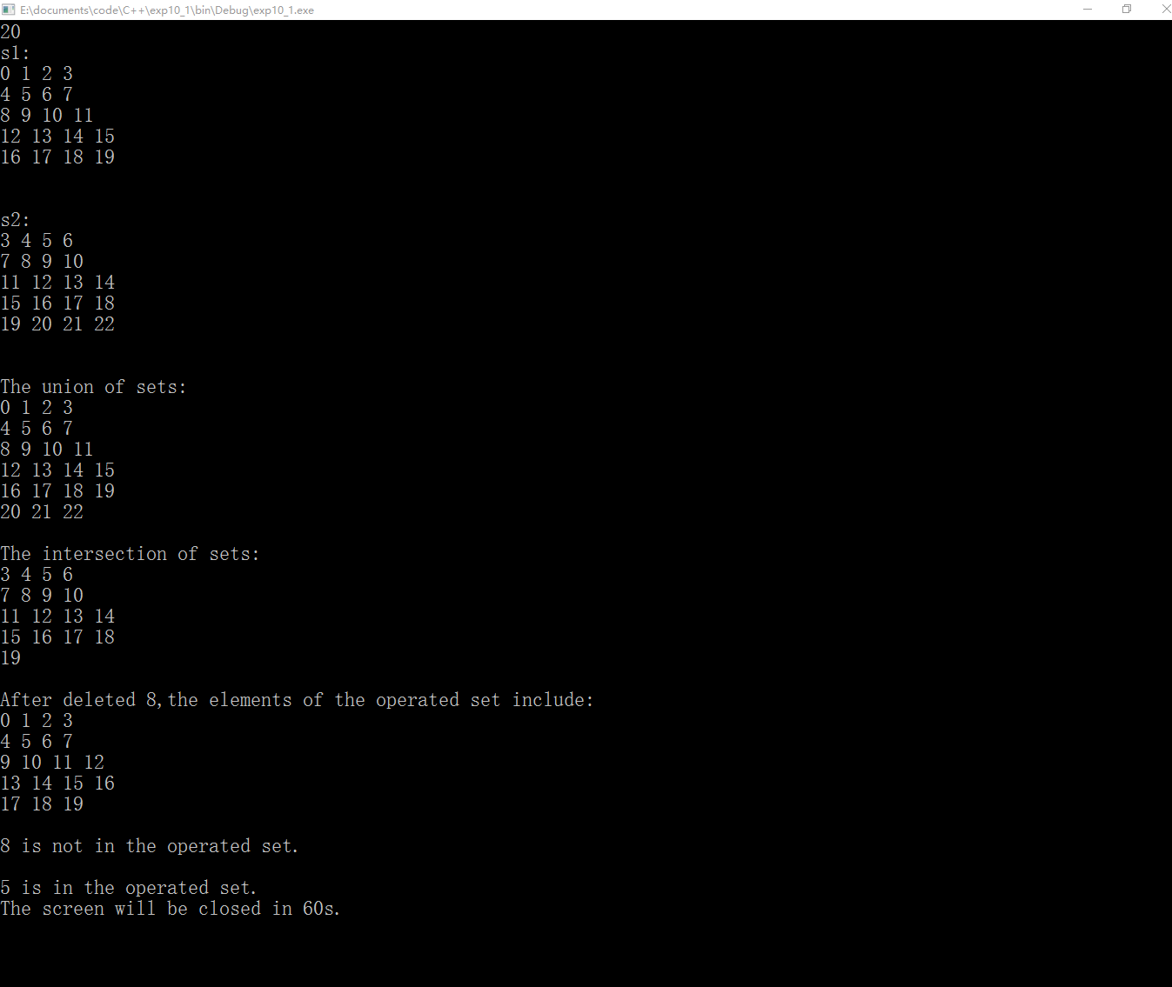

图片1题目（1）程序运行截图

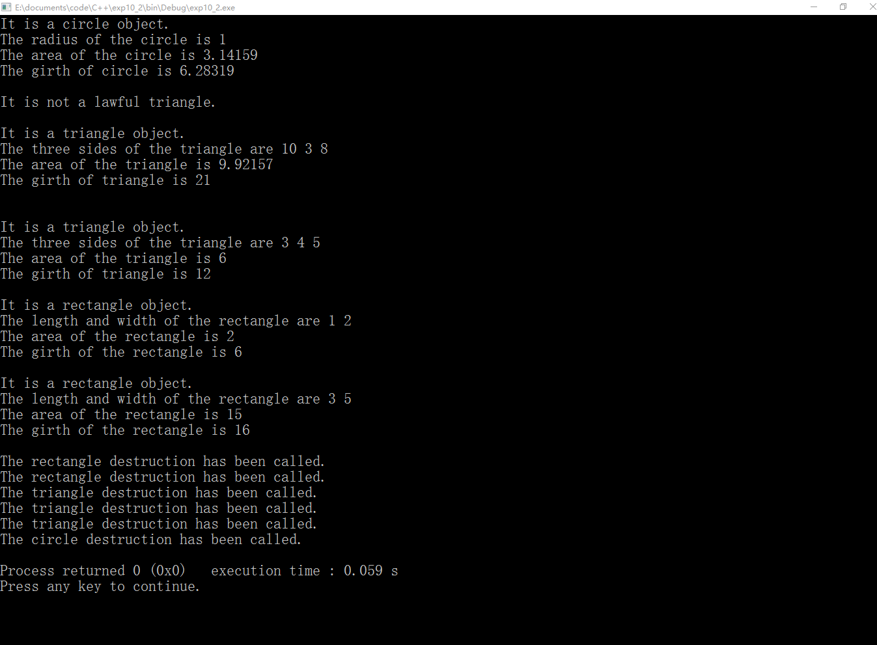

图片2题目（2）程序运行截图

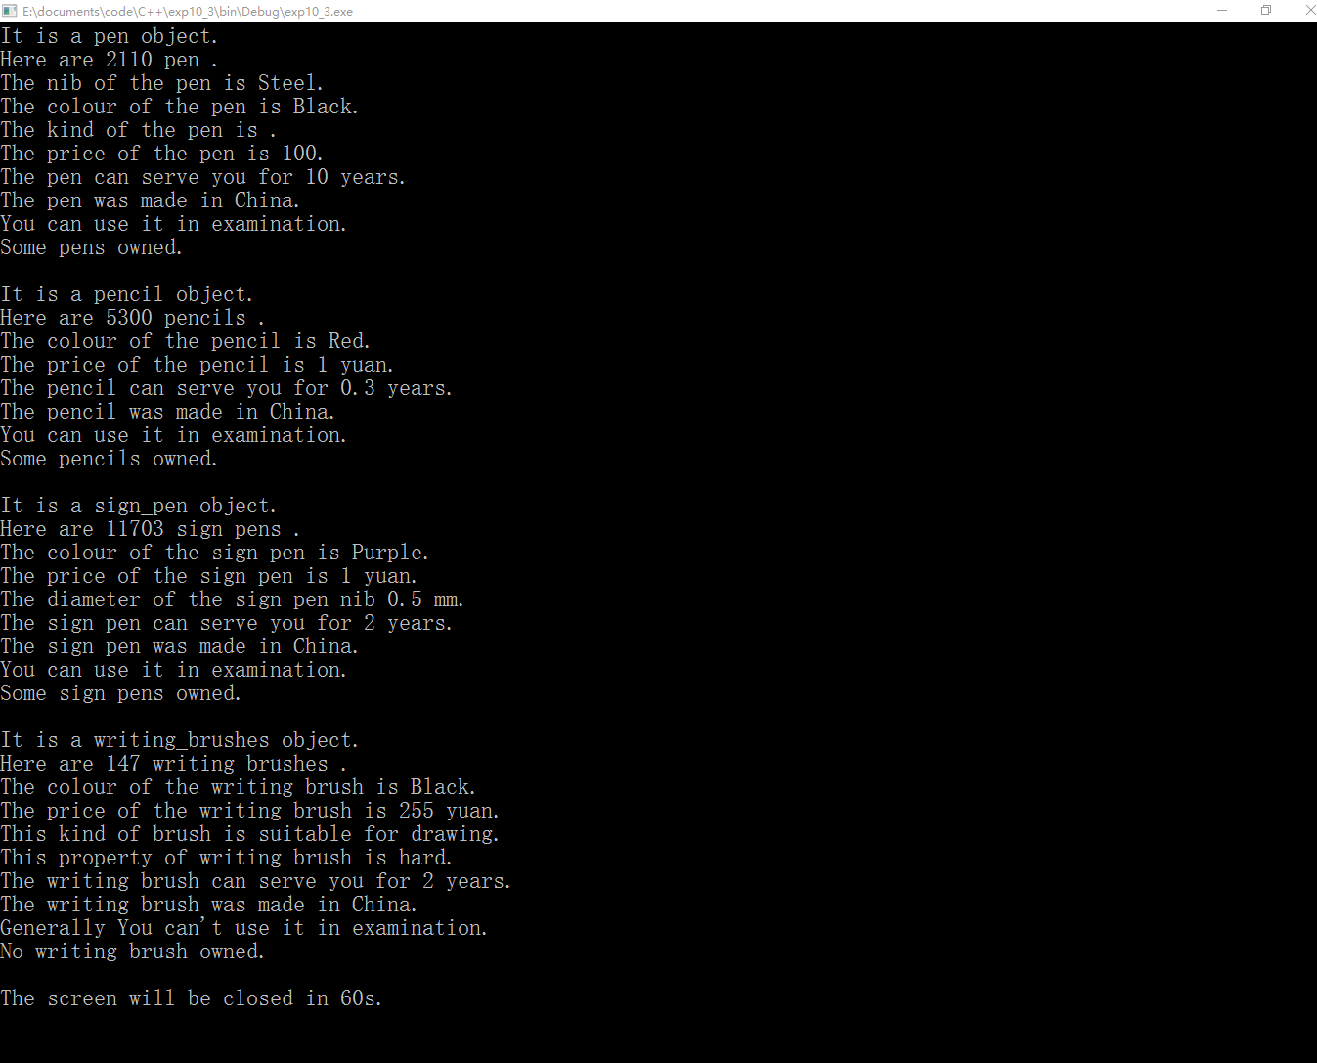

图片3题目（3）程序运行截图

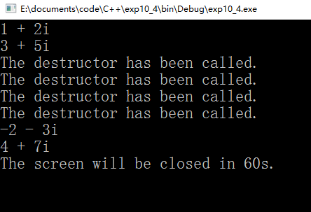

图片4题目（4）程序运行截图

**4源代码**

//题目（1）源代码：

//_set.h

#ifndef _SET_H_INCLUDED

#define _SET_H_INCLUDED

#include <iostream>

#include <cstdio>

#include <windows.h>

class _set

**{**

friend _add**(**_set **&,**int**);**

friend _del**(**_set **&,**int**);**

friendbool _judge**(**_set **&,**int**);**

//friend _set &_union(_set &,_set &);//求并集

//friend _set &_intersection(_set &,_set &);

friend _set _union**(**_set **&,**_set **&);**//求并集

friend _set _intersection**(**_set **&,**_set **&);**//求交集

public**:**

_set**(**int**);**

_set**();**

**~**_set**();**

display**(**_set **&);**

private**:**

int**\***p**;**

int _size**;**//size of number

**};**

#endif // _SET_H_INCLUDED

// _set.cpp: implementation of the _set class.

//

//////////////////////////////////////////////////////////////////////

#include "_set.h"

//////////////////////////////////////////////////////////////////////

// Construction/Destruction

//////////////////////////////////////////////////////////////////////

_set**::**_set**()**

**{**

**}**

_add**(**_set **&**s**,**int n**)**

**{**

s**.**p**[**s**.**_size**++]=**n**;**

**}**

_del**(**_set **&**s**,**int n**)**

**{**

printf**(**"After deleted %d,the elements of the operated set include:\n"**,**n**);**

int index**;**

**for(**inti**=**0**;**i**<**s**.**_size**;**i**++)**

**if(**s**.**p**[**i**]==**n**)**

index**=**i**;**

**for(**int j**=**index**;**j**<**s**.**_size**;**j**++)**

**{**

s**.**p**[**j**]=**s**.**p**[**j**+**1**];**

**}**

s**.**_size**--;**

**}**

bool _judge**(**_set **&**s**,**int n**)**

**{**

**for(**inti**=**0**;**i**<**s**.**_size**;**i**++)**

**if(**s**.**p**[**i**]==**n**)**

**{**

printf**(**"%d is in the operated set.\n"**,**n**);**

**returntrue;**

**}**

printf**(**"%d is not in the operated set.\n"**,**n**);**

**returnfalse;**

**}**

_set _union**(**_set **&**s1**,**_set **&**s2**)**//求并集

//_set _union(_set &s1,_set &s2)//求并集

**{**

_set s3**(**s1**.**_size**+**s2**.**_size**);**

**for(**inti**=**0**;**i**<**s1**.**_size**;**i**++)**

s3**.**p**[**s3**.**_size**++]=**s1**.**p**[**i**];**

**for(**int j**=**0**;**j**<**s2**.**_size**;**j**++)**

**{**

int index**=**0**;**

**for(;**index**<**s2**.**_size**;**index**++)**

**if(**s3**.**p**[**index**]==**s2**.**p**[**j**])**

//continue;

**break;**

**if(**index**==**s1**.**_size**)**

**{**

s3**.**p**[**s3**.**_size**++]=**s2**.**p**[**j**];**

**}**

**}**

std**::**cout**<<**"The union of sets:"**<<**std**::**endl**;**

**return** s3**;**

**}**

_set _intersection**(**_set **&**s1**,**_set **&**s2**)**

//_set _intersection(_set &s1,_set &s2)

**{**

_set s3**(**s1**.**_size**+**s2**.**_size**);**

int bigger**;**

**if(**s1**.**_size**>**s2**.**_size**)**

bigger**=**s1**.**_size**;**

**else**

bigger**=**s2**.**_size**;**

**for(**inti**=**0**;**i**<**bigger**;**i**++)**

**{**

**for(**int j**=**0**;**j**<**bigger**;**j**++)**

**{**

**if(**s1**.**p**[**i**]==**s2**.**p**[**j**])**

s3**.**p**[**s3**.**_size**++]=**s1**.**p**[**i**];**

**}**

**}**

std**::**cout**<<**"The intersection of sets:"**<<**std**::**endl**;**

**return** s3**;**

**}**

_set**::~**_set**()**

**{**

**delete[]**p**;**

std**::**cout**<<**"The destruction has been called"**<<**std**::**endl**;**

**}**

_set**::**_set**(**int n**)**

**{**

p**=new**int**[**n**];**

_size**=**0**;**

**}**

_set**::**display**(**_set **&**s**)**

**{**

**for(**inti**=**0**;**i**<**s**.**_size**;**i**++)**

**{**

std**::**cout**<<**s**.**p**[**i**]<<**" "**;**

**if((**i**+**1**)%**4**==**0**)**

std**::**cout**<<**std**::**endl**;**

**}**

**}**

//test.cpp

#include "_set.h"

int main**()**//测了几次感觉没毛病

**{**

int n**;**

std**::**cin**>>**n**;**

_set s1**(**n**),**s2**(**n**);**

**for(**inti**=**0**;**i**<**n**;**i**++)**

**{**

_add**(**s1**,**i**);**

_add**(**s2**,**i**+**3**);**

**}**

std**::**cout**<<**"s1:\n"**;**

s1**.**display**(**s1**);**

std**::**cout**<<**std**::**endl**;**

std**::**cout**<<**std**::**endl**;**

std**::**cout**<<**"s2:\n"**;**

s2**.**display**(**s2**);**

std**::**cout**<<**"\n\n"**;**

_set s3**=**_union**(**s1**,**s2**);**

s3**.**display**(**s3**);**

std**::**cout**<<**"\n\n"**;**

_set s4**=**_intersection**(**s1**,**s2**);**

s4**.**display**(**s4**);**

std**::**cout**<<**"\n\n"**;**

_del**(**s1**,**8**);**

s1**.**display**(**s1**);**

std**::**cout**<<**"\n\n"**;**

_judge**(**s1**,**8**);**

std**::**cout**<<**"\n"**;**

_judge**(**s2**,**5**);**

std**::**cout**<<**"The screen will be closed in 60s."**<<**std**::**endl**;**

Sleep**(**1000**\***60**);**

**return**0**;**

**}**

//题目（2）源代码：

//Shape.h

#ifndef SHAPE_H_INCLUDED

#define SHAPE_H_INCLUDED

#include <iostream>

//#include <windows.h>

class Shape

**{**

public**:**

Shape**();**

virtual**~**Shape**();**

doublearea**(){return**0**;};**

doublegirth**(){return**0**;};**

virtualvoidshow**(){** std**::**cout**<<**"Shape Object"**<<**std**::**endl**;};**

protected**:**

double _girth**,**_area**;**

**};**

#endif // SHAPE_H_INCLUDED

// Shape.cpp: implementation of the Shape class.

//

//////////////////////////////////////////////////////////////////////

#include "Shape.h"

//////////////////////////////////////////////////////////////////////

// Construction/Destruction

//////////////////////////////////////////////////////////////////////

Shape**::**Shape**()**

**{**

**}**

Shape**::~**Shape**()**

**{**

**}**

//Circle.h

#ifndef CIRCLE_H_INCLUDED

#define CIRCLE_H_INCLUDED

#include "Shape.h"

#define pi 3.1415926

classCircle**:**public Shape

**{**

public**:**

Circle**();**

Circle**(**double**);**

virtual**~**Circle**();**

doublearea**();**

doublegirth**();**

voidshow**();**

private**:**

double r**;**

**};**

#endif // CIRCLE_H_INCLUDED

// ircle.cpp: implementation of the Circle class.

//

//////////////////////////////////////////////////////////////////////

#include "Circle.h"

//////////////////////////////////////////////////////////////////////

// Construction/Destruction

//////////////////////////////////////////////////////////////////////

Circle**::**Circle**()**

**{**

**}**

Circle**::**Circle**(**double R**)**

**{**

r**=**R**;**

**}**

Circle**::~**Circle**()**

**{**

std**::**cout**<<**"The circle destruction has been called."**<<**std**::**endl**;**

**}**

doubleCircle**::**area**()**

**{**

//_area=pi*r*r;

**return** pi**\***r**\***r**;**

**}**

voidCircle**::**show**()**

**{**

_area**=**area**();**

_girth**=**girth**();**

std**::**cout**<<**"It is a circle object."**<<**std**::**endl**;**

std**::**cout**<<**"The radius of the circle is "**<<**r**<<**std**::**endl**;**

std**::**cout**<<**"The area of the circle is "**<<**_area**<<**std**::**endl**;**

std**::**cout**<<**"The girth of circle is "**<<**_girth**<<**std**::**endl**;**

**}**

doubleCircle**::**girth**()**

**{**

//_girth=2*pi*r;

**return**2**\***pi**\***r**;**

**}**

//Rectangle.h

#ifndef RECTANGLE_H_INCLUDED

#define RECTANGLE_H_INCLUDED

//#include <windows.h>

#include "Shape.h"

classRectangle**:**public Shape

**{**

public**:**

Rectangle**();**

Rectangle**(**double**,**double**);**

**~**Rectangle**();**

doublearea**();**

doublegirth**();**

voidshow**();**

private**:**

doublelength**,**width**;**

**};**

#endif // RECTANGLE_H_INCLUDED

//Rectangle.cpp

#include "Rectangle.h"

Rectangle**::**Rectangle**()**

**{**

**}**

Rectangle**::**Rectangle**(**double _a**,**double _b**)**

**{**

length**=**_a**;**

width**=**_b**;**

**}**

Rectangle**::~**Rectangle**()**

**{**

std**::**cout**<<**"The rectangle destruction has been called."**<<**std**::**endl**;**

**}**

voidRectangle**::**show**()**

**{**

_girth**=**girth**();**

_area**=**area**();**

std**::**cout**<<**"It is a rectangle object."**<<**std**::**endl**;**

std**::**cout**<<**"The length and width of the rectangle are "**<<**length**<<**" "**<<**width**<<**std**::**endl**;**

std**::**cout**<<**"The area of the rectangle is "**<<**_area**<<**std**::**endl**;**

std**::**cout**<<**"The girth of the rectangle is "**<<**_girth**<<**std**::**endl**;**

**}**

doubleRectangle**::**area**()**

**{**

**return** length**\***width**;**

**}**

doubleRectangle**::**girth**()**

**{**

**return**2**\*(**length**+**width**);**

**}**

//Triangle.h

#ifndef TRIANGLE_H_INCLUDED

#define TRIANGLE_H_INCLUDED

#include "Shape.h"

#include <cmath>

//#include <windows.h>

classTriangle**:**public Shape

**{**

public**:**

Triangle**();**

Triangle**(**double**,**double**,**double**);**

virtual**~**Triangle**();**

doublearea**();**

doublegirth**();**

voidshow**();**

booljudge**();**

private**:**

double _side1**,**_side2**,**_side3**;**

**};**

#endif // TRIANGLE_H_INCLUDED

// Triangle.cpp: implementation of the Triangle class.

//

//////////////////////////////////////////////////////////////////////

#include "Triangle.h"

#include <math.h>

//////////////////////////////////////////////////////////////////////

// Construction/Destruction

//////////////////////////////////////////////////////////////////////

Triangle**::**Triangle**()**

**{**

**}**

Triangle**::**Triangle**(**double _a**,**double _b**,**double _c**)**

**{**

_side1**=**_a**;**

_side2**=**_b**;**

_side3**=**_c**;**

**}**

Triangle**::~**Triangle**()**

**{**

std**::**cout**<<**"The triangle destruction has been called."**<<**std**::**endl**;**

**}**

doubleTriangle**::**area**()**

**{**

**if(**judge**())**

**{**

double s**=**0.0**,**l**=(**_side1**+**_side2**+**_side3**)/**2**;**

s**=**sqrt**(**l**\*(**l**-**_side1**)*(**l**-**_side2**)*(**l**-**_side3**));**

**return** s**;**

**}**

**return**0.0**;**

**}**

doubleTriangle**::**girth**()**

**{**

**if(**judge**())**

**return** _side1**+**_side2**+**_side3**;**

**return**0.0**;**

**}**

voidTriangle**::**show**()**

**{**

**if(**judge**())**

**{**

_area**=**area**();**

_girth**=**girth**();**

std**::**cout**<<**"It is a triangle object."**<<**std**::**endl**;**

std**::**cout**<<**"The three sides of the triangle are "**<<**_side1**<<**" "**<<**_side2**<<**" "**<<**_side3**<<**" "**<<**std**::**endl**;**

std**::**cout**<<**"The area of the triangle is "**<<**_area**<<**std**::**endl**;**

std**::**cout**<<**"The girth of triangle is "**<<**_girth**<<**std**::**endl**;**

**}**

**else**

std**::**cout**<<**"It is not a lawful triangle."**<<**std**::**endl**;**

**}**

boolTriangle**::**judge**()**

**{**

//abcacb bac bca cab cba

**if(**_side1**+**_side2**>**_side3 **&&** _side1**+**_side3**>**_side2 **&&** _side2**+**_side1**>**_side3 **&&** _side2**+**_side3**>**_side1 **&&** _side3**+**_side1**>**_side2 **&&**_side3**+**_side2**>**_side1**)**

**returntrue;**

**returnfalse;**

**}**

//test.cpp

#include "Circle.h"

#include "Triangle.h"

#include "Rectangle.h"

/*

为什么不能在main.cpp或者其他的的头文件中添加<windows.h>,否则第28到第31行（Rectangle 相关的）会报错？

*/

intmain**()**

**{**

Circle c1**(**1.0**);**

c1**.**show**();**

std**::**cout**<<**std**::**endl**;**

Triangle t1**(**1.0**,**2.0**,**3.0**);**

t1**.**show**();**

std**::**cout**<<**std**::**endl**;**

Triangle t2**(**10.0**,**3.0**,**8.0**);**

t2**.**show**();**

std**::**cout**<<**std**::**endl**;**

std**::**cout**<<**std**::**endl**;**

Triangle t3**(**3.0**,**4.0**,**5.0**);**

t3**.**show**();**

std**::**cout**<<**std**::**endl**;**

Rectangle r1**(**1.0**,**2.0**),**r2**(**3.0**,**5.0**);**

r1**.**show**();**

std**::**cout**<<**std**::**endl**;**

r2**.**show**();**

std**::**cout**<<**std**::**endl**;**

//std::cout<<"The screen will be closed in 60s."<<std::endl;

//Sleep(1000*60);

**return**0**;**

**}**

//题目（3）源代码：

//writing_instruments.h

#ifndef WRITING_INSTRUMENTS_H_INCLUDED

#define WRITING_INSTRUMENTS_H_INCLUDED

#include <iostream>

#include <string>

#include <windows.h>

classwriting_instruments

**{**

protected**:**

double price**;**

boolused_in_exam**;**

boolme_owned_**;**

doubleservice_span**;**

std**::**string place_of_origin**;**

int num**;**

public**:**

writing_instruments**();**

writing_instruments**(**int**);**

virtual**~**writing_instruments**();**

virtualvoid show**(){**std**::**cout**<<**"..."**<<**std**::**endl**;}**

virtualvoidadd**(**int**);**

virtualvoid _minus**(**int**);**

**};**

#endif // WRITING_INSTRUMENTS_H_INCLUDED

//writing_instruments.cpp

#include "writing_instruments.h"

writing_instruments**::**writing_instruments**()**

**{**

price**=**0.0**;**

used_in_exam**=false;**

me_owned_**=false;**

service_span**=**0.0**;**

place_of_origin**=**"xxxxxxxxxxxxxxxxx"**;**

num**=**0**;**

**}**

writing_instruments**::~**writing_instruments**()**

**{**

std**::**cout**<<**"The writing_instruments destructor has been called."**<<**std**::**endl**;**

**}**

writing_instruments**::**writing_instruments**(**int n**)**

**{**

price**=**0.0**;**

used_in_exam**=false;**

me_owned_**=false;**

service_span**=**0.0**;**

place_of_origin**=**"xxxxxxxxxxxxxxxxx"**;**

num**=**n**;**

**}**

voidwriting_instruments**::**add**(**int n**)**

**{**

num**+=**n**;**

**}**

voidwriting_instruments**::**_minus**(**int n**)**

**{**

num**-=**n**;**

**}**

//pen.h

#ifndef PEN_H_INCLUDED

#define PEN_H_INCLUDED

#include "writing_instruments.h"

classpen**:**publicwriting_instruments

**{**

private**:**

std**::**string nib**;**

std**::**string colour**;**

//enumcolour{Red,Orange,Yellow,Green,Blue,Indigo,Violet};

std**::**string kind**;**

public**:**

pen**(**int**,**std**::**string**,**std**::**string**);**

virtual**~**pen**();**

voidshow**();**

void add**(**int**);**

void _minus**(**int**);**

**};**

#endif // PEN_H_INCLUDED

//pen.cpp

#include "pen.h"

pen**::**pen**(**intn**,**std**::**string _colour**,**std**::**string _nib**)**

**{**

price**=**10**;**

nib**=**_nib**;**

num**=**n**;**

colour**=**_colour**;**

price**=**100.0**;**

used_in_exam**=true;**

me_owned_**=true;**

service_span**=**10.0**;**

place_of_origin**=**"China"**;**

**}**

pen**::~**pen**()**

**{**

std**::**cout**<<**"The pen destructor has been called."**<<**std**::**endl**;**

**}**

voidpen**::**add**(**int n**)**

**{**

num**+=**10**\***n**;**

**}**

voidpen**::**_minus**(**int n**)**

**{**

num**-=**100**\*(-**n**);**

**}**

voidpen**::**show**()**

**{**

add**(**10**);**

_minus**(**20**);**

std**::**cout**<<**"It is a pen object."**<<**std**::**endl**;**

std**::**cout**<<**"Here are "**<<**num**<<**" pen "**<<**"."**<<**std**::**endl**;**

std**::**cout**<<**"The nib of the pen is "**<<**nib**<<**"."**<<**std**::**endl**;**

std**::**cout**<<**"The colour of the pen is "**<<**colour**<<**"."**<<**std**::**endl**;**

std**::**cout**<<**"The kind of the pen is "**<<**kind**<<**"."**<<**std**::**endl**;**

std**::**cout**<<**"The price of the pen is "**<<**price**<<**"."**<<**std**::**endl**;**

std**::**cout**<<**"The pen can serve you for "**<<**service_span**<<**" years."**<<**std**::**endl**;**

std**::**cout**<<**"The pen was made in "**<<**place_of_origin**<<**"."**<<**std**::**endl**;**

std**::**cout**<<**"You can use it in examination"**<<**"."**<<**std**::**endl**;**

std**::**cout**<<**"Some pens owned."**<<**std**::**endl**;**

**}**

//pencil.h

#ifndef PENCIL_H_INCLUDED

#define PENCIL_H_INCLUDED

#include "writing_instruments.h"

classpencil**:**publicwriting_instruments

**{**

private**:**

std**::**string colour**;**

std**::**string apply_to**;**

std**::**string XB**;**

public**:**

pencil**(**int**,**std**::**string**,**std**::**string**);**

virtual**~**pencil**();**

voidshow**();**

void add**(**int**);**

void _minus**(**int**);**

**};**

#endif // PENCIL_H_INCLUDED

//pencil.cpp

#include "pencil.h"

pencil**::**pencil**(**intn**,**std**::**string _colour**,**std**::**string _XB**)**

**{**

price**=**10**;**

num**=**n**;**

colour**=**_colour**;**

XB**=**_XB**;**

price**=**1.0**;**

used_in_exam**=true;**

me_owned_**=true;**

service_span**=**0.3**;**

place_of_origin**=**"China"**;**

apply_to**=**"students&&workmen&&white_collar&&etc"**;**

**}**

pencil**::~**pencil**()**

**{**

std**::**cout**<<**"The pencil destructor has been called."**<<**std**::**endl**;**

**}**

voidpencil**::**add**(**int n**)**

**{**

num**+=**120**\***n**;**

**}**

voidpencil**::**_minus**(**int n**)**

**{**

num**-=**100**\*(-**2**\***n**);**

**}**

voidpencil**::**show**()**

**{**

add**(**10**);**

_minus**(**20**);**

std**::**cout**<<**"It is a pencil object."**<<**std**::**endl**;**

std**::**cout**<<**"Here are "**<<**num**<<**" pencils "**<<**"."**<<**std**::**endl**;**

std**::**cout**<<**"The colour of the pencil is "**<<**colour**<<**"."**<<**std**::**endl**;**

std**::**cout**<<**"The price of the pencil is "**<<**price**<<**" yuan."**<<**std**::**endl**;**

std**::**cout**<<**"The pencil can serve you for "**<<**service_span**<<**" years."**<<**std**::**endl**;**

std**::**cout**<<**"The pencil was made in "**<<**place_of_origin**<<**"."**<<**std**::**endl**;**

std**::**cout**<<**"You can use it in examination"**<<**"."**<<**std**::**endl**;**

std**::**cout**<<**"Some pencils owned."**<<**std**::**endl**;**

**}**

//sign_pen.h

#ifndef SIGN_PEN_H_INCLUDED

#define SIGN_PEN_H_INCLUDED

#include "writing_instruments.h"

classsign_pen**:**publicwriting_instruments

**{**

private**:**

std**::**string colour**;**

std**::**string apply_to**;**

doublenib_diameter**;**

public**:**

sign_pen**(**int**,**double**,**std**::**string**);**

virtual**~**sign_pen**();**

voidshow**();**

void add**(**int**);**

void _minus**(**int**);**

**};**

#endif // SIGN_PEN_H_INCLUDED

//sign_pen.cpp

#include "sign_pen.h"

sign_pen**::**sign_pen**(**intn**,**double_nib_diameter**,**std**::**string _colour**)**

**{**

nib_diameter**=**_nib_diameter**;**

price**=**10**;**

num**=**n**;**

colour**=**_colour**;**

price**=**1.0**;**

used_in_exam**=true;**

me_owned_**=true;**

service_span**=**2.0**;**

place_of_origin**=**"China"**;**

apply_to**=**"students&&workmen&&white_collar&&etc"**;**

**}**

sign_pen**::~**sign_pen**()**

**{**

std**::**cout**<<**"The sign_pen destructor has been called."**<<**std**::**endl**;**

**}**

voidsign_pen**::**add**(**int n**)**

**{**

num**+=**n**\***n**+**2**;**

**}**

voidsign_pen**::**_minus**(**int n**)**

**{**

num**-=(**n**\***n**)/**2**;**

**}**

voidsign_pen**::**show**()**

**{**

add**(**109**);**

_minus**(**20**);**

std**::**cout**<<**"It is a sign_pen object."**<<**std**::**endl**;**

std**::**cout**<<**"Here are "**<<**num**<<**" sign pens "**<<**"."**<<**std**::**endl**;**

std**::**cout**<<**"The colour of the sign pen is "**<<**colour**<<**"."**<<**std**::**endl**;**

std**::**cout**<<**"The price of the sign pen is "**<<**price**<<**" yuan."**<<**std**::**endl**;**

std**::**cout**<<**"The diameter of the sign pen nib "**<<**nib_diameter**<<**" mm."**<<**std**::**endl**;**

std**::**cout**<<**"The sign pen can serve you for "**<<**service_span**<<**" years."**<<**std**::**endl**;**

std**::**cout**<<**"The sign pen was made in "**<<**place_of_origin**<<**"."**<<**std**::**endl**;**

std**::**cout**<<**"You can use it in examination"**<<**"."**<<**std**::**endl**;**

std**::**cout**<<**"Some sign pens owned."**<<**std**::**endl**;**

**}**

//writing_brushes.h

#ifndef WRITING_BRUSHES_H_INCLUDED

#define WRITING_BRUSHES_H_INCLUDED

#include "writing_instruments.h"

#include <cmath>

classwriting_brushes**:**publicwriting_instruments

**{**

private**:**

std**::**string property**;**

std**::**string person_apply_to**;**

std**::**string apply_to_what**;**

std**::**string colour**;**

public**:**

writing_brushes**(**int**,**std**::**string**,**std**::**string**,**std**::**string**);**

virtual**~**writing_brushes**();**

voidshow**();**

void add**(**int**);**

void _minus**(**int**);**

**};**

#endif // WRITING_BRUSHES_H_INCLUDED

//writing_brushes.cpp

#include "writing_brushes.h"

writing_brushes**::**writing_brushes**(**intn**,**std**::**string _colour**,**std**::**string _property**,**std**::**string _apply_to_what**)**

**{**

price**=**10**;**

property**=**_property**;**

num**=**n**;**

colour**=**_colour**;**

price**=**255.0**;**

used_in_exam**=false;**

me_owned_**=false;**

service_span**=**2.0**;**

place_of_origin**=**"China"**;**

person_apply_to**=**"students&&workmen&&white_collar&&etc"**;**

apply_to_what**=**_apply_to_what**;**

**}**

writing_brushes**::~**writing_brushes**()**

**{**

std**::**cout**<<**"The writing_brushes destructor has been called."**<<**std**::**endl**;**

**}**

voidwriting_brushes**::**add**(**int n**)**

**{**

num**+=**sqrt**(**n**)\***20**-**1**;**

**}**

voidwriting_brushes**::**_minus**(**int n**)**

**{**

num**-=**n**\***sqrt**(**n**)+**2**;**

**}**

voidwriting_brushes**::**show**()**

**{**

add**(**109**);**

_minus**(**19**);**

std**::**cout**<<**"It is a writing_brushes object."**<<**std**::**endl**;**

std**::**cout**<<**"Here are "**<<**num**<<**" writing brushes "**<<**"."**<<**std**::**endl**;**

std**::**cout**<<**"The colour of the writing brush is "**<<**colour**<<**"."**<<**std**::**endl**;**

std**::**cout**<<**"The price of the writing brush is "**<<**price**<<**" yuan."**<<**std**::**endl**;**

std**::**cout**<<**"This kind of brush is suitable for "**<<**apply_to_what**<<**"."**<<**std**::**endl**;**

std**::**cout**<<**"This property of writing brush is "**<<**property**<<**"."**<<**std**::**endl**;**

std**::**cout**<<**"The writing brush can serve you for "**<<**service_span**<<**" years."**<<**std**::**endl**;**

std**::**cout**<<**"The writing brush was made in "**<<**place_of_origin**<<**"."**<<**std**::**endl**;**

std**::**cout**<<**"Generally You can't use it in examination"**<<**"."**<<**std**::**endl**;**

std**::**cout**<<**"No writing brush owned."**<<**std**::**endl**;**

**}**

//test.cpp

#include "pen.h"

#include "pencil.h"

#include "sign_pen.h"

#include "writing_brushes.h"

intmain**()**

**{**

pen p1**(**10**,**"Black"**,**"Steel"**);**

p1**.**show**();**

std**::**cout**<<**std**::**endl**;**

pencil pc1**(**100**,**"Red"**,**"2B"**);**

pc1**.**show**();**

std**::**cout**<<**std**::**endl**;**

sign_pen sgp1**(**20**,**0.5**,**"Purple"**);**

sgp1**.**show**();**

std**::**cout**<<**std**::**endl**;**

writing_brushes wb1**(**25**,**"Black"**,**"hard"**,**"drawing"**);**

wb1**.**show**();**

std**::**cout**<<**std**::**endl**;**

std**::**cout**<<**"The screen will be closed in 60s."**<<**std**::**endl**;**

Sleep**(**1000**\***60**);**

**return**0**;**

**}**

//题目（3）源代码：

//_complex_number.h

#ifndef _COMPLEX_NUMBER_H_INCLUDED

#define _COMPLEX_NUMBER_H_INCLUDED

#include <iostream>

#include <cmath>

class _complex_number

**{**

private**:**

double re**;**

doubleim**;**

public**:**

_complex_number**();**

_complex_number**(**double**,**double**);**

**~**_complex_number**();**

voiddisplay**(**_complex_number**&);**

_complex_number**operator+(**_complex_number**&)**const**;**

_complex_number**operator-(**_complex_number**&)**const**;**

//_complex_number operator=(_complex_number&);//为什么这里用引用做参数就不行呢？

_complex_number**operator=(**_complex_number**);**

**};**

#endif // _COMPLEX_NUMBER_H_INCLUDED

//_complex_number.cpp

#include "_complex_number.h"

_complex_number**::**_complex_number**()**

**{**

**}**

_complex_number**::**_complex_number**(**double _re**,**double _im**)**

**{**

re**=**_re**;**

im**=**_im**;**

**}**

_complex_number**::~**_complex_number**()**

**{**

std**::**cout**<<**"The destructor has been called."**<<**std**::**endl**;**

**}**

/*

注意，在运算符表示法中，运算符左侧的对象是调用对象，运算符右边的对象是作为参数被传递的对象。

*/

_complex_number _complex_number**::operator+(**_complex_number**&**c1**)**const

**{**

_complex_number c2**;**

c2**.**re**=**re**+**c1**.**re**;**

c2**.**im**=**im**+**c1**.**im**;**

**return** c2**;**

**}**

_complex_number _complex_number**::operator-(**_complex_number**&**c1**)**const

**{**

_complex_number c2**;**

c2**.**re**=**re**-**c1**.**re**;**

c2**.**im**=**im**-**c1**.**im**;**

**return** c2**;**

**}**

_complex_number _complex_number**::operator=(**_complex_number c1**)**//有时需要考虑自赋值的特殊情况

**{**

//_complex_number c2;

re**=**c1**.**re**;**

im**=**c1**.**im**;**

**return*this;**

**}**

void _complex_number**::**display**(**_complex_number**&**c**)**

**{**

**if(**c**.**im**>**0**)**//为什么这里写成 if(c.im>0) 输出与预期不符？

std**::**cout**<<**c**.**re**<<**" + "**<<**c**.**im**<<**"i"**<<**std**::**endl**;**

**else**

std**::**cout**<<**c**.**re**<<**" - "**<<**std**::**abs**(**c**.**im**)<<**"i"**<<**std**::**endl**;**

**}**

//test.cpp

#include "_complex_number.h"

intmain**()**

**{**

_complex_number c1**(**1.0**,**2.0**),**c2**(**3.0**,**5.0**),**c3**,**c4**;**

c1**.**display**(**c1**);**

c2**.**display**(**c2**);**

c3**=**c1**-**c2**;**

c4**=**c1**+**c2**;**

c3**.**display**(**c3**);**

c4**.**display**(**c4**);**

Sleep**(**1000**\***60**);**

std**::**cout**<<**"The screen will be closed in 60s."**<<**std**::**endl**;**

**return**0**;**

**}**