实验5
学号： 姓名： 专业：

5.1 实验目的
熟练掌握队列的顺序链式存储结构。
熟练掌握队列的有关算法设计，并在链队列上实现。
根据具体给定的需求，合理设计并实现相关结构和算法。
5.2 实验要求
5.2.1链队列实验要求
本次实验中的链队列结构指不带头结点的单链表；
链队列结构和运算定义，算法的实现以库文件方式实现，不得在测试主程序中直接实现；
实验程序有较好可读性，各运算和变量的命名直观易懂，符合软件工程要求；
程序有适当的注释。
5.3实验任务
5.3.1链队列实验任务
以不带头结点的单链表表示队列，编写算法实现下列问题的求解。
<1>初始化一个队列。
<2>判断是否队空。
<3>判断是否队满。
设队列最大长度：MaxLen=100
第一组数据：入队n个元素，判断队满
第二组数据：用循环方式将1到99，99个元素入队，判队满（链队理论上不存在满的问题吧？）
<4>入队
第一组数据：4，7，8，12，20，50
第二组数据：a,b,c,d,f,g
<5>出队
<6>取队头元素
<7>求当前队列中元素个数
<8>编写算法实现
①初始化空循环队列；
②当键盘输入奇数时，此奇数入队；
③当键盘输入偶数时，队头出队；
④当键盘输入0时，算法退出；
⑤每当键盘输入后，输出当前队列中的所有元素。
5.5 运行结果截图及说明
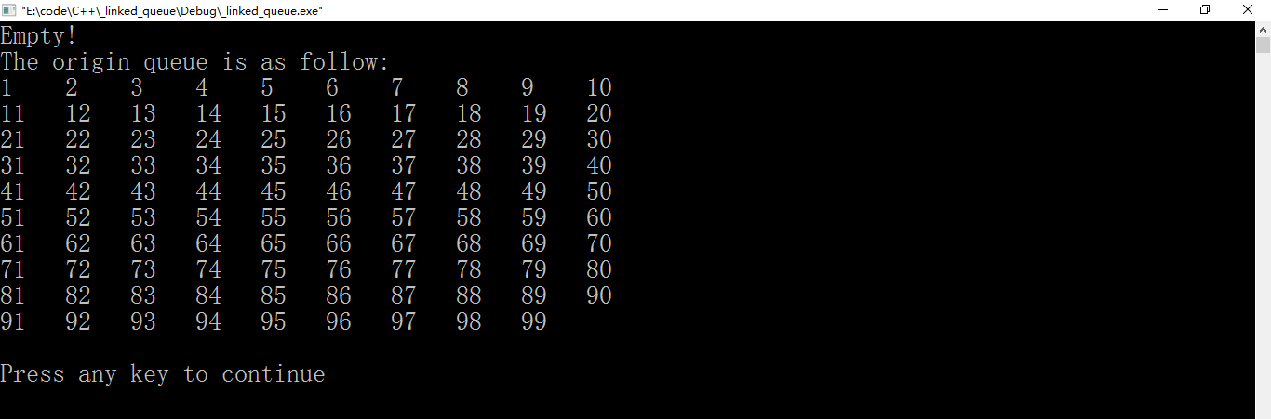
图1 测试（1）、（2）、（3）

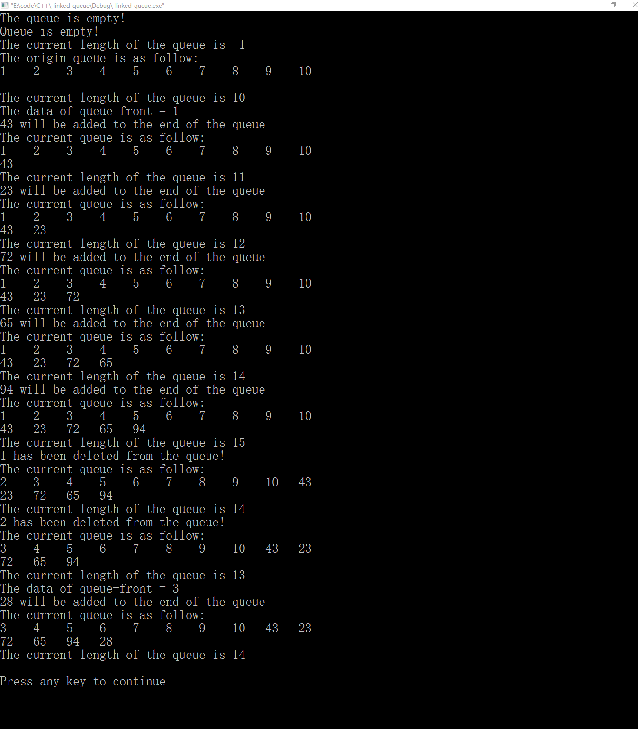
图2 测试（5）、（6）、（7）
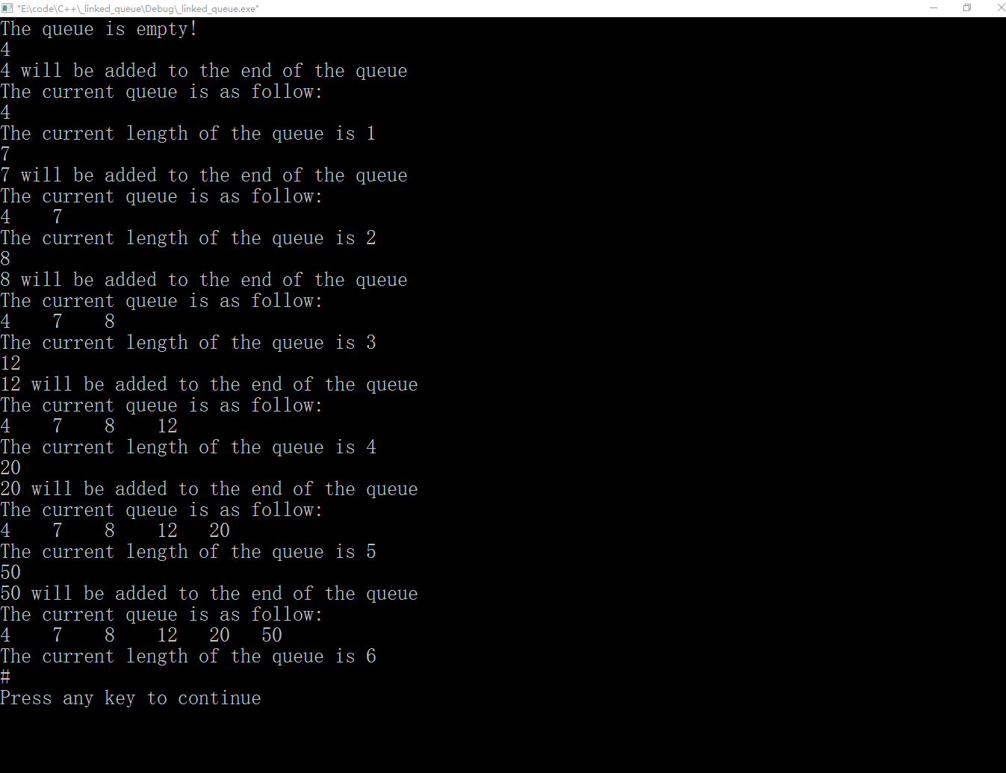
图3 测试（4）

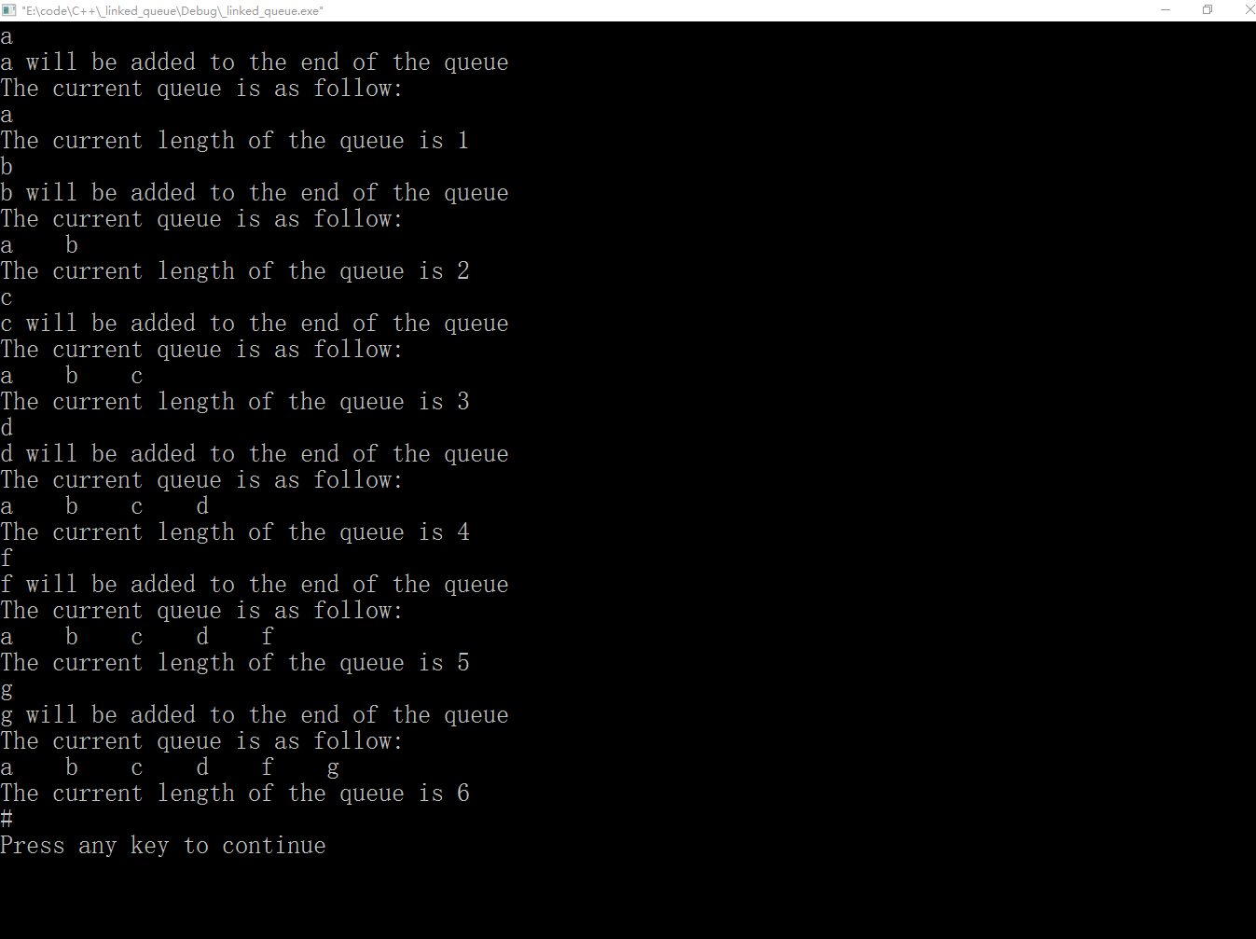
图4 测试（4）

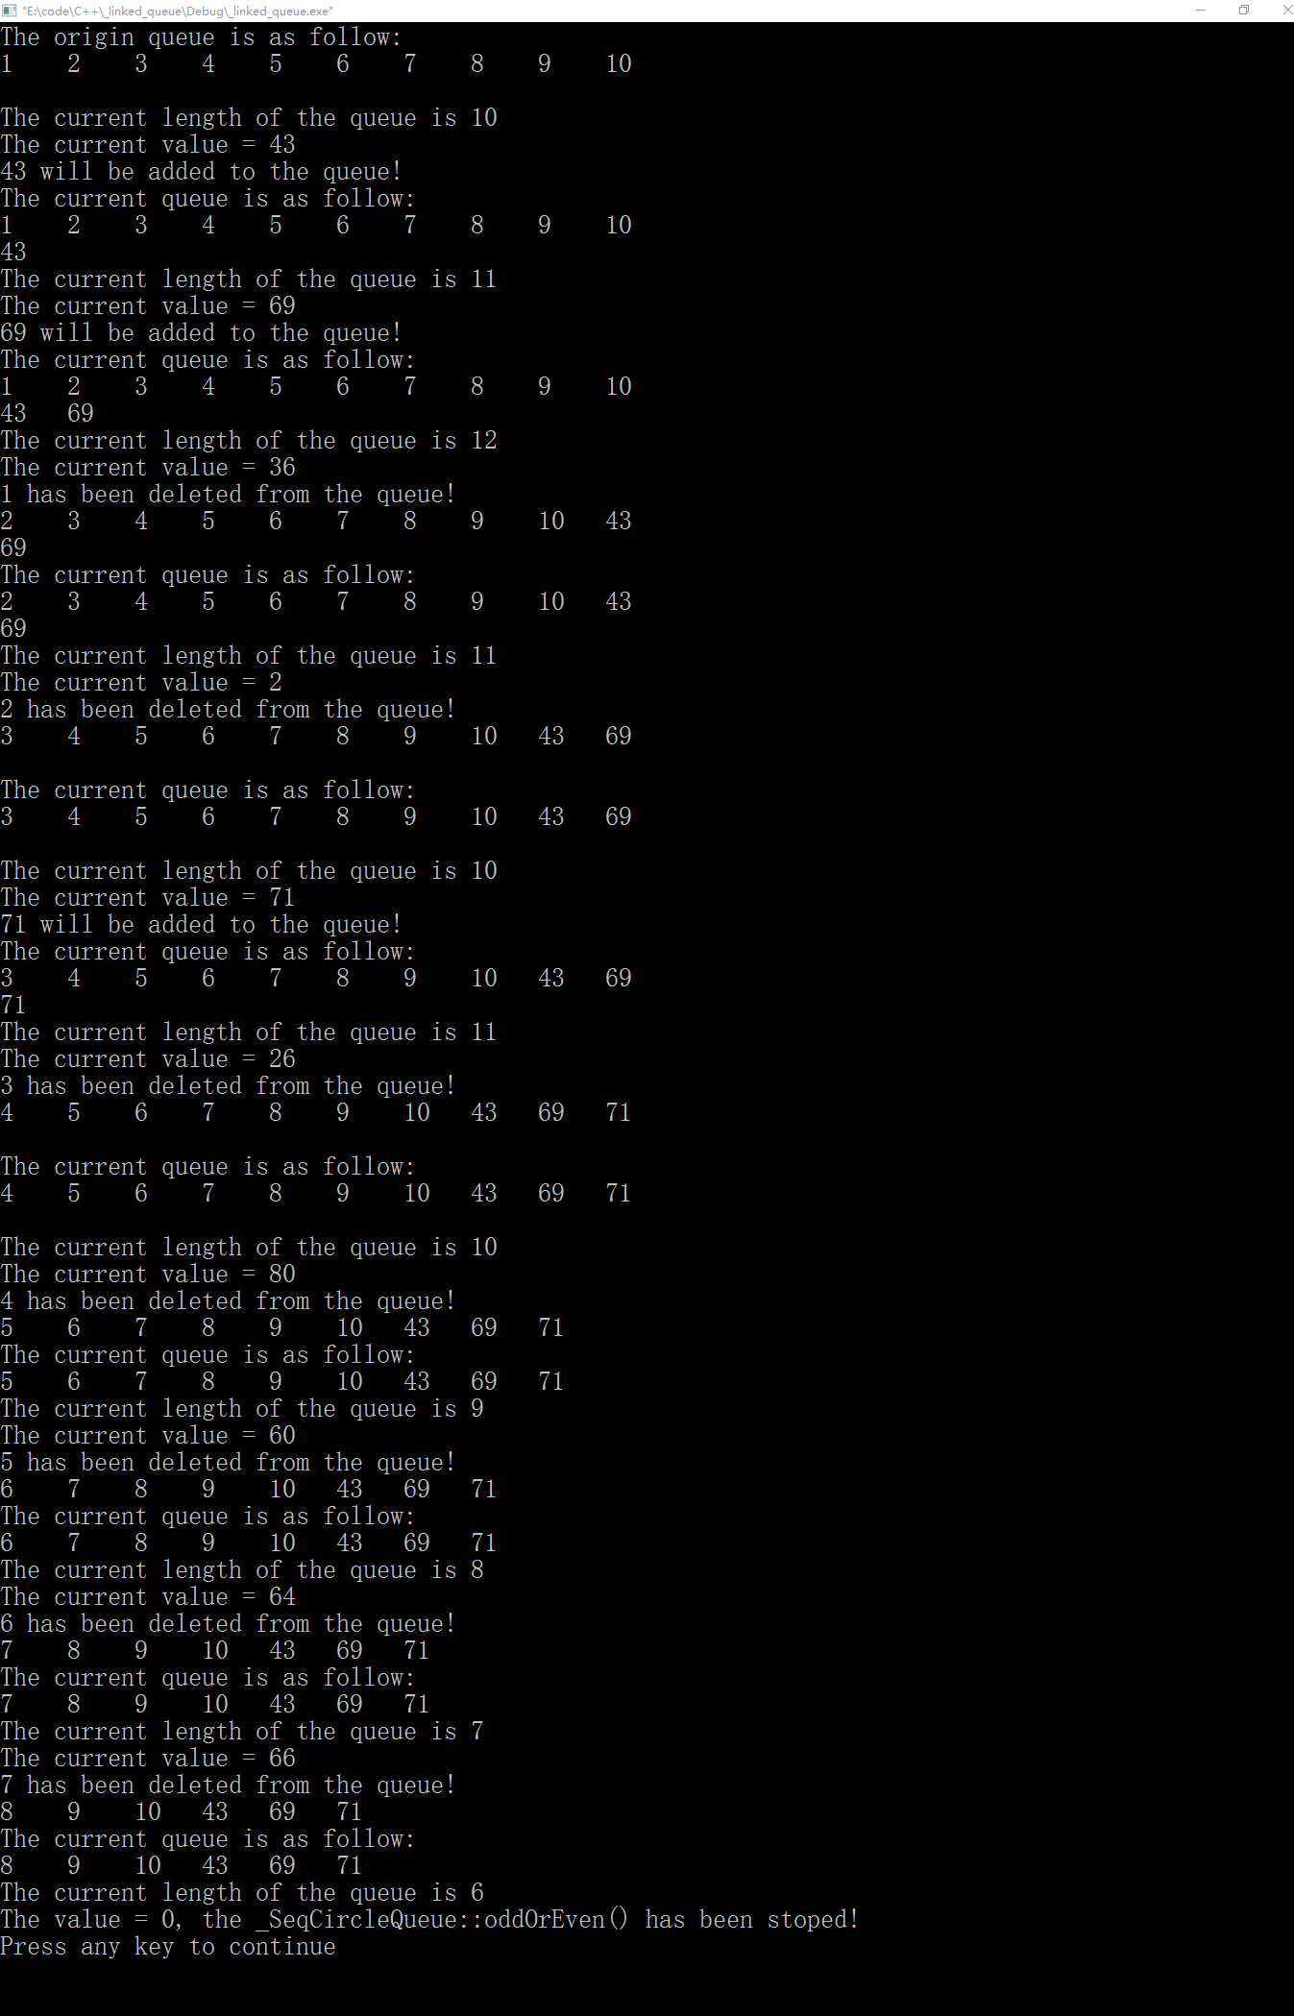
图5 测试（8）

5.6 附源代码
// stdafx.h : include file for standard system include files,
// or project specific include files that are used frequently, but
// are changed infrequently
//

#if !defined(AFX_STDAFX_H__009A1125_2F9A_4B93_9830_51B9398EBC52__INCLUDED_)
#define AFX_STDAFX_H__009A1125_2F9A_4B93_9830_51B9398EBC52__INCLUDED_

#if _MSC_VER > 1000
#pragma once
#endif // _MSC_VER > 1000

#include <stdc++.h>
//#include <iostream>

using namespace std;

typedef int elementType;
typedef char elementType1;

typedef struct node
{
elementType data;
struct node *link;
}LNode, *PNode;

typedef struct charNode
{
elementType1 data;
struct charNode *link;
}CLNode, *CPNode;

//typedef struct linkedQueue
//{
// LNode *_front, *_rear;
//}LQueue, *PQueue;

// TODO: reference additional headers your program requires here

//{{AFX_INSERT_LOCATION}}
// Microsoft Visual C++ will insert additional declarations immediately before the previous line.

#endif // !defined(AFX_STDAFX_H__009A1125_2F9A_4B93_9830_51B9398EBC52__INCLUDED_)

// linkedQueue.h: interface for the linkedQueue class.
//
//////////////////////////////////////////////////////////////////////

#if !defined(AFX_LINKEDQUEUE_H__6DF75075_BE53_4235_872D_3381A1A450D0__INCLUDED_)
#define AFX_LINKEDQUEUE_H__6DF75075_BE53_4235_872D_3381A1A450D0__INCLUDED_

#if _MSC_VER > 1000
#pragma once
#endif // _MSC_VER > 1000

#include "stdafx.h"

class linkedQueue
{
public:
linkedQueue();
virtual ~linkedQueue();
bool emptyLinkedQueue();
//bool fullSeqCircleQueue();
bool enQueue( elementType value );
bool deQueue( elementType &value );
bool getFront( elementType &value );
int length();
void oddOrEven( elementType value );
friend ostream &operator<<( ostream &os, linkedQueue &lq )
{
/*
if( ( scq._front - 1 ) % maxn == scq._rear )
return os;
int column = 0;
for( int i = scq._front; i % maxn != scq._rear; i = ( i + 1 ) % maxn )
{
os << setw(3) << setiosflags(ios::left) << scq.data[i] << " ";
column ++;
if( column % 10 == 0 )
os << endl;
}
os << endl;
*/
if( lq._front == NULL )
return os;
LNode *tmp = lq._front;
int column = 0;
while( tmp != lq._rear->link )
{
os << setw(4) << setiosflags(ios::left) << tmp->data << " ";
column ++;
tmp = tmp->link;
if( column % 10 == 0 )
os << endl;
}
os << endl;
}
private:
LNode *_front;
LNode *_rear;
};

#endif // !defined(AFX_LINKEDQUEUE_H__6DF75075_BE53_4235_872D_3381A1A450D0__INCLUDED_)

// charLinkedQueue.h: interface for the charLinkedQueue class.
//
//////////////////////////////////////////////////////////////////////

#if !defined(AFX_CHARLINKEDQUEUE_H__91C9120D_49FD_417A_8336_57503196B63F__INCLUDED_)
#define AFX_CHARLINKEDQUEUE_H__91C9120D_49FD_417A_8336_57503196B63F__INCLUDED_

#if _MSC_VER > 1000
#pragma once
#endif // _MSC_VER > 1000

class charLinkedQueue
{
public:
charLinkedQueue();
virtual ~charLinkedQueue();
bool emptyCharLinkedQueue();
//bool fullSeqCircleQueue();
bool enQueue( elementType1 value );
bool deQueue( elementType1 &value );
bool getFront( elementType1 &value );
int length();
friend ostream &operator<<( ostream &os, charLinkedQueue &clq )
{
/*
if( ( scq._front - 1 ) % maxn == scq._rear )
return os;
int column = 0;
for( int i = scq._front; i % maxn != scq._rear; i = ( i + 1 ) % maxn )
{
os << setw(3) << setiosflags(ios::left) << scq.data[i] << " ";
column ++;
if( column % 10 == 0 )
os << endl;
}
os << endl;
*/
if( clq._front == NULL )
return os;
CLNode *tmp = clq._front;
int column = 0;
while( tmp != clq._rear->link )
{
os << setw(4) << setiosflags(ios::left) << tmp->data << " ";
column ++;
tmp = tmp->link;
if( column % 10 == 0 )
os << endl;
}
os << endl;
}
private:
CLNode *_front;
CLNode *_rear;

};

#endif // !defined(AFX_CHARLINKEDQUEUE_H__91C9120D_49FD_417A_8336_57503196B63F__INCLUDED_)

// linkedQueue.cpp: implementation of the linkedQueue class.
//
//////////////////////////////////////////////////////////////////////

#include "stdafx.h"
#include "linkedQueue.h"

//////////////////////////////////////////////////////////////////////
// Construction/Destruction
//////////////////////////////////////////////////////////////////////

linkedQueue::linkedQueue()
{
_front = _rear = NULL;
}

linkedQueue::~linkedQueue()
{
LNode *tmp = NULL;
while( _front != _rear )
{
tmp = _front;
_front = _front->link;
delete tmp;
}
cout << "The linkedQueue destruction has been called!" << endl;
}

bool linkedQueue::emptyLinkedQueue()
{
return _front == NULL;
}

bool linkedQueue::enQueue( elementType value )
{
LNode *newNode = new LNode;
if( !newNode )
{
cerr << "Space allocating falied!Error in linkedQueue::enQueue()!" << endl;
return false;
}
newNode->data = value;
newNode->link = NULL;
if( emptyLinkedQueue() )
{
_front = _rear = newNode;
}
else
{
_rear->link = newNode;
_rear = newNode;
}
return true;
}

bool linkedQueue::deQueue( elementType &value )
{
if( emptyLinkedQueue() )
{
cerr << "Node deleting falied!Error in linkedQueue::deQueue()!" << endl;
return false;
}
LNode *tmp = _front;
value = _front->data;
_front = _front->link;
delete tmp;
if( _front == NULL )
_rear = NULL;
return true;
}

bool linkedQueue::getFront( elementType &value )
{
if( emptyLinkedQueue() )
{
cerr << "Queue is empty!\nNode-data acquiring falied!Error in linkedQueue::deQueue()!" << endl;
return false;
}
value = _front->data;
return true;
}

int linkedQueue::length()
{
if( emptyLinkedQueue() )
{
cerr << "Queue is empty!" << endl;
return -1;
}
LNode *tmp = _front;
int _size = 0;
while( tmp != NULL )
{
tmp = tmp->link;
_size ++;
}
return _size;
}

void linkedQueue::oddOrEven( elementType value )
{
if( value & 1 )
{
enQueue(value);
cout << value << " will be added to the queue!" << endl;
//cout << (*this);
cout << "The current queue is as follow:" << endl << (*this);
cout << "The current length of the queue is " << (*this).length() << endl;

}
else if( !( value & 1) && value != 0 )
{
elementType x;
deQueue(x);
cout << x << " has been deleted from the queue!" << endl;
cout << (*this);
cout << "The current queue is as follow:" << endl << (*this);
cout << "The current length of the queue is " << (*this).length() << endl;
}
else //if( value == 0 )
{
cout << "The value = " << value << ", the _SeqCircleQueue::oddOrEven() has been stoped!" << endl;
return;
}
}

// charLinkedQueue.cpp: implementation of the charLinkedQueue class.
//
//////////////////////////////////////////////////////////////////////

#include "stdafx.h"
#include "charLinkedQueue.h"

//////////////////////////////////////////////////////////////////////
// Construction/Destruction
//////////////////////////////////////////////////////////////////////

charLinkedQueue::charLinkedQueue()
{
_front = _rear = NULL;
}

charLinkedQueue::~charLinkedQueue()
{
CLNode *tmp = NULL;
while( _front != _rear )
{
tmp = _front;
_front = _front->link;
delete tmp;
}
cout << "The charLinkedQueue destruction has been called!" << endl;
}

bool charLinkedQueue::emptyCharLinkedQueue()
{
return _front == NULL;
}

bool charLinkedQueue::enQueue( elementType1 value )
{
CLNode *newNode = new CLNode;
if( !newNode )
{
cerr << "Space allocating falied!Error in charLinkedQueue::enQueue()!" << endl;
return false;
}
newNode->data = value;
newNode->link = NULL;
if( emptyCharLinkedQueue() )
{
_front = _rear = newNode;
}
else
{
_rear->link = newNode;
_rear = newNode;
}
return true;
}

bool charLinkedQueue::deQueue( elementType1 &value )
{
if( emptyCharLinkedQueue() )
{
cerr << "Node deleting falied!Error in charLinkedQueue::deQueue()!" << endl;
return false;
}
CLNode *tmp = _front;
value = _front->data;
_front = _front->link;
delete tmp;
if( _front == NULL )
_rear = NULL;
return true;
}

bool charLinkedQueue::getFront( elementType1 &value )
{
if( emptyCharLinkedQueue() )
{
cerr << "Queue is empty!\nNode-data acquiring falied!Error in charLinkedQueue::deQueue()!" << endl;
return false;
}
value = _front->data;
return true;
}

int charLinkedQueue::length()
{
if( emptyCharLinkedQueue() )
{
cerr << "Queue is empty!" << endl;
return -1;
}
CLNode *tmp = _front;
int _size = 0;
while( tmp != NULL )
{
tmp = tmp->link;
_size ++;
}
return _size;
}

// _linked_queue.cpp : Defines the entry point for the console application.
//

#include "stdafx.h"
#include "charLinkedQueue.h"
#include "linkedQueue.h"

int main(int argc, char* argv[])
{
ios::sync_with_stdio(false);
//srand( time(NULL) );
linkedQueue LQ1;
/*
charLinkedQueue CLQ1;

//if( CLQ1.emptyCharLinkedQueue() )
//cout << "The queue is empty!" << endl;
elementType1 value;
while( cin >> value )
//while( ~scanf( "%c", &value ) && value != '#' )
//cin >> value;
//scanf( "%c", &value );
{
if( isdigit(value) || isalpha(value) )
{
cout << value << " will be added to the end of the queue" << endl;
CLQ1.enQueue(value);
cout << "The current queue is as follow:" << endl << CLQ1;
cout << "The current length of the queue is " << CLQ1.length() << endl;
}

if( value == '#' )
break;
}

if( LQ1.emptyLinkedQueue() )
cout << "The queue is empty!" << endl;
elementType value;
while( cin >> value )
{
if( (char)value != '#' )
{
cout << value << " will be added to the end of the queue" << endl;
LQ1.enQueue(value);
cout << "The current queue is as follow:" << endl << LQ1;
cout << "The current length of the queue is " << LQ1.length() << endl;
}
else
break;
}

cout << "The current length of the queue is " << LQ1.length() << endl;
*/
for( int i = 1; i <= 10; i ++ )
LQ1.enQueue(i);
cout << "The origin queue is as follow:" << endl << LQ1;
cout << "The current length of the queue is " << LQ1.length() << endl;
/*
for( int j = 0; j < 10; j ++ )
{
int value;
int key = rand() % 3 + 1;
//cout << key << " ";
if( key == 1 )//get the queue-front data
{
LQ1.getFront(value);
cout << "The data of queue-front = " << value << endl;
}
else if( key == 2 )//delete the queue-front data
{
LQ1.deQueue(value);
cout << value << " has been deleted from the queue!" << endl;
cout << "The current queue is as follow:" << endl << LQ1;
cout << "The current length of the queue is " << LQ1.length() << endl;
}
else//add data to the end of the queue
{
value = rand() % 100 + 2;
cout << value << " will be added to the end of the queue" << endl;
LQ1.enQueue(value);
cout << "The current queue is as follow:" << endl << LQ1;
cout << "The current length of the queue is " << LQ1.length() << endl;
}

}
*/

for( int j = 1; j <= 10; j ++ )
{
elementType value = rand() % 100 + 2;
cout << "The current value = " << value << endl;
LQ1.oddOrEven(value);
}
LQ1.oddOrEven(0);
/**/
/*
if( CSCQ1.emptyCharSeqCircleQueue() )
cout << "Empty!" << endl;

elementType x;
if( SCQ1.deQueue(x) )
{
cout << x << endl;
}
cout << SCQ1;
if( SCQ1.getFront(x) )
cout << x << endl;
cout << SCQ1.length() << endl;

if( SCQ1.fullSeqCircleQueue() )
cout << "Full!" << endl;
*/
cin.get();
//Sleep( 1000 * 120 );
return 0;
}

5.7 调试过程中出现的bug总结
在重载两个类的“<<”运算符时，这句话
os << setw(4) << setiosflags(ios::left) << tmp->data << " ";
我原来写成：
os << setw(4) << setiosflags(ios::left) << lq._front->data << " ";
以及把
os << setw(4) << setiosflags(ios::left) << tmp->data << " ";
写成
os << setw(4) << setiosflags(ios::left) << clq._front->data << " ";
这样导致的结果是：打印出来的队列总是在重复第一个元素，调试了很久（近一个小时），我还一度认为是VC6.0编译器太老了、不能正确处理临时变量，后面才发现是自己在重载“<<”运算符时就写错了。
认真细致真的很重要！

