精品数模资料，各类比赛优秀论文、学习教程、写作模板与经验技巧、matlab程序代码资料等，尽在淘宝店铺：闵大荒工科男的杂货铺！

Team #88255 Page 1 of 20



|  |  |  |  |  |  |
| --- | --- | --- | --- | --- | --- |
| For office use only | | Team Control Number | For office use only | |  |
| **88255** |  |
| T1 |  | F1 |  |  |
|  |  |
| T2 |  |  | F2 |  |  |
| T3 | | Problem Chosen | F3 | |  |
|  |  |  |  |  |



**A**

**2018**

**MCM/ICM**

**Summary Sheet**

The traditional communication methods of high frequency (HF) radio are still widely used worldwide, which has longer propagation distance than other kinds of radio communication systems, and can cover mountainous, deserts and oceans. At present, the study of high frequency radio multi-hop propagation mode has been relatively systematic, which provide various methods to simulate its trajectory and attenuation in the air, ionosphere and earth surface. In this paper, we mainly focus on the reflection properties on the ocean surface, including calm and turbulent conditions. What’s more, the overall propagation process and practical application of HF radio are also involved.

For part one, on the basis of calm surface reflection model proved in the relative literature, we can calculate the reflection coefficient and the attenuation *Lcal* (*dB*) by using relative permittivity *εr* and electrical conductivity *σ* , then we estimate the first reflection strength off the calm ocean is from 0.5-5.5*mW*. Next, a *P-M* spectrum was used to simulate the distribution of sea wave, which is related to wind speed. Based on it, we use finite element analysis to calculate the correction factor *ρ* of tough surface. An alternative way is using the international general standard published by CCIR to calculate ρ in the condition of different wind speed, and the attenuation *Ltur* (*dB*). The estimation of the first reflection strength off the turbulent ocean is 0.2 -2.5*mW*. Afterwards, according to the analysis of the air and ionosphere, we can get the Path Transmission Loss *Lb* (*dB*) and the attenuation in the ionosphere *Lion* (*dB*). The total loss *Lt* (*dB*) of the overall propagation process is the sum of *Lb* , *Lion* , *Lcal* or *Ltur*. Given the source power is 100-watt and the SNR threshold is 10*dB*, by estimating the external noises of receiver, we calculated that the maximal attenuation in the propagation path have to be lower than 151*dB*. For *f*=3*MHz*, our model shows that the signal will take 6 to 7 hops before the total loss *Lt* reach 151*dB*. With the increase of frequency, the number of hops will decrease gradually.

For part two, the difference between land and oceans including different *εr* and *σ*. In addition, the amplitude of fluctuation of land is much larger than the sea surface, which is relatively stable and not related to wind speed. By putting the different parameters to the turbulent surface reflection model, we can calculate the reflection attenuation and estimate the first reflected power is respectively 0.4-4.8*mW* and 0.2-2.4*mW* for rugged terrain and smooth terrain. The estimation of number of hops is 3 reflected by the rugged terrain, and 5 to 6 for smooth terrain. Generally, the attenuation of ground is much larger than ocean.

For part three, for a moving or shaky object, generally we take the circular polarization ways to maintain the stability of signal, which means that there must be a Mismatch Factor *v* as a part of loss. For a sailing ship, we calculated the coverage area of each hop of signal when the frequency is 24*MHz*, between 1900-2676 *km* (1st hop)、3894-5535 *km* (2nd hop)、5768-8302 *km* (3rd hop*)*、8682-11070 *km* (4th hop), the ship could receive effective signal. The time that can receive the signal could be calculated if the direction and speed of the ship is known.

精品数模资料，各类比赛优秀论文、学习教程、写作模板与经验技巧、matlab程序代码资料等，尽在淘宝店铺：闵大荒工科男的杂货铺！

Team #88255 Page 2 of 20

Key words: high frequency radio, ocean surface reflection, multi-hop propagation

精品数模资料，各类比赛优秀论文、学习教程、写作模板与经验技巧、matlab程序代码资料等，尽在淘宝店铺：闵大荒工科男的杂货铺！

|  |  |  |  |  |
| --- | --- | --- | --- | --- |
| Team | | #88255 | | Page 3 of 20 |
|  |  |  | **Contents** |  |
| **1** | **Introductions.........................................................................................................................** | | | **3** |
| **2** | **General Assumptions and Variable Description................................................................** | | | **3** |
|  | 2.1 | General Assumptions....................................................................................................... | | 3 |
|  | 2.2 | Variable Description......................................................................................................... | | 4 |
| **3** | **Model Establishment and Analysis.....................................................................................** | | | **4** |
|  | 3.1 | Ocean Surface Reflection Attenuation............................................................................. | | 4 |
|  | 3.1.1 | | Reflection Properties of Seawater........................................................................................... | 4 |
|  | 3.1.2 | | Calm Oceans Reflection.......................................................................................................... | 5 |
|  | 3.1.3 | | Turbulent Oceans Reflection................................................................................................... | 6 |
|  |  | 3.1.3.1 The Sea Surface Simulation By *P-M* Spectrum............................................................... | | 6 |
|  |  | 3.1.3.2 Finite Element Analysis on Rough Surface..................................................................... | | 6 |
|  |  | 3.1.3.3 International Standard of Sea Surface Roughness........................................................... | | 8 |
|  | 3.1.4 | | The Reflection Attenuation Difference Between Calm and |  |
|  |  |  | Turbulent Sea Surface............................................................................................................. | 8 |
|  | 3.2 | The Maximum Number of Hops.................................................................................... | | 10 |
|  | 3.2.1 | | Free Space Transmission Loss and Path Transmission Loss................................................ | 10 |
|  | 3.2.2 | | The Properties of Ionosphere Reflection............................................................................... | 11 |
|  |  | 3.2.2.1 Physical Properties of Ionosphere.................................................................................. | | 11 |
|  |  | 3.2.2.2 The Absorption of Ionosphere........................................................................................ | | 12 |
|  | 3.2.3 | | The Calculation of Maximum Hops...................................................................................... | 13 |
|  | 3.3 | The Reflection Loss of rugged and smooth terrain........................................................ | | 14 |
|  | 3.4 | Model Improvement About Shipboard Receiver........................................................... | | 15 |
|  | 3.4.1 | | The Properties of Moving Receiver...................................................................................... | 15 |
|  | 3.4.2 | | The range of the communication area of the same multi-hop path....................................... | 15 |
| **4** | **Stability and Sensitivity Analysis.......................................................................................** | | | **16** |
| **5** | **Strengths and Weakness.....................................................................................................** | | | **18** |
|  | 5.1 | Strengths......................................................................................................................... | | 18 |
|  | 5.2 | Weakness........................................................................................................................ | | 18 |
| **6** | **Short note in *IEEE Communication magazine.................................................................*** | | | **19** |
| **7** | **Reference..............................................................................................................................** | | | **20** |

精品数模资料，各类比赛优秀论文、学习教程、写作模板与经验技巧、matlab程序代码资料等，尽在淘宝店铺：闵大荒工科男的杂货铺！

Team #88255 Page 4 of 20



**1 Introductions**

To high frequency radio range from 3*MHz*~30*MHz*, the ionosphere can reflect the transmission electromagnetic back to the earth or oceans, and reflect back to the sky again and again, thus the remote distance communication could be achieved, figure 1 displays the progress. The hop distance could reach several thousand kilometers, so that it could be widely used in international short wave communication business [1]. The propagation mode is also called sky wave.

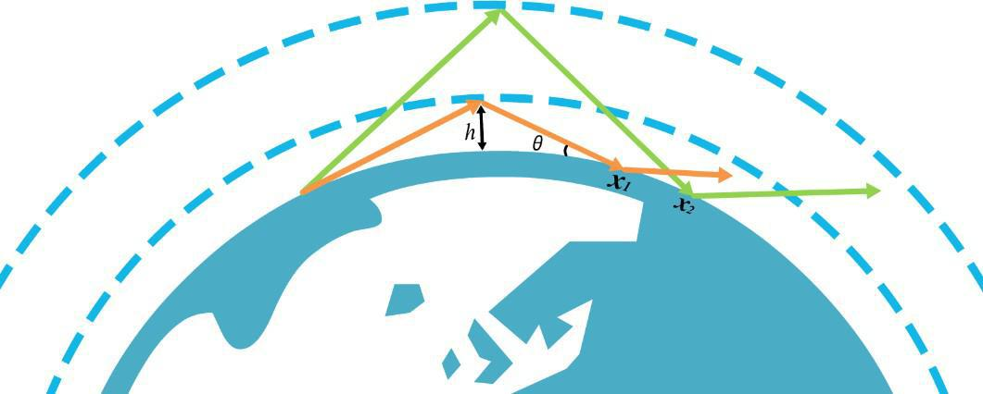

Figure 1: Propagation path of sky wave

The refraction of ionosphere is depend on its electron density, which was generated by solar radiation. Generally, when the frequencies exceed the *maximum usable frequencies* (MUF), the radio will penetrate the ionosphere and won’t be back to the earth. Similarly, if the radio frequencies are lower than *lowest usable frequency* (LUF), the signal-to-noise ratio (SNR) would be lower than a usable threshold.

The reflection point on the ground could be possible for both ground or oceans, which have the different reflection properties. They have something in common that the reflection is mainly depends on the electromagnetic properties of medium and the surface shape. There have been a lot of previous researches and international general standard about the reflection of tough sea surface.

After multi -hops, the signal will be received by a receiver, to acquire the highest *SNR* signal, what we have to do is to reduce the attenuation and lost in the process of transmission. Generally, the most frequently used frequency nearest 0.85 MUF[1]

**2 General Assumptions and Variable Description**

**2.1** **General Assumptions**

**•**The effects of fading, multipath delay, dispersion in the propagation of radio in the atmosphere are not considered. That is to say, even though the signal is not below SNR

threshold when received, it's still possible to be distorted.

**•**The electrical parameter of seawater in a partial area is constant and doesn’t change by the influence of ocean wave or other reasons.

**•**Suppose that the background noises are the same in each receiving point on the earth surface, and the internal noises of the signal receiver is not considered.

精品数模资料，各类比赛优秀论文、学习教程、写作模板与经验技巧、matlab程序代码资料等，尽在淘宝店铺：闵大荒工科男的杂货铺！

|  |  |  |  |  |
| --- | --- | --- | --- | --- |
| Team | | #88255 | Page 5 of 20 | |
| **2.2** | | **Variable Description** | | |
|  |  |  |  |  |
|  |  | **Abbreviation** | **Full Name** | |
|  |  | *Rh* | Reflection Coefficient Of Horizontal Polarized Wave |  |
|  |  | ~ | Complex Permittivity of Sea Surface | |
|  |  | *S(ω)* | *Pierson-Moscowtc* Spectrum |  |
|  |  | ❒ | Correction Factor | |
|  |  | *σ* | Electrical Conductivity |  |
|  |  | *Lcal* | The Attenuation of Clam Ocean | |
|  |  | *Ltur* | The Attenuation Factor of Turbulent Surface |  |
|  |  | *f* | Frequency | |
|  |  | *Lbf* | Free Space Transmission Loss |  |
|  |  | *Lb* | Path Transmission Loss | |
|  |  | *εr* | Relative Permittivity |  |
|  |  | *Aion* | The Attenuation Factor of Ionosphere | |
|  |  | *Lt* | Total Loss |  |
|  |  | *Lship* | Constant Attenuation |  |

**3 Model Establishment and Analysis**

**3.1** **Ocean Surface Reflection Attenuation**

To estimate the reflection loss off calm oceans and turbulent oceans, we have to figure out the reflection properties of seawater as well as the difference between calm surface and tough surface.

**3.1.1 Reflection Properties of Seawater**

The electromagnetic properties of ocean can affect the refection of radio, it mainly depends on the temperature and salinity of seawater, as well as the radio frequency. The parameter to define the electromagnetic properties of ocean surface is complex permittivity, which consists of

relative permittivity *εr*，electrical conductivity *σ*, and wavelength*λ*,the expression is:

|  |  |
| --- | --- |
|  *r*  *i*60 | (1) |



To *εr* and *σ*, there are already international standard published by International Radio Consultative Committee in the real applications. On the frequency of 3~30*MHz*, the approximate estimation is: *εr* =7, *σ=*5*.*[2]

According to *Snell's* law, we can get the Fresnel reflection coefficient of horizontal polarized

|  |  |  |  |  |  |  |  |  |  |  |  |
| --- | --- | --- | --- | --- | --- | --- | --- | --- | --- | --- | --- |
| wave and vertically polarized wave[3]: |  |  |  |  |  |  |  |  |  |  |  |
| *R* |  | sin   |   cos2  | | |  |  |  |  |  |  |
|  |  |  |  |  |  |  |  |  |  |
| *h* |  |  |  |  |  |  |  |  |  |  |  |
|  | sin   |   cos2  | | | (2) | | | | |  |
|  |  |  |
|  |  |  sin   |  |  |   cos2 |  |
| *R* |  |  |  | ❑ | | |  | |  |
| *v* |  |  sin   |  |  |  | | | | |  |  |
|  |  |  |   cos2  | | | | |  |

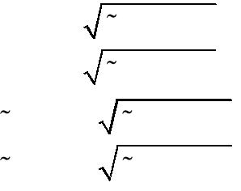

According to the sea surface reflection, the loss of horizontal polarized wave is smaller than vertically polarized wave, so we use horizontal polarization wave as transmitting signal, the horizontal reflection coefficient *Rh* will be used in calculation.

精品数模资料，各类比赛优秀论文、学习教程、写作模板与经验技巧、matlab程序代码资料等，尽在淘宝店铺：闵大荒工科男的杂货铺！

Team #88255 Page 6 of 20



**3.1.2** **Calm Oceans Reflection**

In the ideal condition, we regard the surface of calm oceans as a totally flat plane, on which the radio has the reflection properties in accordance with *Snell's* law[3]. Meanwhile, we adopt the horizontal polarization to decrease the reflection loss as far as possible, the attenuation factor can be calculated by:

|  |  |  |  |
| --- | --- | --- | --- |
| max | *Rh d* | (3) |  |
| *Lcal* (*dB*) 10 lgmin |  |

To define *θmax* and *θmin* , due to the radio was reflected by the ionosphere, we have to analyze from the refraction properties of ionosphere.

*R* is the radius of the earth, *Z* is the height of ionosphere, *Nn* is the electron density of the *nth* reflection point.

According to the law of refraction:

|  |  |
| --- | --- |
| n0 sin0  n1 sin1  n2 sin2   n*n* sinn | (4) |

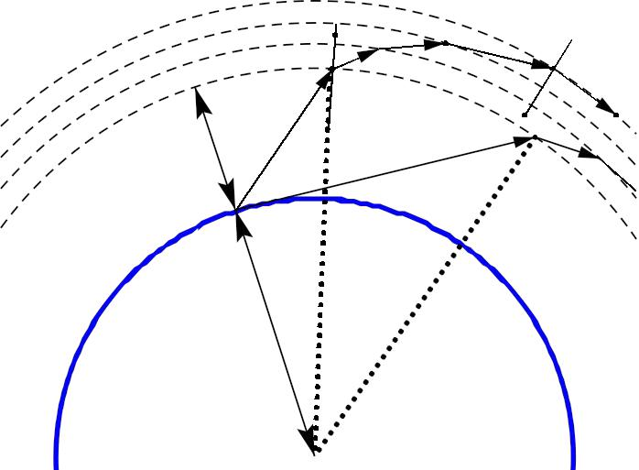

***θ*1** ***θ*2**  ***θn***

***Z*** ***θ*0** ***θmax***

***R***

Figure 2: The reflection process in the ionosphere

The boundary conditions that radio can reflect out from the ionosphere is:

|  |  |
| --- | --- |
| *n*01,*n* 90 | (5) |



Putting the boundary conditions into formula (4):

|  |  |  |  |  |  |  |  |  |  |  |  |
| --- | --- | --- | --- | --- | --- | --- | --- | --- | --- | --- | --- |
| sin  |  |  | 1 | | − | 80.8*Nn* | | | |  |  |
|  |  | *f* 2 | | |  |
| 0 | *n* |  |  |  |  |  |  |  |
|  |  |  |  | 80.8*N* | | | | | (6) | |  |
| max  sin1 | | 1 | − | *n* | |  |
|  |  | *f* | 2 |  |  |
|  |  |  |  |  |  |
|  |  |  |  |  |  |  |  |  |  |  |

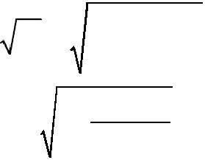

Due to the curvature of the earth, *θ0* can’t reach 90 °.The radio reach the maximum incident angle *θ*min when the projection of it is horizontal.

|  |  |  |  |  |  |
| --- | --- | --- | --- | --- | --- |
| ❑ | min |  sin1 | *R* | (7) |  |
| *R*  *Z* |  |
|  |  |  |  |
|  |  |  |  |  |

精品数模资料，各类比赛优秀论文、学习教程、写作模板与经验技巧、matlab程序代码资料等，尽在淘宝店铺：闵大荒工科男的杂货铺！

Team #88255 Page 7 of 20



Obviously the ideal condition do not exist in the nature, as long as there is a little bit wind or ocean current, the surface of ocean must be rippled. We can regard the rippled surface as a slightly turbulent surface of ocean which will be considered in the next paragraph.

**3.1.3 Turbulent Oceans Reflection**

**3.1.3.1** **The Sea Surface Simulation By *P-M* Spectrum**

The turbulent ocean can be regarded as the combination of infinite harmonic waves that have different amplitudes, frequencies, directions and phases, the contribution of the harmonic waves consist of the sea spectrum. The sea spectrum is the statistical property of a random process, contains each harmonic component about the distributions of frequency and directions.

There are a lot of previous researches about sea spectrum, among which *Pierson-Moscowtc* *spectrum*, *JONSWAP spectrum* and *Elfouhaily spectrum* were widely used. Now we are usingthe first one as our ocean reflection surface.

*Moscowitz*[4]evaluated the spectrum of wind waves in the North Atlantic Ocean byaveraging the observed 54 spectrums then got the *Pierson-Moscowtc spectrum (P-M spectrum)*:

|  |  |  |  |  |  |  |  |
| --- | --- | --- | --- | --- | --- | --- | --- |
| *S*() | *g* | 2 | exp[ ( | *g* | )4 ] | (8) |  |
|  |  |
|  |  |  |
|  |  | 19.5 |  |
|  |  |  |  |  |  |  |

*α=*8.1×10-3, *β=*0.74, *U19.5* is the wind speed of 19.5*m* above the sea.

Figure 3 display the wave simulation distributed by *P-M spectrum*, it's easy to find that the peak and roughness of waves increased following the increase of wind speed.

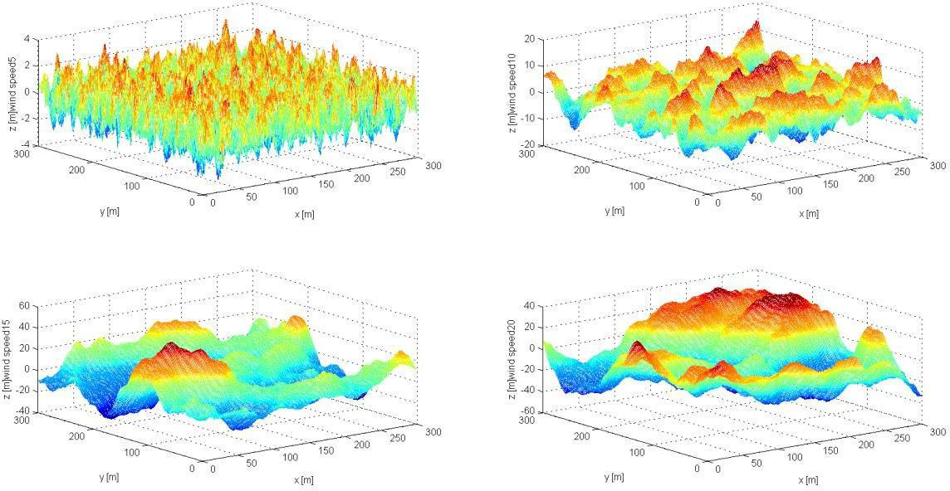

Figure 3: the ocean wave simulated by *P-M spectrum* (*wind speed=*5, 10, 15 and 20 *m/s*)

**3.1.3.2 Finite Element Analysis on Rough Surface**

The differences between turbulent oceans and calm oceans include wave heights, shapes and frequencies, on which the electromagnetic wave can be reflected to all directions. Figure 4 shows the reflection properties:

精品数模资料，各类比赛优秀论文、学习教程、写作模板与经验技巧、matlab程序代码资料等，尽在淘宝店铺：闵大荒工科男的杂货铺！

Team #88255 Page 7 of 20

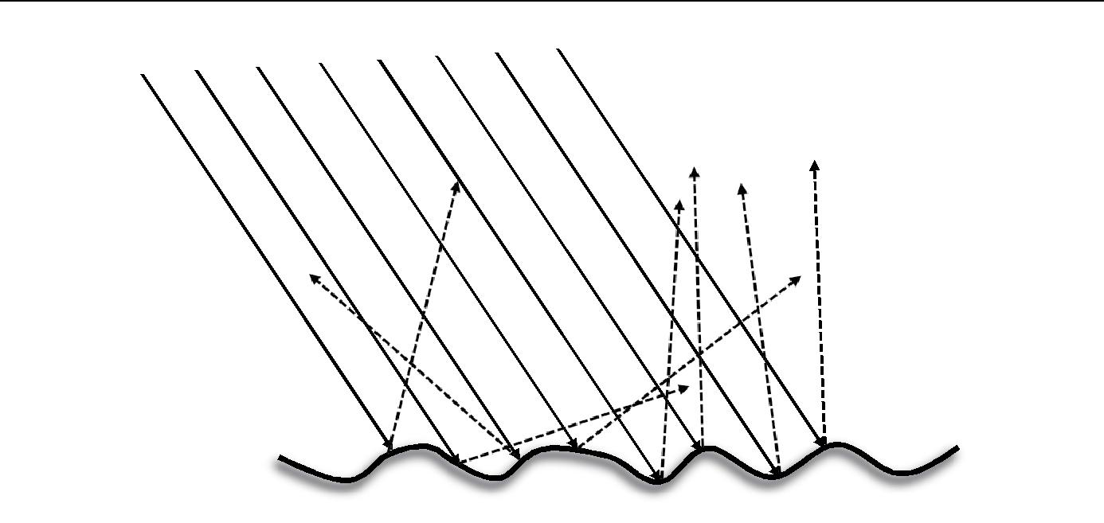

Figure 4: the reflection forms on the turbulent surface

We can simulate the reflection model by *Finite Element Analysis*, then calculate the reflection coefficient of a relatively large ocean surface. By dividing the ocean surface into finite microplane, the combination of each reflections about their own normal vectors determine the properties of diffuse reflection.

The model consist of two parts: one is the distribution expression of the surface, the other is the reflection model to describe the reflection properties of each microplane, which has already discussed in 3.1.1.

*Blinn* (1977) gave an exponential decay model of normal vectors distributions ofmicroplane [5]. In this model, the microplane which have the highest probability density is horizontal, so the criterion normal vector is vertical. The reflection wave shall decay along with the decrease of the angle of normal vector until to be horizontal.

To a smooth surface, the decay is fast, while to rough surface, the decay is progressive. The distribution function of *Blinn’s* model is proportional to the dot product of halfway vector *ωh* and criterion normal factor ***n***.

|  |  |
| --- | --- |
| *D*(*h* )(*h* ***n***)*e* | (9) |

To guarantee the physical effects, the distribution of microplane shall be standardized. That is to say, there must be a height field that has the distributions of *D(ωn)*. the total projected area of every microplanes in the height field equals to 1.

|  |  |
| --- | --- |
| **H** 2 (*n* ) *D*(*h* ) cos*hd**h* 1 | (10) |

So, the normalized *Blinn’s* microplane distribution is:

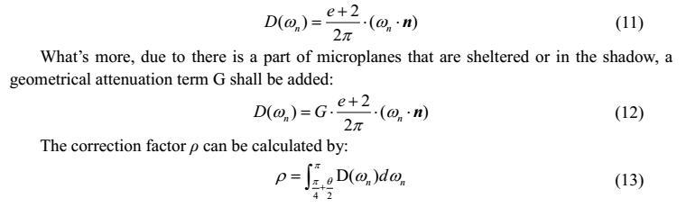

精品数模资料，各类比赛优秀论文、学习教程、写作模板与经验技巧、matlab程序代码资料等，尽在淘宝店铺：闵大荒工科男的杂货铺！

Team #88255 Page 8 of 20



**3.1.3.3 International Standard of Sea Surface Roughness**

To the rough sea surface reflection, the International Radio Consultative Committee (CCIR)

gave the expression of correction factor *ρ* [6]:

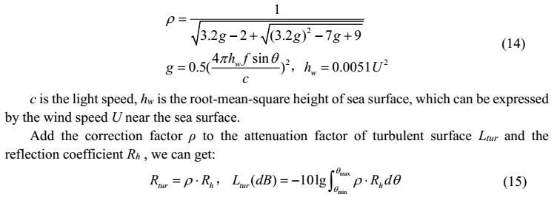

**3.1.4 The** **Reflection Attenuation Difference Between Calm and Turbulent Sea Surface**

By importing the data to formulas (14) and (15), take the wind speed *U* as 20*m/s*, figure 5 shows the relationship between the angle if incidence *θ* and the attenuation of different sea surface *Lcal* and *Ltur* when the frequency *f*=3*MHz*. figure 5 shows the relationship between frequencies and attenuation.

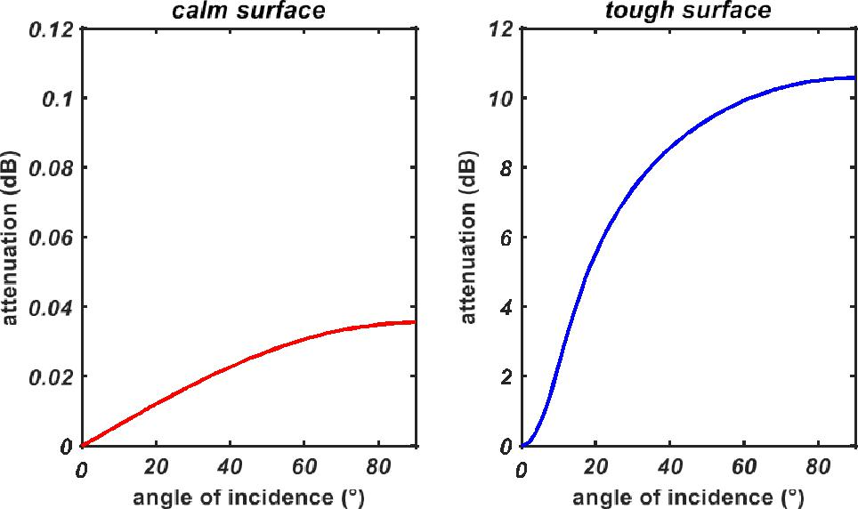

Figure 5: the relationship between *Lcal* or *Ltur* and *θ* on calm surface

versus tough surface, *f*=3*MHz*

From figure 5 we can find that on the calm surface, no matter what angle of incidence, the attenuation is very small that can be ignored, while on a turbulent surface, the attenuation increase along with the increase of *θ*, which can reach 10.578 *dB* when *θ* approach 90°.

精品数模资料，各类比赛优秀论文、学习教程、写作模板与经验技巧、matlab程序代码资料等，尽在淘宝店铺：闵大荒工科男的杂货铺！

Team #88255 Page 9 of 20

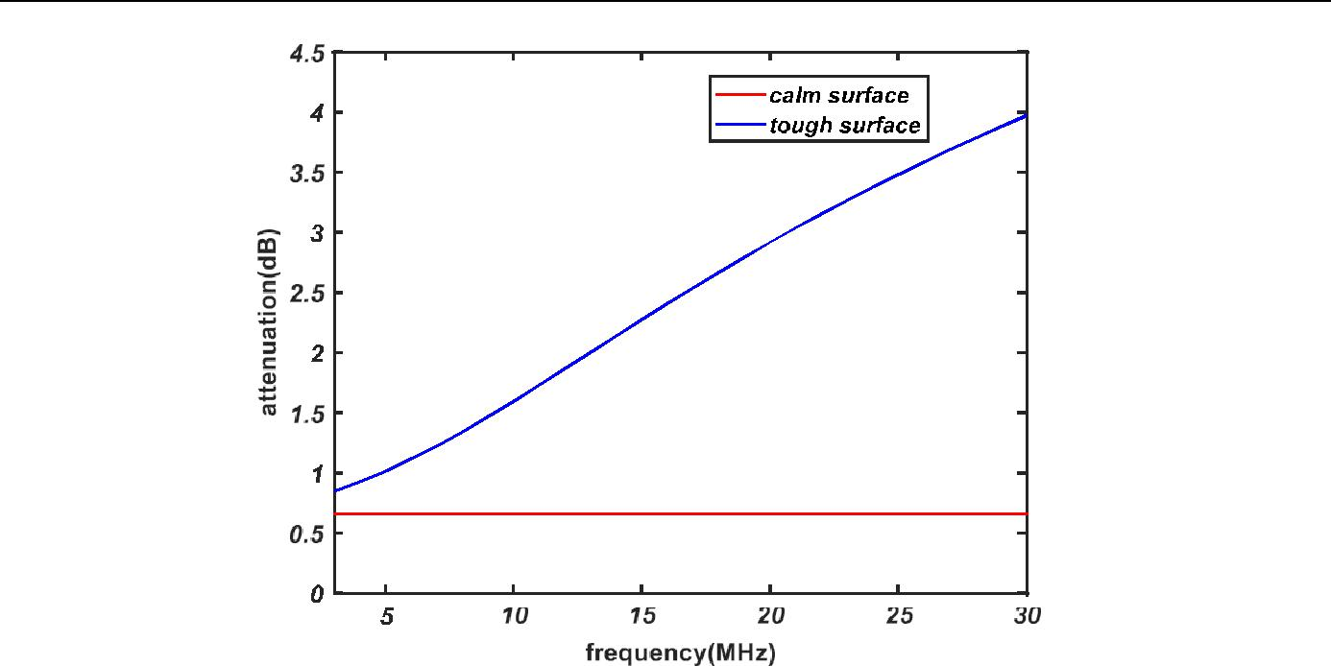

Figure 6：The relationship between *Lcal* or *Ltur* and *f*

on calm surface versus tough surface

From Figure 6 we can find that no matter what frequency it is, the attenuation on calm surface are almost invariable and very small, which below 1*dB*. While the attenuation on the turbulent surface increased along with the increase of frequency, which can reach 4 *dB* when the frequency approach 30*MHz*.

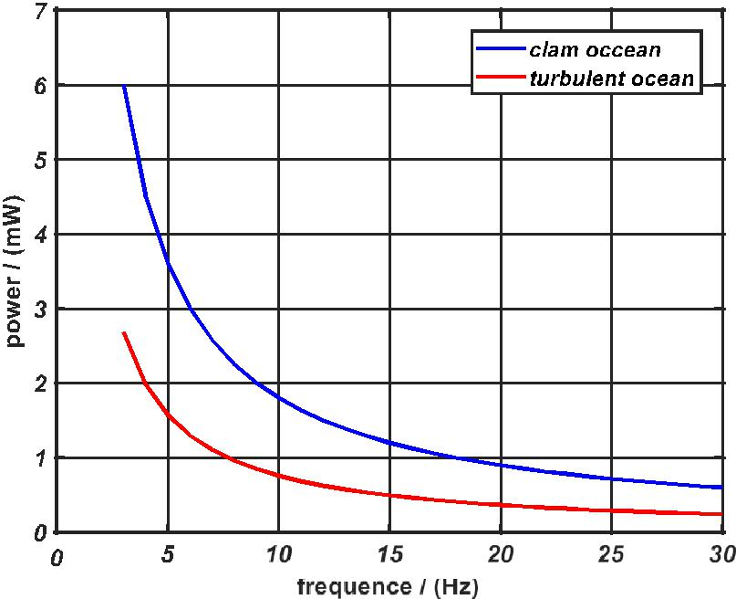

Figure 7: the comparison of reflected power between calm and turbulent ocean

The signal is reflected by the calm and turbulent sea surface after the first reflection of ionosphere. The loss in the air and ionosphere will be mentioned in the next passage 3.2. As shown in the figure 7, the signal strength decreases as the frequency increases. To calm ocean, the range of the reflected signal strength is 0.5 to 5.5*mW*. To turbulent ocean, the range is 0.2 to 2.5*mW*. At the most commonly used frequency of 0.85MUF, the signal power is about 0.5062*mW*.

精品数模资料，各类比赛优秀论文、学习教程、写作模板与经验技巧、matlab程序代码资料等，尽在淘宝店铺：闵大荒工科男的杂货铺！

Team #88255 Page 10 of 20



**3.2** **The Maximum Number of Hops**

To calculate the maximum number of hops, it’s necessary to estimate the signal attenuation in different processes, including path transmission loss, ionosphere reflection attenuation and sea surface reflection attenuation.

**3.2.1 Free Space Transmission Loss and Path Transmission Loss**

Free space is the indefinite space that is filled with homogeneous and dissipationless medium, which has the character of isotropy, electrical conductivity *σ=* 0, relative permittivity *εr=*1, and relative permeability *μr=*1.

Suppose that two ideal point signal source antenna (Gain: *Gt*=*Gr*=1) are respectively transmitting and receiving antenna, *Pt* is the input (transmitting) power, *Pr* is the output (receiving) power, the free space transmission loss *Lbf* can be defined as :

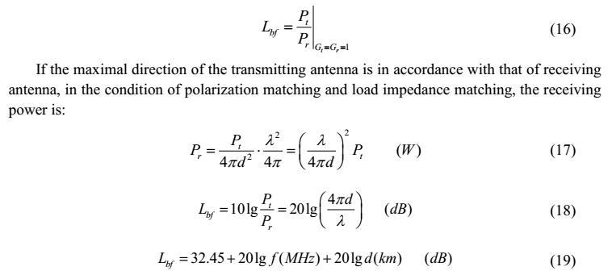

So, when double the radio frequency or propagation distance, the free space transmission loss will be increased by 6*dB*.

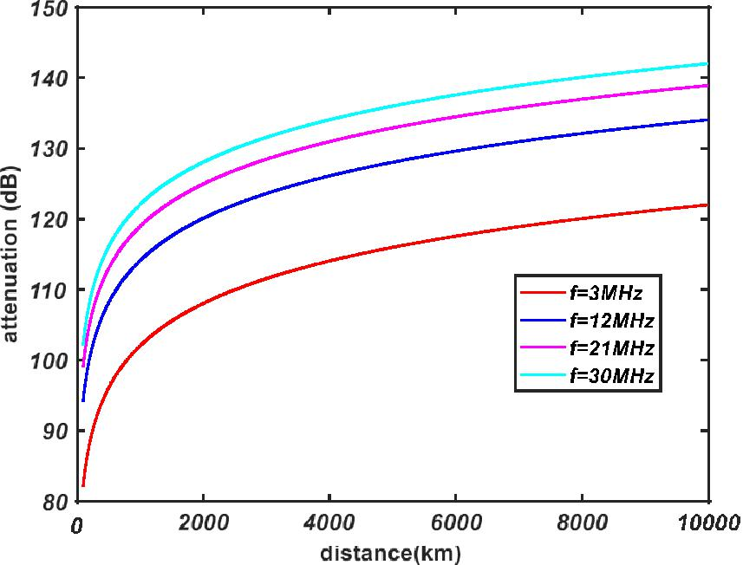

Figure 8: The relationship between *Lbf* *(dB)* and distance *(km), f=*3, 12, 21, 30*MHz*

精品数模资料，各类比赛优秀论文、学习教程、写作模板与经验技巧、matlab程序代码资料等，尽在淘宝店铺：闵大荒工科男的杂货铺！

Team #88255 Page 11 of 20



Figure 8 shows the relationship between transmission distance and attenuation *Lbf*, on different frequencies. The higher frequency, the higher free space transmission loss there will be.

In the atmosphere environment, except for free space transmission loss, electromagnetic wave may also suffer such effects like attenuation, fading, depolarization, time and frequency domain distortion, which can cause a complex change.

Suppose that an antenna is set in a free space, the field strength in maximal direction E0 can be defined as:

| *E*0 |

The field strength of receiving point is:

|  |  |
| --- | --- |
| 60*PtGt* (*V* / *m*) | (20) |
| *d* |  |



|  |  |  |  |  |  |  |  |  |  |
| --- | --- | --- | --- | --- | --- | --- | --- | --- | --- |
| | *E* || *E* | 0 | | *A* | *air* |  | 60*Pt* (*W* )*Gt* | *A* | (*V* / *m*) | (21) |  |
|  |  |
|  |  |  | *d* (*m*) | *air* |  |  |  |
|  |  |  |  |  |  |  |  |  |



*Aair* is the attenuation factor in the atmosphere, which is related to frequency, distance,electrical parameter of medium, propagation mode and so on. We can also convert *Aair* to *dB* form:

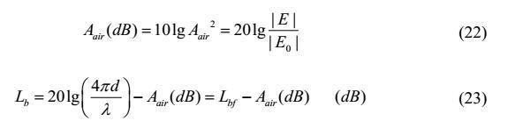

Apparently, *Lb* described the power propagation situation in the medium, so *Lb* is called path transmission loss or basic transmission loss.

So, we can use *Lb* to define the transmission loss in the atmosphere (not include the ionosphere), which is related with propagation distance *d*, wavelength *λ* and attenuation factor

*Aair*, *Lb*.

**3.2.2 The Properties of Ionosphere Reflection**

**3.2.2.1** **Physical Properties of Ionosphere**

The ionosphere is the ionized part of Earth's upper atmosphere, from about 60 *km* to 1,000 *km* altitude[7],which contains electrons and electrically charged atoms and molecules thatsurrounds the earth. Commonly, we use electron density (*electron amounts/m3*) to describe its ionization degree.

The ionosphere is a kind of random, dispersive and anisotropic semiconductor medium, the parameters (thickness, electron density and distribution) change at random.

精品数模资料，各类比赛优秀论文、学习教程、写作模板与经验技巧、matlab程序代码资料等，尽在淘宝店铺：闵大荒工科男的杂货铺！

Team #88255 Page 12 of 20

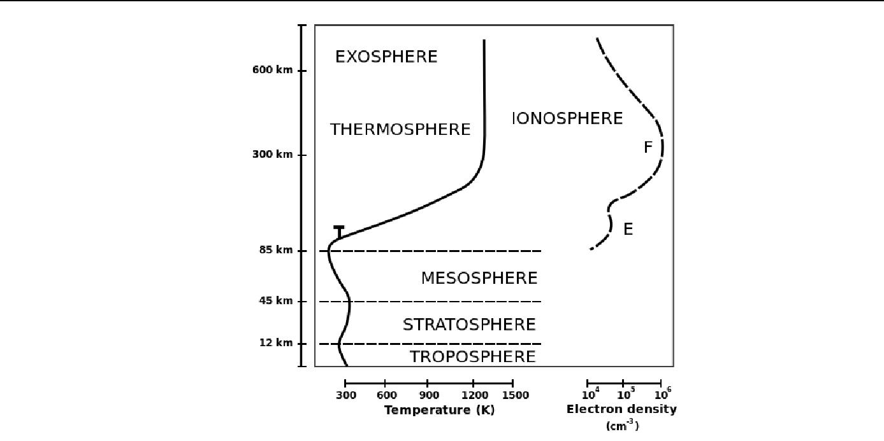

Figure 9: The layers and electron density of ionosphere[8]

Within ionosphere, there are also four parts[8]:

*D layer*: 60～90km above the surface of the Earth. The thickness of D layer decrease graduallyas night comes. In the dark night, D layer almost disappear.

*E layer*: 90～150km, relatively stable at an altitude of 110km. Electron density decrease at night.

*F1 layer*: 170～220km, always appear in the summer daytime and disappear at night and winter.

*F2 layer*: 225～450km, Electron density in the daytime is higher than night, which is also higherin winter than summer.

**3.2.2.2 The Absorption of Ionosphere**

The absorption of ionosphere includes deviative absorption and non-deviative absorption. The non-deviative region is the region whose refractive index *n* approach 1[9], the radio

almost travels in straight lines. The non-deviative absorption is mainly in D layer, which contains large amounts of neutral molecule and ion so that the collision frequency *v* is very high. E and the inferior region of F layer are also included but can be ignored compared with D layer.

To calculate the non-deviative absorption of D layer, according to electromagnetic theory, known *εr* and *σ* of the dissipationless medium, the attenuation factor *Aion* is:

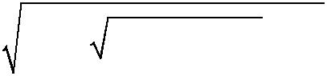

|  |  |  |  |  |  |  |  |
| --- | --- | --- | --- | --- | --- | --- | --- |
| *A* = | 00 | [  2 | (60 )2   | *r* | ] | (24) |  |
|  |  |
| *ion* | 2 | *r* |  |  |  |  |
|  |  |  |  |  |  |  |

ε0 is vacuum permittivity, the approximate value is 8. 854187817 × 10-12 F/m. the vacuum permeability *μ0* is 4π×10-7 *H/m.*

To high frequency wave propagation, the condition  / () 1 is met, then:

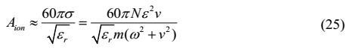

The deviative region is the region whose refractive index *n* is very small, the radio will

change the propagation direction with a curve and back to the earth. Generally there is *εr*≈1[10],

the total attenuation in the ionosphere *Lion* can be calculated by *e* *A*2 *dl* , *l* is the route of radio in the ionosphere. Generally the absorption is quite small and usually under 10 *dB*[11]*.*

精品数模资料，各类比赛优秀论文、学习教程、写作模板与经验技巧、matlab程序代码资料等，尽在淘宝店铺：闵大荒工科男的杂货铺！

Team #88255 Page 13 of 20



**3.2.3 The Calculation of Maximum Hops**

The main reasons to affect *SNR* include internal noises and external noises, the internal noises come from receiving system itself, which can be ignored in this situation.

The external noises origin from the universe, the atmosphere and the earth surface, among which the *cosmic background radiation*[12] is the most important part, which can be represented by:

|  |  |
| --- | --- |
| *Pnoise*  *kTB* 8.01015*W* | (26) |

*k* is Boltzmann constant, the value is 1.3806505 ×10-23 *J/K*, *T* is the background temperature,the general value is 290*K*, *B* is the bandwidth of the signal which is depends on the quality of the signal, we take 2*MHz* to calculate.

The SNR threshold is 10 *dB*, which means

|  |  |  |  |
| --- | --- | --- | --- |
| *SNR* 10lg | *Psignal* |  10*dB* |  |
| *Pnoise* |  |
|  | (27) |  |

*Psignal* _ min81014*W*

The given power of signal source is 100 *W*, so the maximal attenuation that allowed in the transmission process is:

|  |  |  |  |  |
| --- | --- | --- | --- | --- |
| *L*max 10lg | 100 | =150.969 *dB* | (28) |  |
|  |  |



*signal* _ min

By calculating the total loss *Lt*, compared with Lmax, we can estimate the number of hops that the signal can take before its strength falls below the *SNR* threshold.

According to the conclusions in 3.1, 3.2.1 and 3.2.2, the radio suffered several kinds of loss and attenuation in the process of transmission, including the path transmission loss *Lb,* the ionosphere attenuation *Lion*, the sea surface attenuation *Lcal* or *Ltur*.

The total loss can be expressed by:

|  |  |  |  |  |  |  |  |  |  |  |  |  |  |  |  |  |  |  |  |  |  |  |  |  |  |  |  |  |  |  |  |  |  |  |  |  |  |  |  |  |  |  |  |  |  |  |  |  |  |  |  |  |  |  |  |  |  |  |  |  |  |  |  |  |  |  |  |  |  |  |  |  |
| --- | --- | --- | --- | --- | --- | --- | --- | --- | --- | --- | --- | --- | --- | --- | --- | --- | --- | --- | --- | --- | --- | --- | --- | --- | --- | --- | --- | --- | --- | --- | --- | --- | --- | --- | --- | --- | --- | --- | --- | --- | --- | --- | --- | --- | --- | --- | --- | --- | --- | --- | --- | --- | --- | --- | --- | --- | --- | --- | --- | --- | --- | --- | --- | --- | --- | --- | --- | --- | --- | --- | --- | --- |
|  |  |  |  |  |  |  |  |  |  |  |  |  |  |  |  |  |  |  | *Lt*  *Lb*  *Lion*  *Lcal* / *tur* | | | | | | | | | | | | | | | | | | | | | | | | | | | | | | | | | | | | | | | | | | | | | | | | (29) | | | | | |
|  | | | | | | | | | | | | | | | | | | | | | | | | | | | | | | | | | | | | | | | | | | | | | | | | | | | | | | | | | | | | | | | | | | | | | | | |  |
|  | | | | | | | | | | | | |  | | | | | | | | | | | | | |  | | | | | | | | | | | | | |  | | | | | | | | | | | | | | |  | | | | | | | | | | | | | | | |  |
|  |  |  |  |  |  |  |  |  |  |  |  |  |  |  |  |  |  |  |  |  |  |  |  |  |  |  |  |  |  |  |  |  |  |  |  |  |  |  |  |  |  |  |  |  |  |  |  |  |  |  |  |  |  |  | |  |  |  |  |  | |  |  |  |
|  | | | | | | | | | | | | |  | | | | | | | | | | | | | |  | | | | | | | | | | | | | |  | | | | | | | | | | | | | | |  | | | | | | | | | | | | | | | |  |
|  | | | | | | | | | | | | |  | | | | | | | | | | | | | |  | | | | | | | | | | | | | |  | | | | | | | | | | | | | | |  | | | | | | | | | | | | | | | |  |
|  | | | | | | | | | | | | |  | | | | | | | | | | | | | |  | | | | | | | | | | | | | |  | | | | | | | | | | | | | |  | | | | | |  | | | | | | | | | | |  |
|  | | | | | | | | | | | | |  | | | | | | | | | | | | | |  | | | | | | | | | | | | | |  | | | | | | | | | | | | |  | | | | | | | | | | | | |  | | | | |  |
|  | | | | | | | | | | | | |  | | | | | | | | | | | | | |  | | | | | | | | | | | | | |  | | | | | | | | | | | | | |  | | | | | |  | | | | | | | | | | |  |
|  | | | | | | | | | | | | |  | | | | | | | | | | | | | |  | | | | | | | | | | | | | |  | | | | | | | | | | | | | |  | | | | | |  | | | | | | | | | | |  |
|  | | | | | | | | | | | | |  | | | | | | | | | | | | | |  | | | | | | | | | | | | | |  | | | | | | | | | | | | |  | | | | | | | | | | | | |  | | | | |  |
|  | | | | | | | | | | | | |  | | | | | | | | | | | | | |  | | | | | | | | | | | | | |  | | | | | | | | | | | | | |  | | | | | |  | | | | | | | | | | |  |
|  | | | | | | | | | | | | |  | | | | | | | | | | | | | |  | | | | | | | | | | | | | |  | | | | | | | | | | | | | |  | | | | | |  | | | | | | | | | | |  |
|  | | | | | | | | | | | | |  | | | | | | | | | | | | | |  | | | | | | | | | | | | | |  | | | | | | | | | | | | |  | | | | | | | | | | | | |  | | | | |  |
|  | | | | | | | | | | | | |  | | | | | | | | | | | | | |  | | | | | | | | | | | | | |  | | | | | | | | | | | | | |  | | | | | |  | | | | | | | | | | |  |
|  | | | | | | | | | | | | |  | | | | | | | | | | | | | |  | | | | | | | | | | | | | |  | | | | | | | | | | | | | |  | | | | | |  | | | | | | | | | | |  |
|  | | | | | | | | | | | | |  | | | | | | | | | | | | | |  | | | | | | | | | | | | | |  | | | | | | | | | | | | |  | | | | | | | | | | | | |  | | | | |  |
|  | | | | | | | | | | | | |  | | | | | | | | | | | | | |  | | | | | | | | | | | | | |  | | | | | | | | | | | | | |  | | | | | |  | | | | | | | | | | |  |
|  | | | | | | | | | | | | |  | | | | | | | | | | | | | |  | | | | | | | | | | | | | |  | | | | | | | | | | | | | | | | | | | | | | | | | | | | | | |  |
|  | | | | | | | | | | | | |  | | | | | | | | | | | | | |  | | | | | | | | | | | | | |  | | | | | | | | | | | | | | |  | | | | | | | | | | | | | | | |  |
|  | | | | | | | | | | | | |  | | | | | | | | | | | | | |  | | | | | | | | | | | | | |  | | | | | | | | | | | | | | |  | | | | | | | | | | | | | | | |  |
|  | | | | | | | | | | | | |  | | | | | | | | | | | | | |  | | | | | | | | | | | | | |  | | | | | | | | | | | | | | |  | | | | | | | | | | | | | | | |  |
|  | | | | | | | | | | | | |  | | | | | | | | | | | | | |  | | | | | | | | | | | | | |  | | | | | | | | | | | | | | |  | | | | | | | | | | | | | | | |  |

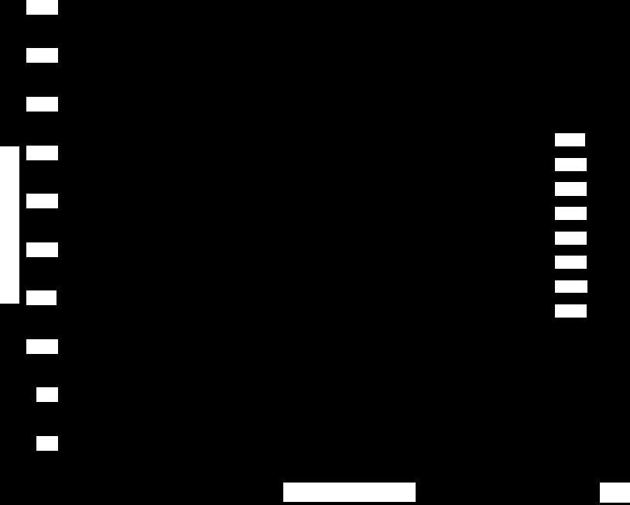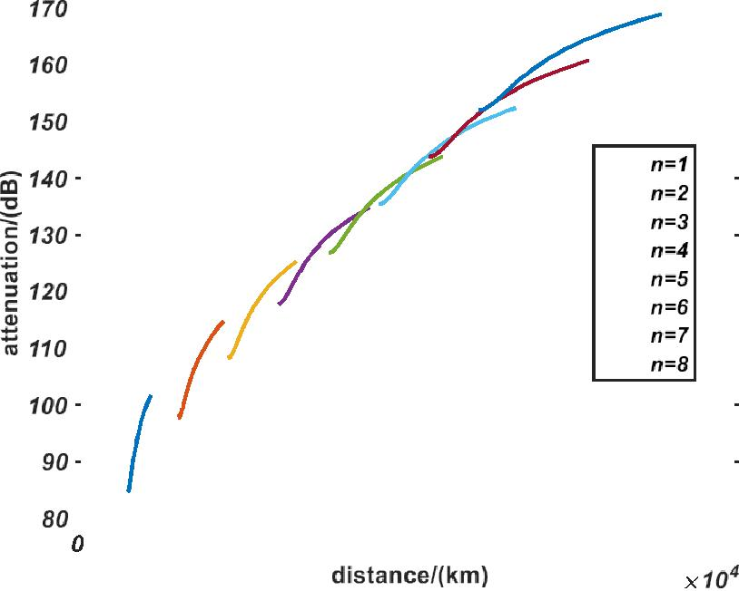

Figure 10: The relationship between distance (*km*) and the total loss *Lt* (*dB*)

*n:* number of hops, *f* = 3*MHz,* reflected by calm oceans

精品数模资料，各类比赛优秀论文、学习教程、写作模板与经验技巧、matlab程序代码资料等，尽在淘宝店铺：闵大荒工科男的杂货铺！

Team #88255 Page 14 of 20



From figure 10, we can see that if the signal was reflected by calm oceans, at the 6th and 7th hops, the attenuation of a part of signal has already exceed 151*dB*, and almost all of the 8th hop have been attenuated to the threshold. So in the frequency of 3*MHz*, the hops of signal could reach 6 to 7 times, along with the transmission distance reach 15,000 *km*.

What’s more, with the increase of frequency, the total number of hops will decrease gradually and finally drop to only one hop.

**3.3** **The Reflection Loss of rugged and smooth terrain**

Compared with sea surface, the surface of the ground have totally different relative permittivity *εr* and electrical conductivity *σ*, the table below shows the different *εr* and *σ* in different geologies.

Table 1: Different *εr* and *σ* in different geologies. [13]

|  |  |  |  |  |  |
| --- | --- | --- | --- | --- | --- |
| Geology | ***εr*** |  | ***σ*** |  |  |
| Range | Average | Range | Average |  |
|  |  |
| Seawater | 70 | 70 | 0.66~6.6 | 5 |  |
| Fresh Water | 80 | 80 | 10-3~2.4×10 -2 | 10-3 |  |
| Wet Soil | 10~30 | 20 | 3×10 -3~3×10 -2 | 10-2 |  |
| Dry Soil | 2~6 | 4 | 1.1×10 -3~2×10 -3 | 10-3 |  |

In addition, the amplitude of fluctuation is much larger than the sea surface. The radio would also scatter to all directions. Take hilly topography (amplitude under 500m, sparse hills) as an example to correct the model in 3.1.3.2. We can use the reflection coefficient formula (1)(2) in

3.1.1 , replace *εr* and *σ* to calculate the reflection coefficient of the ground *Rg*.

It is notable that the reflection off mountainous or rugged terrain is not related with wind speed, which is different from sea surface. If we have known the terrain distribution of the ground, it’s not hard to calculate *Rg*, so that the attenuation of ground can also be calculated by formula

(3) given in 3.1.2.

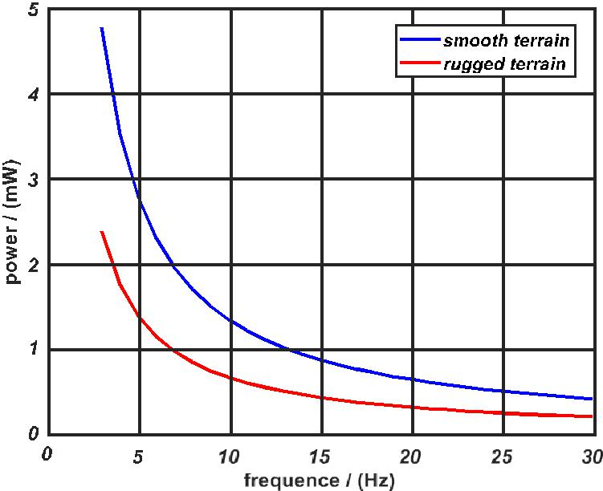

Figure 11: The comparison of reflected power between smooth and rugged terrain

精品数模资料，各类比赛优秀论文、学习教程、写作模板与经验技巧、matlab程序代码资料等，尽在淘宝店铺：闵大荒工科男的杂货铺！

Team #88255 Page 15 of 20



As shown in the figure 11, the signal strength decreases as the frequency increases. To smooth terrain, the range of the reflected signal strength is 0.4 to 4.8*mW*. To rugged terrain, the range is 0.2 to 2.4*mW*.

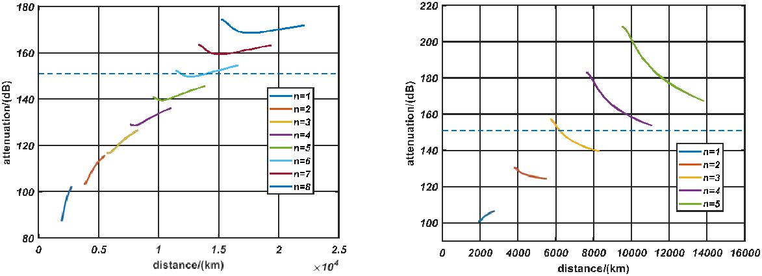

Figure 12: The relationship between distance (*km*) and the total loss *Lt* (*dB*)

*n* : number of hops, *f* = 3*MHz,* reflected by smooth (left) and rugged (right) terrain

Figure 12 shows that when the signal was reflected by smooth terrain, *f*=3*MHz* , there will be 5 to 6 hops of signal could be received, while reflected by rugged terrain, there are only 3 hops of signal. The difference reveals that when the fluctuation of terrain could affect the transmission distance and hops by change the direction of reflected radio.

Compared with the reflection off calm oceans, the land reflection has more attenuation and less reflecting times, it’s also correspond to the smaller *εr* and *σ* of soil than seawater.

**3.4** **Model Improvement About Shipboard Receiver**

**3.4.1** **The Properties of Moving Receiver**

In the process of sailing, to the receiver on the ship, we should not only consider SNR of receiving signal, but also the stability of receiving signal. Usually, in a shaky or moving subject, using the circular polarization antenna can keep the signal as stable as possible.

There are two ways of circular polarization, one is linear polarization transmitting and circular polarization receiver, another is on the contrary. No matter what kind of polarization way we take, the Mismatch Factor *v* is always 1/2.

So our model need to add a constant attenuation:

*Lship*  10lg 0.53.01*dB*

*L*  *L*  *L*  *L* +*L* (30)

*t* *b* *ion* *cal* / *tur* *ship*

**3.4.2 The Range of The Communication Area of The Same Multi-Hop Path**

Figure 13 displays the attenuation degree of the signal reflected by the turbulent ocean and received by a shipboard receiver, it’s not hard to find the signal will take 3 to 4 hops before attenuated to 151*dB*. On this basis, we can also calculate the distance range among which the ship can receive the effective signal. The result was displayed in figure 14.

精品数模资料，各类比赛优秀论文、学习教程、写作模板与经验技巧、matlab程序代码资料等，尽在淘宝店铺：闵大荒工科男的杂货铺！

Team #88255 Page 16 of 20

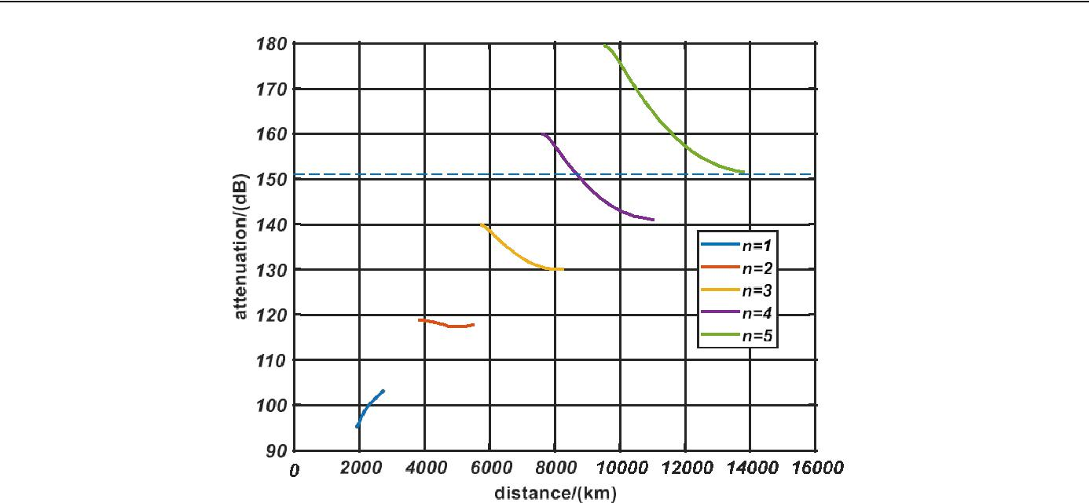

Figure 13: The multi-hop signal received by the shipboard receiver

*n :* number of hops, *f* = 3*MHz*, reflected by turbulent ocean

|  |  |  |  |  |  |  |  |  |  |  |  |  |  |  |  |  |
| --- | --- | --- | --- | --- | --- | --- | --- | --- | --- | --- | --- | --- | --- | --- | --- | --- |
|  |  |  |  |  | ***dship*-*signal*** | | | | | | | |  |  |  |  |
|  |  |  |  |  |  |  |  |  |  | ***d*** | | |  |  |  |  |
| **0** |  |  |  |  |  |  |  |  |  |  |  |  |  |  |  |  |
|  | **1900 2767 3894 5535 5786 *The ship* 8302 8682** | | | | | | | | | | | **11070** | ***dr*/*km*** | |  |
|  |  |  |  |



Figure 14: the range of effective signal

*dr* is the relative distance, suppose that the earth is a regular sphere, every reflected point onthe earth must not in the same plane, so we use *dr* to describe the curve distance that the ship move on the earth. In figure 14, the red lines are the ranges that could receive the signal, that is to say within the red ranges, the *SNR* of signals >10*dB*.

The specific ranges are between 1900-2676 *km* (1st hop)、3894-5535 *km* (2nd hop)、5768-8302 *km* (3rd hop*)*、 8682-11070 *km* (4th hop). Between each range, there are areas like “exclusion zone” where cannot receive the effective signal.

Known the ranges, as long as we know the direction and speed of the ship, it’s quite easy to calculate the time that could receive the signal.

**4 Stability and Sensitivity Analysis**

In the reflection model we established in 3.1, the changes of height, shape of sea surface are mainly caused by wind speed. What’s more, in different sea areas, the temperature and salinity of seawater couldn't be the same, which could change *εr* and *σ* of seawater. So, we mainly analyze the influence of wind speed, *εr* and *σ* to the stability and sensitivity of our model.

We considered the wind speed near the sea surface from 5m/s to 20m/s, and compare them:

精品数模资料，各类比赛优秀论文、学习教程、写作模板与经验技巧、matlab程序代码资料等，尽在淘宝店铺：闵大荒工科男的杂货铺！

Team #88255 Page 17 of 20

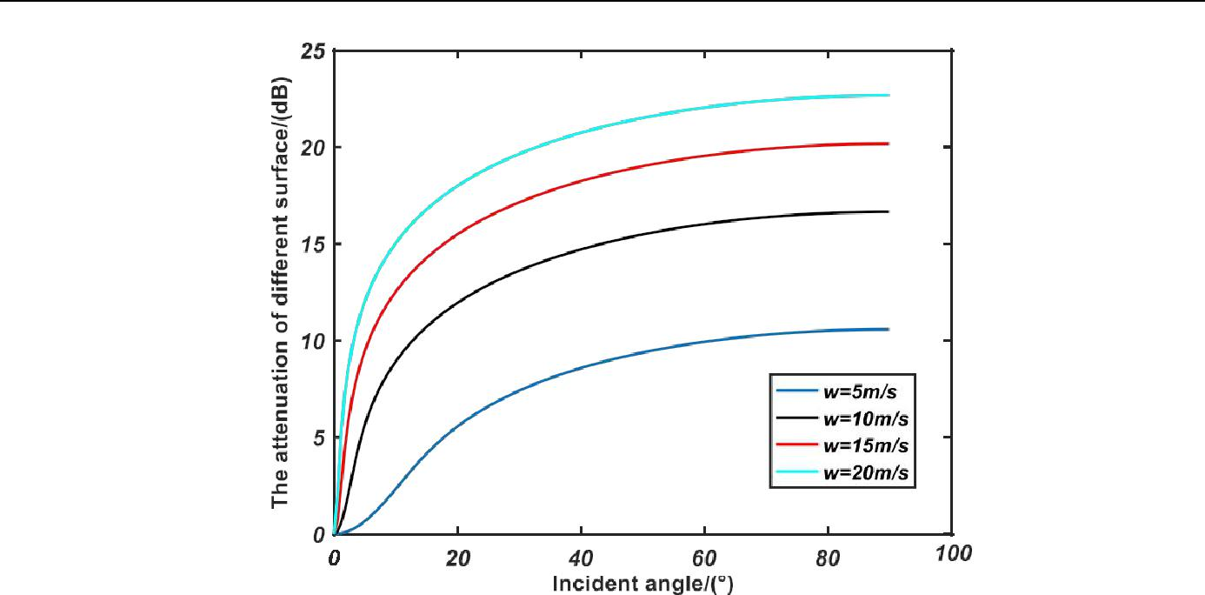

Figure 15: The change of *Ltur* when *wind speed* =5, 10, 15 and 20 *m/s*

From figure 15 we can find that wind speed has a relatively larger influence on the reflection attenuation of sea surface, the attenuation increased following the increase of wind speed, as well as the worse communication effect.

Consider the 20% rise and fall of *εr* and *σ*, the results are:

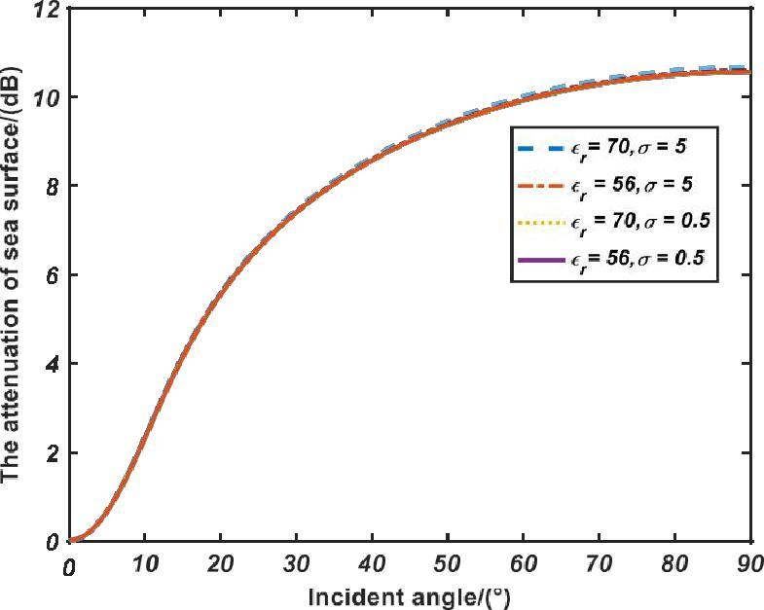

Figure 16: the change of the change of *Ltur* when there are small changes of *εr* and *σ*

The four curves of figure 16 are almost overlapped. Therefore, the small change within 20 percent of *εr* and *σ* has very little influence on the attenuation on sea surface. We can almost ignore the differences.

精品数模资料，各类比赛优秀论文、学习教程、写作模板与经验技巧、matlab程序代码资料等，尽在淘宝店铺：闵大荒工科男的杂货铺！

Team #88255 Page 18 of 20

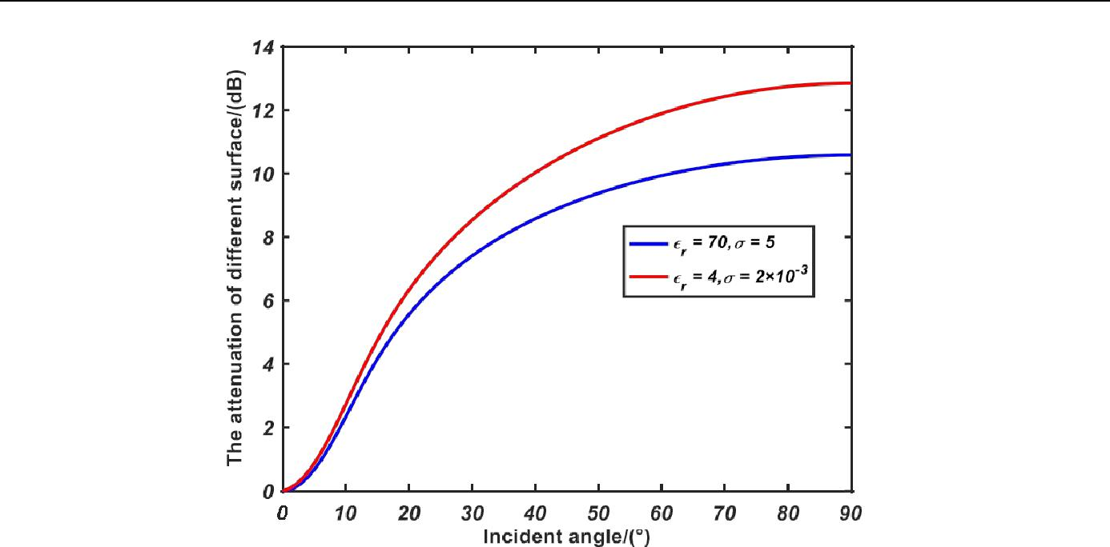

Figure 17: the change of *Ltur* when there are large changes of *εr* and *σ*

However, when there are large changes of reflecting medium, such as the seawater versus the ground. The attenuation of ground is obviously much more than seawater. Figure 17 shows the difference.

**5 Strengths and weakness**

**5.1 Strengths**

**•**There have been systematic previous researches about sky wave. About the sea surface reflection model, most of them were calculated by the empirical model about frequency and

incident angle. Our model used P-M model to simulate the wave of sea surface, Finite Element Analysis is also used to calculate the reflection coefficient, which is more accurate and universal.

**•**To the receiving problem of shipboard receiver, we know the particularity of the moving and shaky objects, in the condition of circular polarization only half of the signal could be

received. To calculate the effective range of reflection, we can display the useable receiving area and attenuation.

**5.2** **Weakness**

**•**In the model of ground reflection, we only change the relative parameters of the sea surface reflection model, there may be some inapplicable places and some errors.

**•**To part Ⅲ, the weaknesses are due to the complexity of ionosphere, the calculation is very difficult, it’s not very accurate to represent the transmission path in the ionosphere by the

function about incident angle, which may affect the result.

精品数模资料，各类比赛优秀论文、学习教程、写作模板与经验技巧、matlab程序代码资料等，尽在淘宝店铺：闵大荒工科男的杂货铺！

|  |  |
| --- | --- |
| Team #88255 | Page 19 of 20 |
| ***6* Short note in *IEEE Communication magazine*** |  |

The background of our research is that to the high frequency radio ( 3*MHz* ~30*MHz*), the ionosphere can reflect the transmission electromagnetic wave back to the earth or oceans, signal could be reflected for several times until get attenuated under the lowest SNR. The propagation mode is also called sky wave.

Our team have finished the model about four aspects: estimating the sea surface reflection properties, calculating the maximal hops of a given power signal source, comparing the land reflecting situation with sea, considering the influence of a shipboard receiver to our model. The four aspects contain the overall process of the propagation of the sky wave, but the key point is to solve the reflection problem off a turbulent sea surface.

To estimate the reflection loss off calm oceans and turbulent oceans, we have to figure out the reflection properties of seawater as well as the difference between calm surface and tough surface. Suppose that the surface of calm oceans is a flat plane, we can use Snell's law to calculate the reflection coefficient *Rh*. The integral of *Rh* among all the possible angle is the attenuation coefficient of calm oceans. To turbulent oceans, we used the *P-M* spectrum to estimate the distribution of wave height, and then take the finite element analysis, by integrating all of the reflected wave of each microplane in a relative large surface, by normalizing the result, we can get the strength distribution of reflected wave. It is also feasible to use the international general standard of tough sea surface correction factor *ρ* to calculate the reflection attenuation.

To calculate the maximum number of hops, it’s necessary to estimate the signal attenuation in different processes, including path transmission loss, ionosphere reflection attenuation and sea surface reflection attenuation. Considering the external noises, to a given signal source of 100-watt power, the maximum attenuation in the propagation path has to under 151*dB* to satisfy the lowest SNR 10*dB*. In the frequency of 3*MHz* and reflected by clam oceans, the hops of signal could reach 6 to 7 times, along with the propagation distance reach 15,000 km. With the increase of frequency, the total number of hops will decrease gradually.

Compared with the reflection off calm oceans, the surface of the ground have totally different relative permittivity *εr* and electrical conductivity *σ*. In addition, the amplitude of fluctuation is much larger than the sea surface so that the land reflection has more attenuation and less reflecting times, it’s also correspond to the smaller *εr* and *σ* of soil than seawater.

To a shipboard receiver, using the circular polarization antenna can keep the signal as stable as possible. The Mismatch Factor *v* is 1/2, which means that there has to be an additional 3*dB* attenuation when received. We calculated the receiving ranges of a sailing ship, every hop has its own radiation range, the areas between ranges are so called “exclusion zone” where cannot the effective signal.

The significance of our model is that solving the problem about the reflection off a turbulent surface, meanwhile combining the loss and attenuation in the process of the whole propagation of sky wave. The previous researches also provide us some methods to solve the problem. The model could be used in long-distance or overseas communication transmitted by high frequency electromagnetic wave.

精品数模资料，各类比赛优秀论文、学习教程、写作模板与经验技巧、matlab程序代码资料等，尽在淘宝店铺：闵大荒工科男的杂货铺！

Team #88255 Page 20 of 20



**7 Reference**

1. Lee W C Y. Mobile Communication Design Fundamentals[M].1993.
2. Barrios A E, Patterson W L, San S. Advanced Propagation Model (APM) Ver. 1.3. 1 Computer Software Configuration Item (CSCI) Documents[J]. 2002.
3. Dockery D, Kuttler J R. An improved impedance-boundary algorithm for Fourier split-step solutions of the parabolic wave equation[J]. IEEE Transactions on Antennas & Propagation, 1996, 44(12):1592-1599.
4. Jr W J P, Moskowitz L. A proposed spectral form for fully developed wind seas based on the similarity theory of S. A. Kitaigorodskii[J]. Journal of Geophysical Research, 1964, 69(24):5181–5190.
5. Zhang S R, Foster J C, Holt J M, et al. Magnetic declination and zonal wind effects on longitudinal differences of ionospheric electron density at midlatitudes[J]. Journal of Geophysical Research Space Physics, 2012, 117(A8).
6. Yokoyama A, King R W P, Sandler S S. Comments on "The electromagnetic field of a vertical electric dipole over the Earth or sea" [with reply][J]. IEEE Transactions on Antennas & Propagation, 1995, 43(5):541-544.
7. Brahmanandam P S, Chu Y H, Wu K H, et al. Vertical and longitudinal electron density structures of equatorial E- and F-regions[J]. Annales Geophysicae, 2011, 29(1):81-89. [8]Patterson W L, Hattan C P, Hitney H V, et al. Engineer's Refractive Effects Prediction System (EREPS), revision 2.0[J]. Interim Report Naval Ocean Systems Center San Diego Ca, 1994, 95. [9]Zhang S R, Chen Z, Coster A J, et al. Ionospheric symmetry caused by geomagnetic declination over North America[J]. Geophysical Research Letters, 2013, 40(20):5350-5354. [10]Ridley A J, Deng Y, Tóth G. The global ionosphere–thermosphere model[J]. Journal of Atmospheric and Solar-Terrestrial Physics, 2015, 68(8):839-864.
8. Wu T T, King R W P. Lateral electromagnetic pulses generated by a vertical dipole on the boundary between two dielectrics[J]. Journal of Electromagnetic Waves & Applications, 1987, 62(11):4345-4355.
9. Cooray V, Ming Y. Propagation effects on the lightning‐generated electromagnetic fields for homogeneous and mixed sea‐land paths[J]. Journal of Geophysical Research Atmospheres, 1994, 99(D5):10641-10652.
10. Mazur V, Ruhnke L H. Common physical processes in natural and artificially triggered lightning[J]. Journal of Geophysical Research Atmospheres, 1993, 98(D7):12913-12930.