Task 1:
Description
The education centre's Desktop Information System (DIS) is a comprehensive digital solution designed to streamline and enhance the management of user data within the institution. The system is intended to replace the current paper-based bookkeeping processes with a robust, user-friendly software platform. It will be capable of handling data for three primary user groups: Teaching Staff, Administration, and Students. For each user, the system will manage basic information such as name, telephone, email, and role. Additionally, the system will process group-specific data: Teaching Staff will have salary and subject details; Administration will include salary, employment status, and working hours; Students will have information on current and previously studied subjects.
Key functionalities of the DIS include the ability to add new user data, view existing data, filter data by user group, edit user information, and delete records. This will allow for efficient data management and easy access to relevant information. The system is designed to operate on Microsoft Windows, leveraging standard desktop hardware. It aims to provide a seamless experience with intuitive navigation and responsive performance, ensuring that staff can quickly and accurately manage information. This transition to a digital platform is expected to improve accuracy, reduce paperwork, and enhance overall administrative efficiency.

Software Requirements Specification for Desktop Information System

I. Introduction:

Purpose:

- The purpose of this document is to outline the software requirements for the Desktop Information System (DIS) for an education centre. This system will replace the current paper- based methods, aiming to streamline data management for teaching staff, administration, and students.

Project Scope:

- The DIS will handle data entry, retrieval, editing, and deletion for various user groups within the institution. It is intended to improve administrative efficiency and data accuracy, providing a reliable platform for managing user information.

II. Overall Description:

Product:

- The DIS is a desktop application that manages user data. It supports functionalities such as
adding new records, viewing all records, filtering records by user group, editing, and deleting records. The application is designed for the Microsoft Windows operating system.

Users:

- The primary users of the DIS will be the administrative, teaching staff, and students

Operational Environment:

- The application will run on desktop computers with Microsoft Windows as the operating system. Standard desktop hardware with sufficient memory and processing power to handle basic database operations will be required.

III. System Features:

Description:

- The system will feature a user-friendly interface that provides access to the main functionalities such as data entry, viewing records, filtering by user group, editing, and deleting records.

Functional Requirements:

  - Add New Data: The system will allow users to input and store new user data.
  - View Existing Data: Users can view all records in the system.
  - Filter Data by User Group: The system will provide options to filter records based on user groups (Teaching Staff, Administration, Students).
  - Edit Existing Data: Users can update information in existing records.
  - Delete Existing Data: Users can remove records from the system.

IV. User Interface Requirements:

The user interface must be intuitive and easy to navigate. It should include:

  - A main menu with options for each primary function.
  - Forms for data entry and editing.
  - Lists and search tools for viewing and filtering records.

V. Platform Requirements:

The DIS will be compatible with Microsoft Windows. It should run efficiently on standard desktop hardware with at least 4GB of RAM and a 2GHz processor.

VI. Quality Attributes:
The system should respond promptly to user inputs, with minimal lag during data operations.

Security:
Data security is paramount. The system must include authentication mechanisms to prevent unauthorized access and ensure that user data is protected.

Safety:
The system must be reliable, with proper error-handling to prevent data loss. Regular backups should be scheduled to safeguard against data corruption or loss.

Task 2:

UML Diagram:

Unified Modeling Language (UML) is a standardized modeling language used to visualize, specify, construct, and document the artifacts of a software system. UML provides a way to create a blueprint for system architecture, making it easier to understand, design, and manage complex software projects. UML diagrams are broadly categorized into two types: structural diagrams and behavioral diagrams.

Class Diagram:
The Class Diagram represents the static structure of the system, showing the system's classes, their attributes, methods, and the relationships between them. This diagram is essential for understanding how data is organized within the system and how different entities interact.

Classes and Attributes:
- Person: The base class representing a general user within the system.
  - Attributes:
    - name: String
    - telephone: String
    - email: String
    - role: String
  - Methods:
    - addData(): Method to add new data.
    - viewData(): Method to view data.
    - editData(): Method to edit data.
    - deleteData(): Method to delete data.
- Teacher: A subclass of Person, representing teaching staff.
  - Attributes:
    - salary: Double
    - subjects: List<String>
- Admin: A subclass of Person, representing administrative staff.
  - Attributes:
    - salary: Double
    - employmentStatus: String
    - workingHours: Double
- Student: A subclass of Person, representing students.
  - Attributes:
    - currentSubjects: List<String>
    - previousSubjects: List<String>

Realationships:
The Teacher, Admin, and Student classes all inherit from the Person class, indicating that they share common attributes and methods defined in the Person class but also have specific attributes that differentiate them
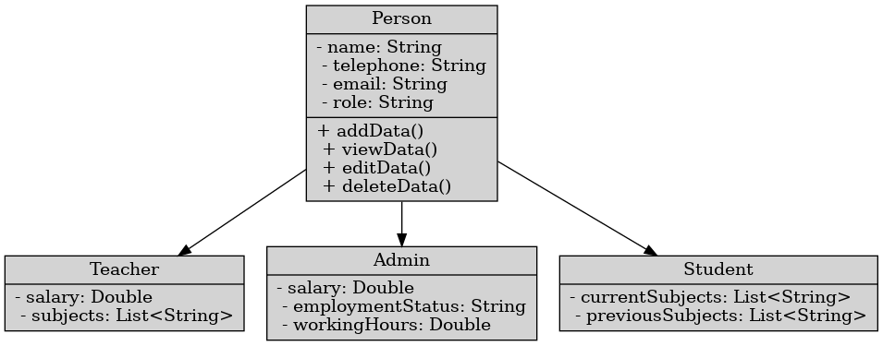

Use Case Diagram:

The Use Case Diagram provides a visual representation of the interactions between users (actors) and the functions (use cases) within a Desktop Information System for an educational center. The primary purpose of this diagram is to depict the functionalities of the system and how different user groups interact with these functionalities.
Actors:
- Admin: Represents the administrative staff who manage and oversee the system's data.
- Teaching Staff: Represents teachers who interact with the system to manage their educational content and student data.
- Students: Represents the students who access the system to view and interact with their data.
Use Cases:
- View All Existing Data: Allows users to view all data available in the system.
- View Data by User Group: Allows users to view data categorized by specific user groups (e.g., teachers, students).
- Edit Existing Data: Enables users to edit data entries in the system.
- Add New Data: Allows users to add new data entries to the system.
- Delete Existing Data: Enables users to delete data entries from the system.
Interactions:
All three actors (Admin, Teaching Staff, and Students) have interactions with each use case, indicating that they all have permissions to perform these actions within the system.
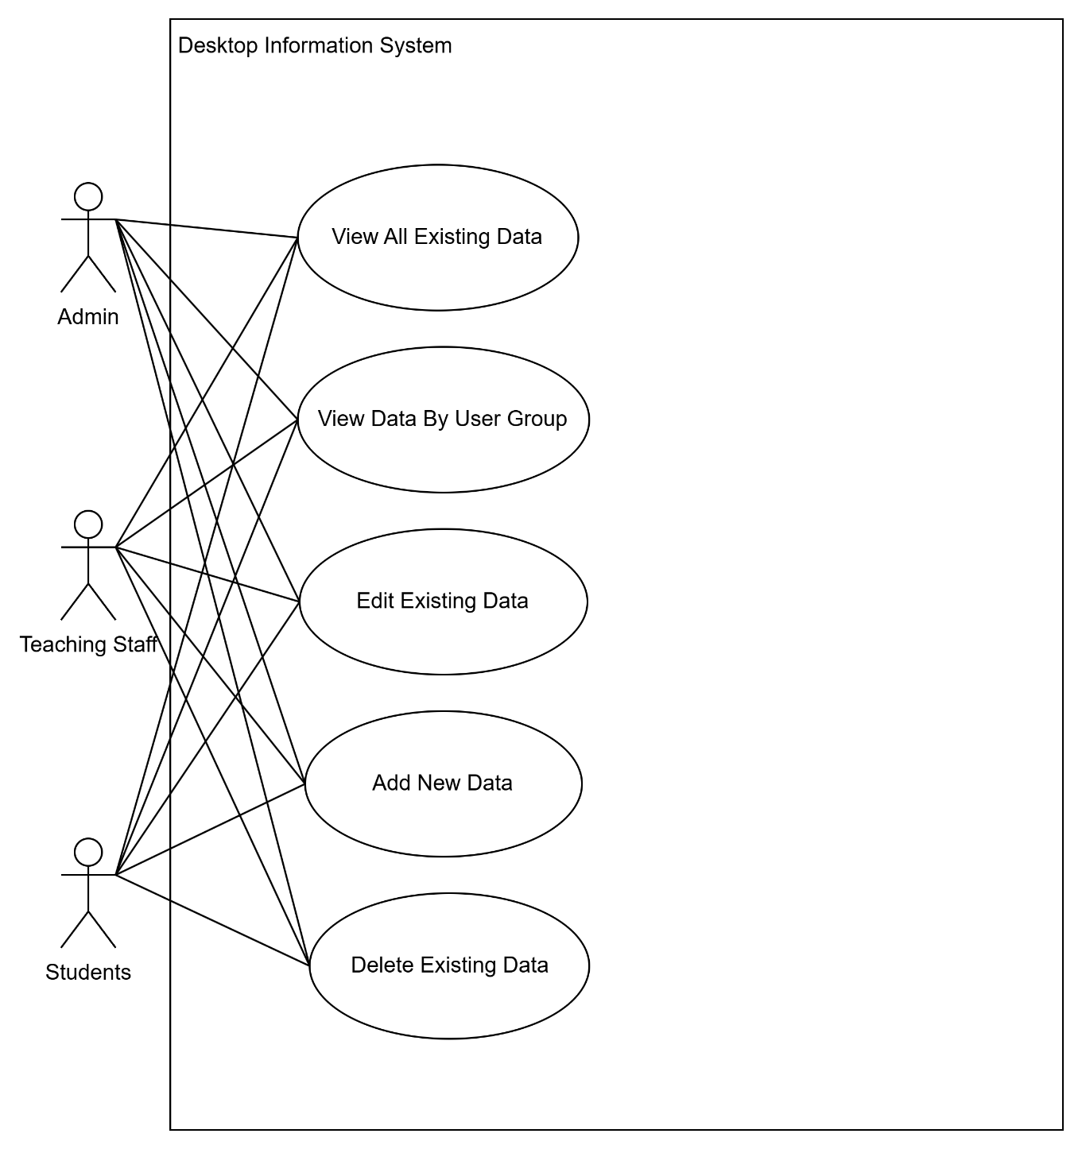

Task 3:

A. Object-Oriented Features:

I. Base class “Person”:

using System;

namespace DesktopInformationSystem
{
// This class represents a base class for various types of people within the system.
public class Person
{
public string Name { get; set; }
public string Gender { get; set; }
public string Email { get; set; }
public string Phone { get; set; }
public string Role { get; set; }
public string Status { get; set; }

// Constructor with all parameters
public Person(string name, string gender, string email, string phone, string role, string status)
{
Name = name;
Gender = gender;
Email = email;
Phone = phone;
Role = role;
Status = status;
}

// Parameterless constructor
public Person()
{
}

// Method to display information
public virtual void DisplayInfo()
{
Console.WriteLine($"Name: {Name}, Gender: {Gender}, Email: {Email}, Phone: {Phone}, Role: {Role}, Status: {Status}");
}
}
}

Attributes (Data Members):

- Public Properties: These properties are used to encapsulate and manage the personal information of an individual.
- Name: Represents the name of the person.
- Gender: Represents the gender of the person.
- Email: Represents the email address of the person.
- Phone: Represents the phone number of the person.
- Role: Represents the role of the person.
- Status: Represents the current status of the person.

- Encapsulation:
- The properties use automatic getters and setters, encapsulating the internal state of the object and allowing controlled access to its attributes.

Constructors:

- Constructor with all parameters: Initializes a new instance of the Person class with specific values for Name, Gender, Email, Phone, Role, and Status.
- This constructor is useful for creating “Person” objects with predefined attributes.

- Parameterless constructor: Initializes a new instance of the Person class with default values.
- This constructor allows creating an instance of Person without initializing any properties.

-Encapsulation:
- Constructors provide a way to ensure that the object is created with valid initial values or can be created with default values when no specific information is provided.

Methods:

“DisplayInfo” Method:
- Functionality: This method outputs the personal information of the Person instance to the console.
- Virtual: The virtual keyword indicates that this method can be overridden in derived classes.
- Purpose: Provides a way to display the basic information of the Person object. Derived classes can override this method to provide a customized implementation.

Polymorphism:
- By marking DisplayInfo as virtual, the Person class allows derived classes to override this method to provide specific implementations for displaying information. For example, a Teacher class can override DisplayInfo to include additional teacher-specific details.

II. Derived classes:

1. Teacher:

using System;
using System.Collections.Generic;
using System.Data.SqlClient;
using System.Data;

namespace DesktopInformationSystem
{
// TeacherData class inherits from Person and represents teacher-related data.
// It includes properties for teacher details and methods for retrieving teacher data from the database.
class TeacherData : Person
{
// Properties to hold teacher-specific data.
public int ID { get; set; }
public string TeacherID { get; set; }
public string Name { get; set; }
public string Gender { get; set; }
public string Email { get; set; }
public string Phone { get; set; }
public string Role { get; set; }
public int Salary { get; set; }
public string TeacherSubject1 { get; set; }
public string TeacherSubject2 { get; set; }
public string Status { get; set; }

// Connection string for connecting to the SQL database.
private static readonly string ConnectionString = ConnectConfig.connection;

// Default constructor.
public TeacherData()
{
}

// Parameterized constructor to initialize a TeacherData object with specific values.
public TeacherData(string name, string gender, string email, string phone, string role, string status, string teacherID, string teacherSubject1, string teacherSubject2, int salary)
: base(name, gender, email, phone, role, status)
{
TeacherID = teacherID;
TeacherSubject1 = teacherSubject1;
TeacherSubject2 = teacherSubject2;
Salary = salary;
}

// Static method to retrieve a list of teacher data from the database.
public static List<TeacherData> GetTeacherListData()
{
// Create a list to hold TeacherData objects.
List<TeacherData> listdata = new List<TeacherData>();

// Establish a connection to the SQL database.
using (SqlConnection connect = new SqlConnection(ConnectionString))
{
try
{
connect.Open(); // Open the database connection.
// SQL query to select all records from the teachers table where delete_date is NULL (not deleted).
string selectData = "SELECT * FROM teachers WHERE delete_date IS NULL";

using (SqlCommand cmd = new SqlCommand(selectData, connect))
{
// Execute the query and obtain a SqlDataReader.
SqlDataReader reader = cmd.ExecuteReader();

// Read each record from the reader and map it to a TeacherData object.
while (reader.Read())
{
TeacherData teacher = new TeacherData
{
// Initialize the TeacherData object with values from the database.
ID = reader.GetInt32(reader.GetOrdinal("id")),
TeacherID = reader["teacher_id"].ToString(),
Name = reader["teacher_name"].ToString(),
Gender = reader["teacher_gender"].ToString(),
Email = reader["teacher_email"].ToString(),
Phone = reader["teacher_phone"].ToString(),
Role = reader["teacher_role"].ToString(),
Status = reader["status"].ToString(),
TeacherSubject1 = reader["teacher_subject1"].ToString(),
TeacherSubject2 = reader["teacher_subject2"].ToString(),
Salary = reader.GetInt32(reader.GetOrdinal("salary"))
};

// Add the TeacherData object to the list.
listdata.Add(teacher);
}
}
}
catch (Exception ex)
{
// Handle any exceptions that occur during database operations.
Console.WriteLine("Error: " + ex.Message);
}
}
// Return the list of TeacherData objects.
return listdata;
}
}
}

Class Definition:

- The “TeacherData” Class: Inherits from Person, encapsulating teacher-specific data and provides functionality to retrieve teacher data from the database.

Properties:

- These properties represent data related to a teacher, such as their ID, TeacherID, Name, Gender, Email, Phone, Role, Subjects, Salary, and Status.

Constructors:

- Default Constructor: “public TeacherData()” initializes an empty TeacherData object.
- Parameterized Constructor: “public TeacherData(string name, ...)” initializes a TeacherData object with specific values and passes some of these values to the base class (“Person”).

Static Method: Retrieving Teacher Data

- This static method retrieves a list of teacher data from the database. It queries the “teachers” table for records where “delete_date” is “NULL”
- The method opens a connection to the database using the connection string. It then executes an SQL query to fetch the relevant records and maps each record to a “TeacherData” object. Finally, it adds each “TeacherData” object to a list and returns this list.

Inheritance:

- The “TeacherData” class inherits from the “Person” class, allowing it to reuse and extend the functionality defined in “Person”.

Encapsulation:

- The “TeacherData” class encapsulates data related to teachers and the methods for retrieving this data, protecting it from external interference. The use of properties and private fields further ensures controlled access to the data

2. Admin:

using System;
using System.Collections.Generic;
using System.Data.SqlClient;
using System.Data;
using System.Linq;
using System.Text;
using System.Threading.Tasks;

namespace DesktopInformationSystem
{
// AdminData class represents an admin in the system and inherits from the Person class.
// It contains additional properties specific to admins and provides methods for handling admin data.
class AdminData : Person
{
// Properties representing the admin's data fields.
public int ID { set; get; }
public string AdminID { set; get; }
public string Name { set; get; }
public string Gender { set; get; }
public string Email { set; get; }
public string Phone { set; get; }
public string Role { set; get; }
public int Salary { set; get; }
public string AdminWorktype { set; get; }
public string AdminWorkinghours { set; get; }
public string Status { set; get; }

// Connection string for the SQL database, used for database operations.
private static readonly string ConnectionString = ConnectConfig.connection;

// Default constructor for the AdminData class.
public AdminData()
{
}

// Parameterized constructor for creating an AdminData object with specific values.
public AdminData(string name, string gender, string email, string phone, string role, string status, string adminID, string adminWorktype, string adminWorkinghours, int salary)
: base(name, gender, email, phone, role, status)
{
// Initializes the properties with the provided values.
AdminID = adminID;
AdminWorktype = adminWorktype;
AdminWorkinghours = adminWorkinghours;
Salary = salary;
}

// Static method to retrieve a list of all admins from the database.
// Returns a List<AdminData> containing the admin records.
public static List<AdminData> GetAdminListData()
{
// List to hold the retrieved admin data.
List<AdminData> listdata = new List<AdminData>();

// Establishes a connection to the SQL database using the connection string.
using (SqlConnection connect = new SqlConnection(ConnectionString))
{
try
{
connect.Open(); // Opens the database connection.

// SQL query to select all admin records that have not been marked as deleted (delete_date IS NULL).
string selectData = "SELECT * FROM admins WHERE delete_date IS NULL";

using (SqlCommand cmd = new SqlCommand(selectData, connect))
{
// Executes the query and retrieves the data using a SqlDataReader.
SqlDataReader reader = cmd.ExecuteReader();

// Reads each record from the database and populates the AdminData object.
while (reader.Read())
{
AdminData admin = new AdminData
{
ID = reader.GetInt32(reader.GetOrdinal("id")), // Retrieves the ID from the database.
Name = reader["admin_name"].ToString(), // Retrieves the admin's name.
Gender = reader["admin_gender"].ToString(), // Retrieves the admin's gender.
Email = reader["admin_email"].ToString(), // Retrieves the admin's email.
Phone = reader["admin_phone"].ToString(), // Retrieves the admin's phone number.
Role = reader["admin_role"].ToString(), // Retrieves the admin's role.
Status = reader["status"].ToString(), // Retrieves the admin's status.
AdminID = reader["admin_id"].ToString(), // Retrieves the admin's unique identifier.
AdminWorktype = reader["admin_worktype"].ToString(), // Retrieves the admin's work type.
AdminWorkinghours = reader["admin_workinghours"].ToString(), // Retrieves the admin's working hours.
Salary = reader.GetInt32(reader.GetOrdinal("salary")) // Retrieves the admin's salary.
};

// Adds the populated AdminData object to the list.
listdata.Add(admin);
}
}
}
catch (Exception ex)
{
// Handles any exceptions that occur during database operations and outputs the error message.
Console.WriteLine("Error: " + ex.Message);
}
}
// Returns the list of admin data.
return listdata;
}
}
}

Class Definition:

- “AdminData” is a class that inherits from the “Person” class, this allows “AdminData” to inherit properties and methods from the “Person” class, enabling code reuse and establishing a relationship between “AdminData” and “Person”.

Properties:

- These properties represent the admin's data fields, such as ID, AdminID, Name, Gender, Email, Phone, Role, Salary, Work type, Working hours, and Status.

- The properties are encapsulated within the AdminData class, and use getters and setters for controlled access and modification.

Constructors:

- Default Constructor: “public AdminData()” initializes an empty “AdminData” object.
- Parameterized Constructor: “public AdminData(string name, ...)” initializes an AdminData object with specific values and passes some of these values to the base class (“Person”) via the “: base(...)” syntax.

Static Method: Retrieving Admin Data

- This static method retrieves a list of admin data from the database. It establishes a connection to the database, executes a SQL query to fetch admin records, and maps each record to an “AdminData” object. The method then adds these objects to a list and returns it.

- The method connects to the database, executes a SQL query, reads the results, and converts each row into an “AdminData” object.

- The method encapsulates the logic for data retrieval within the class, hiding the complexity from other parts of the program.

Inheritance:

- The “AdminData” class inherits from the “Person” class, reusing the properties and methods from “Person” and extending them with additional properties and behaviors specific to admins.

Encapsulation:

- The “AdminData” class encapsulates all data and methods related to an admin, including the properties, constructors, and the method for data retrieval.

3. Student:

using System;
using System.Collections.Generic;
using System.Data;
using System.Data.SqlClient;

namespace DesktopInformationSystem
{
// The StudentData class inherits from the Person class and represents the student data model.
// It includes properties related to student information and methods for data retrieval.
class StudentData : Person
{
// Properties for storing student-specific information.
public int ID { set; get; }
public string StudentID { set; get; }
public string Name { set; get; }
public string Gender { set; get; }
public string Email { set; get; }
public string Phone { set; get; }
public string Role { set; get; }
public string StudentCurrentSubject1 { set; get; }
public string StudentCurrentSubject2 { set; get; }
public string StudentStudiedSubject1 { set; get; }
public string StudentStudiedSubject2 { set; get; }
public string Status { set; get; }

// Static field to store the connection string for the SQL database.
private static readonly string ConnectionString = ConnectConfig.connection;

// Default constructor for the StudentData class.
public StudentData()
{
}

// Constructor that initializes a StudentData object with the provided values.
public StudentData(string name, string gender, string email, string phone, string role, string status, string studentID, string studentCurrentsubject1, string studentCurrentsubject2, string studentStudiedsubject1, string studentStudiedsubject2)
: base(name, gender, email, phone, role, status) // Calls the base class constructor.
{
StudentID = studentID;
StudentCurrentSubject1 = studentCurrentsubject1;
StudentCurrentSubject2 = studentCurrentsubject2;
StudentStudiedSubject1 = studentStudiedsubject1;
StudentStudiedSubject2 = studentStudiedsubject2;
}

// Static method to retrieve a list of student data from the database.
public static List<StudentData> GetStudentListData()
{
// Create a list to hold student data objects.
List<StudentData> listdata = new List<StudentData>();

// Establish a connection to the SQL database using the connection string.
using (SqlConnection connect = new SqlConnection(ConnectionString))
{
try
{
connect.Open(); // Open the connection to the database.

// SQL query to select all student records where the delete_date is NULL (i.e., not deleted).
string selectData = "SELECT * FROM students WHERE delete_date IS NULL";

// Create a SQL command object to execute the query.
using (SqlCommand cmd = new SqlCommand(selectData, connect))
{
// Execute the query and obtain a data reader.
SqlDataReader reader = cmd.ExecuteReader();

// Read each record from the data reader.
while (reader.Read())
{
// Create a new StudentData object and populate it with data from the current record.
StudentData student = new StudentData
{
ID = reader.GetInt32(reader.GetOrdinal("id")), // Get the ID from the database.
Name = reader["student_name"].ToString(), // Get the student's name.
Gender = reader["student_gender"].ToString(), // Get the student's gender.
Email = reader["student_email"].ToString(), // Get the student's email.
Phone = reader["student_phone"].ToString(), // Get the student's phone number.
Role = reader["student_role"].ToString(), // Get the student's role.
Status = reader["status"].ToString(), // Get the student's status.
StudentID = reader["student_id"].ToString(), // Get the student ID.
StudentCurrentSubject1 = reader["student_currentsubject1"].ToString(), // Get the student's current subject 1.
StudentCurrentSubject2 = reader["student_currentsubject2"].ToString(), // Get the student's current subject 2.
StudentStudiedSubject1 = reader["student_studiedsubject1"].ToString(), // Get the student's studied subject 1.
StudentStudiedSubject2 = reader["student_studiedsubject2"].ToString() // Get the student's studied subject 2.
};

// Add the populated StudentData object to the list.
listdata.Add(student);
}
}
}
catch (Exception ex)
{
// Log any errors that occur during data retrieval.
Console.WriteLine("Error: " + ex.Message);
}
}
// Return the list of student data.
return listdata;
}
}
}

Class Definition:

- “StudentData” is a class that represents the data model for a student in the system, This class inherits from the “Person” class, meaning it gains all the properties and methods defined in “Person”. This promotes code reuse and establishes a hierarchical relationship between “StudentData” and “Person”. The class encapsulates all the student-related properties and methods within itself, providing a structured way to manage student data.

Properties:

- These properties store information specific to a student, such as their ID, StudentID, Name, Gender, Email, Phone, Role, Current and Studied Subjects, and Status.

- Each property is encapsulated within the StudentData class, and getters and setters provide controlled access and modification.

Constructors:

- Default Constructor: “public StudentData()” initializes an empty “StudentData” object.

- Parameterized Constructor: “public StudentData(string name, ...)” initializes a “StudentData” object with specific values passed as parameters. The constructor also calls the base class (“Person”) constructor using “: base(...)” to initialize the inherited properties.

- The parameterized constructor demonstrates inheritance by calling the base class constructor to set common properties inherited from the “Person” class.

Static Method: Retrieving Student Data

- This static method retrieves a list of student data from the SQL database, the method first establishes a connection to the database using the connection string. It then executes an SQL query to select records from the “students” table where “delete_date” is “NULL”. The results of the query are read using a “SqlDataReader”, and each record is mapped to a new “StudentData” object. These objects are added to a list, which is returned at the end.

- The method encapsulates the database interaction logic, ensuring that the complexity of database access is hidden from other parts of the program.

Inheritance:

- The “StudentData” class inherits from the “Person” class, allowing it to reuse the properties and methods defined in “Person”. This promotes code reuse and a clear hierarchical structure.

Encapsulation:

- The “StudentData” class encapsulates all the properties and methods related to a student, along with the database connection logic. This keeps the internal workings of the class hidden from outside code and allows for controlled access to the data.

4. Teacher Salary:

using System;
using System.Collections.Generic;
using System.Linq;
using System.Text;
using System.Threading.Tasks;
using System.Data;
using System.Data.SqlClient;

namespace DesktopInformationSystem
{
// The SalaryData class extends the Person class and is used to manage teacher salary data.
class SalaryData : Person
{
// Properties representing the teacher's details.
public string TeacherID { get; set; }
public string Name { get; set; }
public string Gender { get; set; }
public string Email { get; set; }
public string Phone { get; set; }
public string Role { get; set; }
public int Salary { get; set; }
public string Status { get; set; }

// Connection string for connecting to the SQL database.
private static readonly string ConnectionString = ConnectConfig.connection;

// Default constructor.
public SalaryData()
{
}

// Parameterized constructor to initialize SalaryData with specific values.
public SalaryData(string name, string gender, string email, string phone, string role, string status, string teacherID, int salary)
: base(name, gender, email, phone, role, status)
{
TeacherID = teacherID;
Salary = salary;
}

// Retrieves a list of active teachers' salary data from the database.
public static List<SalaryData> SalaryTeacherListData()
{
List<SalaryData> listdata = new List<SalaryData>();

// Using a connection to the database.
using (SqlConnection connect = new SqlConnection(ConnectionString))
{
try
{
connect.Open(); // Open the database connection.
// SQL query to select active teachers who have not been marked for deletion.
string selectData = "SELECT * FROM Teachers WHERE status = 'Active' AND delete_date IS NULL";

// Execute the SQL query.
using (SqlCommand cmd = new SqlCommand(selectData, connect))
{
SqlDataReader reader = cmd.ExecuteReader(); // Read the data.

// Read each row from the result set.
while (reader.Read())
{
// Create a new SalaryData object for each row.
SalaryData salary = new SalaryData
{
TeacherID = reader["teacher_id"].ToString(),
Name = reader["teacher_name"].ToString(),
Gender = reader["teacher_gender"].ToString(),
Email = reader["teacher_email"].ToString(),
Phone = reader["teacher_phone"].ToString(),
Role = reader["teacher_role"].ToString(),
Salary = reader.GetInt32(reader.GetOrdinal("salary")),
Status = reader["status"].ToString()
};

listdata.Add(salary); // Add the object to the list.
}
}
}
catch (Exception ex)
{
Console.WriteLine("Error: " + ex.Message); // Handle any exceptions and output error message.
}
}
return listdata; // Return the list of salary data.
}
}
}

Class Definition:

- “SalaryData” is a class representing the salary-related data of teachers, “SalaryData” inherits from the “Person” class. This means “SalaryData” has access to the properties and methods defined in “Person”, such as Name, Gender, Email, Phone, Role, Status. This promotes code reuse and establishes a hierarchical relationship between “SalaryData” and “Person”.

Properties:

- These properties store teacher-specific details, such as TeacherID, Name, Gender, Email, Phone, Role, Salary, and Status. The properties encapsulate the teacher's salary data within the “SalaryData” class, providing controlled access through getters and setters.

Constructors:

- Default Constructor: “public SalaryData()” initializes an empty SalaryData object.

- Parameterized Constructor: This constructor initializes a “SalaryData” object with specific values passed as parameters. It also calls the base class (“Person”) constructor using “: base(...)” to initialize the inherited properties.

- The parameterized constructor demonstrates inheritance by initializing common properties using the “Person” class constructor.

Static Method: Retrieving Teacher Salary Data

- This static method retrieves a list of active teachers' salary data from the SQL database. The method establishes a connection to the database using the connection string. It then executes an SQL query to select records from the “Teachers” table where status is “'Active'” and “delete_date” is “NULL”. The results are read using a “SqlDataReader”, and each record is mapped to a new “SalaryData” object. These objects are added to a list, which is returned at the end.

- This method encapsulates the logic for interacting with the database, keeping the complexity of database operations hidden from other parts of the application.

Inheritance:

- The “SalaryData” class inherits from the “Person” class, allowing it to reuse the properties and methods defined in “Person”. This promotes code reuse and a clear hierarchical structure within the application.

Encapsulation:

- The “SalaryData” class encapsulates the properties and methods related to teacher salary data, along with the logic for database interaction. This encapsulation keeps the internal workings of the class hidden, providing a clear and controlled interface for interacting with salary data.

5. Admin Salary:

using System;
using System.Collections.Generic;
using System.Linq;
using System.Text;
using System.Threading.Tasks;
using System.Data;
using System.Data.SqlClient;

namespace DesktopInformationSystem
{
// AdminSalaryData class inherits from the Person class.
class AdminSalaryData : Person
{
// Properties specific to the AdminSalaryData class.
public string AdminID { get; set; }
public string Name { get; set; }
public string Gender { get; set; }
public string Email { get; set; }
public string Phone { get; set; }
public string Role { get; set; }
public string AdminWorktype { get; set; }
public string AdminWorkinghours { get; set; }
public int Salary { get; set; }
public string Status { get; set; }

// Connection string for the database.
private static readonly string ConnectionString = ConnectConfig.connection;

// Default constructor.
public AdminSalaryData()
{
}

// Parameterized constructor for initializing an instance with specific values.
public AdminSalaryData(string name, string gender, string email, string phone, string role, string status, string adminID, string adminWorktype, string adminWorkinghours, int salary)
: base(name, gender, email, phone, role, status)
{
// Assigning values to the properties.
AdminID = adminID;
AdminWorktype = adminWorktype;
AdminWorkinghours = adminWorkinghours;
Salary = salary;
}

// Static method to retrieve a list of active admin salary data from the database.
public static List<AdminSalaryData> salaryAdminListData()
{
// List to store the retrieved admin salary data.
List<AdminSalaryData> listdata = new List<AdminSalaryData>();

// Using a SqlConnection to connect to the database.
using (SqlConnection connect = new SqlConnection(ConnectionString))
{
try
{
// Opening the database connection.
connect.Open();

// SQL query to select active admin data where delete_date is null.
string selectData = "SELECT * FROM admins WHERE status = 'Active' AND delete_date IS NULL";

// Using SqlCommand to execute the query.
using (SqlCommand cmd = new SqlCommand(selectData, connect))
{
// Executing the query and reading the results.
SqlDataReader reader = cmd.ExecuteReader();

// Iterating through the results.
while (reader.Read())
{
// Creating a new AdminSalaryData object for each record.
AdminSalaryData salary = new AdminSalaryData
{
// Assigning values from the database to the properties.
AdminID = reader["admin_id"].ToString(),
Name = reader["admin_name"].ToString(),
Gender = reader["admin_gender"].ToString(),
Email = reader["admin_email"].ToString(),
Phone = reader["admin_phone"].ToString(),
Role = reader["admin_role"].ToString(),
AdminWorktype = reader["admin_worktype"].ToString(),
AdminWorkinghours = reader["admin_workinghours"].ToString(),
Salary = reader.GetInt32(reader.GetOrdinal("salary")),
Status = reader["status"].ToString()
};

// Adding the object to the list.
listdata.Add(salary);
}
}
}
catch (Exception ex)
{
// Handling any errors that occur during database operations.
Console.WriteLine("Error: " + ex.Message);
}
}
// Returning the list of admin salary data.
return listdata;
}
}
}

Class Definition:

- The “AdminSalaryData” class represents salary data specific to admins, this class inherits from the “Person” class, which means it automatically includes the properties and methods defined in “Person”, such as Name, Gender, Email, Phone, Role, and Status. This reduces redundancy and promotes reusability.

Properties:

- These properties are specific to “AdminSalaryData” and store information such as “AdminID”, “AdminWorktype”, “AdminWorkinghours”, and “Salary”. The properties are encapsulated within the class, meaning they can only be accessed and modified through the defined getters and setters, providing controlled access to the class data.

Constructors:

- Default Constructor: Initializes a new instance of “AdminSalaryData” with default values.
- Parameterized Constructor: Initializes a new “AdminSalaryData” object with specific values passed as arguments. It also calls the constructor of the “Person” class using “: base(...)” to initialize inherited properties.
- The use of “: base(...)” demonstrates inheritance, as it allows the “AdminSalaryData” class to initialize properties inherited from “Person”.

Static Method: Retrieving Admin Salary Data

- This method retrieves a list of active admins' salary data from the database, a connection to the database is established using the connection string, SQL query is executed to retrieve records from the “admins” table where status is “'Active'” and “delete_date” is “NULL”. The results are read using a “SqlDataReader”, and each record is used to create a new “AdminSalaryData” object. These objects are added to a list, which is returned at the end.

- The database interaction logic is encapsulated within this method, providing a clear interface for retrieving data without exposing the underlying implementation.

Inheritance:

- The “AdminSalaryData” class inherits from the “Person” class, which allows it to reuse the properties and methods defined in “Person”. This promotes code reuse and maintains a clear hierarchical structure within the application.

Encapsulation:

- The “AdminSalaryData” class encapsulates the properties and methods related to admin salary data, as well as the logic for database interaction. This keeps the internal workings of the class hidden, exposing only what is necessary through a well-defined interface.

B. Functionality of the Application:

