Cycle-2

Experiment-9: Create a react application for the student management system having registration, login, contact, about pages and implement routing to navigate through these pages.

Create the React application
Open the VS Code terminal and execute these commands:
npx create-react-app student-management

Then the project will appear like this

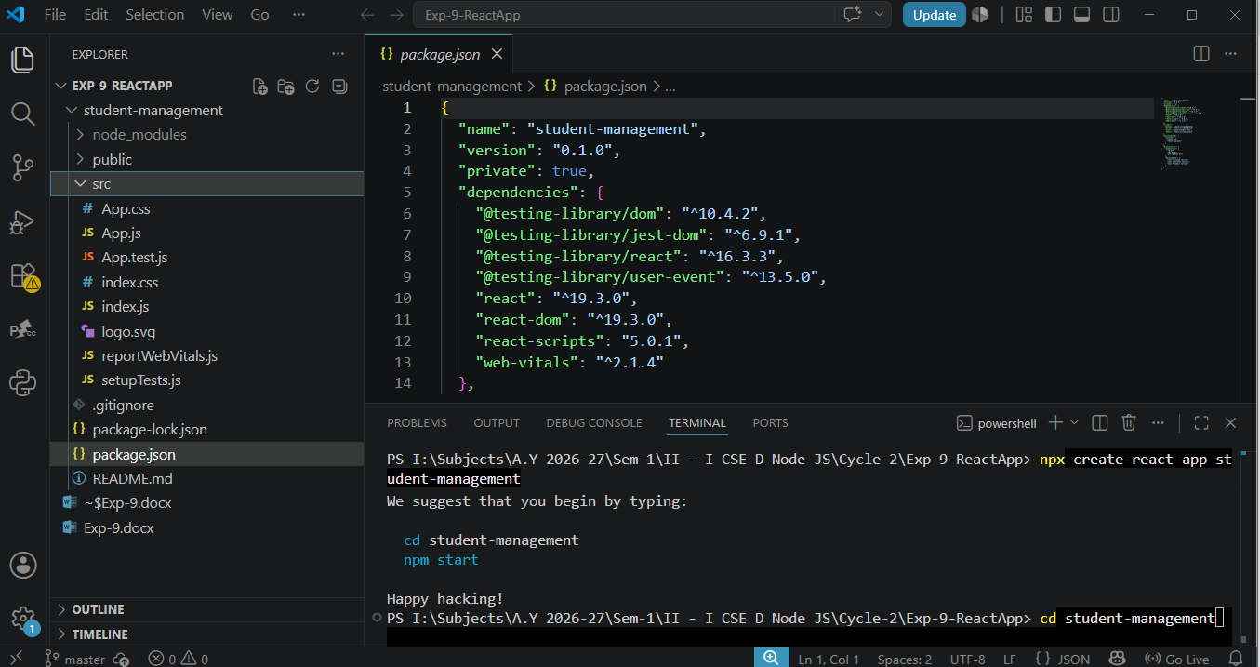
next, cd student-management
npm install react-router-dom

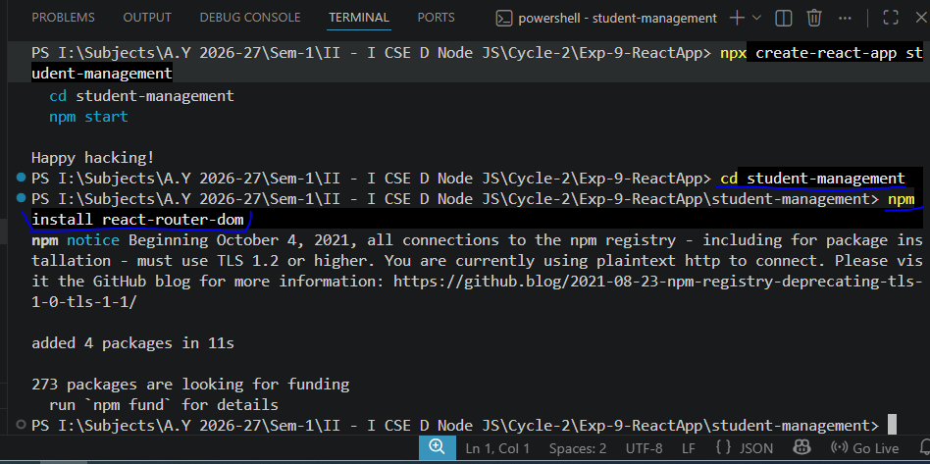

npm start
The application opens at http://localhost:3000.
It will give the default output for react application
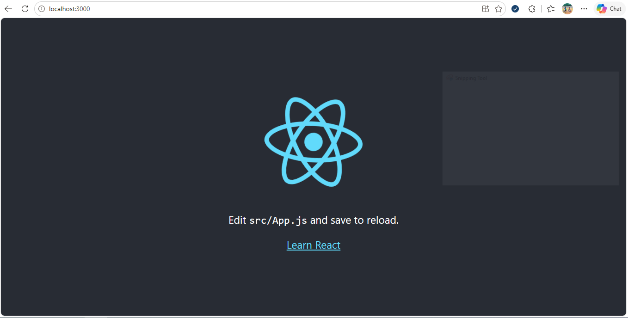

Create the files
Inside the src folder, use this structure:
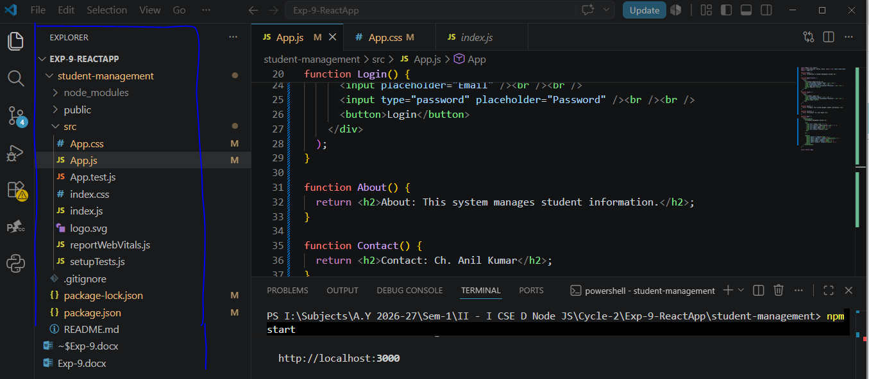

App.js Code
Replace the existing code in src/App.js with this simple program.

import React from "react";
import { BrowserRouter, Routes, Route, Link } from "react-router-dom";
import "./App.css";

function Home() {
return <h2>Welcome to Student Management System</h2>;
}

function Registration() {
return (
<div>
<h2>Student Registration</h2>
<input placeholder="Student Name" /><br /><br />
<input placeholder="Email" /><br /><br />
<input type="password" placeholder="Password" /><br /><br />
<button>Register</button>
</div>
);
}

function Login() {
return (
<div>
<h2>Student Login</h2>
<input placeholder="Email" /><br /><br />
<input type="password" placeholder="Password" /><br /><br />
<button>Login</button>
</div>
);
}

function About() {
return <h2>About: This system manages student information.</h2>;
}

function Contact() {
return <h2>Contact: student@example.com</h2>;
}

function App() {
return (
<BrowserRouter>
<h1>Student Management System</h1>

<nav>
<Link to="/">Home</Link> {" | "}
<Link to="/register">Registration</Link> {" | "}
<Link to="/login">Login</Link> {" | "}
<Link to="/about">About</Link> {" | "}
<Link to="/contact">Contact</Link>
</nav>

<hr />

<Routes>
<Route path="/" element={<Home />} />
<Route path="/register" element={<Registration />} />
<Route path="/login" element={<Login />} />
<Route path="/about" element={<About />} />
<Route path="/contact" element={<Contact />} />
</Routes>
</BrowserRouter>
);
}

export default App;

Then the output will look like this without CSS code
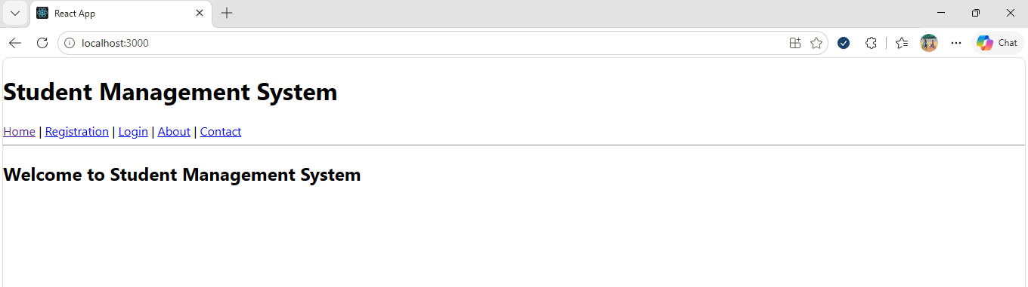

App.css Code
Replace the contents of src/App.css with:

body {
font-family: Arial;
text-align: center;
background-color: #f2f6fc;
}

h1 {
color: navy;
}

nav {
padding: 15px;
background-color: lightblue;
}

nav a {
margin: 10px;
text-decoration: none;
color: darkblue;
}

input {
padding: 8px;
}

button {
padding: 8px 20px;
cursor: pointer;
}

Then the output will be
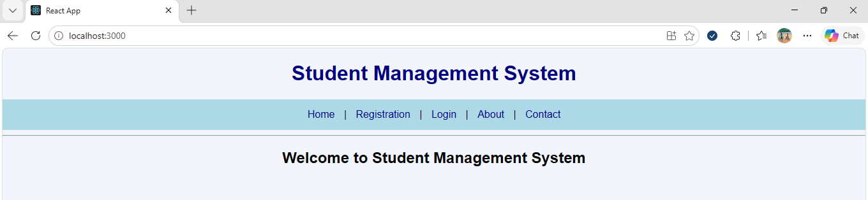

Verify index.js
The default CRA project already has this file. Ensure it imports App and renders it:

import React from "react";
import ReactDOM from "react-dom/client";
import App from "./App";

ReactDOM.createRoot(document.getElementById("root")).render(
<React.StrictMode>
<App />
</React.StrictMode>
);

Run the application
npm start
Open http://localhost:3000 if the browser does not open automatically.
The navigation links will display the following output:
- Home: Welcome message

- Registration: Student name, email, and password fields
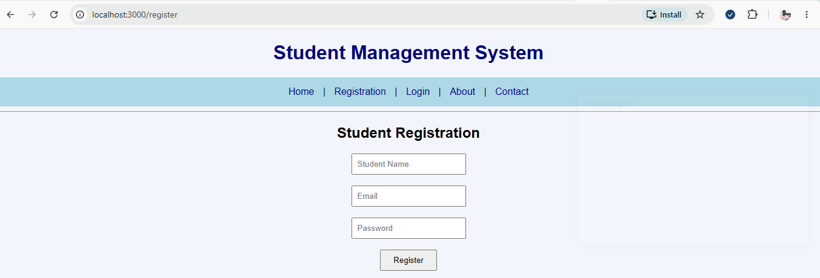

- Login: Email and password fields
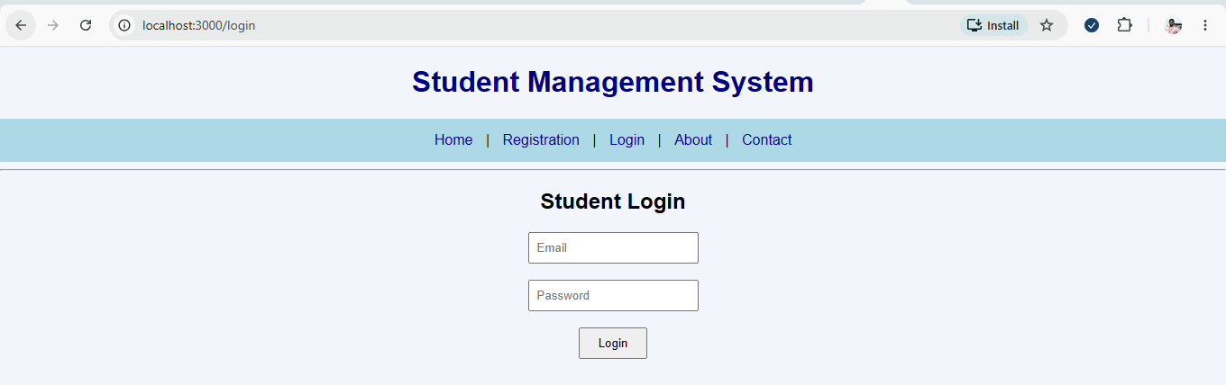

- About: Application description
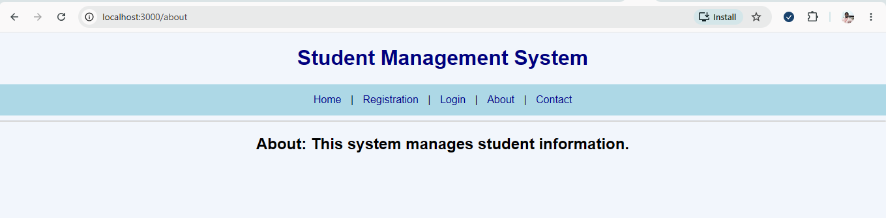

- Contact: Contact information
