CodeStrike
Campus Competition & Activity Community
Software Requirements
Specification (SRS)
EE308FZ Software Engineering | Assignment 3 — Requirements Analysis
Document information | Confirmed baseline / status
Team | CodeStrike — Group 5
Project coordinator | Zhaoyan Wang
Version | V1.0 requirements baseline
Document date | 15 October 2026
Intended users | Primarily first- to third-year students at Fuzhou University
Product surfaces | H5 web client;  WeChat Mini Program;  separate web administration portal

Contents
1. Introduction — purpose, context, terminology and references [p. 3]
2. Overall Description — goals, product boundary, scope, actors and user scenarios [p. 4]
3. Specific Requirements — UML domain diagrams, business rules and system properties [p. 9]
4. Interface Prototypes — P01–P12 low-fidelity requirement sketches [p. 12]
5. Functional Description and Acceptance / Verification Criteria — FR-01–FR-19, AC-01–AC-67 and traceability [p. 17]

Reading guide
For readers who want to ... | See
Understand the project and reference baseline | Sections 1–2
Follow end-to-end workflows and exceptional cases | UC-01 to UC-09 in §2.5
Understand domain classes, constraints and permissions | Section 3
Inspect interaction surfaces and role-specific screens | P01–P12 in Section 4
Find normative functional requirements | FR-01–FR-19 in §5.1
Validate expected behavior | AC-01–AC-67 in §5.2–§5.7
Identifier convention:
UC = User Scenario; FR = Functional Requirement; BR = Business Rule; NFR = Non-functional Requirement;
AC = Acceptance Case; P = Prototype.

1. Introduction

1.1 Purpose and intended readership
This Software Requirements Specification defines the expected product scope, user-facing behavior, domain relationships, privacy boundaries, and planned acceptance conditions of the CodeStrike Campus Competition & Activity Community. It is intended for the CodeStrike team, the EE308FZ instructor and teaching assistants, and future reviewers, developers and testers.
The requirements emphasize competition discovery, community exchanges, captain-reviewed team formation, and independent personal scheduling. The document specifies required behavior rather than a final database schema, API contract or production deployment topology.

1.2 Background and development intention
Competition announcements, teammate recruitment and preparation experience are currently spread across notices and group chats. The proposed product brings a competition introduction, its official reference, recruitment and related discussion into one competition-specific community. Students can apply to teams using a shared skill-tag vocabulary, with captains retaining the final admission decision.
These needs come from the team’s topic selection and requirements discussions, team members’ experiences in their first two university years, and informal feedback from junior students. Formal user interviews have not yet been performed; no unverified interview results are claimed.
An independent personal planner is also mandatory for this scope. Students manually enter courses, timed plans and to-dos, and view them together by day or week. Competition tasks are entered by users manually and are not generated from team membership.

1.3 Document conventions and evidence status
Figures 3-1 to 3-3 describe the conceptual requirements domain, not final physical database tables. Figure 2-1 shows logical product boundaries only. Figures 4-1 to 4-7 are low-fidelity prototypes for P01–P12 and are not screenshots of running applications.
Verification cases describe planned tests and expected results, not test executions. All sample names, competitions, times and dates shown in diagrams are fictional examples.

2. Overall Description

2.1 Objectives

2.1.1 Development intention
Provide a unified competition-information and student collaboration space, in which published competition data, discussion and recruitment are linked to one competition rather than scattered across unrelated channels.

2.1.2 Application goals and scope
The delivery covers accounts and profiles, published competition discovery, competition-specific communities, captain-reviewed team formation, a manual personal planner, in-app business notifications, and an administration portal. Student functionality shall be available through an H5 web client and a WeChat Mini Program with shared account identity and business data.

2.1.3 Product prospects and deferred extension
Future possibilities include a wider campus-activity catalog, more sophisticated team recommendations, WeChat push notifications, personal-plan reminders, and user banning/unbanning. They are outside the current delivery scope and do not form acceptance conditions for this edition.

2.2 System context and logical product boundary
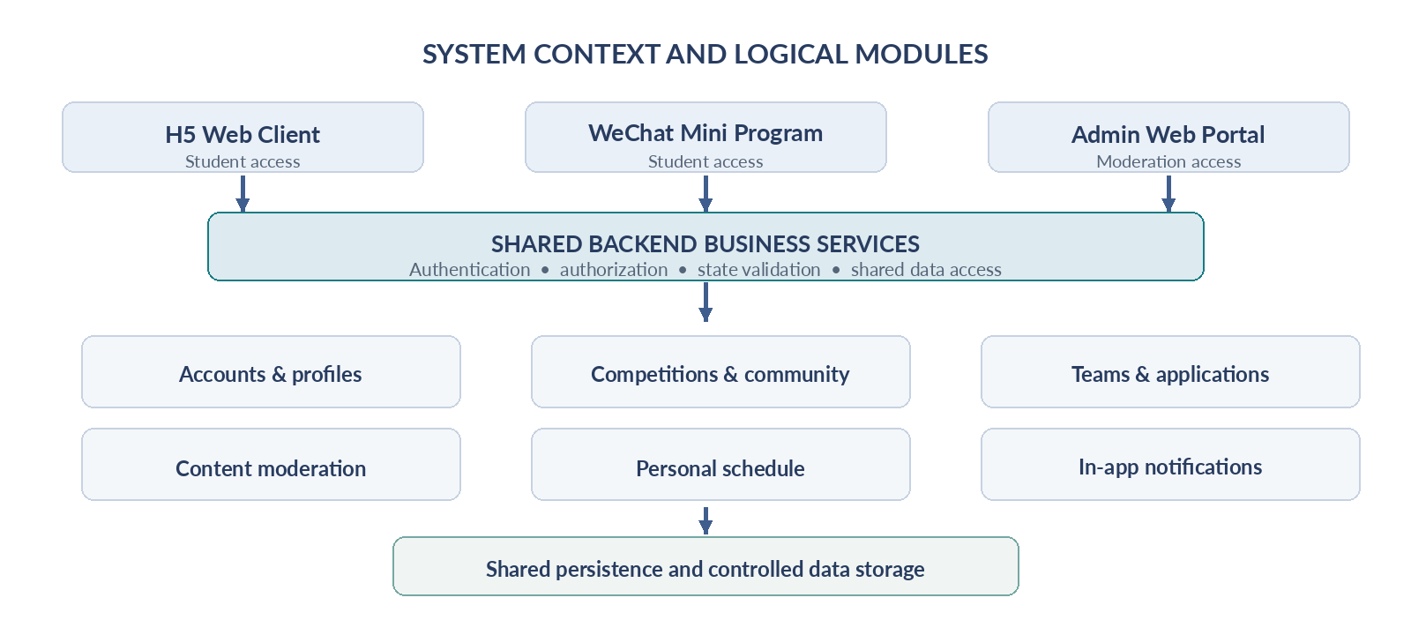
Figure 2-1. Proposed logical product context.
The student-facing H5 client and WeChat Mini Program operate on the same account and business records. An independent web administration surface provides competition, skill and moderation functions with separate permissions. Logical services must enforce authorization and state constraints independently of client rendering. Specific frameworks, cloud services, database engines and deployment topology remain implementation decisions for later design.

2.3 In-scope and out-of-scope functions
Current-scope area | Mandatory capabilities
Accounts and profiles | Username/password accounts, bound email for recovery, owner-managed profile, predefined skills.
Competition and community | Competition maintenance/submissions, name search, one community per competition, posts/comments, likes/favorites and pre-publication review.
Teams and My Team | Skill indication, creation and recruitment, application workflow, captain review, limits, leave/remove, captain transfer, dissolution and limited self-history.
Personal scheduling | Manual courses, timed plans, to-dos, daily/weekly views, bounded weekly recurrence and single-occurrence operations.
In-app notifications and administration | Business notifications/read states; competitions, skill tags, moderation queue and violation removal.
Multi-client delivery | Shared student functionality in H5 and WeChat Mini Program, plus independent admin web interface.

2.4 Actors and access boundaries
Actor | Access and responsibility
Visitor | May browse published competitions, discussion and recruitment. Must log in before personal operations.
Student | May edit own profile and private planner. Must complete the required profile before posting, applying or creating a team.
Captain | A current role within an existing team; reviews that team’s applications and manages its members/recruitment.
Administrator | Provisioned by the project team; maintains competitions and skills, moderates publications and removes violations. Does not implicitly gain access to private schedules or every full student profile.

2.5 User scenarios (UC-01 to UC-09)
Each scenario is specified with actors/goals, preconditions, main steps, alternatives and postconditions. These scenarios define expected behavior and do not attest to completed usability studies.

UC-01 Discover a competition and browse its public community
Actor and goal. Visitor or student locates a relevant competition and available recruitment.
Preconditions. The competition or community items have passed publication review.
1. Open the Competition Hub, search by competition name and view a competition detail page.
2. Read description, category, eligibility, registration deadline, maximum team size and official reference link.
3. Enter the associated community and browse published discussion, experience resources and recruitment.
Alternatives / exceptions. No matches show an explicit empty state. Unapproved, removed, or temporarily delisted recruitment is not accessible to visitors. A deadline does not close community discussion.
Postconditions. No application or membership is created; a login gate appears for personal actions.
Related requirements: FR-04, FR-05

UC-02 Register and prepare a student profile
Actor and goal. Student creates an account and becomes eligible for team/community operations.
Preconditions. A usable email address is available; user is logged out.
1. Choose a unique username and password, bind an email address and sign in.
2. Use the private planner immediately, or complete the profile before posting/applying/creating a team.
3. Enter mandatory details, select tags from the preset skill list, and supply at least one WeChat ID or QQ ID.
Alternatives / exceptions. Duplicate usernames fail. Missing fields are enumerated and relevant operations blocked. Password recovery uses a code sent to the bound email.
Postconditions. Account, owner profile and private records are linked correctly; other students cannot freely read the complete profile.
Related requirements: FR-01, FR-02, FR-03

UC-03 Create a team and publish recruitment
Actor and goal. Student creates a team as captain and recruits members for a competition.
Preconditions. Logged in, complete profile, competition deadline not passed and user has no current team in that competition.
1. Specify team name, introduction, maximum total membership (captain included) and requested skills.
2. Optionally generate recruitment and submit it for administrator moderation.
3. Before initial publication, the team is visible only in My Team and accepts no external applications.
4. After approval, new applications depend on recruitment switch, remaining capacity and deadline.
Alternatives / exceptions. An excess team limit is rejected. Creating a team invalidates the student’s pending applications to other teams in that competition. Rejected recruitment remains private.
Postconditions. The team and its captain membership exist; recruitment is public only with an approved revision.
Related requirements: FR-07, FR-11, FR-14

UC-04 Apply to multiple teams and receive captain review
Actor and goal. Student applies to teams; the current captain decides on membership.
Preconditions. Student profile is complete and student has no active team in that competition; target recruitment is published, enabled, not full and not past deadline.
1. Read the skill match indicator, which is advisory and does not restrict submission.
2. Apply to different teams in the same competition while preventing duplicate pending applications to one team.
3. Captain views only name, college, sex, skills and brief CV; non-matched applicant name is highlighted.
4. Upon approval, add membership, mark application Approved, invalidate other pending applications in that competition and notify affected accounts.
Alternatives / exceptions. Pending applications may be withdrawn, and a rejected application may be resubmitted as a new record. A full/expired/dissolved team, processed application or existing same-competition membership blocks approval. Concurrency must not bypass these constraints.
Postconditions. Application, membership and notifications agree; current captain may read contact details only for current team members.
Related requirements: FR-08, FR-09, FR-10, FR-13

UC-05 Revise recruitment while handling existing applications
Actor and goal. Captain revises a published listing and continues eligible reviews.
Preconditions. An active team has a published recruitment listing and pending applications.
1. Submit a change to team name, introduction, required skills or capacity; public recruitment is immediately delisted.
2. Do not accept new applications during moderation, but retain eligible pending applications.
3. Review prior pending applications against currently effective conditions, not an unapproved revision.
4. Upon approval revalidate capacity and competition constraints, activate the new version and restore publication.
Alternatives / exceptions. A reduced capacity below current membership or an excessive competition limit prevents approval. Rejected revisions remain delisted and can be resubmitted. Manual closure does not automatically cancel pending cases.
Postconditions. The active published revision agrees with effective team conditions; accepting applications still depends on switch, capacity, deadline and existence.
Related requirements: FR-07, FR-10, FR-14

UC-06 Leave a team, transfer captaincy or dissolve it
Actor and goal. Members manage their own membership; the captain manages handover and dissolution.
Preconditions. Current membership and required current role exist.
1. A member leaves voluntarily or is removed by the captain, ending the active membership.
2. The captain may transfer leadership to an existing member; former captain becomes an ordinary member immediately.
3. Captain must transfer or dissolve the team before leaving.
4. Dissolution invalidates pending applications, notifies affected accounts and preserves only concise owner-specific history.
Alternatives / exceptions. Leaving/removal immediately revokes team-based profile access. Former captains cannot continue reading contact details. A vacancy does not automatically reopen recruitment.
Postconditions. Every active team has exactly one captain. Former approved status does not prevent valid reapplication after leaving.
Related requirements: FR-11, FR-12, FR-13

UC-07 Share knowledge and moderate edits
Actor and goal. Student shares posts/resources; administrator reviews publication.
Preconditions. Student logged in and has a complete profile before creating posts.
1. Submit text, images or external links within a competition community for review.
2. Publish after approval; logged-in students may comment, like and favorite.
3. When a published ordinary post/comment is edited, retain the approved old version while the new revision is pending.
4. Approve to replace the public version; reject to retain the old version and send a notification.
Alternatives / exceptions. Out-of-range image quantity, size or type is rejected. Deleted or violation-removed items cease publication and must not be restored by stale review. Recruitment edits follow the separate delisting rule in UC-05.
Postconditions. Public content has an approved effective revision; interactions belong to the right users/content; moderation results appear in notifications.
Related requirements: FR-06, FR-14

UC-08 Manually schedule repeating courses and private to-dos
Actor and goal. Student maintains courses and personal items in common day/week views.
Preconditions. Logged in; competition-profile completeness is not required; school period schedule has been configured.
1. Choose the actual start week, weekday and start/end periods to enter a course manually; room is optional.
2. Set weekly recurrence for a finite number of weeks to generate dated course instances.
3. Create dated timed plans and to-dos with optional weekly recurrence.
4. View all items together by day or week, permitting time overlap.
5. Edit/delete a selected occurrence or complete a single repeated to-do without affecting other dates.
Alternatives / exceptions. A duplicate course with same name, actual date and start/end time is skipped with feedback; other data remains. A to-do may omit a due time. The planner generates no reminders.
Postconditions. Records remain owner-private; operations on an individual repeated occurrence are independent.
Related requirements: FR-16, FR-17, FR-18, FR-19

UC-09 Maintain reference data and receive business messages
Actor and goal. Administrator maintains usable data; students view their notifications.
Preconditions. Administrator account is pre-provisioned; relevant business events occurred.
1. Administrator maintains competitions, skill tags and the moderation queue; student-submitted competitions require approval before publication.
2. Changing the competition team-size limit cannot invalidate any active team; a new deadline governs subsequent operations.
3. Users read and mark notifications about applications, membership changes, transfers, dissolution and moderation.
Alternatives / exceptions. Extending a previously passed deadline does not resurrect invalidated applications or reopen recruitment. Historical message links cannot bypass current profile access.
Postconditions. Public records, team constraints and notifications are consistent; administrators still lack broad private schedule access.
Related requirements: FR-04, FR-13, FR-14, FR-15

3. Specific Requirements

3.1 Conceptual UML class diagrams
The diagrams below represent domain-level requirement concepts. Multiplicities and associations are conceptual, and additional business constraints stated in BR-01–BR-12 remain binding. They are not physical database table definitions.
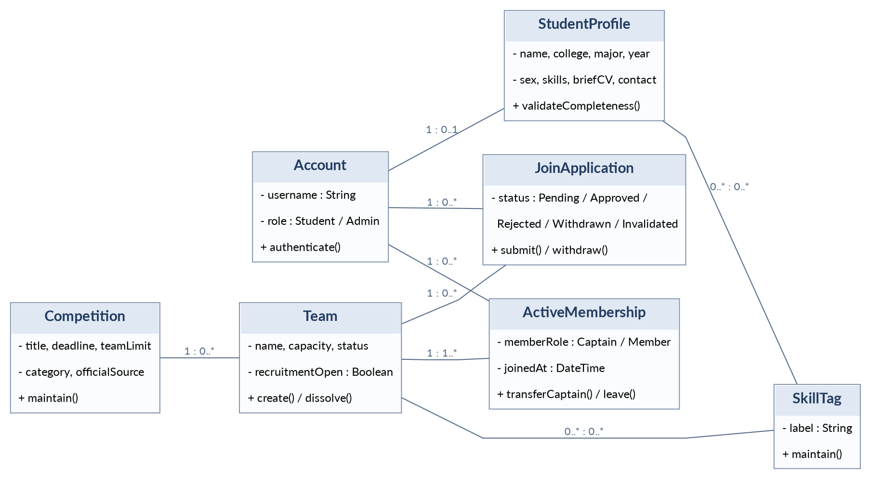
Figure 3-1. Account, student profile, competition, team, application and active membership domain classes.
The captain is a role in an active membership, not merely a successful historical application. Approved application records and active memberships are separate concepts. Profile-access decisions depend on the current captain role, target team, application status and membership state.
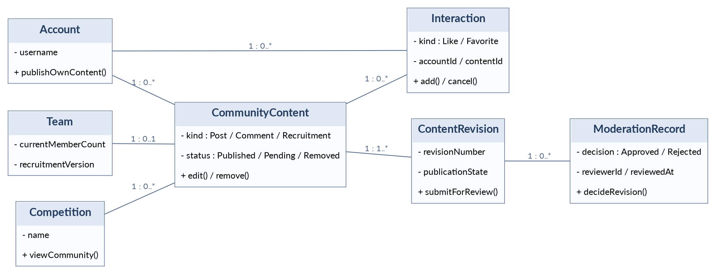
Figure 3-2. Community content, revisions, moderation and interactions.
Each published community item belongs to a competition; comments belong to their parent posts and thus the same community. Revisions represent content candidates and decisions. Ordinary post/comment edits retain the previous public revision, whereas recruitment edits delist the current public entry pending review. A diagram edge does not authorize access outside FR-10 and FR-14.
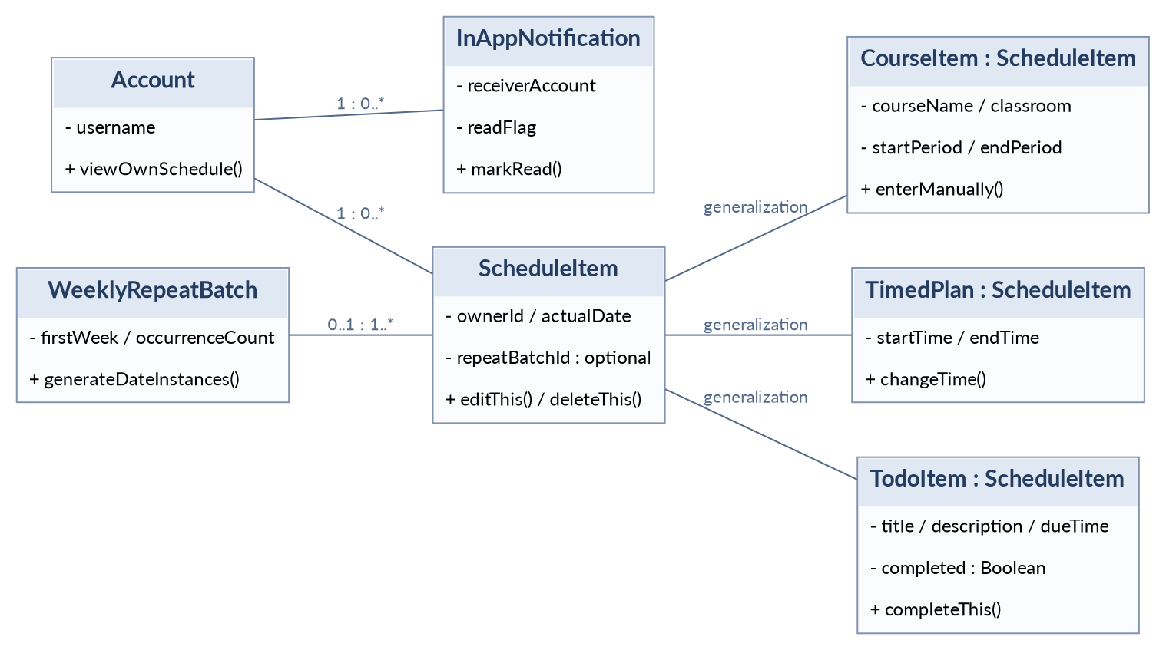
Figure 3-3. Owner-private schedule item subclasses, weekly repeat batch and in-app notification.
Course, timed-plan and to-do items share dated scheduling attributes. A bounded weekly repeat batch generates distinct actual-date instances; editing or completing one instance does not change other dates. In-app notifications belong to their recipients and do not embed unrestricted private profiles.

3.2 Essential domain data and system properties
The system shall maintain consistent account, competition, team, application, active membership, revision and schedule ownership relationships. Contact details and personal schedule records must not appear in public recruitment listings, notification previews or unauthorized member responses.

3.2.1 Availability and cross-client consistency
NFR-01 — H5 and WeChat Mini Program shall share account identity, domain records and access rules. A successful operation on one client shall yield the same business state when the other client queries the data again. (AC-62)

3.2.2 Security and privacy
NFR-02 — Current authorization shall be checked both for user interface behavior and direct data requests. Unauthorized responses must not contain restricted profile fields or private schedule records, including after applicant withdrawal, member departure, team dissolution or captain transfer. (AC-63)

3.2.3 Business integrity and concurrency
NFR-03 — Concurrent team creation, admission, withdrawal and relevant repeated requests shall not produce overcapacity, more than one current team per competition, duplicate pending team applications, or contradictory application/member state. (AC-64)

3.2.4 Response-time objective
NFR-04 — In a recorded acceptance environment, a load of 20 concurrent users performing ordinary reads, saves, applications and moderation actions shall target a single-operation response time of no more than 3 seconds. The load composition, measurement procedure and execution results must be recorded; this performance target has not yet been measured. (AC-65)

3.2.5 Usability and feedback
NFR-05 — Success, failure, no results, pending review, delisting and denied access shall have clear feedback. Overlapping entries in day/week views must remain readable and accessible. Failed actions shall not be reported as successful. (AC-66)

3.2.6 Verification evidence
NFR-06 — Executed verification shall record environment, version, prepared data, procedure, expected and actual results, and evidence. A planned requirement is not automatically marked as tested or passed. (AC-67)

3.3 Business invariants (BR-01–BR-12)
ID | Mandatory business rule
BR-01 | A student shall belong to at most one current team in any particular competition, including a team they created; other competitions are independent.
BR-02 | A historically Approved application does not constitute current membership. After departure/removal, the student may legally reapply or create a team before the competition deadline.
BR-03 | Creating a team or gaining membership invalidates other Pending applications for that competition; at most one Pending application may exist to the same team at a time, and processed records are retained.
BR-04 | A new application requires published recruitment, enabled captain recruitment switch, available capacity, unexpired competition, active team and no other active membership in the same competition.
BR-05 | Approval of an existing Pending application requires eligibility, spare capacity, unexpired deadline and active team; recruitment need not still be public or enabled.
BR-06 | Team capacity includes the captain, may not exceed the competition limit, and may not be less than current membership. Invalidation caused by full capacity, deadline or dissolution is not automatically reversed.
BR-07 | A submitted recruitment revision delists the entire recruitment until approved; ordinary post/comment revisions leave the old approved public version displayed.
BR-08 | Moderation may publish only the reviewed, valid revision. Recruitment approval rechecks current members and competition capacity constraints.
BR-09 | Only the current captain can access five allowed fields on their own active Pending application (name, college, sex, skill tags, brief CV); a current member’s contact information is additionally visible only to the current captain. Historical status grants no access.
BR-10 | Captain transfer changes privileges immediately. A captain must transfer or dissolve before leaving. Dissolved-team history does not expose another student’s profile.
BR-11 | Deadline and dissolution prevent fresh admissions; a closed registration does not close community discussion or delete existing teams.
BR-12 | Repeating items are identified by actual date; single-instance changes do not change other weeks, time overlap is allowed and schedules are accessible only to their owners.

3.4 Application and recruitment state semantics
Current application state | Event | New state / result
No pending application | Submit an eligible application | Pending
Pending | Current captain approves; all guards pass | Approved; create current membership; invalidate other pending applications in same competition
Pending | Current captain rejects | Rejected; no membership is created
Pending | Applicant withdraws | Withdrawn; revoke applicant-profile access
Pending | Team full / deadline / dissolution / join or create another team | Invalidated; record reason and notify
Rejected or other terminal state | Eligible reapplication | Create a new Pending record without overwriting history
Recruitment publication state, the captain’s open/closed recruitment switch, remaining capacity, team life-cycle state and competition deadline are separate conditions. A delisted recruitment must not accept new applications. A manual stop is not dissolution; Invalidated is not Rejected. Existing eligible pending applications may still be reviewed after the captain stops recruitment or submits a revision for review.

3.5 Unresolved implementation clarifications
The supplied requirements do not fix every implementation-level parameter. Before detailed design, the team should document decisions about email-code lifetime and retry limits, the configured semester/period-to-date mapping, persistent content revision retention, and the precise workload mix/measurement method for NFR-04. These are follow-up clarifications, not new requirements already approved by this document.

4. Interface Prototypes
All interface figures are English low-fidelity requirement sketches, not production screenshots. Mobile layouts express the WeChat Mini Program and narrow H5; P11 and P12 express the administration portal and wide-screen H5 respectively. Sample content is fictitious.

4.1 Competition discovery and community
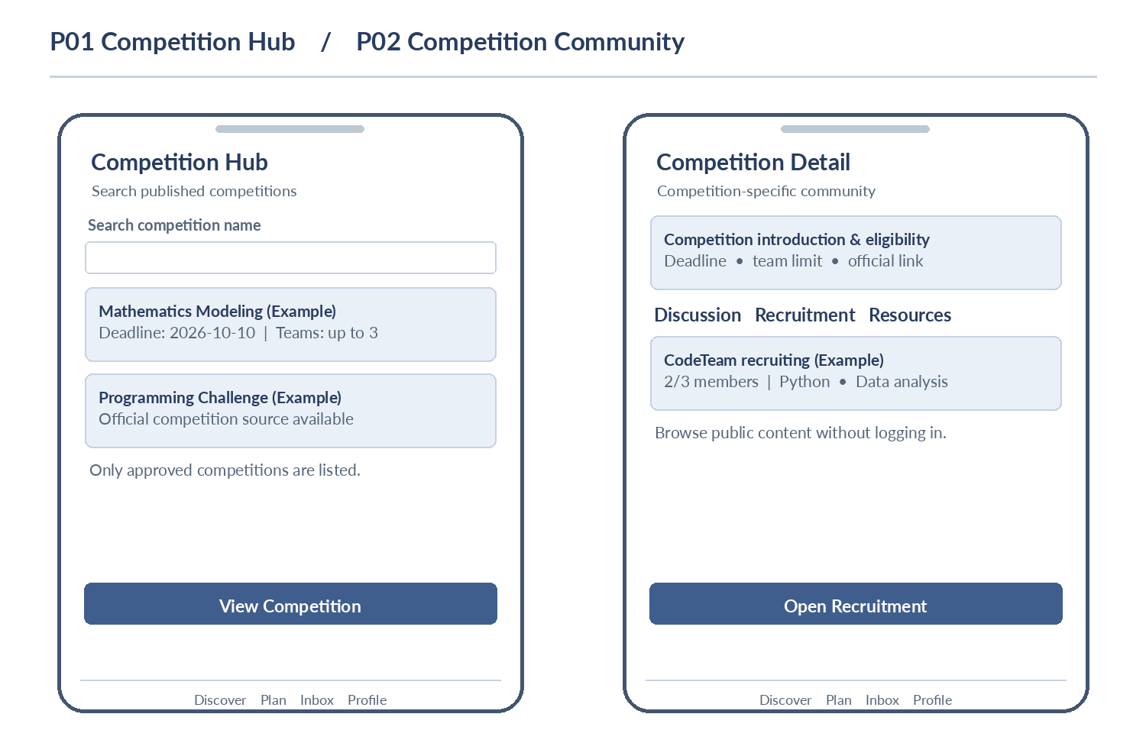
Figure 4-1. P01 Competition Hub and P02 Competition Detail / Community.
Name search and competition details lead to one competition-specific space containing public discussion, resources and recruitment. Related: UC-01; FR-04, FR-05.

4.2 Recruitment and my team
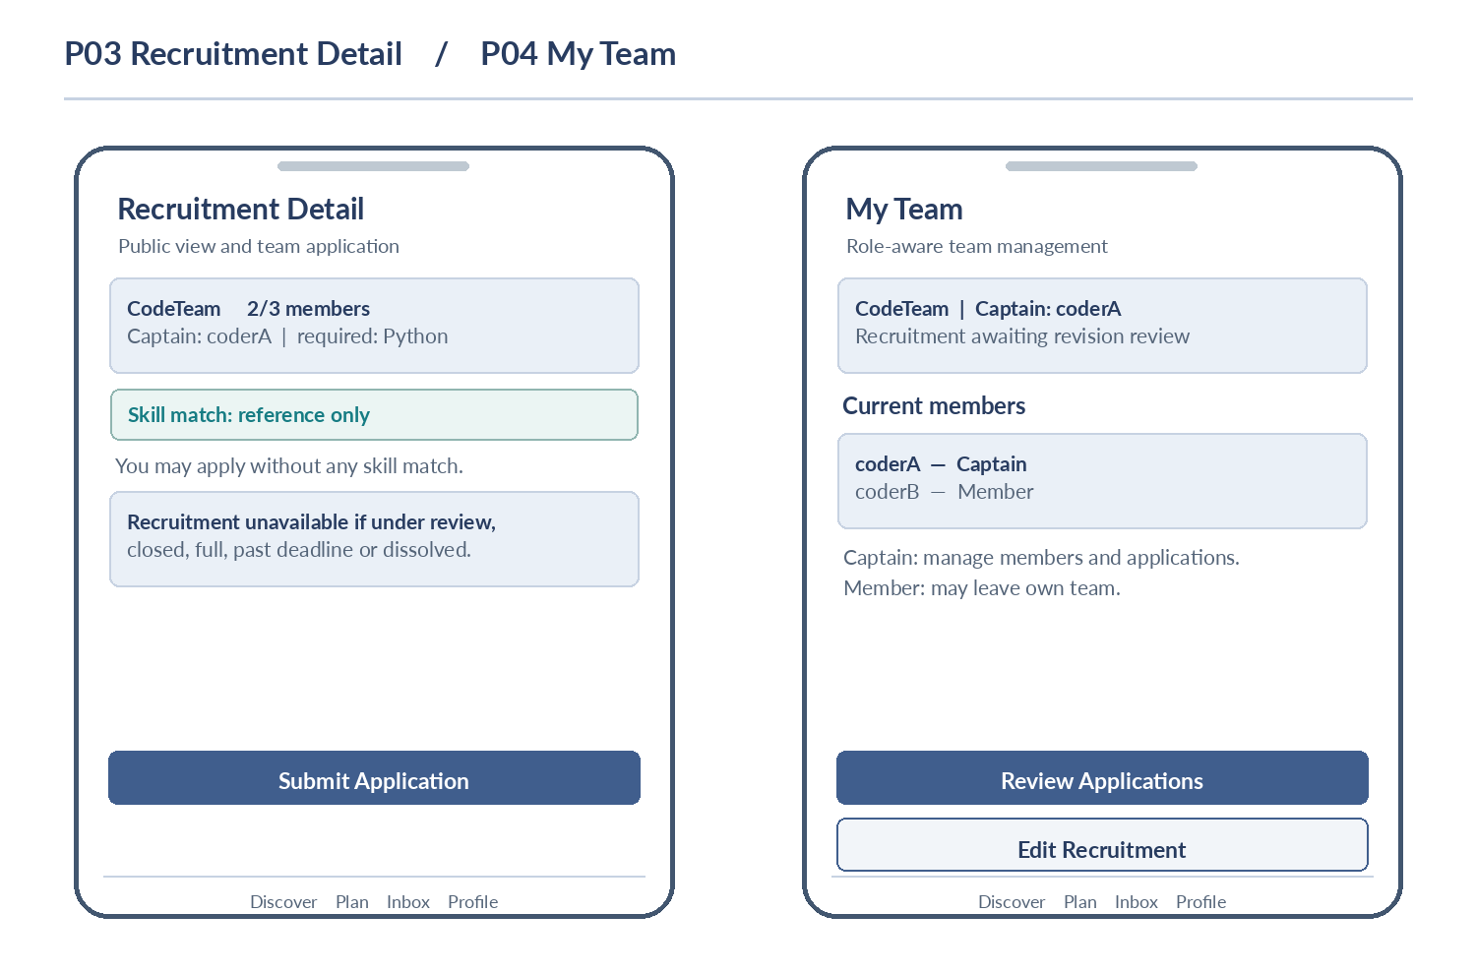
Figure 4-2. P03 Recruitment Detail and P04 My Team.
Public recruitment exposes team and username information, not private contact details. My Team provides role-dependent operations. Recruitment pending revision review is removed from public listing but remains visible inside the team. Related: UC-03–06; FR-07–12.

4.3 Applicant review and personal daily view
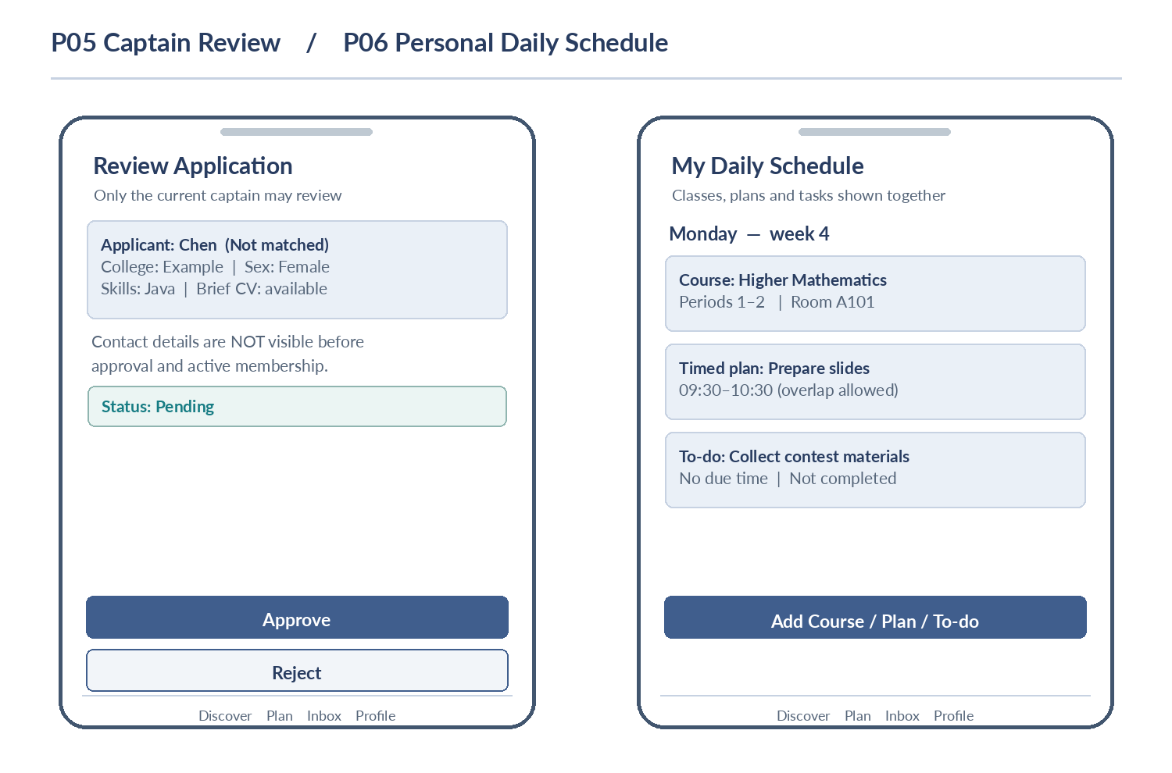
Figure 4-3. P05 Captain Review and P06 Personal Daily Schedule.
Pending review reveals only five approved applicant fields. Contact details are available to the current captain only after approval and during membership. Schedule overlap is allowed and selectable. Related: UC-04, UC-08; FR-10, FR-18.

4.4 Manual course and recurrence operations
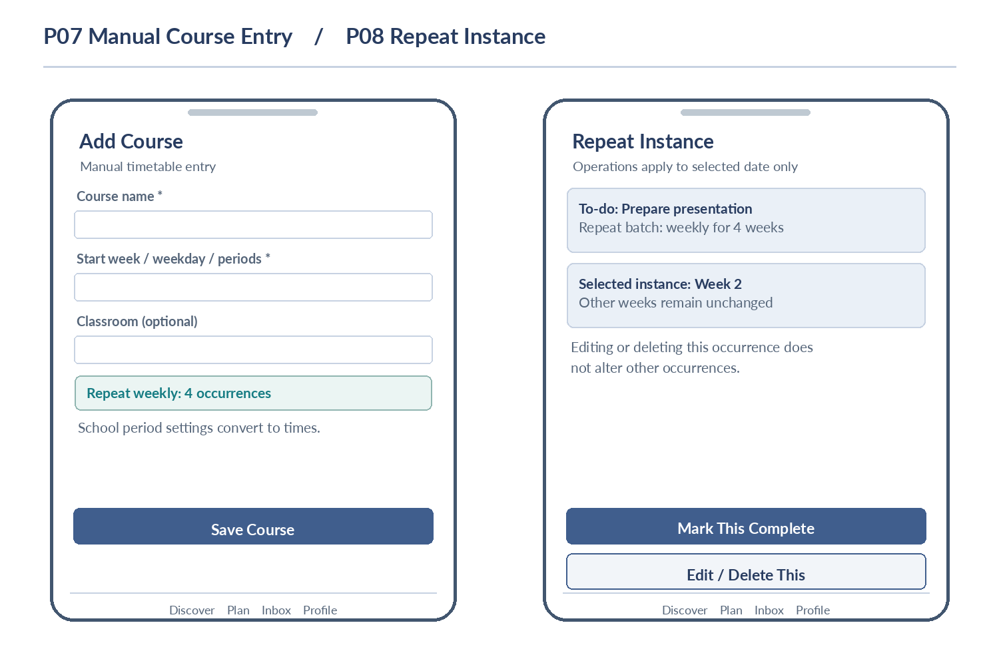
Figure 4-4. P07 Manual Course Entry and P08 Repeat Instance Actions.
Actual dates and school period configuration determine course time. Editing, deleting or marking complete applies only to the selected occurrence; no screenshot import or reminder is provided. Related: UC-08; FR-16, FR-19.

4.5 Notifications and personal center
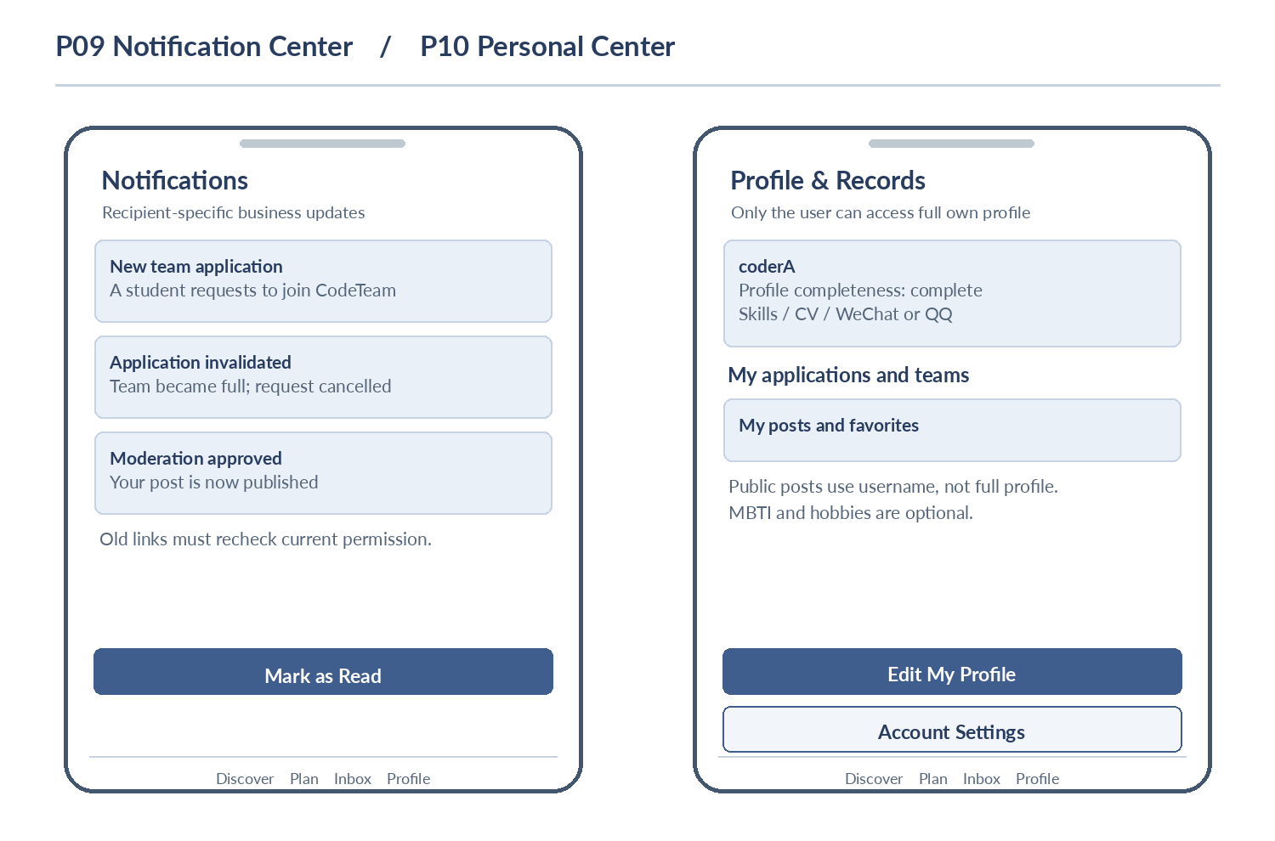
Figure 4-5. P09 Notification Center and P10 Personal Center.
Personal records are separate from public usernames; notification links must re-check the recipient’s current authorization. Related: UC-02, UC-09; FR-02, FR-13.

4.6 Independent administrator portal
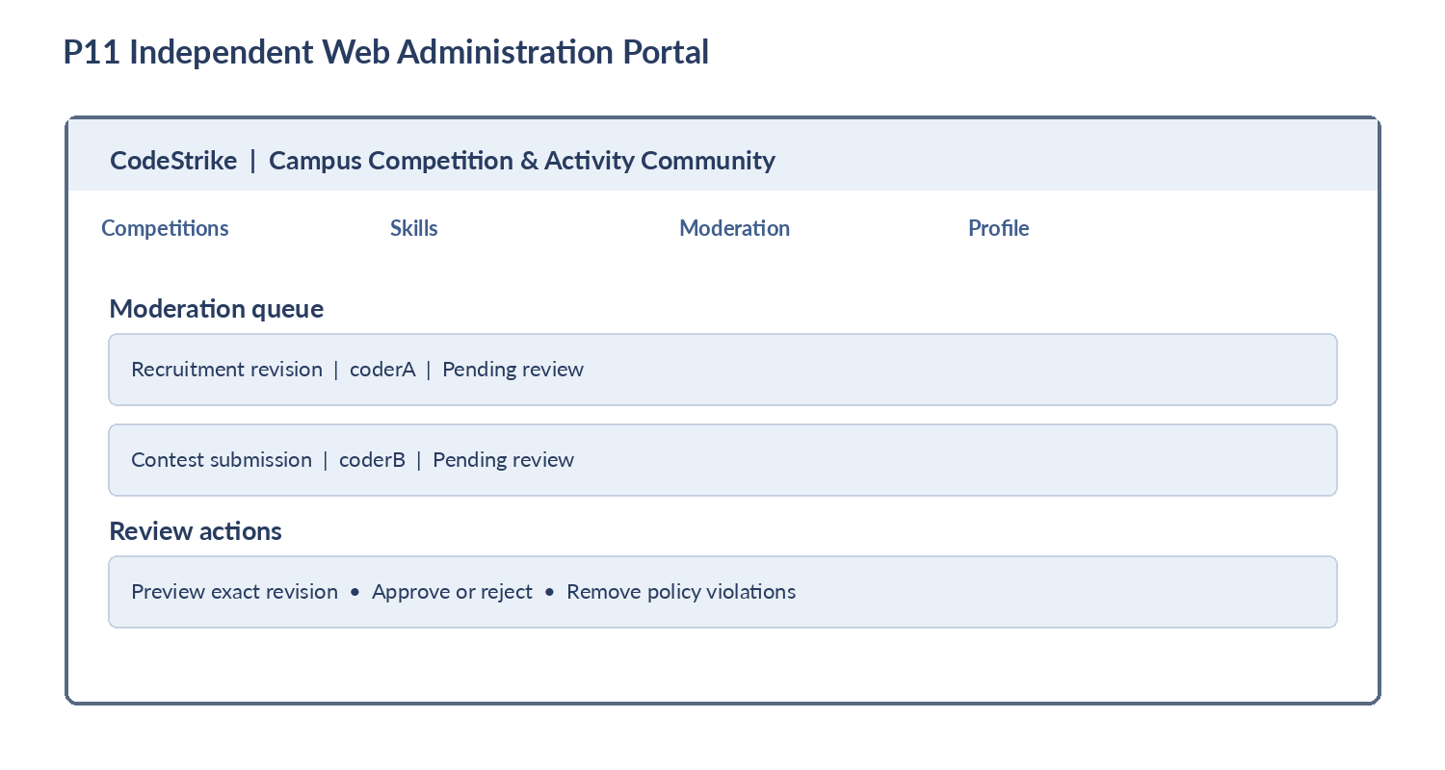
Figure 4-6. P11 Independent Web Administrator Interface.
Lists and previews support competition/skill maintenance and exact-revision content decisions. They exclude private schedule viewing and unrestricted access to student profiles. Related: UC-09; FR-14, FR-15.

4.7 Wide-screen H5
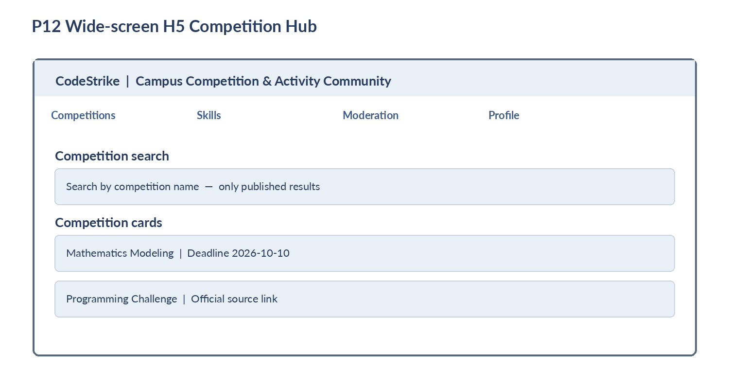
Figure 4-7. P12 Wide-screen H5 Competition Hub.
H5 and Mini Program share account data and business rules. Layout may adapt to screen size, but application, approvals and scheduling outcomes remain consistent. Related: NFR-01.

5. Functional Description and Acceptance / Verification Criteria
Every FR is part of the current mandatory scope. Its acceptance references point to planned cases in §5.2–§5.7. Each case expresses the minimum expected behavior, not a claim that the implementation has passed.

5.1 Functional requirements (FR-01–FR-19)

FR-01 Account registration, sign-in and recovery
Students shall register and sign in using a chosen username and password and bind an email address. Usernames shall be unique. Students shall be able to change their password and recover it with a verification code sent to their bound email address. Administrator accounts are provisioned by the team and cannot be registered publicly.
Visitors may view approved public content. Signed-in accounts own the corresponding profile, schedule, applications and memberships. Student-status documents are not required.
Verification: AC-01–AC-03

FR-02 Self-profile and completeness checks
Mandatory profile fields: name, college, major, academic year, sex, one or more predefined skill tags, brief written CV and contact information (at least one of WeChat ID or QQ ID). MBTI and hobbies are optional. Users maintain their own profiles; ordinary students cannot browse arbitrary complete profiles.
Creating a team, applying and posting require a complete profile and a list of missing fields if invalid. The private planner remains available immediately after sign-in. Public posts/comments/recruitment use the username as the public author label.
Verification: AC-04–AC-06

FR-03 Predefined skill catalog
Student profiles and team recruitment shall select multiple tags from one administrator-maintained predefined catalog. Students cannot create arbitrary new tags.
Catalog maintenance shall preserve existing references and displayed labels; editing a referenced skill must not cause profiles or recruitment to lose their skill records.
Verification: AC-07–AC-08

FR-04 Competition information and maintenance
Each competition shall include a title, description, category, registration deadline, eligibility rules, maximum team size and official source URL; cover image is optional. Administrators can create and maintain competitions; students can submit competitions for approval before publication.
Reducing a competition team-size limit must not make any active team’s configured capacity or membership invalid. Deadline changes apply to later operations; extending a deadline does not restore invalidated applications or reopen recruitment automatically.
Verification: AC-09–AC-12

FR-05 Competition Hub and dedicated community
Users shall search published competitions by competition name and view their details. Each competition shall have exactly one dedicated community for related recruitment, discussion and experience resources.
Empty search results shall be explicit. Expiration of registration shall not make the associated community read-only or remove existing teams.
Verification: AC-13–AC-14

FR-06 Posts, comments, likes and favorites
Logged-in students shall post and comment in competition communities, like/favorite posts, and undo likes/favorites. Posting requires a complete profile. Posts support text, images and external links; arbitrary resource-file attachment uploads are excluded.
A post allows up to 9 JPG/PNG images, each at most 5 MB. Authors may edit/delete their own posts and comments. New posts/comments require review before public display; revisions follow FR-14.
Verification: AC-15–AC-18

FR-07 Team creation and recruitment revisions
An eligible student may create a team for a competition whose registration has not closed and becomes its captain. The team specifies its name, summary, maximum number of members including captain, and requested skills. The captain may create recruitment and submit it for review.
An initially unapproved recruitment exists only within My Team and cannot accept external applications. Submitting a change to an already public recruitment delists it immediately. Revised conditions become effective only after approval; existing eligible applications use current effective conditions. Rejected revisions remain delisted and can be resubmitted.
Verification: AC-19–AC-22

FR-08 Simple advisory skill match
The system shall mark an applicant as matching if at least one student skill tag overlaps any required team skill tag. Lack of overlap shall not block application. During review, the non-matching applicant’s name shall be highlighted and captain retains the decision.
Sex and MBTI shall not influence matching. No percentage recommendation or automatic approval/rejection is included.
Verification: AC-23–AC-24

FR-09 Application submission, withdrawal and reapplication
A student not currently in a team for a competition may apply to multiple teams within that competition; a duplicate Pending application to the same team is prohibited. Pending applications can be withdrawn. Rejected applicants can reapply when eligible.
Status values are Pending, Approved, Rejected, Withdrawn and Invalidated. Each reapplication creates a fresh record and does not rewrite historical decisions. Joining or creating a team invalidates other Pending applications in that competition.
Verification: AC-25–AC-28

FR-10 Captain decision and applicant-profile visibility
Only the current captain can approve/reject an effective Pending application to their team. Before admission, the captain can access only the applicant name, college, sex, skills and brief written CV. After approval, the current captain can additionally see current team members’ contact details.
Approval must revalidate application and member state, capacity, deadline and active-team conditions. Rejection, withdrawal, invalidation, departure, removal and dissolution revoke associated access. Captain transfer changes rights immediately, and both visible pages and direct data requests are restricted.
Verification: AC-29–AC-33

FR-11 Capacity, recruitment switch, deadline and concurrency
Team capacity includes the captain, cannot exceed the competition limit and cannot fall below active membership. On reaching capacity, the team shall stop accepting applications, invalidate other Pending applications with notifications, and show the exact business feedback “This team is full.”
Manual recruitment closure blocks new applications but allows eligible Pending decisions while capacity/deadline/team conditions permit. Reaching the registration deadline blocks team creation, new applications and approvals, and invalidates Pending applications. Member departures and approved increases in capacity do not automatically reopen recruitment. Concurrent approvals and creation must never exceed capacity or the one-current-team-per-competition rule.
Verification: AC-34–AC-38

FR-12 Member management, transfer, dissolution and history
My Team shall show team information and current members. An ordinary member may leave; the captain may remove members, transfer the captain role to an existing active member, or dissolve the team. A captain cannot leave directly without transfer or dissolution.
Transfer is immediate and the former captain becomes a member. Dissolution invalidates Pending applications, notifies users, and retains only concise owner-specific history (e.g., team name, competition and own application results). No team task boards, milestones, deliverable files or internal chat are included.
Verification: AC-39–AC-42

FR-13 In-app notification center
The system shall create recipient-specific messages for new applications, approvals/rejections, invalidations, membership changes, captain transfer, dissolution and moderation results, with a list and read/unread state.
Notifications shall refresh on page entry or application return to foreground. Historical summaries and links may not bypass current data privileges. WeChat push notifications, instant messaging and personal-plan reminders are excluded.
Verification: AC-43–AC-45

FR-14 Moderation and violation handling
Administrators shall moderate student-submitted competitions, posts, comments and recruitment. First publication requires approval. Decisions must refer to the specific proposed revision and preserve approval or rejection results.
When a published ordinary post/comment is edited, the old approved version stays public pending moderation; approval replaces it and rejection retains it. Recruitment edits follow FR-07 and remain delisted until approval. Recruitment approval must revalidate current team/competition constraints. Owner deletion or administrator violation removal stops public exposure; stale decisions cannot restore deleted content.
Verification: AC-46–AC-49

FR-15 Independent web administration portal
An independent web portal shall list competitions, skill tags and pending content, with maintenance forms and moderation previews supporting approval, rejection and violation removal.
Only administrators may enter. Public administrator signup, banning/unbanning, complex operating analytics and viewing private schedules are excluded. Administrative status does not automatically confer access to all student full profiles.
Verification: AC-50–AC-51

FR-16 Manual course entry
Students shall add/edit/delete courses manually by actual week, weekday and start/end school periods. Room is optional; actual times are mapped using the configured school-period timetable. Course records are private to the owner.
A course may repeat weekly for a specified finite number of weeks. Screenshot recognition, whole-semester automatic import and odd/even-week patterns are excluded. Duplicate course instances with the same name, actual date and start/end time are skipped with feedback, without deleting other items.
Verification: AC-52–AC-54

FR-17 Timed plans and to-dos
On a selected date, a student may create a timed plan with start and end, or a to-do with mandatory title and optional description/deadline; entries can be edited/deleted and to-dos completed.
Time overlaps with courses and other private items are permitted. Competition work is added to the personal planner manually by the student.
Verification: AC-55–AC-56

FR-18 Daily / weekly integrated views and overlap
Owner courses, timed plans and to-dos shall appear together in day/week views with date navigation. Overlapping entries must be independently visible and openable.
A to-do with no deadline still appears on its assigned date. Time overlap does not automatically remove or change any entry.
Verification: AC-57–AC-58

FR-19 Bounded weekly recurrence and single-occurrence edits
Courses, timed plans and to-dos may repeat weekly for a specified finite occurrence count starting from the selected week. The starting week counts as the first occurrence, and each generated occurrence has its own actual date.
Editing/deleting one occurrence shall not affect others; each repeated to-do completion is independent. Infinite recurrence, automatic scheduling, reminders and automatic creation of team tasks are excluded.
Verification: AC-59–AC-61

5.2 Verification approach and evidence template
The following cases are acceptance criteria, not reported test passes. Execute applicable student workflows separately on H5 and WeChat Mini Program and administration workflows on the web portal. Prepare independent student, captain and administrator accounts, at least two competitions, multiple teams and application records in multiple states.
For each actual test run, capture environment, date, software version, client/device, seeded account and competition state, steps, expected result, actual result, evidence (screenshots and/or request observations), associated defect ID and retest conclusion. A UI-only authorization check is insufficient when a direct request can be attempted.
Evidence field | Required run-time record
Case and version | AC identifier, date, tested build, and student H5 / Mini Program / admin client
Environment and data | Browser or app, device, service environment, accounts, competition deadlines, capacities and initial application states
Execution and evidence | Actual steps and observations, request or screenshot evidence, defect IDs and retest conclusion

5.3 Account, profile and competition acceptance cases
Case | Trace | Input / action | Expected result
AC-01 | FR-01 | Register/login and retry username. | Username is unique; same account can sign into H5 and Mini Program.
AC-02 | FR-01 | Change password; try old and new. | New password works; old password cannot start a fresh sign-in.
AC-03 | FR-01 | Recover with bound email code, including bad/expired/reused codes. | Valid code permits recovery; invalid, expired or used codes fail.
AC-04 | FR-02 | Omit each mandatory field, or both WeChat and QQ IDs. | Cannot post, create team or apply; missing fields listed.
AC-05 | FR-02, FR-16 | Signed-in student with incomplete competition profile uses planner. | Can still create/view own courses, plans and to-dos.
AC-06 | FR-02 | Inspect public author and access another profile. | Public username only; ordinary student cannot read unrelated full profile.
AC-07 | FR-03 | Select profile/recruitment skills; attempt custom creation. | Same predefined catalog in both places; student cannot create a skill.
AC-08 | FR-03, FR-15 | Administrator maintains a referenced skill. | Existing profile/recruitment links and readable labels remain valid.
AC-09 | FR-04 | Create competition without official URL or maximum team size. | Cannot publish an invalid competition; cover image may be omitted.
AC-10 | FR-04, FR-14 | Submit student competition and browse before/after approval. | Not public before review; searchable and viewable only after approval.
AC-11 | FR-04 | Reduce competition limit such that an active team would violate it. | Reject change; effective team and competition constraints remain unchanged.
AC-12 | FR-04 | Extend deadline after pending applications were invalidated. | No automatic reinstatement or reopening of recruitment.
AC-13 | FR-05 | Search existing and absent competition names. | Only published matching competitions; explicit empty result otherwise.
AC-14 | FR-05 | Browse two communities, including one after deadline. | Correct competition ownership; closed registration does not close discussion.

5.4 Content and recruitment-version acceptance cases
Case | Trace | Input / action | Expected result
AC-15 | FR-06 | Post/comment, inspect page before and after approval. | Unapproved content stays private; published content belongs to its competition.
AC-16 | FR-06 | Submit 9 vs 10 images, 5 MB boundary and unsupported formats. | Within limits accepted; excess size/count or non-JPG/PNG rejected.
AC-17 | FR-06 | Like/favorite and undo on same post. | At most one active interaction per user and type; UI agrees with saved state.
AC-18 | FR-06 | Edit/delete own content and another student’s post/comment. | Owner actions work; another student cannot alter that content.
AC-19 | FR-07 | Create team without published recruitment. | Captain joins as a member; only My Team shows it; external applications blocked.
AC-20 | FR-07 | Reject/approve first recruitment submission. | Reject keeps it private; approval permits applications only if all gates hold.
AC-21 | FR-07 | Submit a change to public recruitment. | Public list/detail delisted; no fresh applications; unapproved settings inactive.
AC-22 | FR-07 | Moderate changed recruitment after membership changes. | Capacity rechecked; legal version activates or illegal version remains delisted.
AC-46 | FR-14 | Edit approved post/comment, then approve or reject revision. | Old public revision remains during review; approve replaces; reject retains.
AC-47 | FR-14 | Reject recruitment revision and revisit public listings. | Listing stays delisted until eligible resubmission/approval; old listing not restored.
AC-48 | FR-14 | Try approving superseded or deleted pending revision. | No stale/deleted revision becomes public; version/state conflict surfaced.
AC-49 | FR-14 | Administrator removes violating content; author revisits. | Content no longer public; previous review cannot re-publish it.

5.5 Team applications, capacity and authorization acceptance cases
Case | Trace | Input / action | Expected result
AC-23 | FR-08 | Team needs Python or Java; applicant matches only one. | Matched; changing sex or MBTI does not change match.
AC-24 | FR-08 | Applicant has no shared skill but applies. | Application allowed; name highlighted in captain review, not auto-rejected.
AC-25 | FR-09 | Apply repeatedly to one team and once to another. | No duplicate pending for same team; distinct teams can each be pending.
AC-26 | FR-09 | Withdraw pending; reapply after a rejection. | Withdrawn terminates old application; reapplication creates a new record.
AC-27 | FR-09 | Approve one team with other pending applications in same competition. | New membership exists; other pending become Invalidated; other competitions unaffected.
AC-28 | FR-09 | Create own team while several applications are pending. | Creator becomes captain-member; other same-competition pending invalidated.
AC-29 | FR-10 | Current captain reads active pending applicant. | Returns only name, college, sex, skills and CV; no contact detail.
AC-30 | FR-10 | Read after approval and after rejection. | Approved active member contact readable by current captain; rejected profile not readable.
AC-31 | FR-10 | Follow previous profile links after withdrawal/invalidation. | Request no longer returns applicant private profile or contact data.
AC-32 | FR-10 | Ordinary member / unrelated captain directly requests profile. | Restricted fields never returned; hiding UI controls alone is insufficient.
AC-33 | FR-10 | Approve twice; race withdraw against approve. | Only one legal terminal outcome; membership and application remain consistent.
AC-34 | FR-11 | Team limit 3 with captain plus two members. | Block new applications and approvals; show “This team is full.”; notify other pending invalidations.
AC-35 | FR-11 | Approve a pending request while recruitment manually closed or revision pending. | Existing eligible application may be approved; fresh application not accepted.
AC-36 | FR-11 | Apply, create and approve around competition deadline. | All new admissions blocked after deadline; pending invalidated; teams/community retained.
AC-37 | FR-11 | Member leaves or approved revision increases capacity. | Recruitment stays closed until captain manually reopens when legally allowed.
AC-38 | FR-11 | Simultaneous last-place approvals, one applicant two teams, concurrent creation. | No excess members; at most one current team per account per competition.

5.6 Membership, notifications and administration acceptance cases
Case | Trace | Input / action | Expected result
AC-39 | FR-12 | Leave/remove a member, then attempt eligible reapplication. | Active relation and access end; historical approval does not prohibit legal reapplication.
AC-40 | FR-12 | Transfer captaincy; former captain requests member contact. | New captain receives rights immediately; former captain loses privileged access.
AC-41 | FR-12 | Captain directly leaves or transfers to a nonmember. | Direct leave blocked; only current member is an eligible transfer target.
AC-42 | FR-12 | Dissolve team; revisit history and former team links. | Pending invalidations/notifications; only brief self-history and no private profile access.
AC-43 | FR-13 | Trigger application, membership and moderation events. | Correct recipients and messages; no wrongly routed or duplicate business outcomes.
AC-44 | FR-13 | Refresh recipient inbox and mark read. | Recipient list and read status persist; unrelated account cannot access.
AC-45 | FR-13 | Open historic notice after invalidation/captain transfer. | Summary hides private data and detail link checks authorization again.
AC-50 | FR-15 | Student vs administrator accesses administration portal. | Student blocked; admin maintains competitions, skills and moderation.
AC-51 | FR-15 | Admin attempts unrestricted student profiles / private schedules. | Admin role alone gives neither; ban features and open admin signup absent.

5.7 Personal planning and non-functional acceptance cases
Case | Trace | Input / action | Expected result
AC-52 | FR-16 | Manually enter course with week, weekday, periods; omit room. | Configured period-to-time conversion; owner-private course saved.
AC-53 | FR-16 | Add identical name/date/start/end course instance twice. | Duplicate is skipped with clear feedback; other entries untouched.
AC-54 | FR-16 | Add same course on same weekday/periods in next actual week. | Different date is allowed, not mistakenly de-duplicated.
AC-55 | FR-17 | Create timed plan and no-deadline to-do. | Correct start/end; title-only to-do is valid.
AC-56 | FR-17 | Create timed plan overlapping a course. | Save permitted without modifying/deleting existing entries.
AC-57 | FR-18 | Switch date/day/week view and open overlapping entries. | Only owner records shown; all overlapping items remain accessible.
AC-58 | FR-18 | Display no-deadline to-do with other entries. | Still visible under its assigned date.
AC-59 | FR-19 | Create weekly repeat of 4 occurrences from chosen first week. | Exactly 4 distinct actual dates, including starting week.
AC-60 | FR-19 | Edit/delete only the second weekly occurrence. | Only second instance changes; other weeks preserved.
AC-61 | FR-19 | Complete one occurrence of repeating to-do; wait until deadline. | Other occurrences incomplete; no planner alerts or team tasks created.
AC-62 | NFR-01 | Save planner item or gain team membership on client A; query B. | Account identity, membership states and record values consistent across clients.
AC-63 | NFR-02 | Unauthorized actor requests private planner/profile by UI and direct query. | No unauthorized private data returned at either layer.
AC-64 | NFR-03 | Concurrent duplicate submissions, team creations and approvals. | No duplicate pending, overcapacity, same-competition multiple memberships or contradictory states.
AC-65 | NFR-04 | Run 20-user mixed read/save/application/moderation test. | Record response times, failures and timeouts; target <= 3 s per operation.
AC-66 | NFR-05 | Induce empty results, logout, denial, pending and delisted states. | Clear feedback, never false success; overlapping planner items usable.
AC-67 | NFR-06 | Compile actual evidence records for test execution. | Log version, environment, data, steps, result and artifacts; untested cases not marked passed.

5.8 Requirements traceability matrix
Verification area | Scenarios | Diagrams / screens | Acceptance cases
Accounts and own profile | UC-02 | Figure 3-1; P10 | AC-01–08
Competition discovery / catalog | UC-01, UC-09 | Figure 3-1; P01, P02, P11, P12 | AC-09–14, AC-50
Community, content and moderation versions | UC-07 | Figure 3-2; P02, P11 | AC-15–22, AC-46–49
Teams, applications and privilege changes | UC-03–06 | Figure 3-1; P03–P05 | AC-23–42
Business notifications and portal | UC-09 | Figures 3-2/3-3; P09, P11 | AC-43–45, AC-50–51
Owner-private schedules | UC-08 | Figure 3-3; P06–P08 | AC-52–61
Multi-client and system properties | All applicable UCs | All relevant interfaces | AC-62–67

5.9 Delivery acceptance interpretation
Completion is assessed against the entire mandatory scope and its related acceptance cases. The course-stage delivery described in the Chinese baseline calls for a usable H5, a Mini Program runnable in the WeChat development environment and on a device experience build, and a separate administrator web portal. Any incomplete, unverified or externally dependent capability must be reported honestly; diagrams, documents and demo screenshots alone are not substitutes for working behavior.
In this Assignment 3 document, the test cases are specifications for later validation; no claim is made that user interviews, usability studies, server deployments, performance measurements or acceptance tests have already passed.

5.10 Requirements revision summary and status
Topic | Confirmed baseline used in this edition
Scope | Shared H5 and Mini Program plus admin web; moderation and notifications mandatory; My Team simplified; personal schedule mandatory.
Accounts/profile | Username/password with bound email recovery; required fields clarified; the current captain can view an approved current member’s contact.
Applications/lifecycle | Withdraw, reapply, invalidate and apply-to-multiple-team flows defined; one active team per competition, capacity and deadline enforced; captain transfer/dissolution included.
Content/recruitment review | First publish after approval; ordinary post/comment changes retain old approved revision; recruitment revisions delist the current listing.
Personal schedule | Manual entry only; finite weekly recurrence, dated duplicate guard, independent occurrence editing, overlap permitted and owner-private access.
Edition changes | English terminology standardized; Group 5 confirmed; logical context diagram and fresh English requirement-aligned diagram/prototype figures added; no unsupported implementation results invented.

