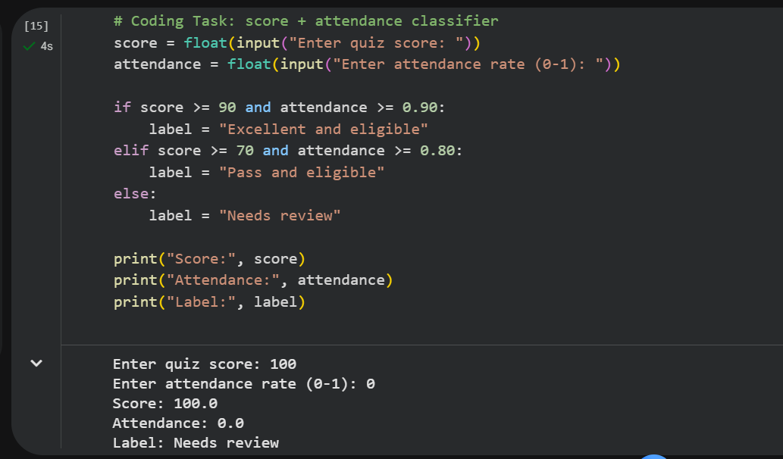

Error 1 — String compared to a number
Answer

Input returns a string and it doesn’t match because it is trying to compare string toa number.
Fix it with score = float(input(“Enter score: ”))
It works because now a float is compared to float.

Error 2 — Missing colon
Answer
No colon and this is syntax error issue.
Fix it by using: if score >= 70 and attendance >= 0.80:
The colon completes the code
Error 3 — Incorrect indentation
Answer
The print(“Eligible”) line underneath the if is not indented, the block needs one.
Fix by indenting line.
It works because this is the proper way Python read it.
Corrected code:
score = float(input("Enter score: "))
attendance = 0.85

if score >= 70 and attendance >= 0.80:
print("Eligible")
else:
print("Needs review")

AI Prompt:
“Ask the AI to explain if, elif, else in beginner-friendly language”
AI Response:
Here's a beginner-friendly explanation of if, elif, and else you can use or adapt for the lab.

if, elif, else — Explained Simply
The big idea: these three keywords let a program make decisions. They check whether something is true, and run different code depending on the answer. Think of it like a flowchart of questions — "Is this true? If so, do this. If not, check the next thing."
if — the first question
The if statement checks a condition. If the condition is True, the indented code below it runs. If it's False, that code is skipped.
score = 85

if score >= 90:
print("Excellent")
Here, score >= 90 is False (85 isn't ≥ 90), so nothing prints. The if block only runs when its condition is true.
elif — "otherwise, check this"
elif (short for "else if") adds another question to ask only if the previous condition was False. You can have as many elif branches as you need.
score = 85

if score >= 90:
print("Excellent")
elif score >= 80:
print("Strong")
Now: the if checks >= 90 → False, so Python moves to the elif and checks >= 80 → True, so it prints "Strong."
else — the catch-all
else is the fallback. It runs when none of the if or elif conditions were true. It has no condition of its own — it just catches everything left over.
score = 55

if score >= 90:
print("Excellent")
elif score >= 80:
print("Strong")
elif score >= 70:
print("Pass")
else:
print("Needs review")
With a score of 55, all three checks fail, so the else runs and prints "Needs review."
The most important rule: only ONE block runs
Python checks the conditions top to bottom and stops at the first True one. Once a branch runs, all the rest are skipped — even if a later condition would also be true. This is why order matters: put the strictest condition first.
If you flipped the order and put >= 70 first, a score of 95 would match it immediately and print "Pass," never reaching the "Excellent" check.

A real-world way to picture it
It's like sorting mail by priority:
- if — "Is it urgent? → put it in the urgent pile"
- elif — "Otherwise, is it a bill? → put it in the bills pile"
- elif — "Otherwise, is it personal? → personal pile"
- else — "Anything left → the everything-else pile"
Each piece of mail lands in exactly one pile, and you stop checking once you've placed it.

For your lab reflection
If you're using this as your AI activity, here's the honest reflection angle: the explanation makes the mechanics clear, but the thing worth internalizing yourself is why the order of conditions matters — that Python stops at the first True condition. You can only really feel that once you've written a classifier with the thresholds in the wrong order and watched every score get the wrong label. That's the kind of understanding that comes from doing it, not just reading about it.
If you use this explanation for the assignment, write your 3 sentences about (1) what specifically clicked, (2) whether you agree with the explanation, and (3) how you'd use if/elif/else in future data work — like sorting data records into categories. Keep it in your own voice.
My Responses:
I learned that how straight forward if, elif, and else are. They are very useful to create logic for different kinds of conditions. I plan to use this to organize decisions and actions for different aspects of data and user input.

