ASSIGNMENT-4
NAME :- A.BHAVITHA
ROLL.NO : 2603A52L02
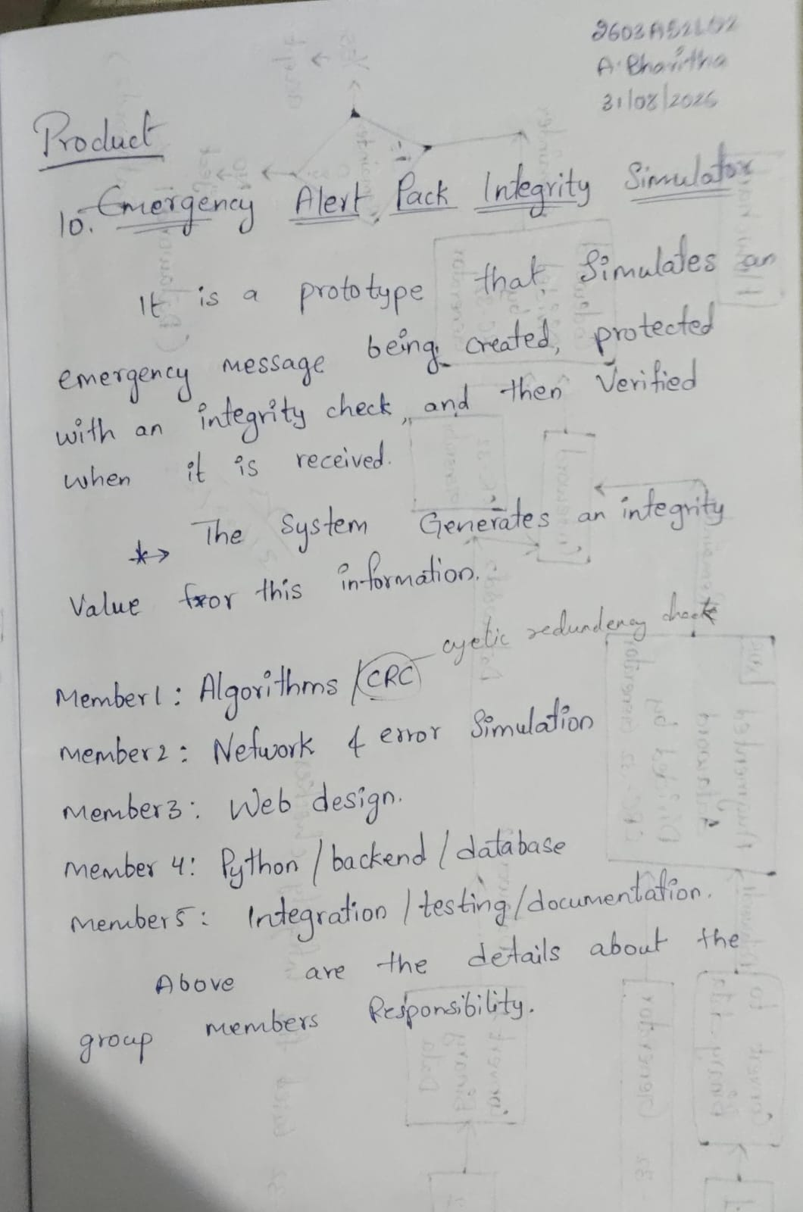

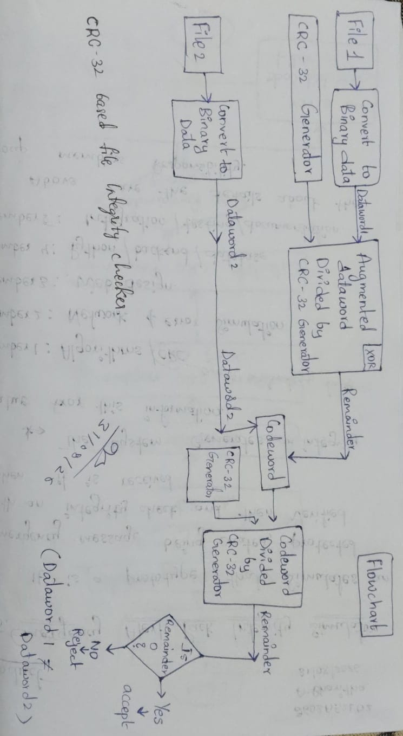
CODE:
# CRC-32 File Integrity Verification

GENERATOR = "100000100110000010001110110110111"

# Convert file content to binary
def get_dataword(filename):
with open(filename, "r") as file:
text = file.read().strip()

dataword = ""

for ch in text:
dataword += format(ord(ch), "08b")

return text, dataword

# CRC modulo-2 division
def crc_division(data, generator):
data = list(map(int, data))
generator = list(map(int, generator))

for i in range(len(data) - len(generator) + 1):
if data[i] == 1:
for j in range(len(generator)):
data[i + j] ^= generator[j]

return "".join(map(str, data[-32:]))

# ---------------- FILE 1 ----------------

content1, dataword1 = get_dataword("CN-1.txt")

print("File 1 Contents:", content1)
print("Dataword 1:", dataword1)
print("Generator:", GENERATOR)

# Add 32 zeros
crc = crc_division(dataword1 + "0" * 32, GENERATOR)

print("CRC Remainder:", crc)

# ---------------- FILE 2 ----------------

content2, dataword2 = get_dataword("file-1.txt")

print("\nFile 2 Contents:", content2)
print("Dataword 2:", dataword2)

# Codeword = Dataword 2 + CRC from File 1
codeword = dataword2 + crc

print("Receiver-Side Codeword:", codeword)

# Receiver-side division
remainder = crc_division(codeword, GENERATOR)

print("Receiver-Side Remainder:", remainder)
# ---------------- RESULT ----------------

if remainder == "0" * 32:
print("\nFINAL RESULT: ACCEPT")
else:
print("\nFINAL RESULT: REJECT")

EXPLANATION:
1. Generator:
Stores the CRC-32 generator polynomial used for division.
2. get_dataword() function:
• Opens the file and reads its content.
• Converts each character into ASCII.
• Converts ASCII into 8-bit binary.
• Combines all binary values to form the Dataword.
3. crc_division() function:
• Performs CRC modulo-2 division.
• Uses XOR operation with the generator.
• Returns the last 32 bits as the CRC remainder.
4. File 1:
File 1 is converted into Dataword 1.
32 zeros are added, and CRC division gives the CRC Remainder.
5. File 2:
File 2 is converted into Dataword 2.
6. Codeword:
Codeword = Dataword 2 + CRC Remainder
7. Receiver Check:
The codeword is divided by the same generator.
• All 32 bits = 0 → ACCEPT
• Any bit = 1 → REJECT
Output :



