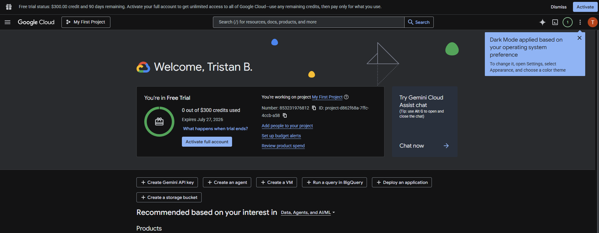
Google Kubernetes Engine (GKE) | - One free Autopilot or zonal Standard cluster per month.  - The Free Tier credit applies to the cluster charge only. This credit doesn't apply to compute, networking, or other resources.

reCAPTCHA | - 10,000 assessments per month.

Secret Manager | - 6 active secret versions per month.  - 10,000 access operations per month.  - 3 secret rotation notifications per month.

