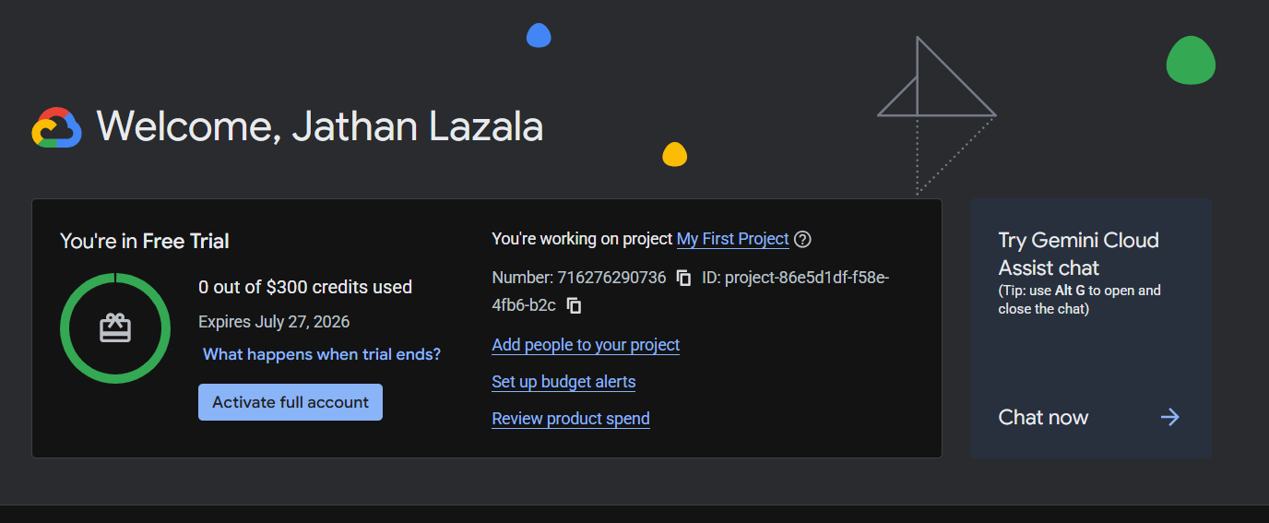

Cloud Build | - 2,500 build-minutes per month for machine type e2-standard-2.

Firestore | - 1 GiB of storage per project.  - 50,000 reads, 20,000 writes, and 20,000 deletes per day per project.  - 10 GiB per month of outbound data transfer.
Web Risk | - 100,000 uris.search calls per month.

