This pro forma has been adapted from a project grant application form of one of the research funding bodies

MSc Research Project Proposal

Q1 RESEARCHER DETAILS | Your full name | JULIET IFEYINWA EZE-ONYEJI
Email address | 2607771@dundee.ac.uk

Q2 Title of your MSc programme
BIOLOGICAL DATA SCIENCE

Q3 Start date of MSc  Project: (dd/mm/yyyy) | APRIL 2024
Q4 End date of MSc  Project: (dd/mm/yyyy) | JULY 2024

MSc RESEARCH PROJECT PROPOSAL

Q5 TITLE OF RESEARCH PROPOSAL (no more than 233 characters, including spaces)

Understanding The Factors Leading to June Drop in Cherries

Q6 SUPERVISOR

Supervisor Details
Full name | ALISON KARLEY
Title (Dr, Prof etc.) | DR
E-mail address | Ali.Karley@hutton.ac.uk

Q7 | RESEARCH SUMMARY
 |  | Please provide a summary of your proposed research, including key goals (no more than 200 words)
Research goal: To find out how pollination affects cherry fruit development and the June drop event that follows. The early fall of cherries from trees, known as the June drop, has a substantial effect on the industry's yield and profitability. Our goal is to identify the main causes of this phenomena by examining the connection between fruit set and pollination.

Key Goals:
1.Examine the relationship between fruit set and the effectiveness of pollination in cherry trees.
2 Examine how the weather and insect activity affect pollination success.
3. Create predictive models to foresee and lessen June drop incidents, increasing cherry cultivation's output and financial viability.

Ultimately, this research aims to provide growers of cherries useful information to improve management techniques and boost fruit yield by comprehending the intricate relationship between pollination and fruit growth.

Q8 |  | LAY SUMMARY  Please provide a summary of your proposed research, including key goals, that is understandable to a non-expert audience (no more than 200 words)
Our goal is to determine why cherry, especially in June, fall from trees before they are ripe. The cherry growers may suffer large losses as a result of this early drop, sometimes referred to as the "June drop." The processes by which bees move pollen from flower to bloom during pollination are the main topics of discussion, along with the reasons why some cherries never reach full maturity.

Key Goals:

1. Find out how effective bee pollination is for cherry blooms.
2. Examine the effects of weather and insect activity on pollination.
3. Recognise why cherries can occasionally fall from trees early.
4. Provide instruments that will enable growers to 5. produce more cherries and experience more 5. success by anticipating and preventing early cherry drop.
We intend to help cherry producers enhance their crops and lessen losses from early cherry drop by understanding more about these issues.

Q9 | DETAILS OF RESEARCH PROJECT
 | (a) Aims of the project (no more than 100 words)
The objective of the project is to examine the function of pollination in order to determine the causes of premature cherry drop in June. Our aim is to create methods for preventing and minimising early cherry drop by examining pollination efficiency, environmental factors, and physiological processes. In the end, i want to help cherry growers optimise their crop yields while maintaining sustainable growing methods.

(b) Brief background information (no more than 800 words)

The authors state that the tetraploid Prunus cerasus L. (sour cherries) and the diploid Prunus avium L. (sweet cherries) are the two main types of cherries traded worldwide. According to several theories, sweet cherries first appeared in a region south of the Caucasus Mountains before spreading later into Europe.Prunus cerasus L., the e sour cherry, is indigenous to north India, Iran, and Kurdistan, but it is native to middle and south Europe( Kappel, F. et al. (2011),( Dondini, L et al. (2018).

Due to their delicious flavour, high nutritional content, and adaptability in cooking, cherries (Prunus avium) are a widely grown fruit with great economic impact. Effective pollination is critical to cherry production since it affects fruit set, yield, and quality directly. But in June, cherry trees frequently experience a natural occurrence called "June drop," which is the shedding of immature fruits throughout the month of June. This results in lower yields and financial losses for growers.

In order to minimise the effects of June drop and maximise cherry output, it is essential to comprehend the intricate interactions between the various components that contribute to this phenomenon. The dynamics of pollination, environmental factors, hormone regulation, genetic factors, and orchard management techniques are some of the major elements that affect fruit set and retention.

Pollination Behaviour:
Since cherries are mostly pollinated by insects( honeybees), pollination is essential to the growth of cherry fruit. Although other insects like flies, solitary bees, and bumblebees also aid in the pollination process. The honey bees and bumble bees (always utilized by growers) and are the main pollinators when the hives are introduced into the plantation. Pollinator diversity, abundance, activity, and efficiency in moving pollen grains from stamens to pistils are some of the variables that affect how successful pollination is.

According to research by Simpson, D. et al. (2022), pollinator population and activity fluctuations have a major impact on cherry fruit set and yield. Additionally, to maximise fruit production and reduce the risk of June drop, research by Pérez-Méndez et al. (2020) and Garibaldi et al. (2020) stressed the significance of increasing pollinator variety and abundance in orchards.

Conditions of the Environment:
Wind, humidity, temperature, and precipitation are examples of environmental variables that affect cherry pollination and fruit growth. The best possible weather during the flowering season encourages pollinator activity and pollen dissemination, which improves fruit set. On the other hand, unfavourable meteorological conditions, including as frost, rain, heat waves, and strong winds, can hinder pollen viability, lower pollinator foraging activity, or physically harm maturing fruits, which can impede pollination and cause June drop.

Research by A. Holzschuh et al. (2012) Cherry tree fruit set rises in direct proportion to the percentage of semi-natural, high-diversity bee habitats in the landscape, which is mediated by rising bee visitation rates within the trees. Furthermore, studies by Primack, R. et al. (2009) highlighted the negative impacts that unpredictable weather patterns have on cherry production in Kyoto. In order to reduce the hazards associated with climate change, adaptive management techniques are essential.
Hormone Control:
Cherry tree fruit set and development are largely controlled by hormonal signalling mechanisms. Auxin, gibberellins, cytokinins, and ethylene are some of the major hormones that regulate physiological processes such fruit development, pollination, development of flowers, and seeds. Fruit set can be hampered and premature fruit drop can be caused by hormonal or signalling pathway imbalances.

Research by Zhao, M. et al. (2020) and Vincent, C. et al. (2023) clarified how ethylene controls abscission processes in fruit development, emphasising how it affects cherry abscission zone differentiation and fruit retention. Moreover, ethylene regulates the development and maturity of sexual organs and petals up to anthesis, according to study by Martínez, C. et al. (2023). By lessening the sensitivity of cells in the abscission zone, auxin (IAA) is known to delay abscission. It has also been discovered that hormonal signalling and environmental signals interact to modulate fruit set and June drop in sweet cherry cultivars (Blanuša, T. et al. 2005).
Best Practices for Orchard Management:
June drop risk reduction and maximum cherry yield depend on good orchard management techniques. Tree vigour, blooming intensity, and fruit set can all be improved with techniques like appropriate pruning, irrigation management, pest and disease control, and nutrient supplementation. Incorporating pollinator-friendly techniques, such as offering floral supplies and enhancing habitat, can also help to maintain healthy pollinator populations and boost pollination efficiency.

In conclusion, June drop affects yield and profitability and poses a serious challenge to cherry growers globally. A multidisciplinary strategy involving studies on pollination dynamics, environmental factors, hormone regulation, genetics, and orchard management techniques is needed to address this problem. Stakeholders may strengthen the sustainability and resilience of cherry production in the face of rising problems by developing comprehensive strategies that integrate ideas from several scientific disciplines.

(c) Experimental design and/or methodologies to be used (no more than 400 words)

1. Descriptive Statistics: Start by calculating descriptive statistics to provide an overview of important variables including fruit set, pollinator abundance, June drop incidence, and environmental factors. To describe the dataset, compute metrics of dispersion (standard deviation, range) and central tendency (mean, median).
2. Correlation Analysis: Use correlation analysis to investigate the links between variables. For example, find out how pollinator activity and fruit set are correlated, or how weather patterns and June drop incidence are correlated. When dealing with non-parametric data, utilise either Pearson's correlation coefficient or Spearman's rank correlation coefficient(Hair, J. F. (2009).

3. Regression Analysis: Regression analysis can be used to model the link between the response variable (fruit set, June drop) and the predictor factors (pollinar abundance, temperature, humidity, etc.). In order to determine the importance of predictor variables and measure their impact on the response variable, fit models using logistic, generalised, or linear regression.
4.Time Series Analysis: Utilise time series analysis methods to investigate seasonal trends in fruit development, pollinator activity, and June drop incidence. To find seasonal trends and cyclical patterns, use techniques like seasonal decomposition or autoregressive integrated moving average (ARIMA) models included in R/Python packages(Shumway, R. et al.(2000)

5. Machine Learning: Learn about machine learning strategies to create predictive models for fruit set and June drop occurrence, such as random forests, support vector machines, or neural networks. Cross-validation techniques are used to assess model performance. Models are trained using historical data on pollination dynamics, weather, and orchard management approaches.
6. Cluster Analysis: Using techniques like k-means clustering or hierarchical clustering, distinguish between different groups or clusters of cherry orchards according to June drop patterns, environmental factors, and pollination traits. Examine cluster profiles to identify shared characteristics and approaches to management linked to good fruit output and low incidence of June drop.

7.Statistical hypothesis testing: To compare means or proportions between various treatments or groups (e.g., natural pollination vs. supplemental pollination, high vs. low June drop orchards), use statistical hypothesis tests (e.g., t-tests, chi-square tests). Evaluate the impact of treatment effects and determine the variables influencing June drop and variations in fruit set.
Using these techniques for data analysis, I am able to draw important conclusions from the gathered information and identify underlying trends and connections that clarify the variables affecting June drop occurrence and cherry pollination.

Q10 | TIME-LINE AND PROJECTED WORK-FLOW
Provide a flow diagram (no greater than 1 A4 page) to illustrate how you foresee your work will proceed over the research period. You should highlight anticipated milestones and branch points where your work could take more than one direction. Include alternative routes that might be explored if, for example, a hypothesis returns a given answer or a particular technique or research area fails to deliver results. You may support your diagram with a brief legend which should be no more than 100 words.

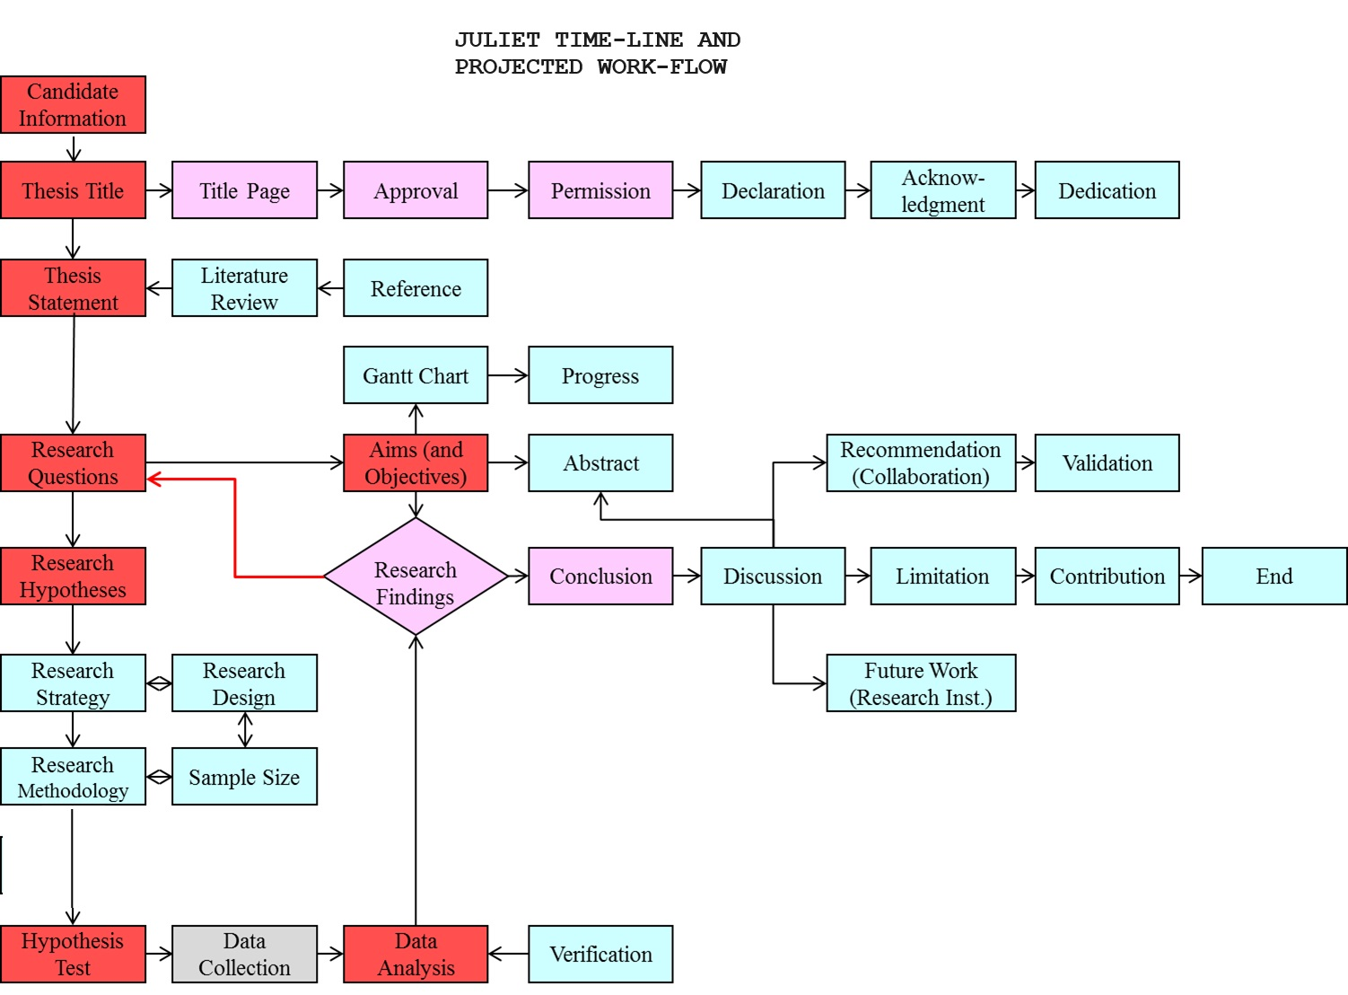

This flowchart above illustrates the expected course of the June drop and cherry pollination research, emphasising significant turning points, critical decisions, and potential side trips based on study findings. For a period of 3months, April 2024 to July 2024.
Rectangles represent milestones, diamonds represent decision points, and arrows represent the flow of work or decision outcomes. This explanation describes the symbols used in the flow diagram.

Timeline of Research
With an emphasis on the function of pollination in fruit growth, I hope to learn more about the elements behind the June reduction in cherry production by following this timeline.

April of 2024:
1. Access the Imaging dataset: Review the imaging on cherry physiology, pollination biology, and fruit drop factors, with an emphasis on current research and pertinent scholarly publications.
2. Develop image processing Algorithm: Describe the goals, approach, and importance of the study in a research proposal that is written. Discuss the idea with the committee members and research advisor to make sure it is in keeping with departmental policies and research objectives.
3. Process the Image Key Variables.

In May 2024:
4. Organize Variables : Create experimental procedures to examine how various pollination techniques affect cherry fruit set and drop. Create a thorough process for gathering and analysing data to guarantee accurate and dependable outcomes. Repeating the void or failed process to yield a better result

June and July of 2024:
5. Descriptive Measures; Using a set of method to analyse the dataset and trying out an alternative method if this doesn’t work.

6. Statistical Analysis: Determine the impact of pollination on cherry fruit yield by statistically analysing the data that has been gathered or collected.

Q11 | REFERENCES (Research project)
 | Please give citation in full, including title of paper and all authors (no more than 25 citations)
Kappel, F., Granger, A. R., Hrotkó, K., & Schuster, M. (2011). Cherry. In Springer eBooks (pp. 459–504). https://doi.org/10.1007/978-1-4419-0763-9_13

Dondini, L., Lugli, S., & Sansavini, S. (2018). Cherry Breeding: Sweet Cherry (Prunus avium L.) and Sour Cherry (Prunus cerasus L.). In Springer eBooks (pp. 31–88). https://doi.org/10.1007/978-3-319-91944-7_2

Simpson, D., Weinman, L., Genung, M. A., Roswell, M., MacLeod, M., & Winfree, R. (2022). Many bee species, including rare species, are important for function of entire plant–pollinator networks. Proceedings - Royal Society. Biological Sciences (Print), 289(1972). https://doi.org/10.1098/rspb.2021.2689

Garibaldi, L. A., Sáez, A., Aizen, M. A., Fijen, T. P., & Bartomeus, I. (2020). Crop pollination management needs flower‐visitor monitoring and target values. Journal of Applied Ecology (Print), 57(4), 664–670. https://doi.org/10.1111/1365-2664.13574

Pérez‐Méndez, N., Andersson, G. K., Réquier, F., Hipólito, J., Aizen, M. A., Morales, C., García, N. G., Gennari, G. P., & Garibaldi, L. A. (2020). The economic cost of losing native pollinator species for orchard production. Journal of Applied Ecology (Print), 57(3), 599–608. https://doi.org/10.1111/1365-2664.13561

Holzschuh, A., Dudenhöffer, J., & Tscharntke, T. (2012). Landscapes with wild bee habitats enhance pollination, fruit set and yield of sweet cherry. Biological Conservation, 153, 101–107. https://doi.org/10.1016/j.biocon.2012.04.032

Primack, R. B., Higuchi, H., & Miller‐Rushing, A. J. (2009). The impact of climate change on cherry trees and other species in Japan. Biological Conservation, 142(9), 1943–1949. https://doi.org/10.1016/j.biocon.2009.03.016

Zhao, M., Li, C., Ma, X., Xia, R., Chen, J., Liu, X., Ying, P., Peng, M., Wang, J., Shi, C., & Li, J. (2020). KNOX protein KNAT1 regulates fruitlet abscission in litchi by repressing ethylene biosynthetic genes. Journal of Experimental Botany, 71(14), 4069–4082. https://doi.org/10.1093/jxb/eraa162

Vincent, C., & Munné‐Bosch, S. (2023). Ethylene in the regulation of major biotechnological processes. In Elsevier eBooks (pp. 89–105). https://doi.org/10.1016/b978-0-323-85846-5.00014-x
Martínez, C., García, A., & Jamilena, M. (2022). Role of Ethylene in Flower and Fruit Development. Role of Ethylene in Flower and Fruit Development, 178–219. https://doi.org/10.1002/9781119744719.ch8

Blanuša, T., Else, M. A., Atkinson, C., & Davies, W. J. (2005). The regulation of sweet cherry fruit abscission by polar auxin transport. Plant Growth Regulation, 45(3), 189–198. https://doi.org/10.1007/s10725-005-3568-9

Shumway, R. H., Stoffer, D. S., & Stoffer, D. S. (2000). Time series analysis and its applications (Vol. 3). New York: springer.
Hair, J. F. (2009). Multivariate data analysis.

Sharma, A., Kumar, V., Shahzad, B., Tanveer, M., Sidhu, G. P. S., Handa, N., Kohli, S. K., Yadav, P., Bali, A. S., Parihar, R. D., Dar, O. I., Singh, K. C., Jasrotia, S., Bakshi, P., Ramakrishnan, M., Kumar, S., Bhardwaj, R., & Thukral, A. K. (2019). Worldwide pesticide usage and its impacts on ecosystem. SN Applied Sciences (Print), 1(11). https://doi.org/10.1007/s42452-019-1485-1

Williams, S. R., Baniya, A. A., Islam, M. S., & Murphy, K. (2023). A data ecosystem for orchard research and early fruit traceability. Horticulturae, 9(9), 1013. https://doi.org/10.3390/horticulturae9091013

Carew, R., Florkowski, W. J., & Meng, T. (2017). Intellectual Property Rights and Plant Variety Protection of Horticultural Crops: Evidence from Canada. Canadian Journal of Plant Science. https://doi.org/10.1139/cjps-2016-0239

Tung-Yi Kho. (2012). Agricultural Commons and Intellectual Property Rights: An anatomy of North-South Germplasm Politics and Cultural change. https://www.academia.edu/download/31410968/Agrarian_South-_Journal_of_Political_Economy-2012-Kho-255-90.pdf.

Q12 | FUNDING OPTIONS
 | If you were tasked with obtaining finances for the project, explain the most likely options for funding. As appropriate, this should include a consideration of potential grant funding bodies and an explanation of how the research area would fit their remit, and/or a consideration of funding options for a start-up company or bio-business venture and a justification of how the project would fit the particular remit of the funding source (no more than 200 words)
There are various ways to raise money for the June drop and cherry pollination research projects:
1.The UK Research and Innovation (UKRI) is a government agency that provides funding for research and innovation in a range of fields, such as biological data science and The UK's innovation agency, Innovate UK, finances and supports initiatives that use innovation to spur economic growth.
2. In addition to providing financing possibilities for researchers in biological data sciences and allied subjects, The Royal Society is the national academy of sciences in the United Kingdom. Foundation Wolfson: Leverhulme Trust: The Leverhulme Trust funds research projects across various disciplines, including biological data sciences and other private organisations that also provide grants. Other charitable foundations that support research infrastructure and facilities include the Healthcare Foundation and the Science Foundation.

3. Venture Capital and knowledge transfer partnership: Take into consideration pitching to venture capital firms that focus on biotechnology or agri-tech startups for funding. Innovative innovations or solutions created through the cherry research may be of interest to these investors; in particular, those with economic potential for enhancing crop yields, sustainability, or agricultural efficiency may be of particular interest.
Researchers can raise the likelihood that they will be able to obtain funding for their June drop and cherry pollination studies by matching the project objectives to the aims and interests of possible funding sources.

Q13 | ETHICAL AND/OR LEGAL CONSIDERATIONS
Explain any ethical and/or legal issues pertaining to the project, and how these might be addressed.
If you do not think there are any issues of this type explain all the points you have considered and how you have arrived at a conclusion that there are no ethical or legal constraints (no more than 200 words maximum)

Research with cherry orchards must take ethical and legal issues very seriously. Potential problems consist of:
1. Impact on the environment: The use of pesticides, which are synthetic or natural chemicals used in various agricultural methods to manage weeds, pests, and plant diseases, as well as habitat degradation, can cause harm to ecosystems and non-target species (Sharma, A. et al., 20019). Mitigation entails protecting natural habitats and implementing integrated pest management techniques.

2. Data Privacy: Sensitive information regarding producers and their methods may be collected as part of the orchard data collection. A unique proof-of-concept data ecosystem that facilitates better data storage, management, integration, processing, analysis, and utilisation must be used, along with ensuring anonymity and gaining informed consent. et al., 2023; Williams, S.
3. Intellectual Property: Preserving genetic data and confidential knowledge about orchard management techniques is essential. It's essential to set up explicit agreements about data sharing and IP rights.

These problems can be successfully resolved, guaranteeing responsible behaviour throughout the study process, by abiding by ethical standards, upholding transparency, and working collaboratively with stakeholders.

Q14 | IMPACT
Explain the future applications or societal benefits that could arise from the work, and how it aligns with current priorities of international, national or local governments. Your explanation might consider benefits to the scientific community, the general public, relevant patient groups, funding of national health services, etc. (no more than 200 words)

Current priorities and possible advantages to society could result from study on June drop and cherry pollination dynamics:
1. Enhanced Agricultural Sustainability: Growers can apply focused management techniques to raise orchard productivity and resilience to environmental challenges, enhancing food security and sustainable agriculture. This is made possible by knowing the factors impacting June drop and cherry output.
2. Economic Growth: Increased cherry yields can stabilise livelihoods in cherry-growing communities and assist rural economies. By creating more export and market options, higher-quality and higher-yielding fruit can help stimulate economic growth.

3. Environmental Conservation: The research's sustainable orchard management techniques, which include preserving habitat and using less pesticides, support international efforts to protect biodiversity and advance ecosystem health.
4. Public Health and Nutrition: Packed with vital minerals and antioxidants, cherries support a nutritious diet. By encouraging the intake of nutrient-dense fruits and lowering dependency on processed foods, the availability of premium cherries can improve public health.
Globally, this research addresses important issues for people and governments around the world, including public health promotion, biodiversity conservation, and sustainable agriculture.

Q15 | INTELLECTUAL PROPERTY
Provide a brief commentary on the existing or potential intellectual property associated with the project area (no more than 200 words)

Research on June drop dynamics and cherry pollination dynamics can give rise to intellectual property (IP) rights in a number of ways. Breeders may be able to regulate the marketing and propagation of novel cherry cultivars that show resistance to June drop or better fruit set if they qualify for Plant Breeder's Rights (PBR) protection. Furthermore, under UPOV or national patent rules, novel technology or approaches for managing orchards that improve pollination efficiency might be protected by patent. Furthermore, in order to protect their intellectual property, proprietary software tools for data analysis or predictive modelling might be copyrighted. But managing intellectual property rights in agriculture means giving ethical and fair access concerns a lot of thought. Achieving a fair benefit-sharing arrangement and the spread of innovations in the agriculture sector requires a delicate balance between intellectual property protection and wider social interests, which calls for cooperative methods and legal knowledge.( Tung-Yi Kho. (2012) and (Carew, et al. (2017).

