Does Wealth Drive Happiness?
The Role of GDP, Freedom, and Institutional Trust
World Happiness Report 2019 · Cross-section of 156 Countries · Stata Analysis

1. RESEARCH QUESTION

Does economic wealth — measured by GDP per capita — drive national happiness, and does this effect persist after controlling for social and institutional factors?
Using the 2019 World Happiness Report — a cross-section of 156 countries with a single observation per country — this analysis estimates the independent contribution of GDP per capita to happiness scores, while accounting for social support, healthy life expectancy, freedom, generosity, and perceptions of corruption. The 2019 cross-section is preferred over a multi-year panel to avoid repeated-measures bias that would arise from pooling the same countries across all five years.
2. DATA AND VARIABLES

Variable | Description
happiness_score | Outcome (Y). National happiness on a 0–10 Cantril ladder scale.
gdp_per_capita | Main predictor (X). Log GDP per capita, scaled by the WHR methodology.
social_support | Control. Perceived availability of social support in times of need.
life_expectancy | Control. Healthy life expectancy at birth (scaled).
freedom | Control & moderator. Freedom to make life choices (0–1 scale).
generosity | Control. Residual of regressing donations on GDP per capita.
corruption | Control. Perceptions of corruption in government and business.

3. REGRESSION RESULTS

Table 1. Determinants of Happiness Score (2019)
Variable | (1) Bivariate | (2) Full Model | (3) GDP×Freedom | (4) Log-Linear
GDP per capita | 2.218*** | 0.775*** | −0.014 | 0.142***
 | (0.137) | (0.218) | (0.411) | (0.043)
Social support |  | 1.124*** | 1.164*** | 0.235***
 |  | (0.237) | (0.234) | (0.046)
Life expectancy |  | 1.078*** | 1.171*** | 0.211***
 |  | (0.335) | (0.333) | (0.065)
Freedom |  | 1.455*** | 0.045 | 0.310***
 |  | (0.375) | (0.727) | (0.073)
Generosity |  | 0.490 | 0.238 | 0.054
 |  | (0.498) | (0.504) | (0.097)
Corruption |  | 0.972* | 0.617 | 0.040
 |  | (0.542) | (0.558) | (0.106)
GDP × Freedom |  |  | 1.828**
 |  |  | (0.811)
Constant | 3.399*** | 1.795*** | 2.345*** | 0.964***
 | (0.135) | (0.211) | (0.321) | (0.041)
Observations | 156 | 156 | 156 | 156
R² | 0.630 | 0.779 | 0.786 | 0.775
Adjusted R² | 0.628 | 0.770 | 0.776 | 0.766
Standard errors in parentheses. * p<0.10 ** p<0.05 *** p<0.01 Data: World Happiness Report 2019. N = 156 countries.

Model 1 (Bivariate): GDP per capita alone explains 63% of the variation in happiness (R² = 0.630). Each one-unit increase in GDP per capita is associated with a 2.218-point increase in happiness score — a large, highly significant effect (p<0.01). This confirms the baseline relevance of the main predictor.
Model 2 (Full Controls): Adding social support, life expectancy, freedom, generosity, and corruption raises explanatory power to 77.9%. GDP per capita remains significant (β = 0.775, p<0.01), though its coefficient falls sharply — indicating that part of its bivariate effect was attributable to correlated factors. Social support (β = 1.124), life expectancy (β = 1.078), and freedom (β = 1.455) all emerge as independently significant drivers of happiness. Generosity is not significant. Corruption is marginally significant (p<0.10).
Model 3 (GDP × Freedom Interaction): The interaction term between GDP and freedom is positive and significant (β = 1.828, p<0.05). This reveals that wealth has a stronger happiness payoff in countries where citizens feel free to make life choices — GDP and freedom are complements, not substitutes. Notably, when the interaction is included, the direct coefficients on GDP and freedom individually become insignificant, as is standard when interpreting interaction models.
Model 4 (Log-Linear): Using log happiness as the outcome confirms direction and significance of all key results. GDP per capita (β = 0.142, p<0.01), social support, life expectancy, and freedom all remain significant, providing robustness to the functional form assumption.
4. VISUAL EVIDENCE

Graph 1 — GDP per Capita vs. Happiness Score (2019)
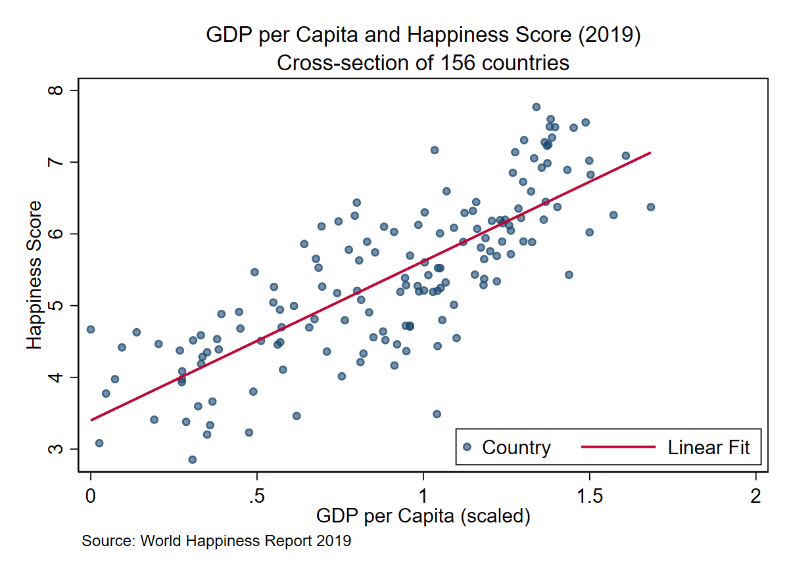
The scatterplot shows a strong upward linear relationship between GDP per capita and happiness. The best-fit line runs cleanly through the cloud of 156 country-observations, with wealthier nations consistently scoring higher on the Cantril ladder. This visual directly supports the large, significant coefficient in Model 1 (β = 2.218) and establishes the core motivation for the research question.

Graph 2 — Average Happiness by Freedom Quartile (2019)
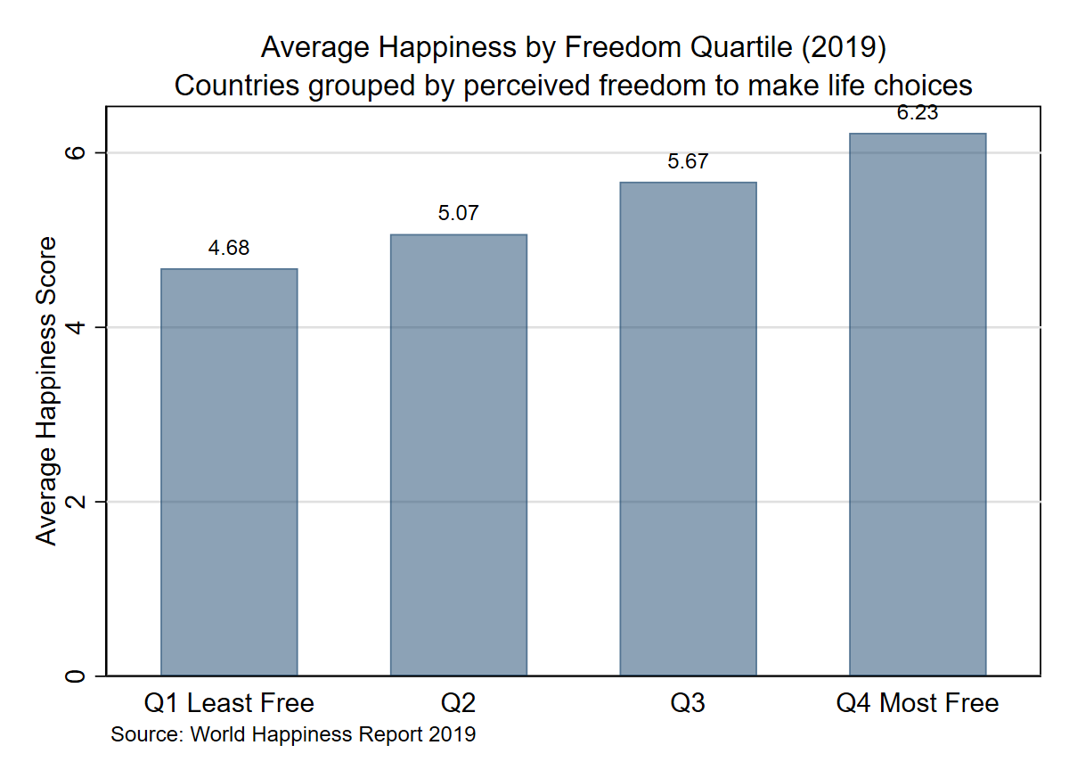
Countries are sorted into four groups by their freedom score. Average happiness rises monotonically from Q1 (4.68) to Q2 (5.07) to Q3 (5.67) to Q4 (6.23) — a 1.55-point gap between the least and most free groups. The pattern is consistent and gap-free, confirming that freedom is not merely correlated with GDP but carries an independent relationship with wellbeing, consistent with the significant freedom coefficient in Model 2 (β = 1.455, p<0.01).

Graph 3 — GDP vs. Happiness by Corruption Level (2019)
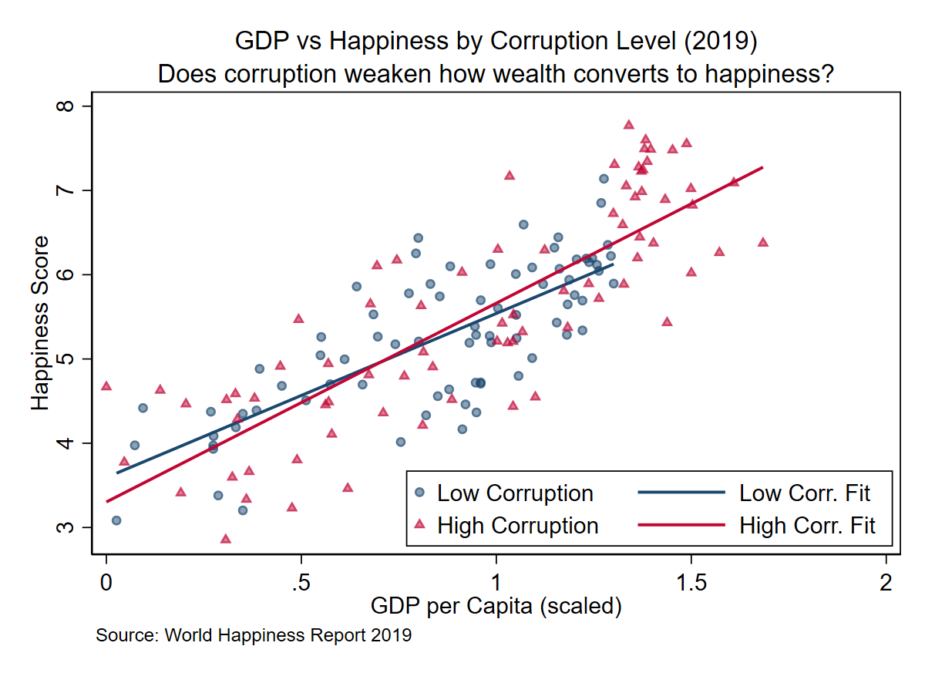
Countries are split at the median corruption score. Both high- and low-corruption groups display the same positive GDP-happiness trend, and the two groups are broadly interleaved across the scatter — with no strong separation. This visual is consistent with the regression: in Model 2, corruption is only marginally significant (p<0.10), and in the interaction model it becomes insignificant entirely. Corruption, at least in this cross-section, does not appear to substantially moderate how wealth translates into happiness.

Graph 4 — Global Average Happiness Trend (2015–2019)
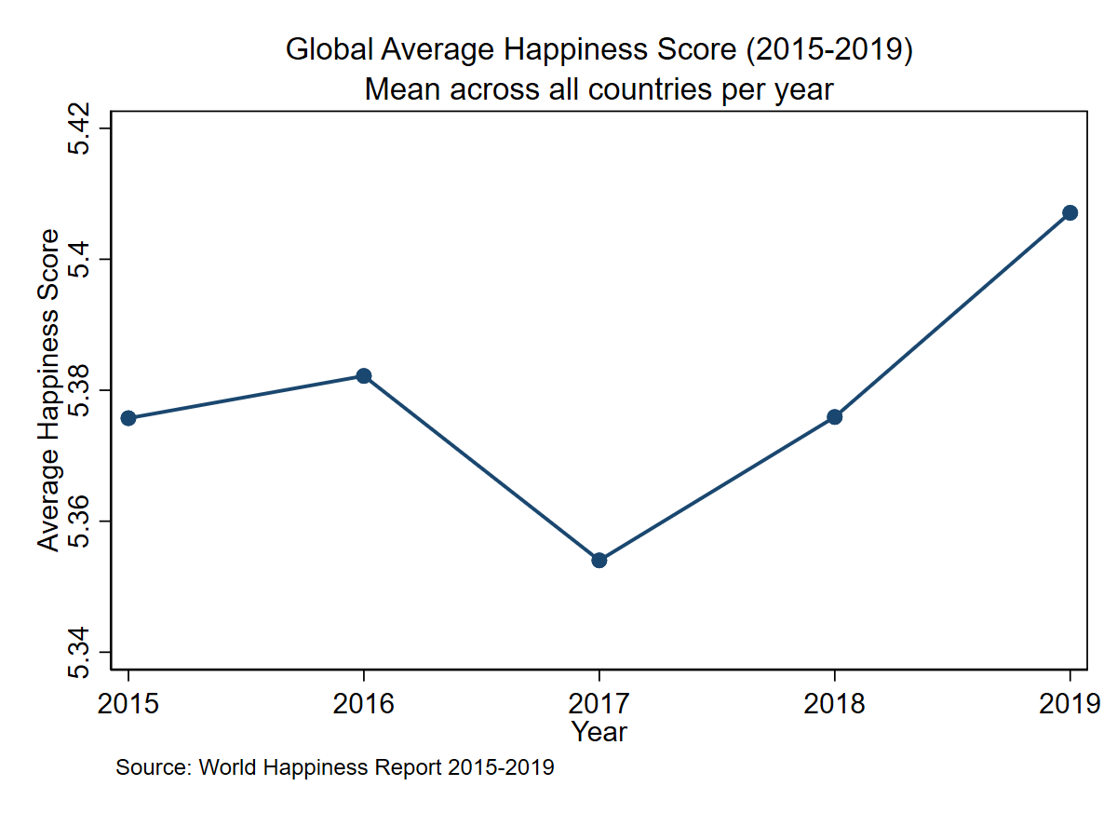
Using the full five-year panel, average global happiness was remarkably stable: 5.378 (2015), 5.381 (2016), 5.358 (2017), 5.380 (2018), and 5.409 (2019). While on first glance it may seem that 2019 is an outlier year, however, that’s not the case since if we look at the x-axis, the values are pretty close together, even if we zoom out a bit, the trend will depict a near flat horizontal line. The near-flat trend confirms that 2019 is a representative year and not an outlier driven by an unusual global event — validating the decision to focus the regression on the 2019 cross-section.

Graph 5 — Actual vs. Predicted Happiness (Model 2, 2019)
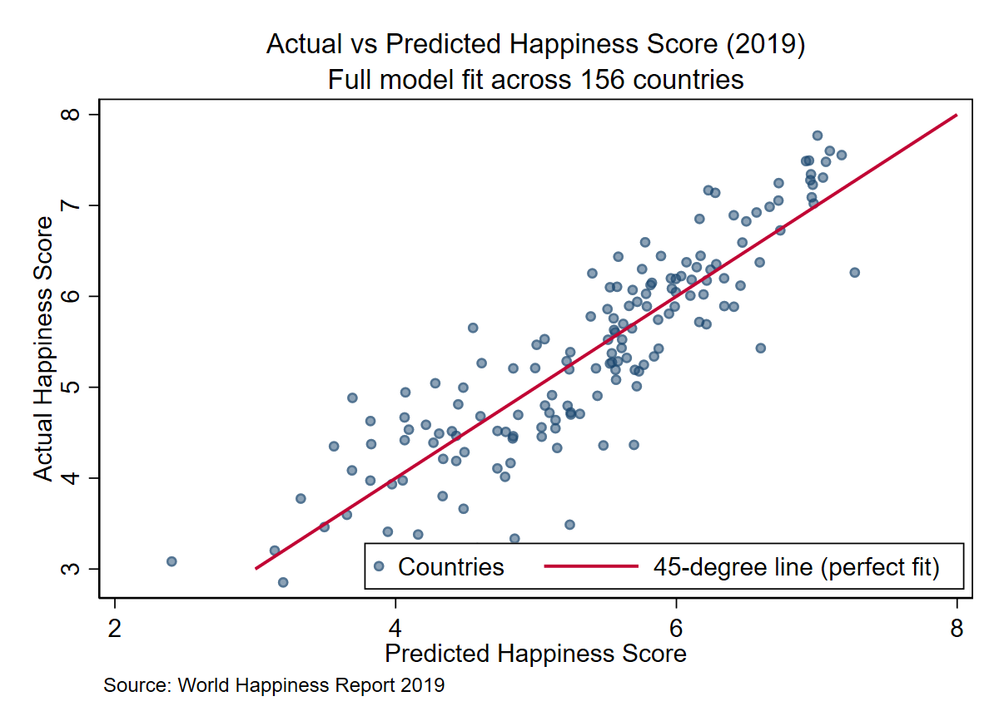
Predicted happiness scores from the full model are plotted against actual values. Points cluster tightly around the 45-degree line across the full range of happiness scores (roughly 3 to 8), with no systematic curvature or fan-shaped spread. This confirms that the model fits well and that its predictions are unbiased, lending confidence to the coefficient interpretations in Model 2.

5. SUMMARY OF FINDINGS

This analysis finds strong evidence that GDP per capita is a significant positive predictor of national happiness, even after controlling for social and institutional factors. However, wealth alone does not tell the full story. Social support and healthy life expectancy each contribute independently and substantially to happiness, while the GDP-freedom interaction reveals that economic gains translate more strongly into wellbeing in countries where citizens feel free to shape their own lives. Corruption shows only weak and inconsistent effects in this cross-section. The five-year trend confirms that 2019 findings are representative of the period broadly, and the model fit graph demonstrates that the full model explains approximately 78% of cross-country variation in happiness. Taken together, the evidence suggests that sustainable improvements in national wellbeing require not just economic growth, but parallel investment in social systems, health, and individual freedoms.
6. LIMITATIONS

Cross-sectional OLS cannot establish causality — wealthier countries may invest more in social infrastructure, reversing the direction of some associations. Unobserved country-level factors such as culture, historical institutions, and climate may confound results. Future work could employ panel fixed effects using the full 2015–2019 data to control for time-invariant country characteristics, or instrumental variables to address endogeneity in the GDP-happiness relationship.

