AI-Agent KYC Automation
Project Overview — From Customer Documents to KYC Case Routing
A simple explanation for business and technical audiences

1. What is this project?
KYC (Know Your Customer) is the process of checking that a customer has provided enough information and evidence to establish who they are and to identify relevant compliance risks. This project shows how AI agents can automate the repetitive parts of that journey while keeping people and business rules in control of important decisions.

2. What does the customer provide?
- An identity document.
- A document supporting the customer's address.
- A customer photo.
- Basic information entered during onboarding, such as name, date of birth and address.

3. Workflow at a glance
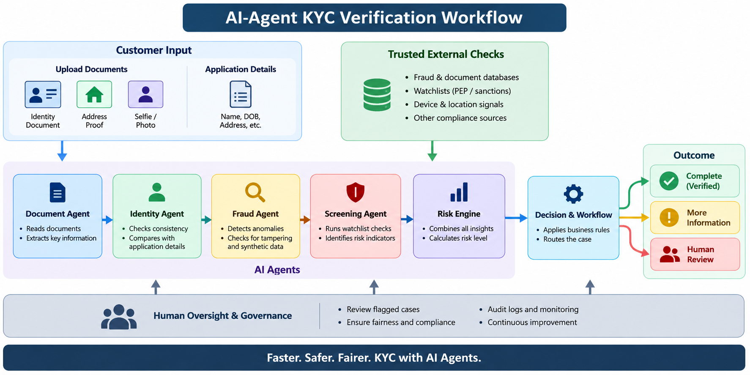
Figure 1. Customer evidence flows through AI-assisted checks and is then routed to the appropriate next step.

4. The main idea
Think of the system as a digital KYC team: one part reads documents, another compares information, another looks for warning signals, and a final control layer decides what should happen next.

5. The AI Agents Explained
Agent | In simple terms | What it produces
Document Agent | Reads the uploaded documents and finds useful information. | Names, dates, addresses, document details and observations
Identity Agent | Checks whether information agrees across the application and documents. | Matches, mismatches or unclear fields
Photo Agent | Checks whether the supplied photos appear visually consistent and usable. | Photo quality and similarity signal
Fraud Agent | Brings together warning signs found during the checks. | Fraud-risk signals and reasons
Screening Agent | Checks the customer's name against a demonstration watchlist. | Potential screening match or no match
Risk Engine | Applies clear business rules to the signals. | Risk level used for routing
Orchestrator | Chooses the next workflow step. | Complete, more information, or human review

6. What happens to the documents?
- The system receives the three supplied pieces of evidence.
- AI reads the visible information rather than requiring a person to manually type every field.
- The extracted information is compared with the information entered by the customer.
- The system checks for inconsistencies and other configured warning signals.
- The results are brought together into one case view.
- A workflow rule determines the next step.

7. Example of a simple check
Suppose the application says the customer lives at Address A, while the address document appears to show Address B. The system records an address mismatch. It does not automatically declare the customer fraudulent; instead, the mismatch can become a reason to request clarification or send the case to an analyst.

8. Why use multiple agents?
A single large AI prompt can become difficult to understand and control. Separate agents give each task a clear responsibility. That makes the workflow easier to explain, test, change and audit.

9. What the Customer Sees vs. What Happens Behind the Scenes
Customer / Business view | Behind the scenes
Upload documents | Files are validated and prepared for AI processing
Enter personal details | Information becomes the reference point for consistency checks
Wait for verification | Specialized AI agents process different evidence types
Receive a next-step request | Rules combine the signals and route the case
Case may need review | An analyst receives the relevant evidence and reasons

10. How the AI Fits Into the Process
The AI is best understood as an assistant that reads, compares and summarizes evidence. It is not the only source of truth. In a real system, authoritative verification and screening services provide important external evidence, while business rules define how the organization responds to different conditions.

11. The Decision Layer
- If the required information is present and configured checks are clear, the case can continue through the normal workflow.
- If information is missing or unclear, the system can ask for more evidence.
- If there is a material inconsistency, screening alert or higher-risk signal, the case can be sent to human review.
- The exact thresholds and actions are business and compliance decisions, not something the general-purpose AI should invent.

12. The Demo Data
Supplied file | Used for
pan.jfif | Identity-document evidence
demo_address_proof(1).png | Address evidence
synthetic_portrait.png | Customer-photo evidence
The supplied files are used as demonstration/test evidence in the walkthrough. A production KYC platform would use controlled customer-data handling, approved verification sources and appropriate privacy and retention controls.

13. What makes the workflow auditable?
- Each stage has a defined purpose.
- The system keeps structured results rather than relying only on free-form explanations.
- Important routing is based on explicit rules.
- The case can show which evidence created a particular warning or escalation.

14. Business Benefits
Area | How the approach helps
Speed | Automates repetitive document-reading and comparison work.
Consistency | Applies the same configured checks to each case.
Analyst productivity | Presents relevant evidence and reasons in one place.
Scalability | Multiple specialized tasks can be processed automatically.
Traceability | Structured outputs make the workflow easier to review.
Flexibility | Individual agents or external services can be replaced without redesigning the whole journey.

15. Important Controls
- The system should preserve uncertainty instead of guessing missing information.
- A mismatch is a signal for investigation, not automatic proof of fraud.
- Photo analysis should be treated as a supporting signal unless a dedicated, approved biometric service is used.
- Sanctions and PEP screening should use maintained and approved data sources in a real deployment.
- Important exceptions should be reviewed by trained people.
- Sensitive customer information should be protected with appropriate access, encryption and retention controls.

16. From Demo to Production
Demo component | Production evolution
AI reads documents | Approved document and identity verification service
Demo watchlist | Maintained sanctions/PEP screening provider
Photo similarity signal | Dedicated biometric verification/liveness service, where required
Notebook dashboard | Controlled case-management application
Simple rules | Approved compliance rules with versioning and governance
Demo evidence | Secure customer-data platform with retention and access controls

17. Example Case Journey
1) Customer uploads evidence → 2) documents are read → 3) details are compared → 4) risk and screening signals are checked → 5) rules route the case → 6) the customer either continues, provides more information, or the case goes to an analyst.

18. Key Takeaway
The value of the project is the combination of AI assistance and controlled workflow. AI handles reading and organizing evidence; clear rules and human oversight keep the process understandable and accountable.

19. Technical Architecture — Explained Simply
Under the simple customer journey, the system is a collection of cooperating components. Each component has a small job and passes structured information to the next component.
Layer | Role
Customer evidence | Documents, photo and application details
AI processing | Reads, extracts and compares evidence
Risk & screening | Adds warning signals from configured checks
Decision controls | Applies business rules consistently
Workflow | Routes the case and records what happened
Human review | Handles important exceptions and compliance decisions

20. What This Project Demonstrates
- Multimodal AI can read both text-heavy documents and images in one workflow.
- Specialized agents can divide a complex KYC journey into understandable tasks.
- Structured outputs allow AI results to feed deterministic business rules.
- The workflow can explain why a case needs more information or human attention.
- The same architecture can later connect to enterprise verification, screening, fraud and case-management services.

21. Project Deliverables
- Google Colab notebook for the AI-agent KYC walkthrough.
- OpenRouter-powered multimodal document processing.
- Processing of the supplied identity, address and photo evidence.
- Identity consistency, photo, fraud, screening, risk and workflow stages.
- Analyst-oriented case view and audit trail.
- Five-page project document with a simplified workflow diagram.

22. Final Summary
This project presents KYC automation as a journey rather than a single AI decision: collect evidence, understand it, compare it, check for relevant risks, and route the case. That structure makes the concept understandable to non-technical stakeholders while also giving technical teams a clear path toward a production architecture.
AI-assisted KYC • Clear workflow • Explicit controls • Human oversight

