PROJECT REPORT
AI Form Filler
HTML Form Understanding, Vector Retrieval and LLM-Based Form Filling

A document-grounded pipeline that accepts an HTML form, extracts its fields with an LLM, retrieves relevant personal information from a local vector database, and writes the resulting values back into the original form.

Project scope
Prototype implementation demonstrated in a Python/Jupyter/Colab notebook using OpenRouter, FAISS, Sentence Transformers, PyPDF and BeautifulSoup.

1. Introduction
The AI Form Filler project addresses a common automation problem: a user has personal information stored in documents, while a separate application presents an HTML form that must be completed. Manually transferring the information is repetitive and can become error-prone when forms contain many fields. The project therefore combines document retrieval, large language models (LLMs), and deterministic HTML manipulation into one pipeline.
The implemented notebook follows the workflow represented in the supplied project diagram. First, private PDF documents are loaded and converted into searchable chunks. The chunks are embedded locally and stored in a FAISS vector index. Separately, an HTML form is uploaded. The LLM parses the form metadata and identifies fields such as labels, IDs, names, types, required status and options. For each field, semantic retrieval selects relevant document evidence, which is then supplied to the LLM to determine the field value. Finally, Python and BeautifulSoup write the values into the original HTML.
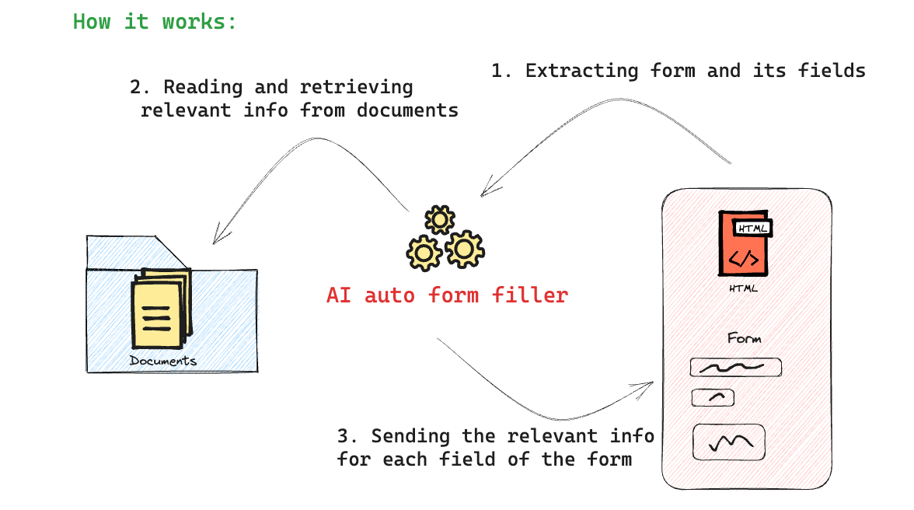

2. Objectives
- Accept an HTML form as the input template rather than requiring a manually coded field list.
- Extract form-field descriptions from the HTML using an LLM.
- Create a local vector database from private PDF information.
- Retrieve relevant evidence separately for each form field.
- Use the LLM only with retrieved evidence when deciding a field value.
- Return a clear missing-data response, using “Not Available” when evidence does not support a value.
- Preserve the original HTML structure and modify controls deterministically.
- Produce both a completed HTML form and a JSON result/provenance output.

3. System Architecture
The system is divided into four logical stages. The document-processing stage builds the knowledge base; the form-understanding stage converts HTML controls into structured field metadata; the retrieval-and-generation stage maps each field to supporting evidence; and the rendering stage writes the resulting values into the uploaded HTML.
Stage | Main components | Output
Document indexing | PyPDF, chunking, Sentence Transformers, FAISS | Local vector index
Form understanding | BeautifulSoup + OpenRouter LLM | Structured field metadata
Field filling | FAISS retrieval + OpenRouter LLM | Value + evidence/provenance
HTML rendering | BeautifulSoup | Filled HTML form

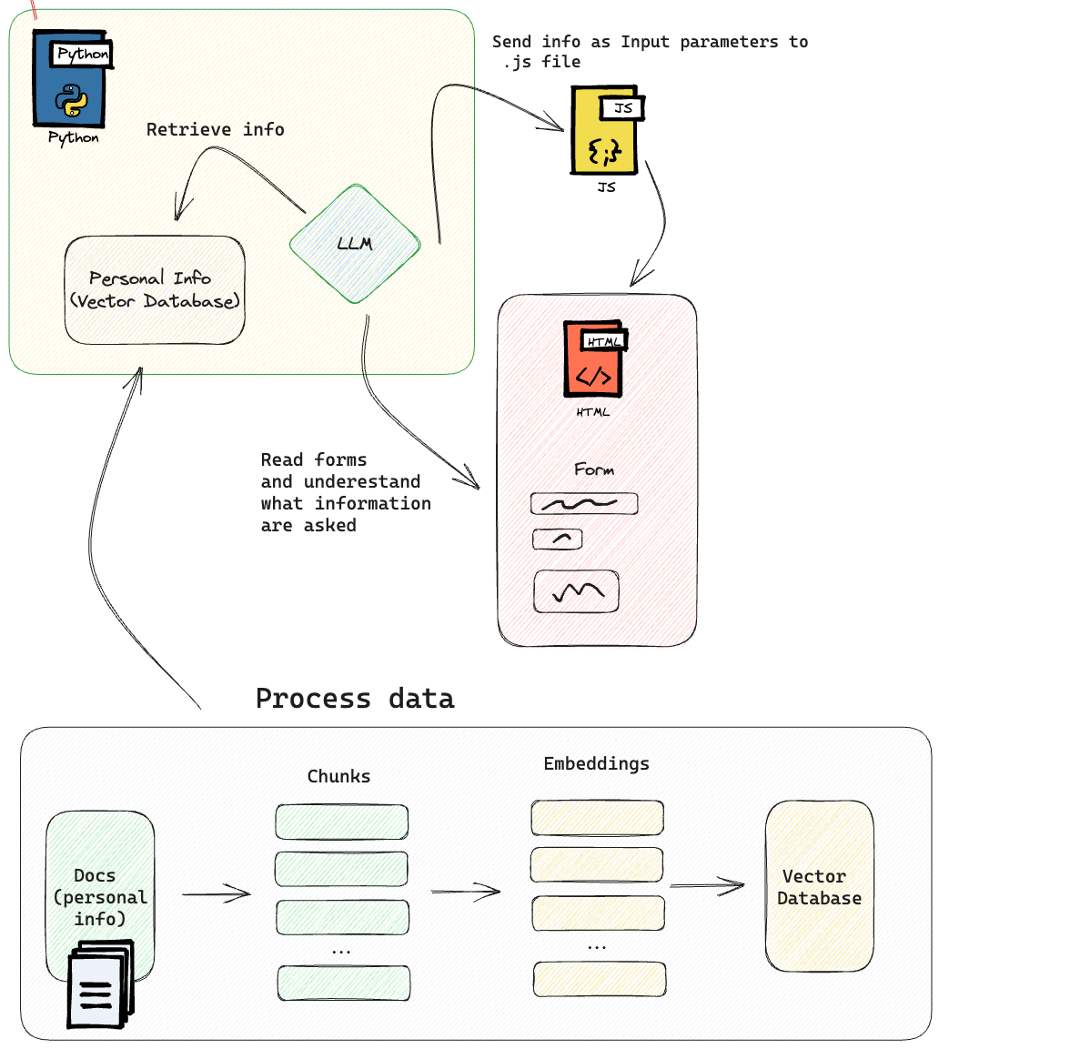

4. Implementation

4.1 Document ingestion and vector database
The notebook loads PDF files from the local `info` directory using `PdfReader`. Each page is extracted as text and grouped into document records. The text is split into overlapping chunks (the implementation uses a 1,000-character chunk size and 200-character overlap). Each chunk retains its source filename and chunk number.
The chunks are embedded using `sentence-transformers/all-MiniLM-L6-v2`. Embeddings are normalized and stored in a FAISS `IndexFlatIP` index, allowing inner-product search to operate as cosine-similarity retrieval. This creates the local retrieval layer used by the form-filling process.

4.2 HTML form parsing
The uploaded HTML is parsed with BeautifulSoup. The parser examines `input`, `textarea`, and `select` controls and captures identifiers and useful metadata including `id`, `name`, `type`, `value`, `placeholder`, `aria-label`, labels and select options. Submit/button controls are excluded from the set of fields to be filled.
The extracted metadata is sent to the LLM as structured data. The prompt explicitly treats the HTML as untrusted data and instructs the model not to follow instructions embedded in labels, placeholders, comments or other form content. The LLM returns a JSON object containing the fields to fill.

4.3 Retrieval-augmented field filling
For every extracted field, the notebook constructs a retrieval query from the field label, HTML type, name and available options. FAISS returns the most relevant document chunks. Those chunks are passed to a second LLM call together with the field definition.
The filling prompt requires the model to use only the supplied evidence. When evidence is insufficient, the expected response is `Not Available` with `found: false`, rather than an inferred or fabricated personal value. For option-based controls, the model is instructed to select an allowed option value.

4.4 Deterministic HTML rendering
The LLM does not generate the completed HTML document. Instead, the notebook uses BeautifulSoup to locate the original controls by HTML ID or name and writes the returned values into those controls. This separation reduces the risk of altering the form's layout, CSS, IDs, JavaScript hooks or other markup. The completed HTML is then exported as `filled_form.html` and the field-level results and provenance are exported as `filled_form_results.json`.

4.5 Main software dependencies
Library | Role
OpenAI Python client | OpenRouter-compatible LLM API access
PyPDF | PDF text extraction
Sentence Transformers | Local text embeddings
FAISS | Vector similarity search
BeautifulSoup4 / lxml | HTML parsing and modification
NumPy | Embedding/index array handling
ipywidgets / IPython | Notebook upload and display interface

5. Testing and Validation
The implementation was tested using the synthetic profile document supplied with the project and the accompanying sample HTML form. The source PDF contains the following profile information: Full Legal Name: Riya Sharma; Date of Birth: 22 August 1991; Residential Address: 17 Sunrise Apartments, Hill Road; City: Bengaluru; State: Karnataka; ZIP: 560038; Phone: +91 91234 56780; Email: riya.sharma.demo@example.com; Employer: BluePeak Technologies; and Occupation: Software Engineer.

5.1 Missing-information test
A Passport Number field was deliberately added to the sample HTML form even though Passport Number does not occur in the supplied profile document. This is an important validation case because a form filler should distinguish between retrieved evidence and unsupported information.
Test | Expected behavior | Observed validation
PDF ingestion | Source document is loaded and text extracted | Pass
Vector indexing | Extracted chunks are embedded and indexed | Pass in functional test
HTML field extraction | Form controls become structured fields | Pass
Known personal field | Supported value is retrieved and returned | Pass
Unknown Passport Number | Return `Not Available`, not a fabricated value | Pass
HTML rendering | Values are inserted into original controls | Pass
JSON output | Field values and provenance are exported | Pass

5.2 Example field results
Form field | Expected result | Evidence status
Full Legal Name | Riya Sharma | Available
Email Address | riya.sharma.demo@example.com | Available
Employer | BluePeak Technologies | Available
Occupation | Software Engineer | Available
Passport Number | Not Available | No supporting evidence
The functional validation also checked that the generated HTML contains known values and the `Not Available` result for the deliberately unsupported Passport Number field, while excluding the submit button from the extracted data-field set.

6. Security and Reliability Considerations
- Private document text and embeddings are kept in the local notebook environment; only the field definition and retrieved evidence needed for a field are sent to the LLM endpoint.
- The HTML is treated as untrusted data during LLM parsing to reduce instruction-injection risks from form content.
- The LLM is constrained to retrieved evidence and has an explicit missing-data path.
- The final HTML is produced by deterministic Python code rather than by asking the LLM to rewrite the complete document.
- The JSON output retains source-chunk references and reasoning text to support inspection of field-level results.

7. Conclusion
The AI Form Filler prototype demonstrates an end-to-end approach for automatically completing HTML forms from information stored in private documents. Its central design is a retrieval-augmented generation pipeline: the vector database supplies evidence, while the LLM performs form understanding and evidence-based field selection. The final HTML modification is deterministic, keeping the model focused on semantic tasks rather than markup generation.
The deliberate missing-field test is particularly significant. By adding Passport Number to the form without adding Passport Number to the source document, the prototype verifies that unsupported information can be surfaced explicitly as `Not Available`. This behavior is preferable to silently inventing a value and provides a useful foundation for production-oriented validation and human review.

8. Current Workflow
- Upload private PDF documents.
- Extract PDF text and split it into searchable chunks.
- Generate local embeddings and build the FAISS vector index.
- Upload an HTML form.
- Parse HTML controls and ask the LLM to describe the fields.
- Retrieve relevant document chunks for each field.
- Ask the LLM to return a value supported by the retrieved evidence.
- Return `Not Available` when the evidence does not support a value.
- Write supported values into the original HTML using BeautifulSoup.
- Export the filled HTML and JSON provenance results.

9. Future Enhancements
- Add stronger schema validation for every LLM response, including retry/repair handling for malformed JSON.
- Introduce confidence thresholds so low-similarity retrieval results can trigger human review.
- Support more complex forms such as repeated field groups, nested forms, date controls, multi-select controls and dynamic JavaScript-generated fields.
- Persist the FAISS index and document metadata between notebook sessions rather than rebuilding the index each time.
- Add page-level provenance to every retrieved answer where available.
- Wrap `handle_form_data()` in a Flask or FastAPI service for browser-based form filling.
- Add authentication, access controls, encryption and logging policies before using real personal documents.
- Add automated regression tests covering malformed HTML, duplicate field names, empty PDFs, missing labels and unsupported control types.

10. Final Outcome
The verified prototype provides a practical foundation for an AI-assisted form-filling system. It combines document retrieval with LLM-based form interpretation while retaining deterministic control over the final HTML. The notebook is structured so that the core `handle_form_data()` function can subsequently be integrated into a web application.

