CPP_PlayerClassExample: Easy Solution Moving Up and Down
For this solution, we just need to edit CPP_PlayerClassExample.cpp. It assumes you have finished the main task in the README, so the player can already move left and right with a and d, and PrintPos tells you where the player is.

Step 1: Update the prompt
The player needs to know the new keys exist. At the top of the while loop, change the prompt (if you do not have one yet, add it above the cin):
cout << "Press w, a, s or d to move\n";
Always tell the player what they can do before you ask for input; a blank console waiting for a key is a bad first impression.

Step 2: Add the up and down checks
Moving up and down is the same as left and right, but on the y axis instead of the x. Under the input[0] == 'd' block, add two more else if blocks:
else if (input[0] == 'w')
{
p.Move(0, 1);
cout << "Player moved up\n";
}
else if (input[0] == 's')
{
p.Move(0, -1);
cout << "Player moved down\n";
}
Notice we pass 0 for the x and 1 or -1 for the y. I am using maths-style axes, where up makes y bigger. Screens often flip this so y grows downwards; either is fine as long as you stay consistent, which matters a lot once you have walls and items on the grid.
Save, build (Ctrl + Shift + B) and run (F5).

Step 3: Test it
Try each key and check the position changes the way you expect:
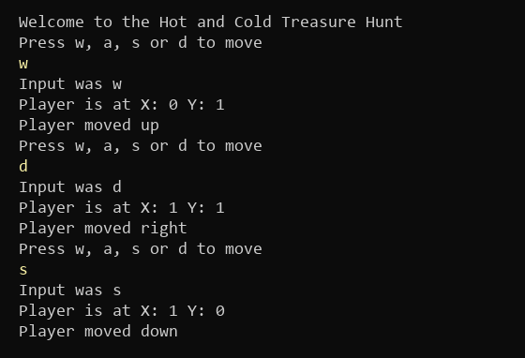
Figure 1: Moving up, right and then down (what you type is in yellow)
You will notice you can walk forever in any direction, including into negative numbers. That is the next Easy task.

Things to think about
This works, but we now have four blocks that are nearly identical; only the key, the direction and the message change. Repeated code like this is where bugs hide, because a fix in one block is easy to forget in the others. You could:
- Use a switch on input[0] instead of a chain of else if statements
- Work out an x and y direction first, then call Move once at the end (we do this in the third Easy solution)
- Add diagonal moves with q, e, z and c, and see how quickly the copy-and-paste version grows
Also, the "getting warmer/colder" messages from the main task are not real yet; they only become meaningful once there is an Item to find in the Medium task.

