CPP_PlayerClassExample: Easy Solution Keeping the Player on a 10 x 10 Grid
For this solution, we edit Player.h, Player.cpp and CPP_PlayerClassExample.cpp. It follows on from the first Easy solution, so you should be able to move in all four directions.

Step 1: Declare CanMove in the header
The header is the floor plan of the class, so first we say the Player can answer the question "can I move this way?". In Player.h, under PrintPos, add:
bool CanMove(int xDir, int yDir);
It returns a bool, true or false, and takes the same direction values as Move, so the two functions line up.

Step 2: Implement CanMove
In Player.cpp, add the implementation at the bottom of the file. Remember the Player:: at the front, which says this function belongs to the Player class:
bool Player::CanMove(int xDir, int yDir)
{
// work out where the player would end up
int newX = x + xDir;
int newY = y + yDir;

// 0 to 9 on each axis gives a 10 * 10 grid
return newX >= 0 && newX < 10 && newY >= 0 && newY < 10;
}
We check where the player would end up, rather than moving them and then moving them back. The grid runs from 0 to 9, which is 10 squares, so we use < 10 and not <= 10. Getting this wrong by one is so common it has a name: an off-by-one error.

Step 3: Check before moving
Back in CPP_PlayerClassExample.cpp, add && p.CanMove(...) to each of the four checks, passing the same values you pass to Move:
if (input[0] == 'a' && p.CanMove(-1, 0))
{
p.Move(-1, 0);
cout << "Player moved left\n";
}
Do the same for d (1, 0), w (0, 1) and s (0, -1). The && only calls CanMove if the key matched first; if the key is wrong, C++ does not bother checking the right-hand side. This is called short-circuit evaluation, and it works the same way in C#.

Step 4: Test it
The player starts at X: 0 Y: 0, which is the bottom-left corner, so a and s should now do nothing, while w and d still work:
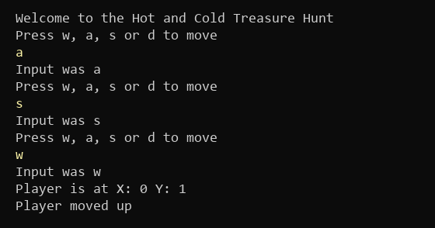
Figure 1: a and s are blocked at the corner, w still moves (what you type is in yellow)
Walk to the other edges too and make sure the player stops at 9, not 10.

Things to think about
The number 10 is hard coded in CanMove. This is called a magic number: if a designer wants a bigger map, they have to find it in the code. You could:
- Store the size as a variable, e.g. const int GridSize = 10;, or pass the bounds in through a constructor
- Start the player in the middle of the grid instead of a corner. With 10 squares there is no exact middle, which is one reason grids are often an odd size like 9 x 9
Most importantly, when the player hits the edge nothing happens. No message, no feedback; the game just ignores them. That is a poor experience, and it is exactly what the next Easy task fixes.

