CPP_PlayerClassExample: Easy Solution Feedback and Input Checking
For this solution, we only edit CPP_PlayerClassExample.cpp. It follows on from the first two Easy solutions. We will make the game tell the player what happened every turn: where they moved, when they hit the edge, when they typed the wrong thing, and when they typed nothing at all.

Step 1: Swap cin >> for getline
To spot "no input", we need to change how we read it. cin >> input skips over spaces and Enter, so if the player just presses Enter, it keeps waiting and our code never sees an empty string. getline reads the whole line, including an empty one. Replace the cin >> input; line with:
getline(cin, input);
You can also remove the "Input was" line now; we are about to give much better feedback.

Step 2: Catch empty and long input
Straight after the getline, check the input before doing anything else:
// nothing typed, just Enter
if (input.empty())
{
cout << "You didn't type anything, try w, a, s or d\n";
continue;
}

// more than one letter, e.g. "dd" or "left"
if (input.size() > 1)
{
cout << "One letter please, you typed \"" << input << "\"\n";
continue;
}
empty() is true when nothing was typed, and size() tells us how many characters there are. The continue keyword skips the rest of the loop and jumps back to the top, so the player is simply asked again.

Step 3: Ignore caps lock
If caps lock is on, W is not the same character as w. At the top of the file, add the include for the character functions:
#include <cctype> // for tolower
Then, after the checks from Step 2, turn the key into lower case:
// turn W into w, so caps lock doesn't matter
char key = (char)tolower(input[0]);
tolower hands back an int, so the (char) turns it back into a character. This is a C-style cast; C++ also has static_cast<char>(...), which does the same job more safely.

Step 4: Work out the direction, then check it
In the second Easy solution, a blocked move and a wrong key both fell through the else if chain silently, so we could not tell them apart. Replace your four if blocks with this, which works out the direction first:
// work out the direction first, then check it
int xDir = 0;
int yDir = 0;
string direction;

if (key == 'a') { xDir = -1; direction = "left"; }
else if (key == 'd') { xDir = 1; direction = "right"; }
else if (key == 'w') { yDir = 1; direction = "up"; }
else if (key == 's') { yDir = -1; direction = "down"; }
else
{
cout << "\"" << input << "\" isn't a move\n";
continue;
}
The final else catches every key that is not a move, so a wrong key now gets its own message.

Step 5: Tell the player what happened
Now we know the direction, we check the edge once and move once, instead of four times:
if (!p.CanMove(xDir, yDir))
{
cout << "You can't go " << direction << ", it's the edge\n";
continue;
}

cout << "You moved " << direction << "\n";
p.Move(xDir, yDir);
The ! means "not", so the message only appears when the move is blocked. Finally, add p.PrintPos(); just after Player p; so the player knows where they start.

Step 6: Test it
Try to break your own game. Test every case on purpose:
- Press Enter with nothing typed
- Type W with caps lock on
- Type a whole word, like left
- Type a key that is not a move, like q
- Walk into the edge of the map
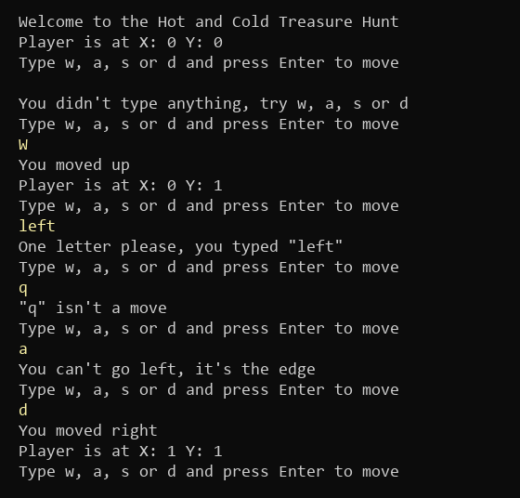
Figure 1: Every case gets a clear message (what you type is in yellow)

The finished code
Here is the whole of CPP_PlayerClassExample.cpp after all three Easy tasks, if you want to check yours against it:
#include <iostream>
#include "Player.h"
#include <string>
#include <cctype> // for tolower
using namespace std;

int main()
{
cout << "Welcome to the Hot and Cold Treasure Hunt\n";
Player p;
p.PrintPos();

string input;
while (true)
{
cout << "Type w, a, s or d and press Enter to move\n";
getline(cin, input);

// empty check
if (input.empty())
{
cout << "You didn't type anything, try w, a, s or d\n";
continue;
}

// more than one letter
if (input.size() > 1)
{
cout << "One letter please, you typed \"" << input << "\"\n";
continue;
}

// handle caps
char key = (char)tolower(input[0]);

// work out the direction first, then check it
int xDir = 0;
int yDir = 0;
string direction;

if (key == 'a') { xDir = -1; direction = "left"; }
else if (key == 'd') { xDir = 1; direction = "right"; }
else if (key == 'w') { yDir = 1; direction = "up"; }
else if (key == 's') { yDir = -1; direction = "down"; }
else
{
cout << "\"" << input << "\" isn't a move\n";
continue;
}

if (!p.CanMove(xDir, yDir))
{
cout << "You can't go " << direction << ", it's the edge\n";
continue;
}

cout << "You moved " << direction << "\n";
p.Move(xDir, yDir);
}
}

Things to think about
Clear feedback is one of the cheapest ways to make a game feel polished, and it is something you are marked on in the assignment. You could:
- Give the messages some personality; the wall message in the Hard task slots straight into the CanMove check
- Move the key-to-direction code into its own function that returns true or false, which keeps main short and readable
- Use the carriage return \r from the Refinements to stop the console filling up with old messages

