CPP_PlayerClassExample: Medium Solution Creating an Item Class
For this solution, we add a new class, Item, and make one in CPP_PlayerClassExample.cpp. It follows on from the Easy solutions, so the player can move around the 10 x 10 grid with clear feedback. The Item is the treasure the player is hunting for.

Step 1: Add the class
In the Solution Explorer, right click the project (CPP_PlayerClassExample, just under the solution) and choose Add -> Class.... Right clicking the solution itself gives you Add -> New Project, which is not what we want.
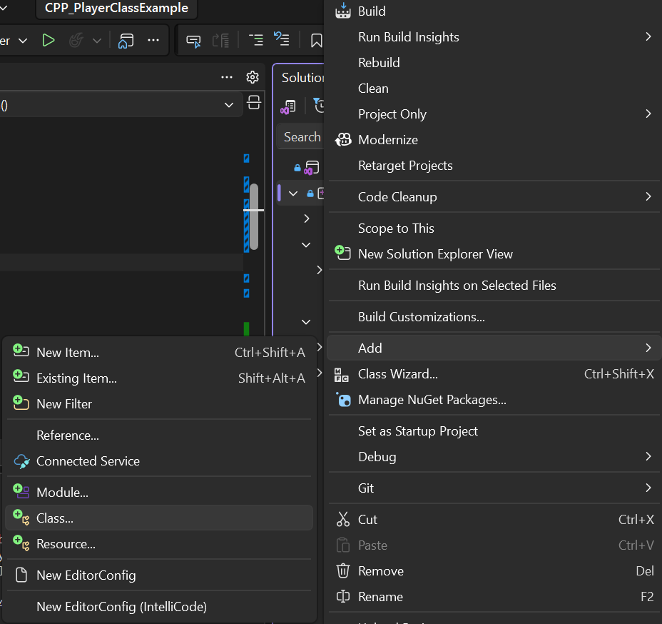
Figure 1: Add -> Class... on the project
Name the class Item, Visual Studio fills in the .h and .cpp file names for you. Leave the base class empty and click OK:
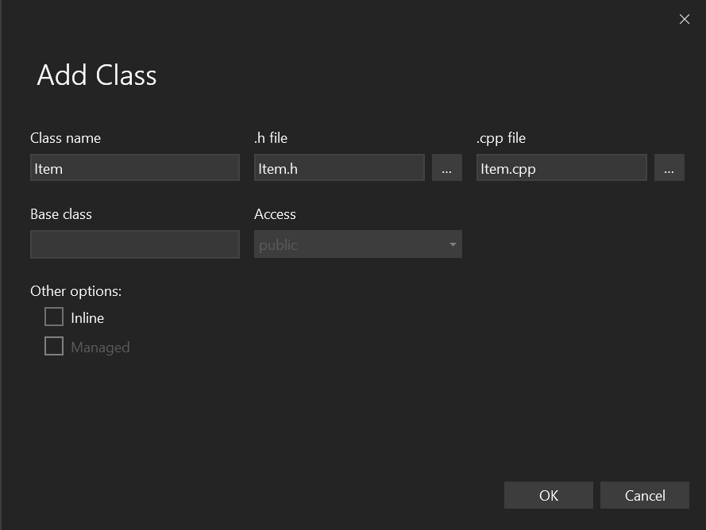
Figure 2: Naming the class Item
You now have Item.h and Item.cpp, just like the Player.

Step 2: Give the Item a position
The Item needs to know where it is on the grid, exactly like the Player. In Item.h, add an x and y under public:
#pragma once
class Item
{
public:
int x = 0;
int y = 0;
};
Remember the public: label; in C++ a class is private by default, so without it the main could not read item.x.

Step 3: Make an Item in main
In CPP_PlayerClassExample.cpp, include the new header next to the Player one:
#include "Item.h"
Then, after the Player is made and before the while loop, make the Item and place it somewhere to test with:
// the item we are hunting for, made once before the loop
Item item;
item.x = 3;
item.y = 2;

// DEBUG: remove this once you know it works
cout << "(debug) Item is at X: " << item.x << " Y: " << item.y << "\n";
Notice there is no new here. In C# you would write Item item = new Item();, but in C++ Item item; creates the whole object straight away, on the stack, just like an int. It is cleaned up automatically when main ends; we will look at new and the heap when we cover pointers.
It must be made before the loop. If you make it inside the loop, a brand new item is created every turn and the player can never find it.
The debug line is just for us, so we can check the item is where we think it is. Remove it once the game works, otherwise it rather spoils the hunt.

Step 4: Test it
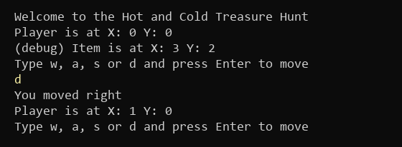
Figure 3: The item is made at X: 3 Y: 2 (what you type is in yellow)

Things to think about
The Item and the Player both have an x and a y, and later the walls from the Hard task will too. That is the same code three times. You could:
- Make a Position struct, or a base class both inherit from, so the x and y live in one place
- Keep the debug print, but wrap it in a bool debug = true; check so you can switch it off without deleting it

