CPP_PlayerClassExample: Medium Solution Item Constructors and a Random Position
For this solution, we edit Item.h, Item.cpp and CPP_PlayerClassExample.cpp. We give the Item two constructors: one where we choose the square, and a default one that picks a random square on the 10 x 10 grid.

Step 1: Declare the constructors
A constructor, just like in C#, has the same name as the class and no return type. In Item.h, add both under the x and y:
#pragma once
class Item
{
public:
int x = 0;
int y = 0;

Item(); // default: a random square
Item(int StartX, int StartY); // a square we choose
};
Having two functions with the same name but different parameters is called overloading; C++ picks the right one from what you pass in.

Step 2: Implement the constructor with a position
In Item.cpp, we implement it like the Player functions, with Item:: in front, but still no return type:
Item::Item(int StartX, int StartY)
{
x = StartX;
y = StartY;
}
Now in main you can make an item at a chosen square with:
Item i(1, 2);

Step 3: Implement the random constructor
At the top of Item.cpp, include the library with rand in it:
#include <cstdlib> // for rand
Then add the default constructor:
Item::Item()
{
// rand() % 10 gives 0 to 9, which matches our 10 * 10 grid
x = rand() % 10;
y = rand() % 10;
}
rand() gives a big random number, and % 10 (the remainder after dividing by 10) squashes it into 0 to 9. Be careful if you followed the dice example: it adds 1 to get 1 to 6, but our grid from the Easy task runs 0 to 9. rand() % 10 + 1 would give 1 to 10, and an item on 10 is off the grid and can never be found.

Step 4: Seed the random numbers once
Computers cannot really make random numbers; rand() follows a fixed sequence from a starting seed. Without a seed, the item lands on the same square every time you play. In CPP_PlayerClassExample.cpp, include the two libraries:
#include <cstdlib> // for srand
#include <ctime> // for time
And at the very start of main, seed it with the clock:
// seed the random numbers once, using the clock
srand((unsigned int)time(0));
Only seed once, here at the start of main. If you put srand in the constructor, every Item made in the same second gets the same seed, so they all land on the same square. You will not notice with one item, but you will with the walls in the Hard task.

Step 5: Use the random constructor
Remove the item.x = 3; and item.y = 2; lines from the Medium 1 solution, so the item is just:
Item item;
Notice there are no brackets. It is tempting to write Item item(); to show you mean the default constructor, but C++ reads that as declaring a function called item that returns an Item. You only find out later, when item.x gives you this rather unhelpful error:
error C2228: left of '.x' must have class/struct/union
Visual Studio does warn you on the line itself with C4930 "prototyped function not called (was a variable definition intended?)", but warnings are easy to miss. If you see that error, check your brackets.

Step 6: Test it
Run the game a few times; the debug line should show a different square each time:
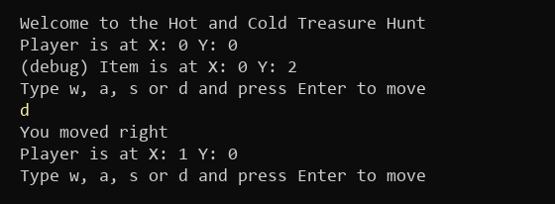
Figure 1: A random item, yours will be somewhere else (what you type is in yellow)

Things to think about
- The item can land on X: 0 Y: 0, right under the player. How could the default constructor avoid that square?
- The 10 is now in two places, CanMove and the Item constructor. If one changes and the other does not, items will appear off the grid; this is a good reason for a single GridSize value
- Modern C++ has a better random library, <random>, with std::mt19937; worth a look once you are comfortable

