CPP_PlayerClassExample: Medium Solution Warmer or Colder
For this solution, we edit Player.h, Player.cpp and CPP_PlayerClassExample.cpp. Until now the "getting warmer/colder" messages were made up; now we work out how far the player really is from the item, and compare it to how far they were last turn.

Step 1: Pick a distance
There are two common ways to measure distance:
- Euclidean: the straight line, as the crow flies. It needs sqrt from <cmath> and gives decimals, so it must be stored as a float
- Manhattan: the number of grid moves, across plus up. It only needs abs and stays as whole numbers
As our player moves on a grid, Manhattan is the better fit, so we will use that. It is named after the grid layout of Manhattan's streets: you cannot walk diagonally through the buildings.

Step 2: Add DistanceTo to the Player
The Player is the one moving, so it makes sense for the Player to answer "how far am I from this square?". In Player.h, under CanMove, add:
int DistanceTo(int targetX, int targetY);
We pass in the item's x and y as two ints, rather than the Item itself; we will look at passing whole objects around when we cover pointers. In Player.cpp, include the library for abs:
#include <cstdlib> // for abs
And implement it at the bottom of the file:
int Player::DistanceTo(int targetX, int targetY)
{
// Manhattan distance: how many grid moves away the target is
return abs(targetX - x) + abs(targetY - y);
}
abs gives the absolute value, so -3 becomes 3. We need it because the item could be to the left or below the player, which would make the difference negative.

Step 3: Remember the starting distance
To say warmer or colder, we need something to compare against. In CPP_PlayerClassExample.cpp, after the item is made and before the loop, store the starting distance:
// how far away we start, so the first move has something to compare to
int lastDistance = p.DistanceTo(item.x, item.y);
This has to be outside the loop; a variable made inside the loop is created fresh every turn and forgets the last value.

Step 4: Compare after each move
At the end of the loop, straight after p.Move(xDir, yDir);, work out the new distance, compare it, and then save it for next turn:
// compare the new distance to the last one
int distance = p.DistanceTo(item.x, item.y);
if (distance < lastDistance)
{
cout << "Warmer...\n";
}
else
{
cout << "Colder...\n";
}
lastDistance = distance;
The last line is the one people forget. Without it, every move is compared to the starting distance, not the last one, so the messages stop making sense once you have moved a few squares.
If your a and d moves still print "getting warmer" or "getting colder" from the main task, remove those messages now; they were never checking the item.

Step 5: Test it
Use the debug line to see where the item is, walk towards it, then step away:
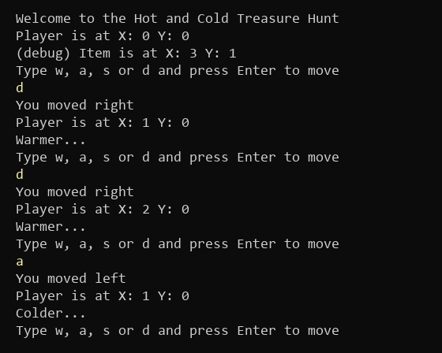
Figure 1: Two steps towards the item, then one away (what you type is in yellow)
With Manhattan distance on a grid, every move changes the distance by exactly 1, so you always get warmer or colder, never "the same".

Things to think about
- When the distance reaches 0 the player is standing on the item, but the game just says "Warmer...". That is the first Hard task
- The Refinements ask for more context than warmer or colder. The distance is now an actual number, so you could say "Warmer, but still a long way off" when it is over 10, or "Red hot!" at 1
- Try the Euclidean version too, and print both distances each turn to see how they differ as you walk around the item

