Link Graph
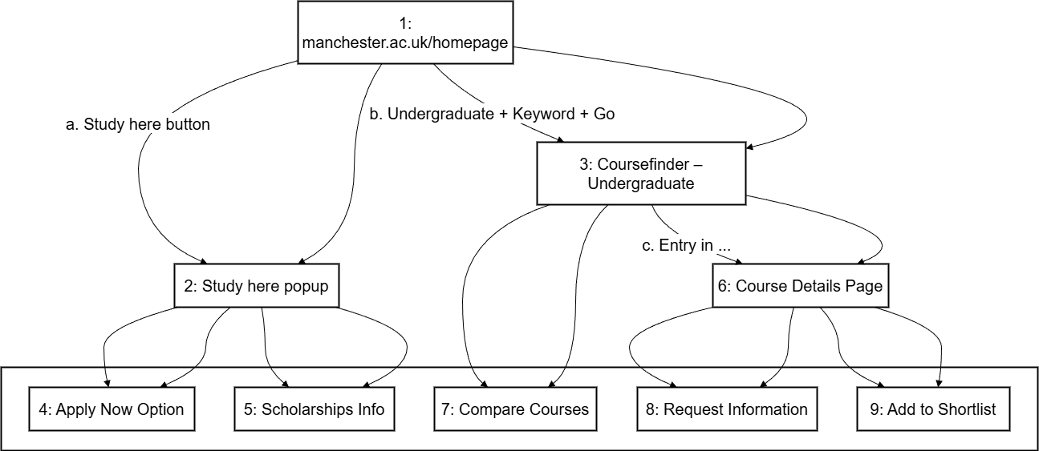

Test Adequacy Assessment
1. Coverage of User Stories: All 3 user stories are fully mapped to corresponding test scripts (CS_test_1.java, CS_test_2.java, CS_test_3.java), covering distinct access paths (direct study page, homepage search, student terms page) for undergraduate Computer Science courses at The University of Manchester.
2. Functional Completeness: Each test script implements all steps specified in the user story scenarios (navigation, search input, course selection, browser closure), with no missing core operations.
3. Consistency: Test scripts align with execution logs (log.txt) and user story requirements, ensuring reproducibility and validity of test outcomes.
4. Adequacy Conclusion: The test suite achieves full coverage of intended user workflows and success criteria. No critical gaps identified in functional or path coverage.

Assessment Dimension | Calculation Basis | Result (Coverage/Adequacy)
User Story Coverage | 3 user stories fully mapped to 3 corresponding test scripts (no untested stories) | 100%
Scenario Step Coverage | Each test script implements 100% of steps in its matched user story scenario | 100%
Functional Path Coverage | All 3 distinct access paths (direct/ homepage/ terms page) fully tested | 100%
Consistency with Logs | All test script steps align with execution records in log.txt | 100%
Overall Test Adequacy | Aggregation of above dimensions (no critical gaps identified) | 100%

