1. Settings of hyperparameters and training set lengths for the four models

The hyperparameter configurations of the models corresponding to the prediction results of all the models shown in the report under different scenarios are described in the appendix.

When you need to check the performance of the models, you only need to adjust the length of the training set (if short-term data is used as the training set) and the hyperparameters of the models according to the appendix.

2. Data filtering

When you want to use the whole week's data, run the following cell:

.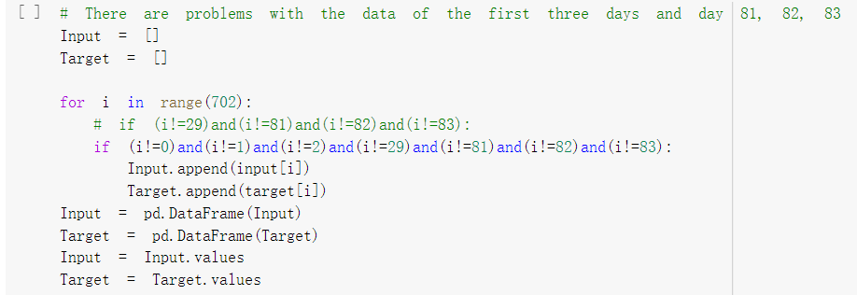

When you want to use data for weekdays only, run the following cell:

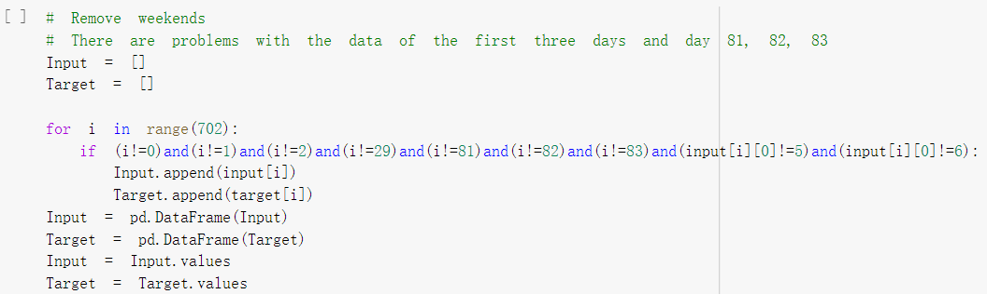

3. Change the scoring criteria of the model when hyperparameter adjustment

In the grid search of "forecasting_4_households_(D2).ipynb", as shown in the figure below, the top two lines of code indicate that MSE is used as the scoring criterion, and the bottom two lines of code indicate that MAPE is used as the scoring criterion.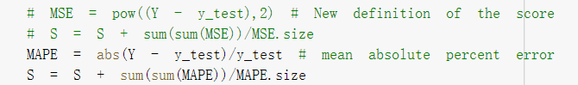

4. Replace the used dataset in the code

In "forecasting_4_households_(D2).ipynb", the default is to use the data from all four households in D2 and calculate the average of the four households' electricity consumption for evaluating and testing the model. If you want to see the model for 1, 2, and 3 households separately, you need to comment out (2, 3, 4), (3, 4), and (4) in the figure below, and modify the code to find the average.

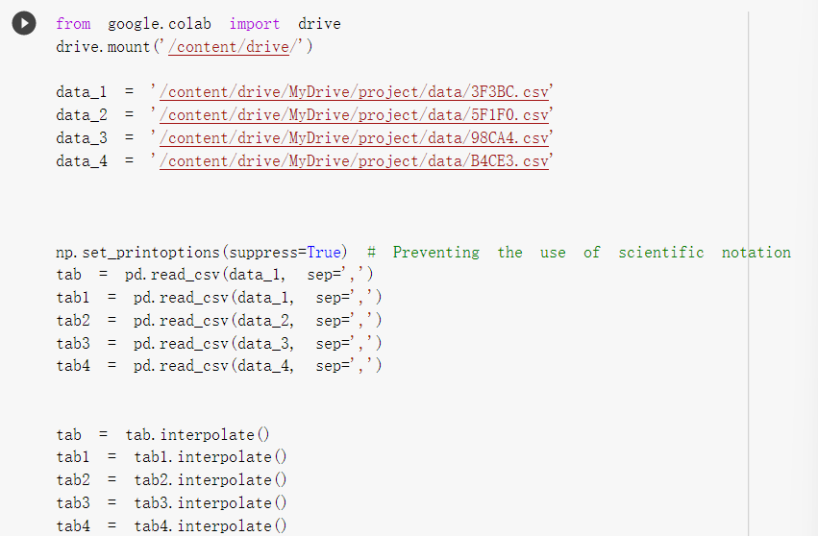

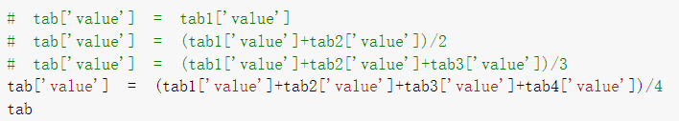

The "forecasting 200 households (D3)" also requires replacing the dataset in the code below to see the performance of the model for the corresponding dataset, but without changing the average values for the different households' electricity consumption (the average values are already calculated in the dataset).

