**COFFEE**

**Ben’s Green Cafe**

Address: Bougainvilla Street, Timog Hills Subdivision Pampang Angeles City 2009

Contact No.: 0917 728 1288

Facebook Page: @bensgreencafe



**Coffee Imprints**

Address: Don Juico Ave Angeles City 2009

Contact No.: 0915 123 4567

Facebook Page: @CoffeImprints



**NorthernBrew Coffee Shop**

Address: G/F, Nmp Building 11 Trinity Square, Villa Angela Angeles City 2009

Facebook Page: @nbcoffeeac

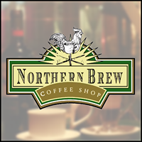

**Coffee ARENA**

Address: Balibago Angeles City 2009

Contact No.: 0926 475 4103

Facebook Page: @COFFEEARENABALIBAGO

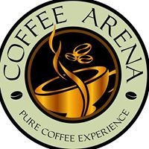

**Sesttle’s Best Coffee**

Address: Newpoint Mall, Newpoint Nepo Center, Sto Rosario, Angeles City, Pampanga, 2009

Facebook Page: @SeattlesBestCoffeeAngeles

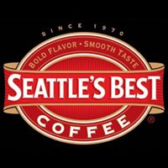

**Starbucks**

Address: M.A. Roxas Hwy Angeles City 2009

Contact No.: (045) 499 0332

Facebook Page: Starbucks Philippines (Angeles City)

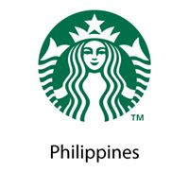

**MILK TEA**

**Bon Appetea Angeles, Pampanga**

Address: 2 Sto Entierro, Sto Rosario Angeles City 2009

Contact No.: (045) 901 0477

Facebook Page: Bon Appetea Angeles, Pampanga



**Owl Milk Tea and Snack Bar**

Address: Upper Ground Floor 04 Newpoint Mall, Entec 2 Bldg., Plaridel cor. Catarina st., Nepo Center, Angeles City, Pampanga

Contact No.: 0917 450 3129

Facebook Page: @owlmilkteabar

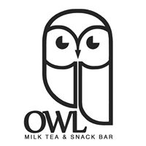

**Lianhei Teahouse**

Address: 2nd Floor, Busy Bee Commercial Center, #307 Sto. Rosario St., Brgy.Sto. Rosario Angeles City 2009

Contact No.: 0923 388 4556

Facebook Page: @LianheiTeaHouse



**Cheers House Of Milk Tea**

Address: Mc Arthur Hi-way Angeles City

Contact No.: 0922 242 3446

Facebook Page: Cheers house of milk tea



**La Nilad Coffee & Tea House**

Address: 2nd Floor, SM City Clark, M. A. Roxas Hi-Way, CSEZ, Angeles City 2009

Contact No.: 0926 621 7396

Facebook Page: @Laniladclark



**Grabatea Milk Tea Shop**

Address: Oceana Commercial Complex Balibago Angeles City 2009

Contact No.: 0920 623 1583

Facebook Page: @GrabateaMilkTeaShop



**FRAPPES**

**Foss Coffee Balibago**

Address: Balibago Angeles City 2009

Facebook Page: @FossCoffeeBalibago

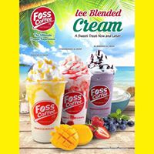

**Star Frappe’**

Address: MacArthur Hwy Angeles City 2009

Contact No.: (045) 892 2375

Facebook Page: Star Frappe’

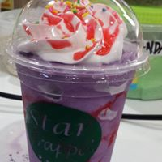

**DJ Frappe Zone**

Address: Nepo St Angeles City 2009

Facebook Page: @djfrappezone

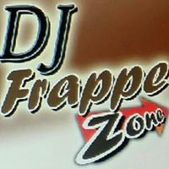

**Vince Frappe**

Address: 245 Lakandula st, San Jose Angeles City

Contact No.: 0933 102 3650

Facebook Page: @vincefrappe



**FRAPELLO**

Address: Miranda st Angeles City 2009

Contact No.: 0926 707 4272

Facebook Page: FRAPELLO

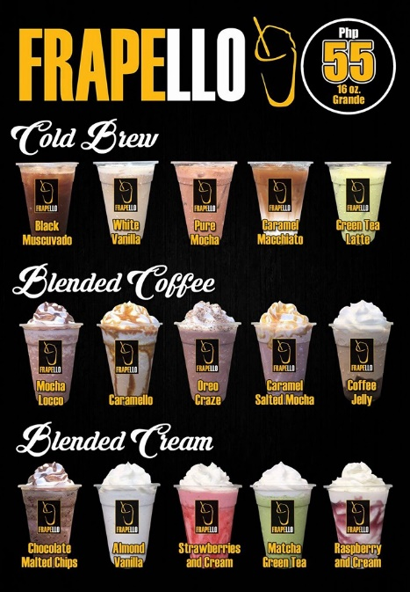

**Bon Appetea Angeles, Pampanga**

Address: 2 Sto Entierro, Sto Rosario Angeles City 2009

Contact No.: (045) 901 0477

Facebook Page: Bon Appetea Angeles, Pampanga

