BLUESTOCK FINTECH
Mutual Fund Analytics Capstone
End-to-End Project Report: Data Engineering, Exploratory Data Analysis,
Performance Analytics & Interactive Power BI Dashboard
Analysis Period: January 2022 – December 2025
Prepared for: Bluestock Fintech
Report Date: June 2026
Deliverable: bluestock_mf.pbix (Power BI Dashboard)

Table of Contents

1. Executive Summary ................................................................ 3

2. Data Overview ..................................................................... 4
2.1 Data Sources ................................................................. 4
2.2 Data Model ................................................................... 4
2.3 Table Reference .............................................................. 5
2.4 Coverage and Scale ........................................................... 6

3. ETL Process ........................................................................ 7
3.1 Extraction ................................................................... 7
3.2 Transformation ............................................................... 7
3.3 Loading and Modelling ........................................................ 8
3.4 Data Quality Checks .......................................................... 8
3.5 Refresh Considerations ....................................................... 8

4. Exploratory Data Analysis Findings ................................................ 9
4.1 NAV and Return Trends ........................................................ 9
4.2 AUM and Industry Growth ...................................................... 9
4.3 SIP Trends and Category Flows ................................................ 9
4.4 Investor Demographics and Behaviour ......................................... 10
4.5 Portfolio Composition and Sector Bias ....................................... 10

5. Performance Analytics ............................................................ 11
5.1 Benchmark Comparison — Growth of ₹1 Invested ................................ 11
5.2 Risk-Adjusted Performance — Rolling 90-Day Sharpe Ratio ..................... 12
5.3 Sector Concentration — Herfindahl-Hirschman Index (HHI) ..................... 13

6. Power BI Dashboard Overview ...................................................... 15
6.1 Page 1 — Industry Overview .................................................. 15
6.2 Page 2 — Fund Performance ................................................... 15
6.3 Page 3 — Investor Behaviour ................................................. 16
6.4 Page 4 — SIP and Inflows .................................................... 16

7. Recommendations ................................................................... 18
7.1 For Investment and Product Teams ............................................ 18
7.2 For Marketing and Growth Teams .............................................. 18
7.3 For the Analytics and Dashboard Team ........................................ 18

8. Limitations ........................................................................ 20
8.1 Data Coverage Limitations .................................................... 20
8.2 Methodological Limitations ................................................... 20
8.3 Dashboard and Tooling Limitations ............................................ 20

9. Appendix ........................................................................... 22
9.1 Glossary of Terms ............................................................. 22
9.2 Source Files Referenced ...................................................... 22

1. Executive Summary
Bluestock Fintech's Mutual Fund Analytics Capstone was undertaken to build a complete, end-to-end analytics solution for the Indian mutual fund industry, covering the period from January 2022 to December 2025. The project combines a structured data warehouse, a Python-based exploratory data analysis (EDA) and performance analytics workflow, and an interactive Power BI dashboard (bluestock_mf.pbix) that brings together fund-level, investor-level, and industry-level data into a single analytical environment.
The underlying data model follows a star schema with two dimension tables (dim_fund and dim_date) and six fact tables capturing daily NAV history, investor transactions, fund performance metrics, portfolio holdings, fund-house AUM, and industry-wide SIP statistics. In total, the model spans roughly 80,000 rows across approximately 40 mutual fund schemes, providing a representative cross-section of the open-ended equity and hybrid fund universe.
Exploratory analysis confirms several well-known characteristics of the Indian mutual fund industry over the study period, while also surfacing a number of actionable patterns:
- Industry growth has been substantial — total folio counts nearly doubled, rising from approximately 13.26 crore in January 2022 to approximately 26.12 crore in December 2025.
- Systematic Investment Plan (SIP) inflows have shown a sustained upward trend, reaching a peak of close to ₹31,002 crore in December 2025, reflecting growing retail participation.
- Assets under management (AUM) remain concentrated among a small number of large fund houses, with SBI Mutual Fund consistently among the largest by AUM.
- NAV trajectories show a clear 2023 rally followed by a 2024 correction across the sampled funds, with strongly positive return correlations indicating that most funds are driven by common market factors.
- Investor participation is skewed toward specific age groups and a relatively small number of states and higher-tier cities, indicating an urban, working-age bias in mutual fund adoption.
- Portfolio holdings are concentrated in a handful of sectors for most funds, with sector concentration (HHI) analysis showing that the majority of sampled funds fall into the 'moderately concentrated' to 'highly concentrated' range.
On performance, a benchmark comparison of five top-performing funds against the NIFTY 50 and NIFTY 100 indices shows that all five funds comfortably outperformed both benchmarks over the analysis window, with cumulative growth of roughly ₹1 invested reaching between 3.0x and 3.6x, compared to approximately 1.1x–1.2x for the NIFTY 50 and around 1.0x for the NIFTY 100. A rolling 90-day Sharpe ratio analysis, however, shows that risk-adjusted performance is highly cyclical — funds that look attractive on a 3-year cumulative basis can swing through extended periods of negative risk-adjusted returns, underscoring the importance of monitoring rolling risk metrics rather than relying on point-in-time return figures alone.
This report documents the data sources and data model, the ETL pipeline used to prepare the data for analysis, the key EDA findings, the performance analytics methodology and results, an overview of the Power BI dashboard pages, and a set of recommendations and known limitations to guide future iterations of the project.

2. Data Overview
The analytics solution is built on a relational data model designed in a classic star-schema pattern: two slowly-changing dimension tables provide descriptive context (fund attributes and calendar attributes), while six fact tables capture transactional and measured data at different grains — daily NAV observations, individual investor transactions, periodic performance ratios, point-in-time portfolio holdings, monthly AUM by fund house, and monthly industry-wide SIP statistics.

2.1 Data Sources
The source data was assembled from publicly available mutual fund industry datasets, consistent with information that AMFI (Association of Mutual Funds in India) and individual asset management companies publish on a regular basis. The principal categories of source data are summarised below.
- Fund master data — scheme identifiers (AMFI codes), fund house names, scheme categories (e.g., large-cap, mid-cap, hybrid), and expense ratios for approximately 40 schemes.
- Daily NAV history — end-of-day Net Asset Value for each scheme, used to derive daily returns and cumulative growth series.
- Investor transaction records — individual purchase, redemption, and SIP transaction events, including investor demographics (age group), location (state, city tier), and transaction amounts.
- Fund performance summaries — periodic return, risk and risk-adjusted return statistics (1-year return, Sharpe ratio, alpha, maximum drawdown) computed as of specific reporting dates.
- Portfolio holdings — sector- and stock-level portfolio composition snapshots for each scheme, used for diversification and concentration analysis.
- Fund-house AUM — monthly assets under management and scheme counts by fund house, used to analyse industry concentration.
- Industry SIP statistics — month-on-month SIP inflow values (in ₹ crore) and the number of SIP accounts (in crore), used to track systematic investment trends at an industry level.

2.2 Data Model
The data model follows the star schema illustrated below. dim_fund and dim_date sit at the centre of the model and connect to the fact tables via amfi_code and date_id respectively, enabling consistent slicing of all measures by fund attributes (fund house, category, expense ratio) and by time attributes (year, month, quarter, weekday flag).
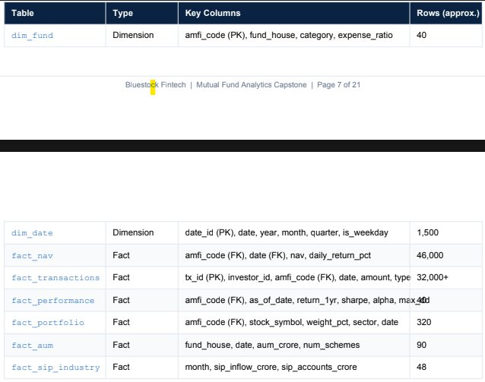
Figure 2.1 — Data model overview: dimension and fact tables with key columns and approximate row counts

2.3 Table Reference
The table below consolidates the structure of the data model for reference throughout this report.
Table | Type | Key Columns | Approx. Rows | Purpose
dim_fund | Dimension | amfi_code (PK), fund_house, category, expense_ratio | 40 | Fund master attributes used to slice all fact tables by fund house, category and cost structure
dim_date | Dimension | date_id (PK), date, year, month, quarter, is_weekday | 1,500 | Calendar table enabling time-intelligence (YoY, QoQ, rolling windows) across all date-based facts
fact_nav | Fact | amfi_code (FK), date (FK), nav, daily_return_pct | 46,000 | Daily NAV and return series — the foundation for growth charts, correlation and rolling-risk analytics
fact_transactions | Fact | tx_id (PK), investor_id, amfi_code (FK), date, amount, type | 32,000+ | Investor-level purchase/redemption/SIP transactions used for behavioural and demographic analysis
fact_performance | Fact | amfi_code (FK), as_of_date, return_1yr, sharpe, alpha, max_dd | 40 | Point-in-time performance and risk-adjusted return summary per scheme
fact_portfolio | Fact | amfi_code (FK), stock_symbol, weight_pct, sector, date | 320 | Portfolio holdings used for sector concentration (HHI) and diversification analysis
fact_aum | Fact | fund_house, date, aum_crore, num_schemes | 90 | Monthly AUM and scheme counts by fund house — industry concentration analysis
fact_sip_industry | Fact | month, sip_inflow_crore, sip_accounts_crore | 48 | Industry-wide monthly SIP inflow and account growth trends

2.4 Coverage and Scale
- Time period: January 2022 – December 2025 (48 months / approximately 1,500 calendar days).
- Fund universe: approximately 40 schemes (amfi_code values) spanning multiple fund houses and categories.
- Total data volume: roughly 80,000 rows across the six fact tables, the largest being fact_nav (~46,000 rows) and fact_transactions (32,000+ rows).
- Granularity: daily for NAV, transaction-level for investor activity, monthly for AUM and SIP industry statistics, and point-in-time snapshots for performance and portfolio holdings.

3. ETL Process
The ETL (Extract, Transform, Load) pipeline converts raw source extracts into the analysis-ready star schema described in Section 2. The pipeline was implemented using Python (pandas) for data preparation and feature engineering, with the resulting tables loaded into Power BI via Power Query for modelling, relationship definition, and DAX measure creation.

3.1 Extraction
Raw extracts were collected for each of the eight tables in the model. Fund master attributes, daily NAV files, transaction logs, portfolio holdings, AUM-by-fund-house figures, and industry SIP statistics were each extracted as flat tabular files (CSV-style) covering the January 2022 – December 2025 window. Dates were captured in a consistent ISO format at the point of extraction to simplify downstream joins to the date dimension.

3.2 Transformation
The transformation stage applied a series of cleaning, derivation, and aggregation steps to each table:

Dimension tables
- dim_fund: deduplicated on amfi_code, standardised fund house naming (e.g., consistent casing and abbreviation handling), and validated that category and expense_ratio values fell within expected ranges.
- dim_date: generated programmatically for the full Jan 2022 – Dec 2025 range, deriving year, month, quarter and an is_weekday flag to support both calendar and trading-day based time intelligence.

fact_nav
- Parsed and validated daily NAV values per amfi_code; rows with missing or non-positive NAV values were flagged and excluded.
- Derived daily_return_pct as the percentage change in NAV from the prior trading day, handling non-trading days (weekends/holidays) by forward-filling the prior NAV before computing returns where required.
- Used the resulting return series as the basis for cumulative growth-of-₹1 calculations and rolling risk metrics in the performance analytics stage (Section 5).

fact_transactions
- Standardised transaction type values (e.g., purchase, redemption, SIP) and validated that amounts were non-negative.
- Joined investor demographic attributes (age group, state, city tier) onto each transaction record to support behavioural segmentation in Section 4.
- Checked for duplicate tx_id values and removed exact-duplicate records.

fact_performance
- Computed return_1yr, sharpe, alpha and max_dd per scheme as of each reporting date from the underlying NAV series, using standard formulas (trailing 1-year return for return_1yr; annualised mean excess return divided by annualised standard deviation for sharpe; regression-based alpha versus the relevant benchmark; peak-to-trough decline for max_dd).

fact_portfolio
- Validated that weight_pct values for each scheme summed to approximately 100% as of each snapshot date, and mapped each stock_symbol to a sector classification used in the Herfindahl-Hirschman Index (HHI) concentration analysis (Section 5.3).

fact_aum and fact_sip_industry
- Aggregated AUM to the fund-house / month grain and validated against the number of schemes reported (num_schemes).
- Validated industry SIP inflow and account figures for monotonic, plausible month-on-month growth, flagging any unexpected drops for manual review.

3.3 Loading and Modelling
- All transformed tables were loaded into the Power BI data model (bluestock_mf.pbix) via Power Query.
- Relationships were defined as one-to-many from dim_fund and dim_date to each fact table on amfi_code and date / date_id respectively, enforcing referential integrity within the model.
- Data types were optimised (dates as Date, identifiers as Whole Number / Text as appropriate, percentages and ratios as Decimal Number) to minimise model size and ensure correct aggregation behaviour.
- Calculated measures (e.g., Total AUM, Total SIP, Total Folio, SIP Growth YoY, Net Inflow by Category) were implemented in DAX on top of the loaded fact tables, ready for use across the dashboard pages described in Section 6.

3.4 Data Quality Checks
- Row-count reconciliation between source extracts and loaded tables for each of the eight tables.
- Null and range checks on key measures (NAV > 0, weight_pct between 0 and 100, transaction amounts ≥ 0).
- Referential integrity checks confirming that every amfi_code in the fact tables exists in dim_fund and every date exists in dim_date.
- Outlier review on daily_return_pct to identify and investigate any implausible single-day NAV movements.

3.5 Refresh Considerations
Because AMFI publishes AUM and SIP statistics on a monthly cycle, the pipeline is designed to support a monthly incremental refresh: new NAV records and transactions are appended, while fact_aum and fact_sip_industry are extended with the latest month's figures and fact_performance is recomputed as of the new reporting date. The date dimension was pre-built through December 2025 and should be extended ahead of any refresh beyond that horizon.

4. Exploratory Data Analysis Findings
Exploratory data analysis was carried out across the full data model to understand industry-level trends, fund-level return behaviour, investor demographics, and portfolio composition. The key findings are grouped into five themes below.

4.1 NAV and Return Trends
The NAV time series for the sampled schemes shows a clear long-term upward trajectory over the four-year window, consistent with the broad rise in Indian equity markets during the period. Within this overall uptrend, two distinct regimes stand out: a strong rally through 2023, during which most funds posted sustained gains, and a 2024 correction in which NAV growth flattened or reversed for a period before resuming its upward path.
Correlation analysis of daily returns across the sampled funds shows strongly positive pairwise correlations. This indicates that the funds in the sample — despite differences in category and fund house — are largely driven by common market factors (broad equity market movements) rather than by idiosyncratic, fund-specific drivers. The practical implication is that holding multiple funds from this sample does not, on its own, provide strong diversification benefits; true diversification would require funds with materially different return drivers (for example, debt funds, international funds, or funds with very different sector tilts).

4.2 AUM and Industry Growth
Assets under management across the industry are concentrated among a relatively small number of large fund houses. SBI Mutual Fund appears consistently as one of the largest fund houses by AUM across the monthly fact_aum series, reflecting the broader 'winner-take-most' dynamic typically seen in the Indian asset management industry, where the top five to ten fund houses account for a disproportionate share of total industry AUM.
At the same time, the breadth of retail participation has expanded markedly. Total folio counts — a proxy for the number of active investor accounts — grew from approximately 13.26 crore in January 2022 to approximately 26.12 crore in December 2025, representing close to a doubling over the four-year period. This combination of rising folio counts alongside continued AUM concentration suggests that industry growth has been driven primarily by new retail investors entering the market through established, large fund houses, rather than through a broadening of market share across a wider set of asset managers.

4.3 SIP Trends and Category Flows
Monthly SIP inflows show a sustained upward trend across the analysis window, reaching a peak of approximately ₹31,002 crore in December 2025. This steady climb in systematic investment inflows is one of the clearest structural trends in the dataset and reflects the growing role of SIPs as the primary retail investment channel into mutual funds.
Category-level net inflows, however, are considerably less smooth. A heatmap of net inflows by category and month shows uneven patterns across product segments — certain categories receive concentrated inflows in specific months while others show more muted or even negative net flows in the same periods. This points to category-level seasonality (for example, tax-saving-related inflows around the fiscal year-end, or inflows following periods of strong category-level performance) and to rotation of investor preference between categories over time, rather than a uniform 'rising tide' across all product segments.

4.4 Investor Demographics and Behaviour
Investor transaction data shows that participation is concentrated within a narrow set of age groups, with the overall age distribution of SIP participants skewed toward what are typically the prime working-age cohorts. This is consistent with the expectation that salaried, working-age individuals represent the core SIP investor base, with lower participation among both younger and older age groups.
SIP amount distributions also vary materially by age group — different cohorts exhibit different typical investment sizes, reflecting differences in income, financial priorities, and investment experience across age groups. This suggests that a one-size-fits-all approach to product communication and SIP ticket-size recommendations may be sub-optimal, and that age-based segmentation could improve engagement.
Geographically, mutual fund investment activity is concentrated in a small number of states and in higher-tier cities. This urban/regional concentration is consistent with broader financial inclusion patterns in India, where access to digital investment platforms, financial literacy, and disposable income tend to be higher in metro and tier-1 locations. It also highlights an opportunity: regions and city tiers with lower current participation represent a largely untapped segment for future SIP growth.

4.5 Portfolio Composition and Sector Bias
Analysis of portfolio holdings shows that, for most sampled funds, holdings are concentrated in a relatively small number of top sectors. This sector bias is examined in more depth in Section 5.3 using the Herfindahl-Hirschman Index (HHI), but at the EDA stage it is already evident that sector allocation is not evenly spread across the available sector universe — certain sectors (typically those that have performed well over the analysis period) attract a disproportionate share of portfolio weight across multiple funds.

5. Performance Analytics
Building on the EDA findings, the performance analytics workstream applies three complementary lenses to fund performance: absolute growth versus market benchmarks, risk-adjusted (Sharpe ratio) performance over time, and portfolio-level sector concentration. Together these provide a more complete picture than any single metric in isolation — a fund can look attractive on cumulative growth alone while carrying meaningfully higher risk, volatility, or concentration than its peers.

5.1 Benchmark Comparison — Growth of ₹1 Invested
The chart below tracks the cumulative growth of a hypothetical ₹1 invested at the start of the period in each of five top funds (identified by AMFI code: 120505, 148567, 120843, 100033, and 148569), alongside the NIFTY 50 and NIFTY 100 indices as broad market benchmarks. All series are indexed to 1.0 at the start date and computed from the daily_return_pct series in fact_nav.
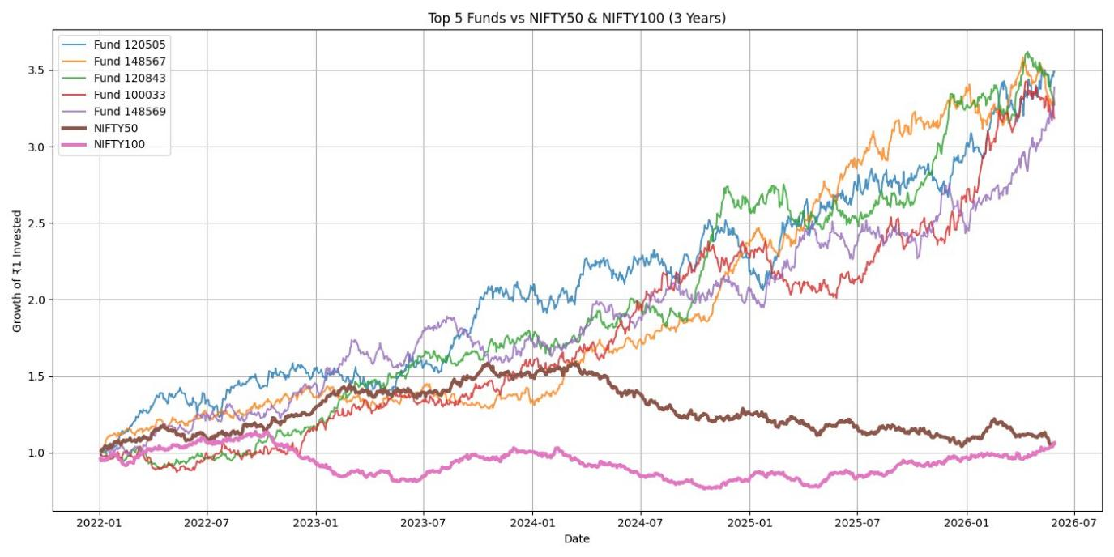
Figure 5.1 — Growth of ₹1 invested: Top 5 funds vs NIFTY 50 and NIFTY 100
Several patterns are evident:
- All five funds tracked closely with the NIFTY 50 through 2022, then began to diverge meaningfully from early 2023 onward, broadly coinciding with the 2023 rally identified in the EDA.
- By the end of the period, the five funds had grown to between roughly 3.0x and 3.6x of the initial investment, while the NIFTY 50 reached only around 1.1x–1.2x and the NIFTY 100 remained close to 1.0x–1.1x — implying the sampled funds delivered substantially higher cumulative returns than either broad-market benchmark over the period.
- The 2024 correction is visible as a flattening or mild pullback across all series around late 2024 / early 2025, but the funds resumed their upward trajectories afterward while the NIFTY 50 and NIFTY 100 remained comparatively range-bound.
- Fund 120843 and Fund 148567 show the strongest cumulative growth toward the end of the period, while Fund 100033 — though still outperforming both benchmarks — trails the other four funds for much of 2023–2024.
These results should be interpreted with care: outperformance versus broad-market benchmarks over a single multi-year window does not guarantee future outperformance, and the comparison does not yet account for differences in risk taken to achieve these returns — which is addressed in the rolling Sharpe ratio analysis below.

5.2 Risk-Adjusted Performance — Rolling 90-Day Sharpe Ratio
To understand how risk-adjusted performance evolves over time (as opposed to a single point-in-time Sharpe ratio in fact_performance), a rolling 90-day annualised Sharpe ratio was computed from the daily return series for five funds (100016, 100025, 100033, 101206, and 101207). The Sharpe ratio measures excess return per unit of volatility; a positive Sharpe ratio indicates returns above the risk-free rate after adjusting for volatility, while a negative Sharpe ratio indicates the fund underperformed the risk-free rate on a risk-adjusted basis over that window.
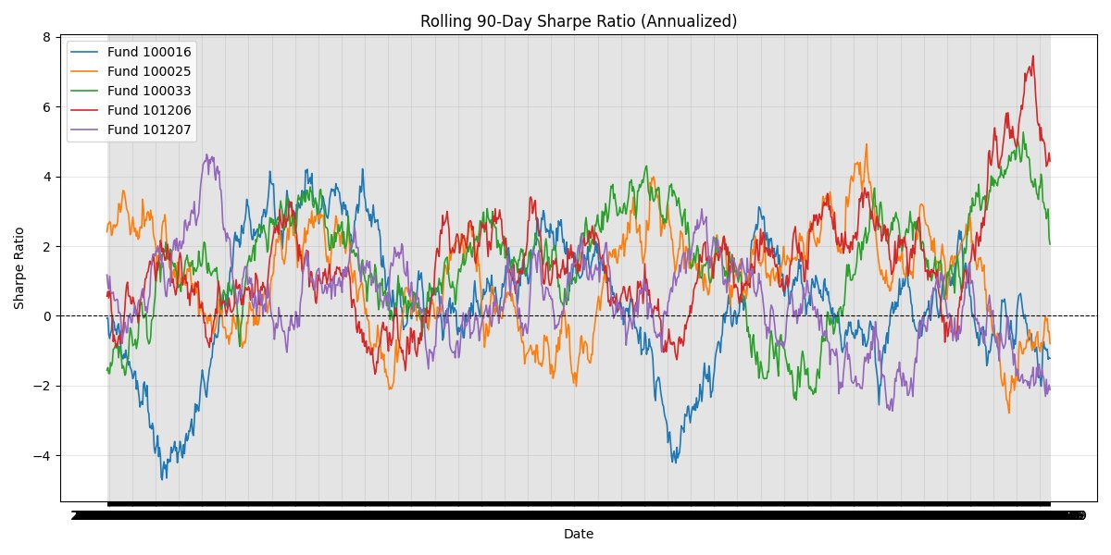
Figure 5.2 — Rolling 90-day annualised Sharpe ratio for five selected funds
The chart highlights the cyclical, regime-dependent nature of risk-adjusted returns:
- Rolling Sharpe ratios swing widely — from below -4 to above +7 — for individual funds over the analysis window, demonstrating that short-term risk-adjusted performance is highly volatile even for funds with solid long-term track records.
- Fund 101206 shows a particularly strong recent period, with its rolling Sharpe ratio climbing to roughly 7.4 in the most recent window — the highest of the five funds shown — while Fund 100016 has spent extended periods with negative rolling Sharpe ratios, including a trough below -4 earlier in the period.
- There are periods (visible as broad bands where multiple lines move together) where all five funds experience simultaneously elevated or depressed Sharpe ratios, reinforcing the EDA finding that fund returns are strongly correlated and driven by common market factors.
- No single fund maintains a consistently high Sharpe ratio throughout the window — every fund experiences at least one extended period of negative risk-adjusted performance, underscoring that past risk-adjusted outperformance is not a reliable standalone predictor of future risk-adjusted performance.
This analysis reinforces the recommendation (Section 7) that performance dashboards should surface rolling, time-varying risk metrics alongside cumulative return figures, rather than relying solely on point-in-time summary statistics such as the single return_1yr / sharpe values stored in fact_performance.

5.3 Sector Concentration — Herfindahl-Hirschman Index (HHI)
Portfolio diversification was assessed using the Herfindahl-Hirschman Index (HHI), calculated for each fund as the sum of the squared sector weight percentages from fact_portfolio (HHI = Σ (sector weight %)²). HHI is a standard concentration measure: a fund with an equal 10% weight across ten sectors would have an HHI of 1,000, while a fund concentrated entirely in two sectors at 50% each would have an HHI of 5,000. Three reference thresholds are commonly used to interpret HHI: below 1,500 indicates a diversified portfolio, 1,500–2,500 indicates moderate concentration, and above 2,500 indicates high concentration.
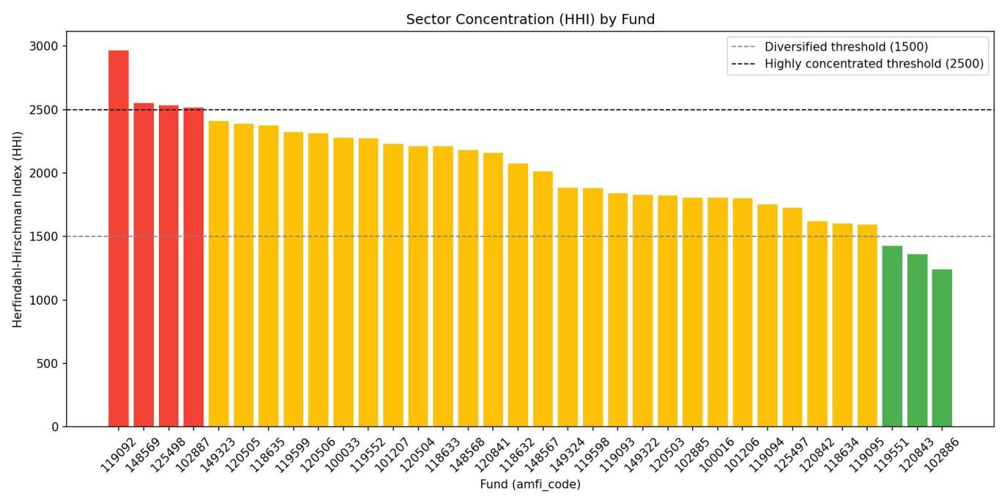
Figure 5.3 — Sector concentration (HHI) by fund, ranked from most to least concentrated
Key observations from the HHI analysis:
- Four funds (AMFI codes 119092, 148569, 125498, and 102887) fall above the high-concentration threshold of 2,500, with fund 119092 the most concentrated at an HHI close to 2,960 — indicating that a small number of sectors account for the large majority of these funds' portfolios.
- The majority of the remaining funds fall in the moderately concentrated band between 1,500 and 2,500, indicating that some sector concentration is the norm rather than the exception across this fund universe.
- Only three funds (119551, 120843, and 102886) fall below the diversified threshold of 1,500, with fund 102886 the most diversified at an HHI of approximately 1,240.
- Notably, fund 120843 — one of the strongest performers in the benchmark comparison (Section 5.1) — is also one of the most diversified funds by HHI, suggesting that strong returns in this case were not solely the product of a concentrated sector bet. By contrast, fund 148569, which also performed well in Section 5.1, sits among the most concentrated funds, indicating its strong returns may be more sensitive to the continued performance of a small number of sectors.
Taken together, the sector concentration results provide important context for the return and risk findings above: funds with similar headline returns can carry very different concentration risk profiles, and this should factor into any fund selection or risk-monitoring process.

6. Power BI Dashboard Overview
The analytics outputs from Sections 4 and 5 are operationalised in an interactive Power BI dashboard (bluestock_mf.pbix), built directly on top of the star-schema data model described in Section 2. The dashboard consists of four report pages, each targeting a different stakeholder question. The structure and contents of each page are summarised below; page numbers correspond to the tabs as built in the .pbix file.

6.1 Page 1 — Industry Overview
This page provides a high-level view of the mutual fund industry's growth over the analysis period, intended as a landing page for senior stakeholders.
Visual | Type | Description
Industry AUM by Jan 2022 – Dec 2025 | Line chart | Trend of total industry AUM (₹ crore) month by month across the full analysis period, sourced from fact_aum
Fund House by AUM | Column chart | Ranks fund houses by total AUM, highlighting industry concentration among the largest asset managers (e.g., SBI Mutual Fund)
TOTAL AUM | KPI card | Latest total industry AUM (₹ crore) as of the most recent month in the dataset
TOTAL SIP | KPI card | Latest monthly SIP inflow (₹ crore), sourced from fact_sip_industry
TOTAL FOLIO | KPI card | Latest total folio count (crore), illustrating overall retail participation
Together, these visuals let a viewer answer 'how big is the industry, how is it growing, and who are the dominant players?' in a single glance — directly supporting the AUM growth and concentration findings from Sections 4.2 and 4.5.

6.2 Page 2 — Fund Performance
This page is the primary fund-comparison and screening tool, designed for analysts evaluating individual schemes.
Visual | Type | Description
Return by StdDev | Scatter chart | Plots each fund's return against its volatility (standard deviation), giving an at-a-glance risk-return map (efficient-frontier style view)
NAV by Benchmark | Line chart | Compares a selected fund's NAV-based growth against the NIFTY 50 / NIFTY 100 benchmarks — the interactive equivalent of Figure 5.1
Category slicer | Slicer | Filters all visuals on the page by scheme category (e.g., large-cap, mid-cap, hybrid)
Plan slicer | Slicer | Filters by plan type (e.g., Direct vs. Regular)
Fund House slicer | Slicer | Filters by fund house, enabling house-level performance comparisons
The combination of the risk-return scatter and the benchmark-relative line chart allows users to quickly identify funds that sit in the favourable upper-left region of the risk-return map (higher return, lower volatility) and then drill into their NAV history relative to the benchmark — directly extending the analysis in Section 5.1.

6.3 Page 3 — Investor Behaviour
This page focuses on who is investing, where, and how — supporting the demographic and geographic findings from Section 4.4.
Visual | Type | Description
Transaction by State | Bar chart | Ranks states by total transaction volume / value, highlighting the geographic concentration identified in Section 4.4
Transaction Type | Donut chart | Breaks down transactions by type (e.g., purchase, redemption, SIP)
Age group by Avg SIP amount | Column chart | Compares average SIP ticket size across investor age groups
Transaction by Month | Line chart | Tracks overall transaction activity over time, complementing the SIP inflow trend in Page 4
State slicer | Slicer | Filters all visuals by state
City Tier slicer | Slicer | Filters by city tier (e.g., Tier 1 / Tier 2 / Tier 3)
Age Group slicer | Slicer | Filters by investor age group
The three slicers (State, City Tier, Age Group) allow stakeholders to interactively explore the urban/regional concentration and age-skew patterns identified during EDA, and to identify specific underserved segments for targeted SIP campaigns (see Section 7).

6.4 Page 4 — SIP and Inflows
This page tracks systematic investment trends at both the industry and category level, supporting the findings in Section 4.3.
Visual | Type | Description
SIP inflow by year | Line + clustered column combo chart | Shows annual SIP inflow values alongside a complementary measure (e.g., SIP accounts), highlighting the sustained growth trend reaching ~₹31,002 crore by December 2025
Pivot table | Table / matrix | Detailed month-by-category breakdown of net inflows, supporting the seasonality patterns identified in the EDA heatmap
Category by Net Inflow | Bar chart | Ranks product categories by net inflow, highlighting which segments are gaining or losing investor capital
SIP growth YOY | KPI | Headline year-over-year growth rate in SIP inflows, calculated via DAX time-intelligence measures
Action button | Navigation | Provides in-report navigation back to other pages of the dashboard
Note on dashboard screenshots: the Power BI report file (bluestock_mf.pbix) was supplied as part of this project's deliverables; rendering live, data-populated screenshots of each report page requires opening the file in Power BI Desktop or the Power BI Service, which was outside the scope of this document-generation environment. The page-by-page descriptions above are derived directly from the report's visual layout definitions and should be read alongside the live .pbix file or exported PDF/image snapshots of each page for a complete visual reference.

7. Recommendations
Based on the EDA and performance analytics findings, the following recommendations are organised by audience: investment/product teams, marketing and growth teams, and the analytics/dashboard team responsible for maintaining this solution.

7.1 For Investment and Product Teams
- Use the combination of cumulative return (Section 5.1), rolling Sharpe ratio (Section 5.2), and sector HHI (Section 5.3) together when assessing funds, rather than any single metric — a fund that ranks well on one dimension (e.g., 3-year growth) may rank poorly on another (e.g., sector concentration or recent risk-adjusted performance).
- Flag the four funds identified as 'highly concentrated' by HHI (119092, 148569, 125498, 102887) for additional sector-risk review, particularly where these funds are marketed as core or balanced holdings.
- Investigate the drivers behind funds with persistently negative rolling Sharpe ratios (e.g., fund 100016 during its multi-month trough) to determine whether this reflects a temporary market regime, a style mismatch with current market conditions, or a more structural issue with the fund's strategy.
- Given the strongly positive return correlations across the sampled funds, consider expanding the fund universe used in future analyses to include debt, international, and alternative categories, which would provide a more meaningful test of cross-fund diversification.

7.2 For Marketing and Growth Teams
- Target SIP growth campaigns toward states, city tiers, and age groups currently underrepresented in fact_transactions, using Page 3 of the dashboard to identify specific gaps — this directly addresses the geographic and demographic concentration identified in Section 4.4.
- Tailor SIP ticket-size recommendations and product messaging by age group, reflecting the differences in average SIP amounts observed across cohorts (Section 4.4).
- Time category-specific marketing campaigns around the seasonality patterns visible in the category net-inflow heatmap (Section 4.3), aligning messaging with periods of historically stronger inflows for each category.
- Continue to highlight the industry-wide growth story — folio counts nearly doubling and SIP inflows reaching record highs (Section 4.2–4.3) — as part of broader financial-literacy and participation campaigns, since this growth signals an expanding addressable market.

7.3 For the Analytics and Dashboard Team
- Extend Page 2 (Fund Performance) with a rolling-Sharpe time series view (similar to Figure 5.2) so that users can see how risk-adjusted performance evolves, rather than relying only on the point-in-time sharpe value in fact_performance.
- Add a sector-concentration (HHI) visual to the dashboard, surfacing the analysis in Section 5.3 directly to end users rather than as an offline chart.
- Implement a monthly incremental refresh process as outlined in Section 3.5, including extension of dim_date and validation checks on the newly loaded fact_aum and fact_sip_industry records.
- Consider adding additional benchmark indices beyond NIFTY 50 / NIFTY 100 (e.g., category-specific indices such as a mid-cap or hybrid benchmark) so that benchmark-relative performance is assessed against a more appropriate comparator for each fund's category.
- Add drill-through functionality from Page 1 (Industry Overview) and Page 3 (Investor Behaviour) to Page 2 (Fund Performance), enabling a seamless path from 'which fund house / segment is interesting' to 'how have its funds actually performed'.

8. Limitations
The following limitations should be considered when interpreting the findings in this report and when planning future iterations of the project.

8.1 Data Coverage Limitations
- The fund universe in dim_fund covers approximately 40 schemes, which is a sample of the much larger universe of mutual fund schemes available in the Indian market (typically numbering in the thousands across all AMCs and categories). Findings on AUM concentration, sector bias, and benchmark outperformance should be understood as representative of this sample, not as a complete industry census.
- fact_portfolio contains approximately 320 rows across the fund universe — roughly 8 holdings per fund on average. This may understate true portfolio diversification for funds that hold a long tail of smaller positions not captured in the snapshot, which would affect the HHI calculations in Section 5.3.
- Investor demographic fields (age group, state, city tier) in fact_transactions reflect the structure of the available transaction data; if this data was sampled or simulated for the purposes of this capstone, the demographic and geographic patterns described in Section 4.4 may not fully reflect real-world investor distributions and should be validated against actual industry data (e.g., AMFI investor data) before being used for business decisions.

8.2 Methodological Limitations
- The rolling Sharpe ratio in Section 5.2 uses a 90-day window and an implicit risk-free rate assumption; both choices affect the absolute level of the Sharpe ratio (though less so its relative movements over time). Shorter windows (e.g., 90 days) are also inherently noisier than longer windows (e.g., 180 or 365 days), which contributes to the wide swings observed.
- The benchmark comparison in Section 5.1 uses NIFTY 50 and NIFTY 100 as universal benchmarks for all five funds, regardless of each fund's stated category. A more rigorous comparison would match each fund to a category-appropriate benchmark (e.g., a mid-cap index for a mid-cap fund).
- HHI is computed from a single portfolio snapshot per fund in fact_portfolio rather than a time series of snapshots, so the concentration analysis in Section 5.3 reflects a point in time and may not capture how concentration has changed over the analysis period.
- Correlation analysis in Section 4.1 was performed on a sample of funds rather than the full universe; correlations may differ for funds outside the sample, particularly across asset classes not represented (e.g., debt or international funds).

8.3 Dashboard and Tooling Limitations
- Live, data-populated screenshots of the four Power BI dashboard pages could not be generated within this document-creation environment, as this would require Power BI Desktop or the Power BI Service. Page layouts and visuals were instead documented from the report's underlying definitions (Section 6) and should be supplemented with exported page images from the .pbix file for a complete visual record.
- The dashboard currently relies on a manually refreshed data model; until the incremental refresh process recommended in Section 3.5 and Section 7.3 is implemented, the dashboard will require manual data updates to remain current beyond December 2025.
- Some DAX measures (e.g., SIP growth YOY) depend on dim_date being extended to cover future periods; the date dimension as built currently spans only through December 2025.

9. Appendix

9.1 Glossary of Terms
Term | Definition
AMFI | Association of Mutual Funds in India — the industry body that publishes standardised mutual fund data, including AMFI codes used to uniquely identify schemes
AUM | Assets Under Management — the total market value of assets managed by a fund or fund house, typically expressed in ₹ crore
NAV | Net Asset Value — the per-unit value of a mutual fund scheme, used to calculate returns
SIP | Systematic Investment Plan — a recurring (typically monthly) investment into a mutual fund scheme
Folio | A unique account number assigned to an investor's holding in a mutual fund scheme; folio counts are a common proxy for the number of investor accounts
Sharpe Ratio | A risk-adjusted return measure calculated as (return − risk-free rate) ÷ standard deviation of returns; higher values indicate better risk-adjusted performance
Alpha | The excess return of a fund relative to its benchmark after adjusting for the risk (beta) taken, indicating manager-driven outperformance or underperformance
Max Drawdown (max_dd) | The largest peak-to-trough decline in NAV over a given period, used as a measure of downside risk
HHI | Herfindahl-Hirschman Index — a concentration measure calculated as the sum of squared percentage shares (e.g., sector weights); higher values indicate greater concentration
City Tier | A classification of Indian cities by population and economic development (commonly Tier 1, Tier 2, Tier 3), used to analyse geographic investment patterns

9.2 Source Files Referenced
- bluestock_mf.pbix — Power BI report containing the data model, DAX measures, and four dashboard pages described in Section 6.
- eda_findings.ipynb — Jupyter notebook documenting the exploratory data analysis findings summarised in Section 4.
- performance_analytics.ipynb — Jupyter notebook used to produce the performance analytics charts referenced in Section 5 (benchmark comparison, rolling Sharpe ratio, and sector HHI).

