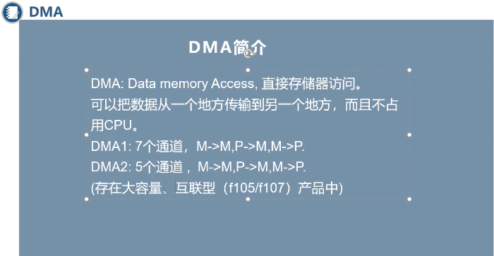
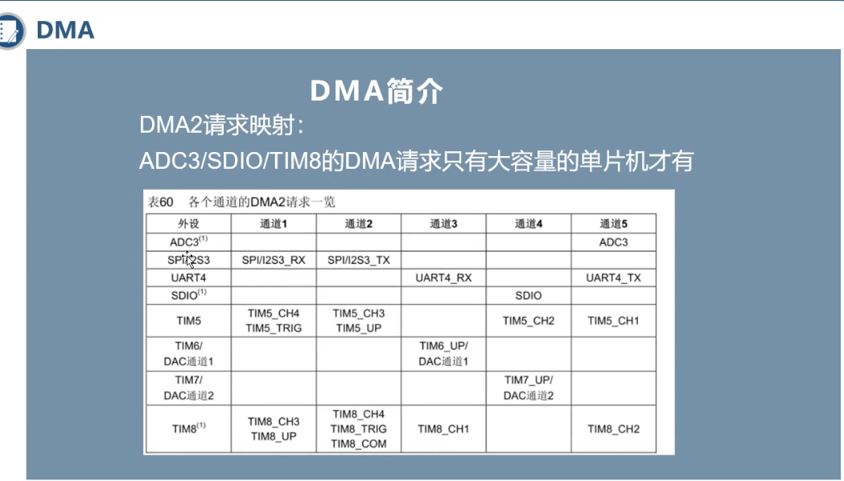

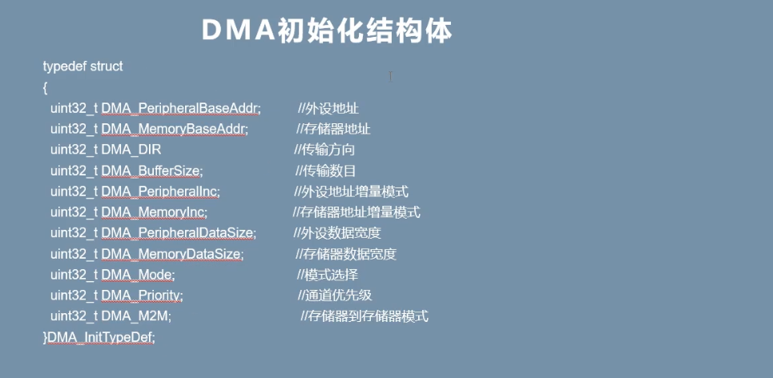
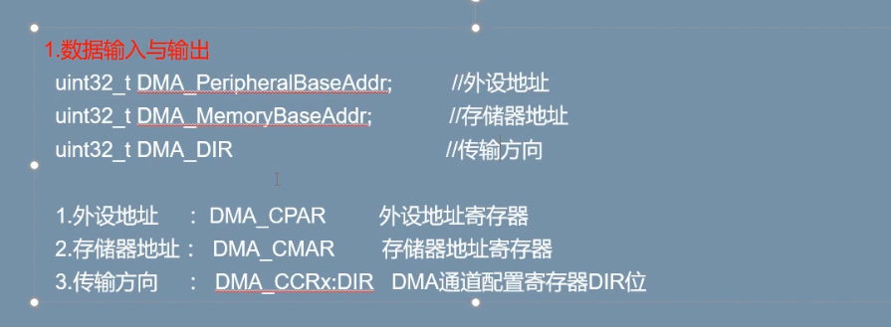
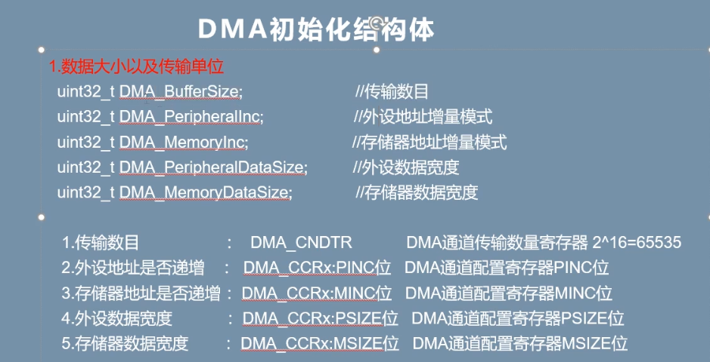
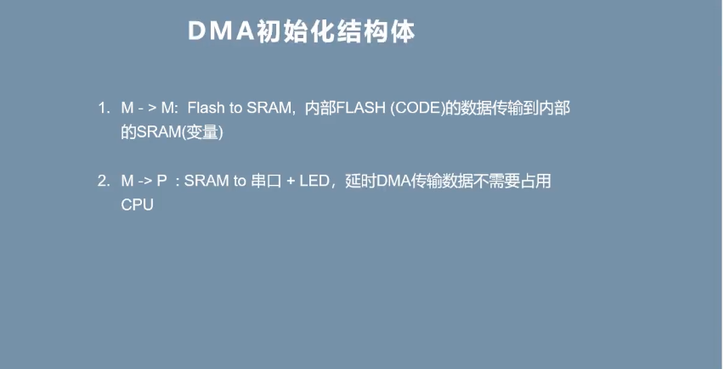
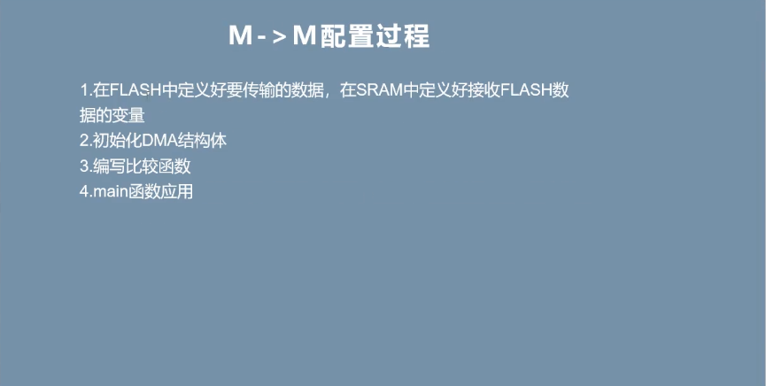

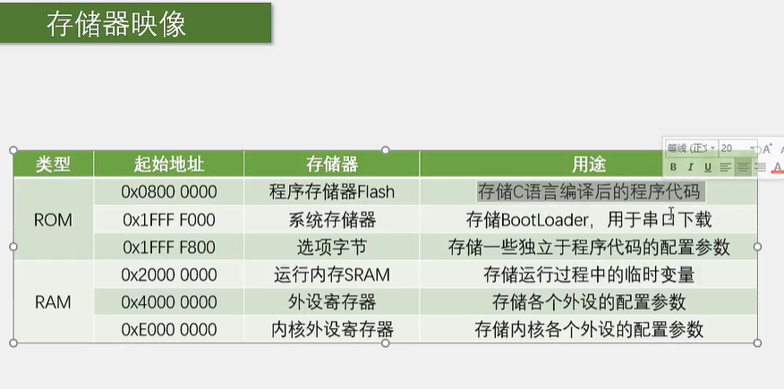

Int a在sram里面 const int a就储存在flash里面了
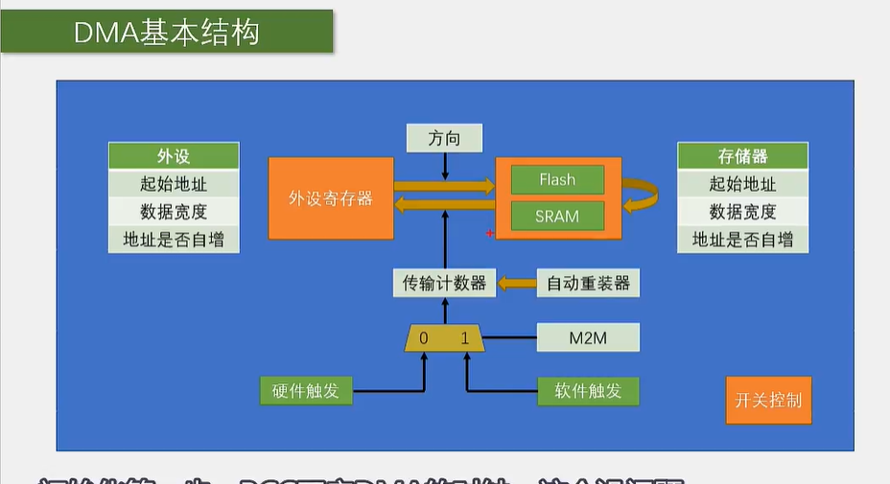

#include "stm32f10x.h"

uint8_t DMA_size = size;
void DMA_Iint(uint32_t addra,uint32_t addrb,uint16_t size){

DMA_size = size;

RCC_APBPeriphClockCmd(RCC_AHBPeriph_DMA1, ENABLE);
DMA_InitTypeDef DMA_StructInit;
DMA_StructInit.DMA_PeripheralBaseAddr = addra;
//扫描的起始地址
DMA_StructInit.DMA_PeripheralDataSize = DMA_PeripheralDataSize_Byte;
DMA_StructInit.DMA_PeripheralInc = DMA_PeripheralInc_Enable;
//把addra放到addrb中
DMA_StructInit.DMA_MemoryBaseAddr = addrb;
DMA_StructInit.DMA_MemoryDataSize = DMA_MemoryDataSize_Byte;
DMA_StructInit.DMA_MemoryInc = DMA_MemoryInc_Enable;
//扫描的范围
DMA_StructInit.DMA_BufferSize = size;
DMA_StructInit.DMA_DIR = DMA_DIR_PeripheralSRC;
DMA_StructInit.DMA_M2M = DMA_M2M_Enable;
;
DMA_StructInit.DMA_Mode = DMA_Mode_Normal;
DMA_StructInit.DMA_Priority = DMA_Priority_Medium;

DMA_Cmd(DMA1_Channel1; DISABLE);

DMA_Init(DMA1_Channel1, &DMA_StructInit);
}

uint8_t dataa[] = {0x01, 0x02, 0x03};
uint8_t datab[] = {0, 0, 0};
void DMA_Iint(uint8_t dataa, uint8_t datab, 3);

void DMA_Trans(void){
DMA_Cmd(DMA1_Channel1, DISABLE);
DMA_SetCurrDataCounter(DMA1_Channel1, DMA_size);

while (DMA_GetFlagStatus(DMA1_FLAG_TC1)==RESET);
DMA_ClearFlag(DMA1_FLAG_TC1);
}

