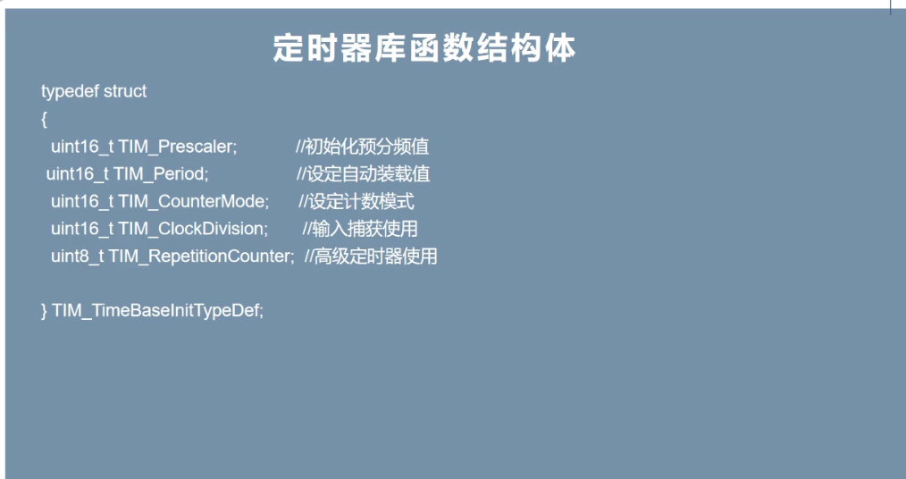
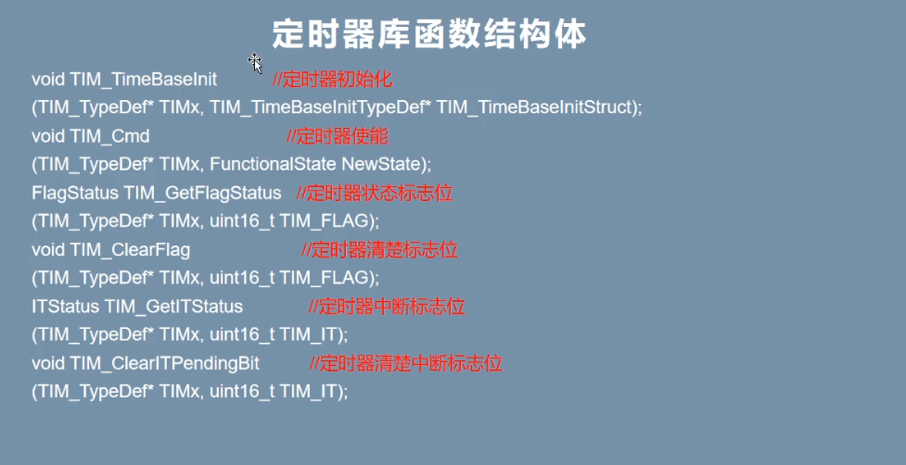
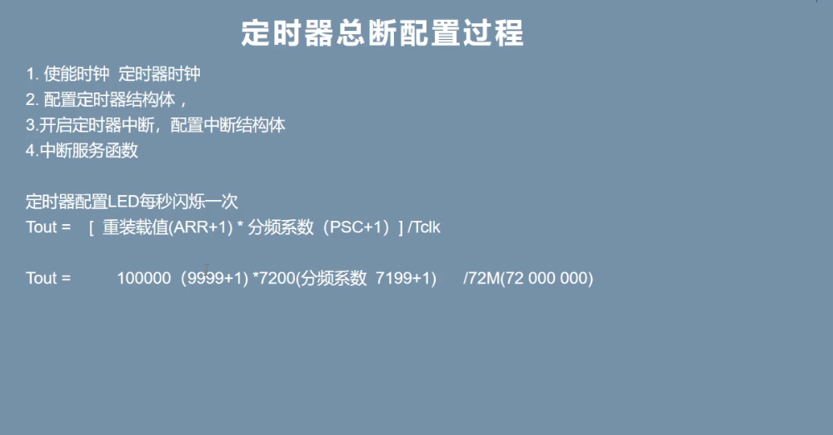

#include "timer.h"

void timer_config(void){
RCC_APB1PeriphClockCmd(RCC_APB1Periph_TIM2, ENABLE);
RCC_APB2PeriphClockCmd(RCC_APB2Periph_GPIOA,ENABLE);
TIM_TimeBaseInitTypeDef TIM_TimeBaseStructInit;
TIM_TimeBaseStructInit.TIM_ClockDivision = TIM_CKD_DIV1;
TIM_TimeBaseStructInit.TIM_CounterMode = TIM_CounterMode_Up;
TIM_TimeBaseStructInit.TIM_Period = 10000 - 1;
TIM_TimeBaseStructInit.TIM_Prescaler = 7200 - 1;
TIM_TimeBaseStructInit.TIM_RepetitionCounter = 0;
TIM_TimeBaseInit(TIM2, &TIM_TimeBaseStructInit);
TIM_ClearFlag(TIM2, TIM_FLAG_Update);
TIM_ITConfig(TIM2, TIM_IT_Update, ENABLE);
NVIC_PriorityGroupConfig(NVIC_PriorityGroup_1);
NVIC_InitTypeDef NVIC_InitStruct;
NVIC_InitStruct.NVIC_IRQChannel = TIM2_IRQn;
NVIC_InitStruct.NVIC_IRQChannelCmd = ENABLE;
NVIC_InitStruct.NVIC_IRQChannelPreemptionPriority = 1;
NVIC_InitStruct.NVIC_IRQChannelSubPriority = 2;
NVIC_Init(&NVIC_InitStruct);
TIM_Cmd(TIM2, ENABLE);
}
void TIM2_IRQHandler(void){
if (TIM_GetITStatus(TIM2, TIM_IT_Update) !=RESET){
GPIO_WriteBit(GPIOA, GPIO_Pin_2, Bit_SET);
}
TIM_ClearITPendingBit(TIM2, TIM_IT_Update);
}

