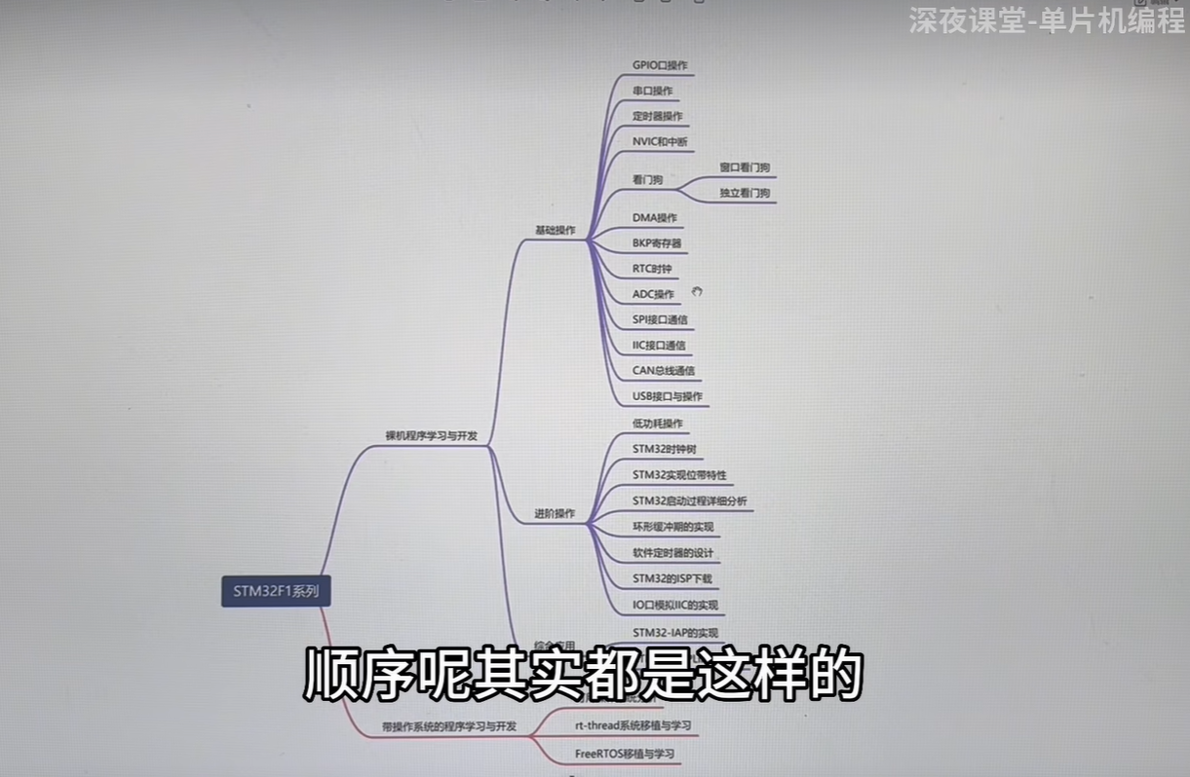

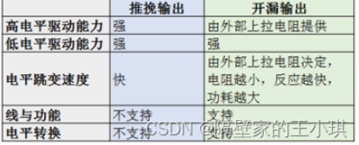

**（1）GPIO_Mode_AIN模拟输入**

**（2）GPIO_Mode_IN_FLOATING浮空输入**

**（3）GPIO_Mode_IPD下拉输入**

**（4）GPIO_Mode_IPU上拉输入**

**（5）GPIO_Mode_Out_OD开漏输出**

**（6）GPIO_Mode_Out_PP推挽输出**

**（7）GPIO_Mode_AF_OD复用开漏输出**

**（8）GPIO_Mode_AF_PP复用推挽输出**

**Pwm控制引脚**

**中断线1-4, 单独 5-9一个, 10-15一个**

抢占优先级1个中3个 响应优先级 0-3 越小越优先。

**RCC_ APB2PeriphClockCmd (RCC_ APB2Periph AFIO, ENABLE) ;**

**GPIO_ PinRemapConfig (GPIO_ PartialRemap1_TIM2，ENABLE) ;**

**GPIO_ PinRemapConfig (GPIO_ Remap_ SWJ_ JTAGDisable, ENABLE) ;**

**重新定义引脚解除复用**

Pa0 = tim_ch1

**与运算赋值（&=）**两位同时为1，结果才为1，否则为0谁小取谁

## **异或运算赋值（^=）**应位为“异”（值不同），则该位结果为1，否则为0。

## **或运算赋值（|=）**两位只要有一个为1，其值为1，其它都为0。谁大去谁

**Exit外部中断**

void CountSensor_Init(void)

{

**RCC_APB2PeriphClockCmd(RCC_APB2Periph_GPIOB, ENABLE);**

**使能gpiob**

**RCC_APB2PeriphClockCmd(RCC_APB2Periph_AFIO, ENABLE);**

**使能 afio**

**GPIO_InitTypeDef GPIO_InitStructure;**

**GPIO_InitStructure.GPIO_Mode = GPIO_Mode_IPU;**

**GPIO_InitStructure.GPIO_Pin = GPIO_Pin_14;**

**GPIO_InitStructure.GPIO_Speed = GPIO_Speed_50MHz;**

**GPIO_Init(GPIOB, &GPIO_InitStructure);**

**把gpio 14与中断相连**

**GPIO_EXTILineConfig(GPIO_PortSourceGPIOB, GPIO_PinSource14);**

EXTI_InitTypeDef EXTI_InitStructure;

EXTI_InitStructure.EXTI_Line = **EXTI_Line14**;

EXTI_InitStructure.EXTI_LineCmd = ENABLE;

**EXTI_InitStructure.EXTI_Mode = EXTI_Mode_Interrupt;**

***中断模式：中断模式***

**EXTI_InitStructure.EXTI_Trigger = EXTI_Trigger_Falling;**

***触发方式：上升沿触发***

EXTI_Init(&EXTI_InitStructure);

**NVIC_PriorityGroupConfig(NVIC_PriorityGroup_2);**

**选用中断线2**

NVIC_InitTypeDef NVIC_InitStructure;

**NVIC_InitStructure.NVIC_IRQChannel = EXTI15_10_IRQn;**

**蓝色地方必须相同**

NVIC_InitStructure.NVIC_IRQChannelCmd = ENABLE;

NVIC_InitStructure.NVIC_IRQChannelPreemptionPriority = 1;

NVIC_InitStructure.NVIC_IRQChannelSubPriority = 1;

NVIC_Init(&NVIC_InitStructure);

}

**void EXTI15_10_IRQHandler(void)**

**蓝色地方必须相同**

{//因为EXTI10--15都能进这个中断函数，所以先判断是不是EXTI14进的中断

if (****EXTI_GetFlagStatus**(EXTI_Line14**) == SET)

{

/*如果出现数据乱跳的现象，可再次判断引脚电平，以避免抖动*/

if (GPIO_ReadInputDataBit(GPIOB, GPIO_Pin_14) == 0)

{

CountSensor_Count ++;

}

EXTI_ClearITPendingBit(EXTI_Line14);

}

}

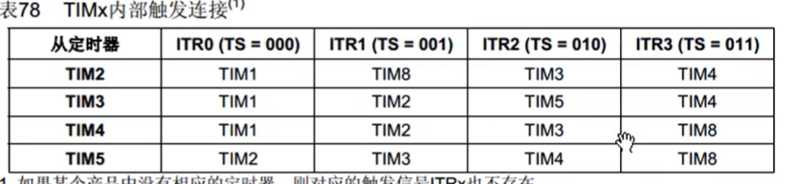

**定时器**

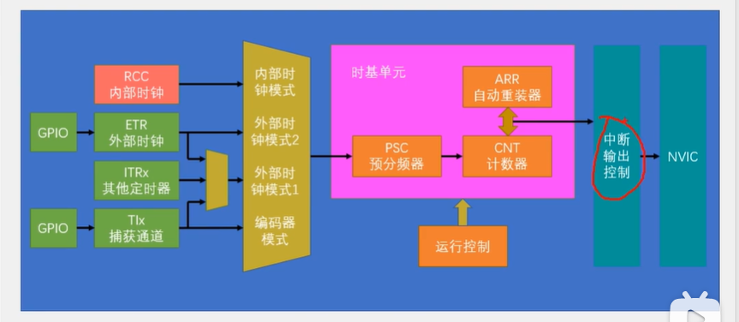

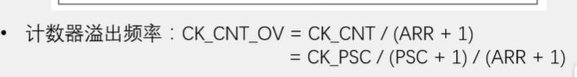

**时间就是溢出频率倒数**

**定时器**

**void timer_config(void){**

**RCC_APB1PeriphClockCmd(RCC_APB1Periph_TIM2, ENABLE);**

**1.选择内部时钟**

**1.TIM_InternalClockConfig(TIM2);**

**2.选择外部时钟**

**2.TIM_ETRClockMode2Config(TIM2,TIM_ExtTRGPSC_OFF, TIM_ExtTRGPolarity_NonInverted, 0x00);**

**RCC_APB2PeriphClockCmd(RCC_APB2Periph_GPIOA, ENABLE);**

**GPIO_InitTypeDef GPIO_StructInit;**

**GPIO_StructInit.GPIO_Mode = GPIO_Mode_IPU;**

**GPIO_StructInit.GPIO_Pin =GPIO_Pin_0;**

**GPIO_StructInit.GPIO_Speed = GPIO_Speed_50MHz;**

**GPIO_Init(GPIOA, &GPIO_StructInit);**

**TIM_TimeBaseInitTypeDef TIM_TimeBaseInitStructure;**

**TIM_TimeBaseInitStructure.TIM_ClockDivision = TIM_CKD_DIV1;**

**TIM_TimeBaseInitStructure.TIM_CounterMode = TIM_CounterMode_Up;**

**TIM_TimeBaseInitStructure.TIM_Period = 10000 - 1;**

**TIM_TimeBaseInitStructure.TIM_Prescaler = 7200 - 1;**

**TIM_TimeBaseInitStructure.TIM_RepetitionCounter = 0;**

**TIM_TimeBaseInit(TIM2, &TIM_TimeBaseInitStruct);**

**TIM_ClearFlag(TIM2, TIM_FLAG_Update);**

**启用定时器定时器**

**TIM_ITConfig(TIM2, TIM_IT_Update, ENABLE);**

**NVIC_PriorityGroupConfig(NVIC_PriorityGroup_1);**

**NVIC_InitTypeDef NVIC_InitStruct;**

**NVIC_InitStruct.NVIC_IRQChanne = TIM2_IRQn;**

**NVIC_InitStruct.NVIC_IRQChannelCmd = ENABLE;**

**NVIC_InitStruct.NVIC_IRQChannelPreemptionPriority = 1;**

**NVIC_InitStruct.NVIC_IRQChannelSubPriority = 2;**

**NVIC_Init(&NVIC_InitStruct);**

**启动定时器外围**

**TIM_Cmd(TIM2, ENABLE);**

**}**

**void TIM2_IRQHandler(void){**

**if (TIM_GetFlagStatus(TIM2, TIM_FLAG_Update) == SET){**

**TIM_ClearITPendingBit(TIM2, TIM_IT_Update);**

**}**

**}**

**Pwm**

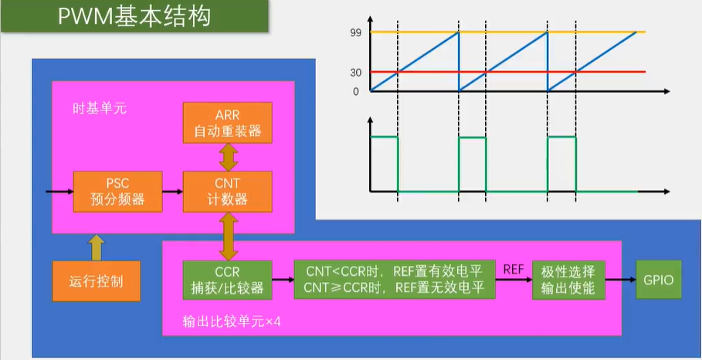

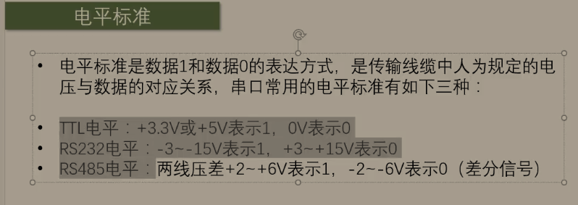

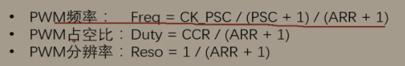**void Pwm_Init(){**

**RCC_APB1PeriphClockCmd(RCC_APB1Periph_TIM2, ENABLE);**

**RCC_APB2PeriphClockCmd(RCC_APB2Periph_GPIOA, ENABLE);**

**GPIO_InitTypeDef GPIO_InitStructure;**

**GPIO_InitStructure.GPIO_Mode = GPIO_Mode_AF_PP;**

**GPIO_InitStructure.GPIO_Pin = GPIO_Pin_0;**

**GPIO_InitStructure.GPIO_Speed = GPIO_Speed_50MHz;**

**GPIO_Init(GPIOA, &GPIO_InitStructure);**

**TIM_ETRClockMode2Config(TIM2, TIM_ExtTRGPSC_OFF, TIM_ExtTRGPolarity_NonInverted, 0x0f);**

**RCC_APB2PeriphClockCmd(RCC_APB2Periph_GPIOA, ENABLE);**

**GPIO_InitTypeDef GPIO_StructInit;**

**GPIO_StructInit.GPIO_Mode = GPIO_Mode_IPU;**

**GPIO_StructInit.GPIO_Pin = GPIO_Pin_0;**

**GPIO_StructInit.GPIO_Speed = GPIO_Speed_50MHz;**

**GPIO_Init(GPIOA, &GPIO_StructInit);**

**TIM_InternalClockConfig(TIM2);**

**TIM_TimeBaseInitTypeDef TIM_TimeBaseInitStructure;**

**TIM_TimeBaseInitStructure.TIM_ClockDivision = TIM_CKD_DIV1;**

**TIM_TimeBaseInitStructure.TIM_CounterMode = TIM_CounterMode_Up;**

**TIM_TimeBaseInitStructure.TIM_Period = 10000 - 1; //ARR**

**TIM_TimeBaseInitStructure.TIM_Prescaler = 7200 - 1; //PSC**

**TIM_TimeBaseInitStructure.TIM_RepetitionCounter = 0;**

****TIM_TimeBaseInit(TIM_TypeDef* TIMx, TIM_TimeBaseInitTypeDef* TIM_TimeBaseInitStruct);****

**TIM_OCInitTypeDef TIM_OCStructInit;**

**TIM_OCStructInit(&TIM_OCInitStruct);**

**TIM_OCStructInit.TIM_OCMode = TIM_OCMode_PWM1;**

**TIM_OCStructInit.TIM_OCPolarity = TIM_OCPolarity_High;**

**TIM_OCStructInit.TIM_OutputState = TIM_OutputState_Enable;**

**TIM_OCStructInit.TIM_Pulse= ; //CCR**

**TIM_OC1Init(TIM2, &TIM_OCInitStruct);**

**//TIM_OC1PreloadConfig(TIM2,TIM_OCPreload_Enable);**

//TIM_ITConfig(TIM2,TIM_IT_Update,ENABLE);

**IM_Cmd(TIM2, ENABLE);**

**}**

**void PwmSetCompare(uint16_t compare){**

**TIM_SetCompare1(TIM2, compare);**

**}**

**Uart**

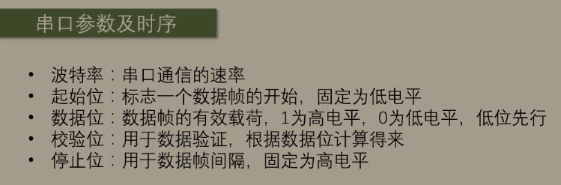

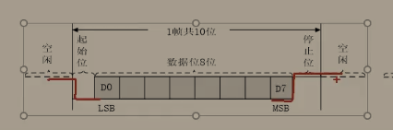

**起始位为下降沿，停止位为上升沿。**

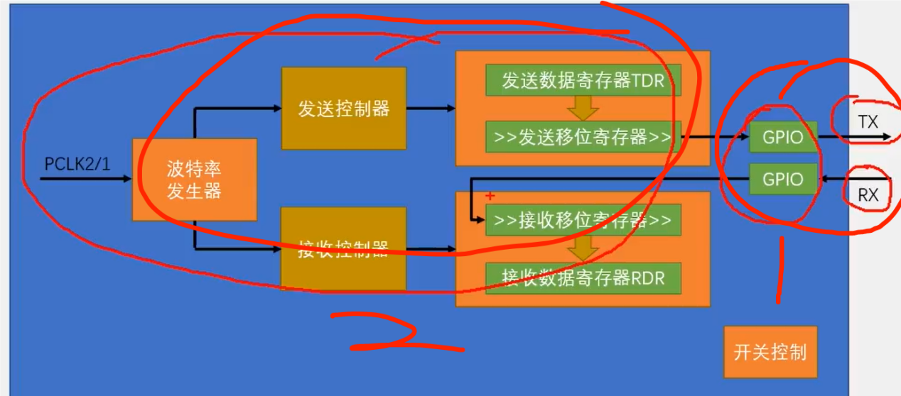

**void usart_init(void){**

**RCC_APB2PeriphClockCmd(RCC_APB2Periph_GPIOA, ENABLE);**

**RCC_APB2PeriphClockCmd(RCC_APB2Periph_USART1, ENABLE);**

**GPIO_InitTypeDef GPIO_StructInit;**

**GPIO_StructInit.GPIO_Mode = GPIO_Mode_AF_PP;**

**GPIO_StructInit.GPIO_Pin = GPIO_Pin_9;**

**GPIO_StructInit.GPIO_Speed = GPIO_Speed_50MHz;**

**GPIO_Init(GPIOA, &GPIO_StructInit);**

**USART_InitTypeDef USART_StructInit;**

**USART_StructInit.USART_BaudRate = 9600;**

**USART_StructInit.USART_HardwareFlowControl = USART_HardwareFlowControl_None;**

**USART_StructInit.USART_Mode = USART_Mode_Tx;**

**USART_StructInit.USART_Parity = USART_Parity_No;**

**USART_StructInit.USART_StopBits = USART_StopBits_1;**

**停止位1格**

**USART_StructInit.USART_WordLength = USART_WordLength_8b;**

**8位没有校验位**

**USART_Init(USART1, &USART_StructInit);**

**USART_Cmd(USART1, ENABLE);**

**}**

**void send_byte(uint8_t byte){**

**USART_SendData(USART1, byte);**

**while(USART_GetFlagStatus(USART1,USART_FLAG_TXE) ==RESET);**

**}**

**ADC**

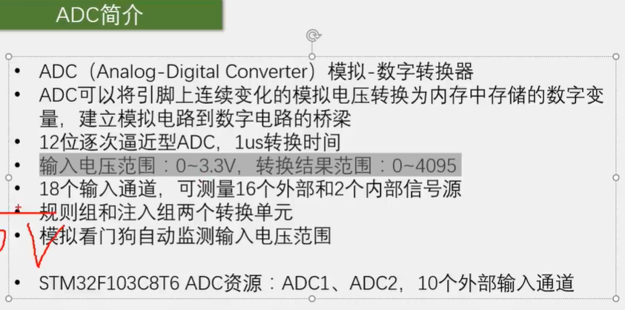

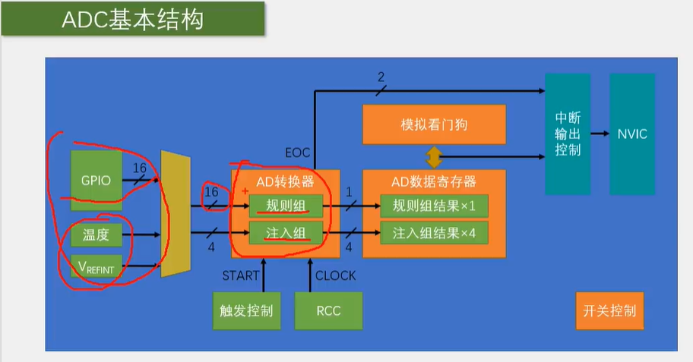

**多通道adc**

**void AD_Init(void)**

**{**

**RCC_APB2PeriphClockCmd(RCC_APB2Periph_ADC1, ENABLE);**

**RCC_APB2PeriphClockCmd(RCC_APB2Periph_GPIOA, ENABLE);**

**RCC_ADCCLKConfig(RCC_PCLK2_Div6);**

**GPIO_InitTypeDef GPIO_InitStructure;**

**GPIO_InitStructure.GPIO_Mode = GPIO_Mode_AIN;**

**GPIO_InitStructure.GPIO_Pin = GPIO_Pin_0 | GPIO_Pin_1 | GPIO_Pin_2 | GPIO_Pin_3;**

**GPIO_InitStructure.GPIO_Speed = GPIO_Speed_50MHz;**

**GPIO_Init(GPIOA, &GPIO_InitStructure);**

**ADC_InitTypeDef ADC_InitStructure;**

**ADC_InitStructure.ADC_Mode = ADC_Mode_Independent;**

**ADC_InitStructure.ADC_DataAlign = ADC_DataAlign_Right;**

**ADC_InitStructure.ADC_ExternalTrigConv = ADC_ExternalTrigConv_None;**

**ADC_InitStructure.ADC_ContinuousConvMode = DISABLE;**

**ADC_InitStructure.ADC_ScanConvMode = DISABLE;**

**ADC_InitStructure.ADC_NbrOfChannel = 1;**

**ADC_Init(ADC1, &ADC_InitStructure);**

**ADC_Cmd(ADC1, ENABLE);**

**ADC_ResetCalibration(ADC1);**

**while (ADC_GetResetCalibrationStatus(ADC1) == SET);**

**ADC_StartCalibration(ADC1);**

**while (ADC_GetCalibrationStatus(ADC1) == SET);**

**}**

**uint16_t AD_GetValue(uint8_t ADC_Channel)**

**{**

**ADC_RegularChannelConfig(ADC1, ADC_Channel, 1, ADC_SampleTime_55Cycles5);**

**ADC_SoftwareStartConvCmd(ADC1, ENABLE);**

**while (ADC_GetFlagStatus(ADC1, ADC_FLAG_EOC) == RESET);**

**return ADC_GetConversionValue(ADC1);**

**}**

**在主函数中定义**

**AD1，AD2，AD3**

**AD1 = AD_GetValue(ADC_Channel_1);**

**AD2 = AD_GetValue(ADC_Channel_2);**

**AD3 = AD_GetValue(ADC_Channel_3);**

**开启三个gpio通道**

**ADC_InitStructure.ADC_Mode = ADC_Mode_Independent;**

**单通道扫描**

**ADC_InitStructure.ADC_DataAlign = ADC_DataAlign_Right**

**右对齐**

**ADC_InitStructure.ADC_ContinuousConvMode = DISABLE;**

**连续转换模式一直检测**

**ADC_InitStructure.ADC_NbrOfChannel = 1**

**指定通道数量**

**Spi**

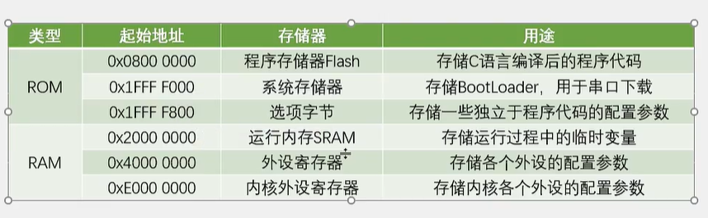

**&可以查询**

**Const a = 0x00 锁定了这个值**

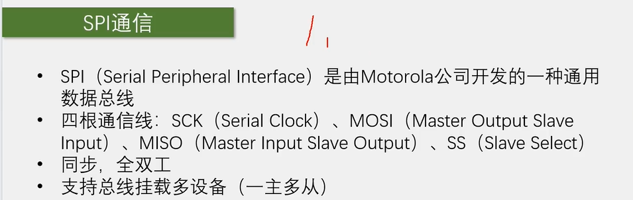

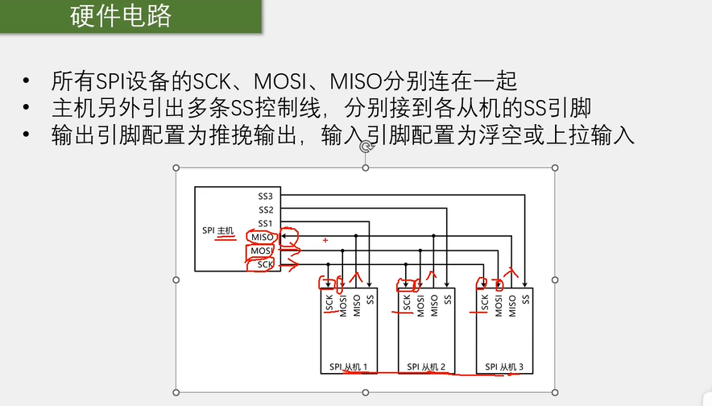

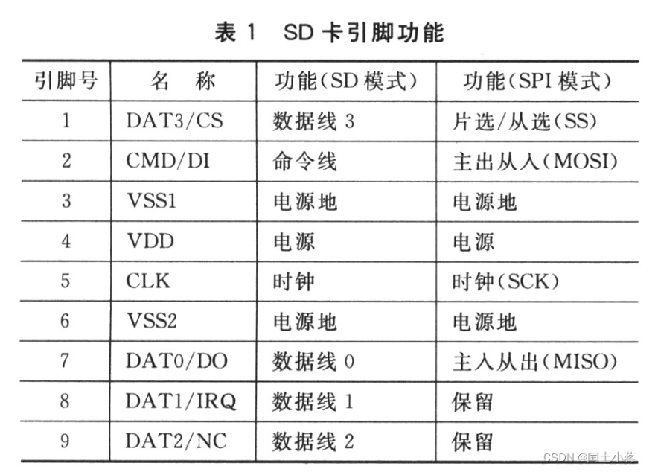

**要在STM32中使用链表来存储USART接收到的数据，可以按照以下步骤进行：**

**1. 首先，定义一个结构体来表示链表节点，每个节点包含数据和指向下一个节点的指针。例如：**

**```c**

**typedef struct Node {**

**uint8_t data; // 数据**

**struct Node *next; // 指向下一个节点的指针**

**} Node;**

**```**

**2. 在全局范围内定义一个指向链表头节点的指针和一个指向链表尾节点的指针。例如：**

**```c**

**Node *head = NULL; // 指向链表头节点的指针**

**Node *tail = NULL; // 指向链表尾节点的指针**

**```**

**3. 在USART接收中断处理函数中，将接收到的数据插入链表。例如：**

**```c**

**void USART1_IRQHandler(void) {**

**if (USART_GetITStatus(USART1, USART_IT_RXNE) != RESET) {**

**// 读取接收到的数据**

**uint8_t rxData = USART_ReceiveData(USART1);**

**// 创建一个新的节点**

**Node *newNode = (Node *)malloc(sizeof(Node));**

**newNode->data = rxData;**

**newNode->next = NULL;**

**// 如果链表为空，则将新节点设置为头节点**

**if (head == NULL) {**

**head = newNode;**

**tail = newNode;**

**} else {**

**// 否则，将新节点插入到链表的尾部**

**tail->next = newNode;**

**tail = newNode;**

**}**

**}**

**}**

**```**

**4. 使用链表中的数据进行后续处理，例如打印链表中的数据：**

**```c**

**void printLinkedList() {**

**Node *current = head;**

**while (current != NULL) {**

**printf("%d ", current->data);**

**current = current->next;**

**}**

**printf("\n");**

**}**

**```**

**通过以上步骤，你可以在STM32中使用链表来存储USART接收到的数据。注意，在实际应用中，还需要考虑内存管理、错误处理等方面的问题。**