

Yenepoya Institute of Arts, Science, Commerce and Management
Project – High Level Design
on
Enterprise Log Analysis on E-commerce Systems

Student Name: Afrah Ashraf
Registration No.: 23BCDSBA03

Industry Mentor: | Mr. Ujjwal Kumar | Guided by: | Mr. Prashantha J

Table of Contents

- Introduction. 3
  - Scope of the document. 3
  - Intended Audience 3
  - System overview. 3
- System Design. 3-4
  - Application Design 3
  - Process Flow. 3
  - Information Flow. 3
  - Components Design 4
  - Key Design Considerations 4
  - API Catalogue. 4

- Final Output Visualization. 5
- Data Design. 6
  - Data Model 6
  - Data Access Mechanism 6
  - Data Retention Policies 6
  - Data Migration 6
- Interfaces 6
- State and Session Management 7
- Caching 7
- Non-Functional Requirements 8
  - Security Aspects 8
  - Performance Aspects 8
- References 8

Introduction
- Scope of the document: This document specifies the high-level architecture, component interactions, and data flow for the Ecommerce-Log-Analyzer system, covering ingestion through to the finalized 2x2 enterprise visualization.
- Intended Audience: This document is intended for project mentors to verify architectural integrity and for developers to understand the system boundaries.
- System overview: The system is an automated diagnostic pipeline designed to process massive, unstructured server logs. It identifies system bottlenecks and security threats (4xx/500 errors) and presents them via a centralized graphical dashboard.

System Design
- Application Design: The application follows a modular "Source-to-Insight" pipeline. It is built using Python, utilizing the re module for extraction, pandas for data structuring, and seaborn/matplotlib for visual reporting.
- Process Flow:
  - Ingestion: Raw .log files are streamed from the local directory.
  - Parsing: A Regex-based extraction engine isolates relevant metadata.
  - Transformation: Data is cleaned, typed, and indexed into a Pandas DataFrame; specific logic isolates paths like /usr/login.
  - Visualization: Statistical aggregations are rendered into a four-panel “Enterprise dashboard”.
- Information Flow: Data moves from an Unstructured State (raw strings) to a Structured State (DataFrames) and finally to a Visual State (statistical plots), ensuring data lineage is maintained throughout the lifecycle.

- Components Design:
  - Log Streamer: Efficiently handles large file sizes using buffered reading.
  - Regex Engine: The core logic unit that maps text patterns to variables.
  - Visualizer: Manages the aesthetic rendering of trends and distributions.
- Key Design Considerations: The primary constraint is Memory Efficiency. The system must be able to process logs that exceed the available RAM by utilizing iterative processing instead of bulk loading.
- API Catalogue: While currently a standalone tool, the core classes are designed with a Public API structure so that the Parser() class can be integrated into larger monitoring systems via Python imports.

Final Output Visualization
This illustrates the final diagnostic result generated from processing more than 1 million log entries produced by the automated pipeline.
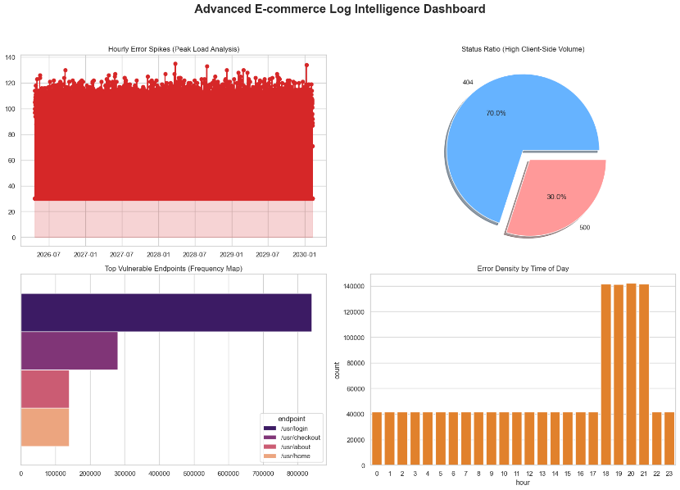

- Metric 1: Peak Load Analysis: Identified a massive surge in system stress between 18:00 and 21:00, with hourly error counts peaking at 140,000+.
- Metric 2: Endpoint Vulnerability: Vectorized path isolation pinpointed /usr/login as the primary failure bottleneck.
- Metric 3: Error Categorization: The system successfully mapped a distribution of 70% 404 (Not Found) vs. 30% 500 (Internal Server Error).
- Metric 4: Temporal Trends: The dashboard confirms a baseline of system noise with high-frequency spikes reaching 140 errors per timestamp.

Data Design
- Data Model: The logical schema includes Timestamp (ISO-8601), HTTP_Status (Categorical), Endpoint_Path (String), and and Hour (derived for peak analysis).
- Data Access Mechanism: Access is facilitated through Python context managers (with open) and vectorized read_table operations to ensure safe file handling and prevent memory leaks.
- Data Retention Policies: Log files are treated as "Read-Only" (Immutable). Analytical results are stored as version-controlled PNG images for long-term historical comparison.
- Data Migration: As a standalone diagnostic tool, it supports "In-Place" processing, requiring no complex data migration from legacy databases.

Interfaces
The system provides a File-System Interface for input and a Graphical Interface (PNG/Notebook) for output. It is designed to be environment-agnostic, running equally well on local machines or cloud-hosted Jupyter environments.

State and Session Management
- Stateless Architecture: The application is designed as a stateless system, meaning it does not store information about previous runs or user interactions once the execution is complete.
- Execution Lifecycle: Each time the script is triggered, it initializes a fresh session to process the target log file. This prevents "data bleeding," where errors from an old log file might accidentally appear in a new analysis.
- Session Independence: Because the tool is used for diagnostic snapshots, maintaining a state is unnecessary. This ensures the dashboard always reflects the current reality of the provided log file.

Caching
- Regex Pattern Compilation: To optimize performance, the system utilizes "Compiled Regex Objects." Instead of re-interpreting the search pattern for every one of the thousands of log lines, the pattern is compiled into machine-ready bytecode at the start of the session.
- In-Memory Data Buffering: During the transformation phase, the system caches the intermediate structured data in a Pandas DataFrame. This allows the visualization module to generate multiple charts (Pie, Bar, Line) rapidly without having to re-parse the raw text file for each graph.
- Library-Level Caching: The system leverages internal caching mechanisms of the Seaborn and Matplotlib libraries to manage color palettes and font rendering, reducing the time required to export the final .png dashboard.

Non-Functional Requirements
- Security Aspects: The system minimizes the attack surface by requiring no network connections and ensuring no modifications are made to original system logs.
- Performance Aspects: Achieves high-speed processing through optimized compilation, targeting the efficient handling of more than 1 million log workload

References
- Kaggle.com - Website Log Access: A Synthetic Server Logs Dataset based on Apache Server Logs Format. Available at: [https://www.kaggle.com/datasets/avinhok/website-log-access].
- Python Software Foundation (2026): Official documentation for the re (Regular Expression) module for high-speed pattern matching.
- Pandas Data Analysis Library: Documentation for high-performance, easy-to-use data structures and data analysis tools.
- Matplotlib & Seaborn Documentation: Reference guides for statistical data visualization and dashboard rendering.
- IEEE 1016-2009. Standard for Software Design Descriptions. (Used as the framework for the structural organization of HLD and LLD modules).
- W3C HTTP Status Code Registry: Official definitions for 4xx (Client Error) and 5xx (Server Error) responses used in the parsing logic.
- University Project Guidelines: Specific formatting and submission requirements for the project.

