
本科生毕业设计（论文）

外文科技文献译文

译文题目 | 基于Spring Boot的旅游  互动共享平台的设计与实现
(外文题目) | Design and Implementation of Interactive Platform for Sharing Travel Guide Based on Spring Boot
学 院 | 数学与大数据学院
专 业 | 数据科学与大数据技术
学 号 | 2021300619
学生姓名 | 陈苏烨
日 期 | 2025年5月10日

指导教师签名 日期

安 徽 理 工 大 学
毕业设计英文材料翻译
专业、班级 数大21-4班 姓名 陈苏烨 学号 2021300619
1．英文材料
Design and Implementation of Interactive Platform for Sharing
Travel Guide Based on Spring Boot
STianjie Guo, Zhengyuan Xue*
School of Artificial Intelligence and Big Data, Henan University of Technology, Zhengzhou, China
xuezy@haut.edu.cn
*Corresponding author

Abstract. In order to cope with the traditional way of sharing travel guide information update is not timely, lack of personalized recommendation, limited communication and interaction, media content restrictions, retrieval and use of inconvenience and other problems. The system uses Java as programming language, builds back-end services based on Spring Boot framework, uses Vue/UniApp to develop front-end interface, uses MyBatisPlus to realize data persistence, and uses MySQL database to store data. It has built an efficient and convenient interactive platform for sharing travel tips. The platform provides online editing and multimedia content support functions, users can share travel experience and play guides, keyword search and classification search, the platform for personalized recommendation, users can evaluate, collect posts, and communicate and interact under the post. Through these technical means, a functional and convenient interactive platform for sharing tourism guides is built, which effectively solves the problems of traditional tourism guides.

Keywords: Travel guide, Sharing and interaction, Recommendation, Spring Boot.

1 Introduction

With the improvement of people's living standards and the change of consumption concepts, travelers pay more attention to personalized and customized travel experience. We hope to be able to customize my own travel plans and itineraries according to my interests, time and budget. A good tourism strategy can improve the tourist experience. However, there are several problems in the traditional way of sharing travel guides. First, there is a lack of personalized recommendation; Second, communication and interaction are limited; Third, it is inconvenient to retrieve and use . Thus, it is useful to develop an efficient and convenient interactive platform for sharing travel tips.
Previous studies have explored how to enhance user interaction and secure content sharing in social networks. These studies have provided us with valuable insights. In the field of tourism strategy platform, the researchers focus on improving the functions of user interaction and content sharing . These works have important enlightening significance for systematic research. However, there is still room for improvement in personalized interaction , sharing, and intelligent retrieval.
In order to develop an excellent interactive platform for sharing tourism guides, we must first have two requirements, one is the comprehensiveness and timeliness of information, and the guide information provided by the platform should be comprehensive, accurate, and updated in time. Second, the user experience is good. The platform should be easy to use and able to provide personalized recommendations and services according to users' preferences [3] . In response to these requirements, new approaches are planned to be explored in this paper. It will focus on how to better understand users' travel interests and provide them with instant, relevant travel information [5] . The result is a more user-friendly platform that allows users to easily discover new travel destinations [6, 7], share their travel experiences, and quickly retrieve the information they need.
The system uses IntelliJ IDEA integrated development environment, which is based on Java language and Spring Boot framework to build Web applications. MyBatisPlus database persistence layer framework and MySQL database are integrated in the system. Maven construction tools, Vue, Uniapp and other front-end frameworks are used. Knife4j API document generation tool, and using Shrio, Jwt implements a complete permission control mechanism to ensure the security of the system. The system development environment is as follows: jdk: JDK-1.8.0_201. Integrated Development Environment: IntelliJ IDEA 2023.3.2. Operating system: Windows 10 Home Chinese 64-bit (10.0).Database system: 8.0.26 MySQL Community Server-GPL.

2 System design

2.1.Overall system architecture

The system is divided into 5 layers, namely access layer, UI layer, interaction layer, back-end logic layer, data cache layer. The access layer includes the mobile side and the PC side, so the front-end involves two technology stacks, namely Vue+Element-ui and Uniapp+Uview. The back-end is implemented based on the Springboot framework, using the persistence layer framework of Mybatis Plus and the permission control technology of Shiro+Jwt. The back-end is mainly divided into two modules, which are App module and management system module. The overall architecture is shown in Figure 1.
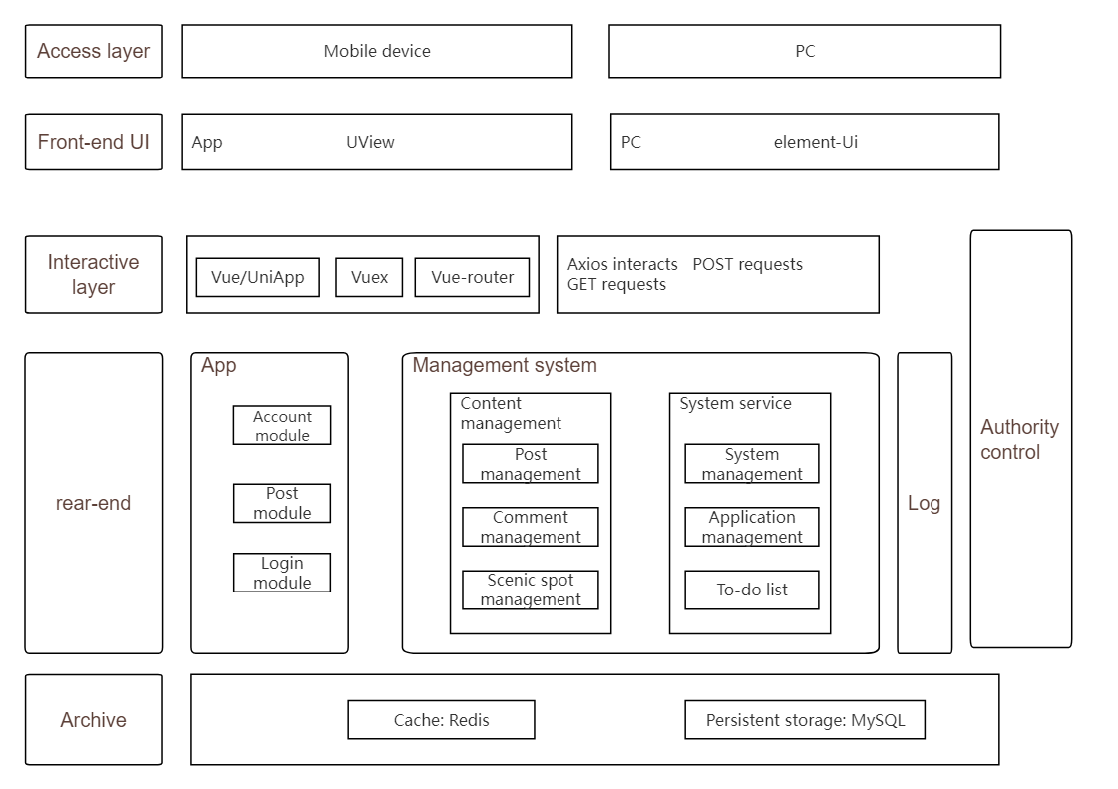
Figure 1: The system architecture.

2.2. System module division

The system is divided into two modules: the App side and the management side. The specific functions and modules of the App side and the management side are discussed below. The App side of the system contains three big modules: account module, post module and interactive module. The account module includes login, registration, viewing and modifying personal information modules. The post module covers the function modules of post, browse, remove, search, like and comment. The interactive module includes following users, responding to comments, and functional feedback modules. The module diagram of App side of the system is shown in Figure 2.
The content management of the system management side includes: post management, comment management, scenic spot management, notification management. System service is divided into: system management, application management, affairs and other modules. The system management module diagram is shown in Figure 3.

Figure 2: Module diagram of App side of the system.

Figure 3: System management module diagram.

2.3.Database design

According to the E-R model, the database table of the system is designed as Table 1 to Table 6.
In Table 1, the user table includes fields such as mobile number, password, gender, city, avatar, creation time, and update time. The user table is used to store user information. The UID field is used to establish relationships with other tables.
In Table 2, the post table contains the post number, post title, content, uploaded image, creator, category, created time, views, status fields. The type field is used to establish a relationship with the type table.
In Table 3, the comment table contains fields such as comment number, post number, author ID, comment content, comment status, replied user id, parent id, and creation time. uid and to_uid are used to store comment information. Uid and to_uid are used to establish a relationship with the user table.
In Table 4, the attraction table contains primary key id, attraction name, detailed address, introduction, price, rating, views, pictures and other fields. Used to store attraction information, where the id field is used to establish relationships with other tables.
In Table 5, the post category table contains the primary key ID, category name, and recommendation fields. Used to hold post category information, where the id field is used to establish a relationship with the post table.
In Table 6, the post like entity includes primary key, user Uid, post Pid, creation time field. The id, cid, and uid fields are used to establish relationships with other tables.
Table 1: User table.
Field name | Name | Data type
User id | uid | int
Mobile phone number | mobile | varchar(11)
Username | username | varchar(50)
Cipher | password | varchar(32)
Avatar | avatar | varchar(255)
Gender | gender | int
Province | province | varchar(50)
City | city | varchar(20)
Status | status | int
Update time | update_time | datetime
Creation time | create_time | datetime
Table 2: Post table.
Field name | Name | Data type
User id | uid | int
Title | title | varchar(50)
Content | content | longtext
Picture | media | text
Page view | read_count | int
Pinned | post_top | int
Address name | address | varchar(255)
Post type | type | int
Status (0 Normal 1 Audit) | status | int
Creation time | create_time | datetime
Table 3: Comment table.
Field name | Name | Data type
ID | id | bigint
Review author ID | uid | bigint
ID of the user being replied to | to_uid | int
Comment post ID | post_id | bigint
Comment content | content | varchar(255)
Comment status | status | tinyint
Parent comment | Pid | bigint
Creation time | create_time | datetime
Table 4: Scenic spots table.
Field name | Name | Data type
ID | id | int
Name of scenic spot | name | varchar(255)
Detailed address | address | varchar(255)
Introduce | introduce | varchar(255)
Ticket price | price | decimal(10,2)
Star Level | rank_grade | varchar(255)
Page view | read_count | int unsigned
picture | img_url | varchar(255)

3.System function realization

3.1.Login registration function

The user login process includes verifying the validity of the password. After verifying the password, a Token is generated to store the user information, and subsequent requests are authenticated using the Token. The registration process involves verifying the data format of the mobile number and password, which is then stored in the database and directed to the login page.
The implementation effect of the Login function is shown in Figure 4.
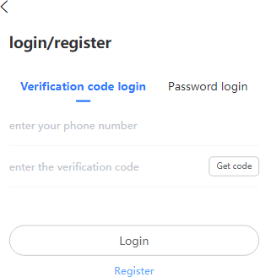
Figure 4: Login page.

3.2.Comment function

The system mainly uses secondary comments to display the interactive effect. First, the list of primary comments is queried, and then the sub-comments under the specified parent comments are queried according to the user's selection.
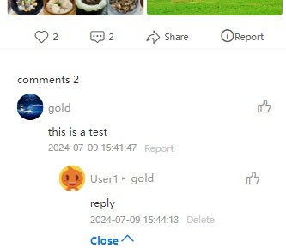
The implementation effect of the Comments function is shown in Figure 5.
Figure 5: Comment page.

3.3.Posting function

Users enter the Posting page, you can enter the title, content, upload pictures, you can also choose the post classification, travel time and travel costs and other content, the background will verify the content.
The implementation effect of the Posting function is shown in Figure 6.
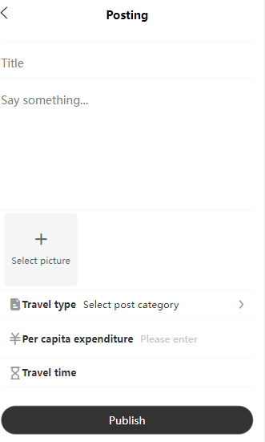
Figure 6: Posting page.

3.4.Recommendation function

According to the collaborative filtering algorithm, posts are recommended based on user similarity, and user behavior data is first collected: including post likes, favorites, and comments data. The similarity between users is then calculated: the Jaccard correlation coefficient is used to calculate the similarity between users. Finally, for each user who is similar to the target user, find posts they like that the target user has not yet interacted with.
The implementation effect of the Recommendation function is shown in Figure 7.
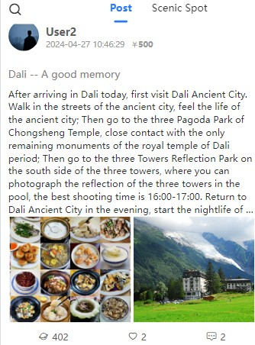
Figure 7: Homepage recommendation page.

4.System test

The system uses black box testing, which focuses on software functions and user interfaces to find defects related to user interaction and reduce the risk of system failure. The system will carry out input and output black box test, and develop test cases to verify the normal operation of the system.

4.1.Test case

Account module. The account module includes account registration, account login and other functions. We take Login as an example to test the functions. The results are shown in Table 7.
Table 7: Login test table.
ID | input | Expected output | Actual output
1 | All empty | The account password cannot be empty | The account password cannot be empty
2 | Account error | The user name or password  is incorrect | The user name or  password is incorrect
3 | Password error | The user name or password is incorrect | The user name or password is incorrect
4 | Normal information | Login successful | Login successful
Post module. Post module includes creating, deleting, modifying post content and other functions.
We take creating post as an example to test the functions. The results are shown in Table 8.
Table 8: Creating a post test table.
ID | input | Expected output | Actual output
1 | Title blank | The title cannot be empty | The title cannot be empty
2 | Content is empty | The content cannot be empty | The content cannot be empty
3 | Travel time is empty | Travel time cannot be empty | Travel time cannot be empty
4 | Correct input | Created successfully | Created successfully
Interactive module. The interactive module includes Posting, deleting, reporting comments and other functions. We take Posting comments as an example to test the functions. The results are shown in Table 9.
Table 9: Post a comment test table.

ID | input | Expected output | Actual output
1 | Content is empty | The content cannot be empty | The content cannot be empty
2 | Correct input | Release success | Release success

4.2.Test result analysis

From the test results, most of the actual output is consistent with the expected output, which means that the function of the system works as expected. For the account module, test cases 1, 2, and 3 of the login function show that the system can correctly handle null and incorrect input, and test case 4 shows that the login function can work properly. For the post creation module, test cases 1, 2, and 3 show that the system can correctly handle mandatory checks for title, content, and travel time. Test case 4 shows that the post creation function works. For the interactive module, test case 1 of the comment function shows that the system can correctly handle checks with empty content. Test case 2 shows that the comment function works. From the above tests, it can be seen that the system function is normal and meets expectations.

Conclusions

This paper describes in detail the design and implementation of the interactive platform for sharing travel guides based on SpringBoot technology. From demand analysis to system design, and then to the test and acceptance stage, the platform integrates the functions of publishing, browsing, commenting and collecting travel guides, aiming to provide a convenient and efficient sharing and communication space for travel enthusiasts. Using the flexibility of Spring Boot framework and the responsive design of Vue framework, the development cycle is greatly shortened, and the interface design is concise and beautiful through rich plug-ins and custom styles. The platform not only improves the user experience, but also promotes the exchange and dissemination of tourism culture, and successfully builds an interactive and shared online community for tourism enthusiasts.

- 中文翻译

基于Spring Boot的旅游互动共享平台的设计与实现
郭思捷，薛正元*
中国郑州，河南工业大学人工智能与大数据学院
xuezy@haut.edu.cn
*通讯作者

摘要：为了应对传统旅游指南信息共享方式存在更新不及时、缺乏个性化推荐、沟通互动有限、媒体内容限制、检索使用不便等问题，本系统采用Java作为编程语言，基于Spring Boot框架构建后端服务，使用Vue/UniApp开发前端界面，利用MyBatisPlus实现数据持久化，并采用MySQL数据库存储数据。该平台构建了一个高效便捷的旅游分享互动平台。平台提供在线编辑和多媒体内容支持功能，用户可以分享旅行体验和玩指南、关键词搜索和分类搜索，平台还提供个性化推荐功能，用户可以评价、收藏帖子并在帖子下进行交流互动。通过这些技术手段，构建了一个功能齐全且便捷的旅游分享互动平台，有效解决了传统旅游指南的问题。

关键词：旅游指南、分享与互动、推荐、Spring Boot。

1.简介

随着人们生活水平的提高和消费观念的变化，旅行者越来越注重个性化和定制化的旅行体验。我们希望能够根据自己的兴趣、时间和预算定制旅行计划和行程。良好的旅游策略可以提升游客的体验。然而，在传统的分享旅行指南方式中存在几个问题。首先，缺乏个性化的推荐；其次，沟通和互动有限；再次，检索和使用不便。因此，开发一个高效便捷的互动平台来分享旅行小贴士是非常有用的。
先前的研究探讨了如何增强社交网络中的用户互动和内容共享的安全性。这些研究为我们提供了宝贵的见解。在旅游策略平台领域，研究人员专注于改进用户互动和内容共享的功能。这些工作对于系统研究具有重要的启发意义。然而，在个性化互动、分享和智能检索方面仍有改进的空间。
为了开发一个优秀的互动平台来分享旅游指南，我们必须首先满足两个要求，一是信息的全面性和时效性，平台提供的导游信息应当全面、准确且及时更新。二是用户体验良好，平台应易于使用，并能够根据用户的偏好提供个性化推荐和服务[3]。针对这些要求，本文计划探索新的方法。重点在于如何更好地了解用户的旅行兴趣，并为他们提供即时、相关的旅行信息[5]。最终目标是打造一个更加用户友好的平台，让用户能够轻松发现新的旅游目的地[6,7]，分享他们的旅行体验，并快速获取所需信息。
系统采用基于Java语言和Spring Boot框架的集成开发环境IntelliJ IDEA构建Web应用。系统中集成了MyBatisPlus数据库持久层框架和MySQL数据库。前端框架使用了Maven构建工具、Vue、Uniapp等。API文档生成工具为Knife4j，通过Shrio、Jwt实现完整的权限控制机制，确保系统的安全性。系统开发环境如下：jdk：JDK-1.8.0_201。集成开发环境：IntelliJ IDEA 2023.3.2。操作系统：Windows 10 Home Chinese 64位（10.0）。数据库系统：8.0.26 MySQL Community Server-GPL。

2系统设计

2.1.系统总体架构

系统分为5层，即接入层、UI层、交互层、后端逻辑层、数据缓存层。接入层包括移动端和PC端，因此前端涉及两种技术栈，即Vue+Element-ui和Uniapp+Uview。后端基于Springboot框架实现，使用Mybatis Plus的持久层框架和Shiro+Jwt的权限控制技术。后端主要分为两个模块，即应用模块和管理系统模块。整体架构如图1所示。

图1：系统架构图

2.2系统模块划分

系统分为App端和管理端两个模块，下面对App端和管理端的具体功能和模块进行说明。 系统应用端包含三大模块：账号模块、发帖模块和互动模块。账号模块包括登录、注册、查看和修改个人信息模块。发帖模块涵盖发帖、浏览、删除、搜索、点赞和评论等功能模块。互动模块包括关注用户、回复评论和功能反馈模块。系统应用端模块图如图2所示。
系统管理侧的内容管理包括：岗位管理、评论管理、景区管理、通知管理等，系统服务分为：系统管理、应用管理、事务等模块，系统管理模块图如图3所示。

图2：系统App端模块图

图3：系统管理模块图

2.3数据库设计

根据E-R模型，系统数据库表设计为表1至表6。
表1中，用户表包含手机号码、密码、性别、城市、头像、创建时间、更新时间等字段，用于存储用户信息，UID字段用于与其他表建立关系。
表2中，帖子表包含帖子编号、帖子标题、内容、上传图片、创建者、分类、创建时间、浏览量、状态字段，类型字段用于与类型表建立关系。
表3中，评论表包含评论编号、帖子编号、作者ID、评论内容、评论状态、回复用户ID、父ID、创建时间等字段，uid和to_uid用于存储评论信息，uid和to_uid用于与用户表建立关系。
表4中，景点表包含主键id、景点名称、详细地址、介绍、价格、评分、浏览量、图片等字段，用于存储景点信息，其中id字段用于与其他表建立关系。
表5中，帖子分类表包含主键ID、分类名称和推荐字段，用于保存帖子分类信息，其中id字段用于与帖子表建立关系。
表6中，帖子的实体包括主键、用户Uid、帖子Pid、创建时间字段，id、cid、Uid字段用于与其他表建立关系。
表1：用户表
字段名称 | 名称 | 数据类型
用户ID | uid | int
手机号码 | mobile | varchar(11)
用户名 | username | varchar(50)
密码 | password | varchar(32)
化身 | avatar | varchar(255)
性别 | gender | int
省 | province | varchar(50)
城市 | city | varchar(20)
状况 | status | int
更新时间 | update_time | datetime
创建时间 | create_time | datetime
表2：岗位表
字段名称 | 名称 | 数据类型
用户ID | uid | int
标题 | title | varchar(50)
内容 | content | longtext
图片 | media | text
页面浏览量 | read_count | int
已固定 | post_top | int
地址名称 | address | varchar(255)
帖子类型 | type | int
状态（0正常1审核） | status | int
创建时间 | create_time | datetime
表3：备注表
字段名称 | 名称 | 数据类型
身份证 | id | bigint
审查者ID | uid | bigint
被回复的用户的ID | to_uid | int
帖子ID如何发布 | post_id | bigint
评论内容 | content | varchar(255)
评论状态 | status | tinyint
家长评论 | Pid | bigint
创建时间 | create_time | datetime
表4：景区一览表
字段名称 | 名称 | 数据类型
身份证 | id | int
景区名称 | name | varchar(255)
详细地址 | address | varchar(255)
介绍 | introduce | varchar(255)
票价 | price | decimal(10,2)
星级 | rank_grade | varchar(255)
页面浏览量 | read_count | int unsigned
照片 | img_url | varchar(255)

3、系统功能实现

3.1登录注册功能

用户登录过程包括验证密码的有效性。验证密码后，生成一个令牌以存储用户信息，后续请求则使用该令牌进行身份验证。注册过程涉及验证手机号码和密码的数据格式，这些信息随后会被存储在数据库中，并导向登录页面。
登录功能的实现效果如图4所示。


图4：登录页面图

3.2.评论功能

系统主要通过二级评论来显示交互效果，首先查询主评论列表，然后根据用户选择查询指定父评论下的子评论。
评论功能的实现效果如图5所示。

图5：评论页图

3.3.发帖功能

用户进入发帖页面，可以输入标题、内容、上传图片，还可以选择发帖分类、旅行时间、旅行费用等内容，后台会对内容进行审核。
发帖功能的实现效果如图6所示。

图6：发布页面图

3.4.推荐功能

根据协同过滤算法，帖子推荐基于用户相似度，首先收集用户行为数据：包括帖子点赞、收藏和评论数据。然后计算用户之间的相似度：使用杰卡德相关系数来计算用户间的相似度。最后，对于每个与目标用户相似的用户，找到他们喜欢但目标用户尚未互动过的帖子。
建议功能的实现效果如图7所示。

图7：主页推荐页面图

4、系统测试

系统采用黑盒测试，主要针对软件功能和用户界面进行测试，以发现与用户交互相关的缺陷，降低系统故障风险，系统将进行输入输出黑盒测试，并开发测试用例来验证系统的正常运行。

4.1.测试用例

账号模块，账号模块包括账号注册、账号登录等功能，我们以登录为例进行测试，结果如表7所示。
表7：登录测试表
ID | 输入 | 预期输出 | 实际输出
1 | 全部为空 | 帐户密码不能为空 | 帐户密码不能为空
2 | 账号错误 | 用户名或密码  不正确 | 用户名或  密码不正确
3 | 密码错误 | 用户名或密码不正确 | 用户名或密码不正确
4 | 正常信息 | 登录成功 | 登录成功
帖子模块。帖子模块包括创建、删除、修改帖子内容等功能。
我们以创建帖子为例来测试这些功能，结果如表8所示。
表8：创建后测试表
ID | 输入 | 预期输出 | 实际输出
1 | 标题空白 | 标题不能为空 | 标题不能为空
2 | 内容为空 | 内容不能为空 | 内容不能为空
3 | 行程时间为空 | 行程时间不能为空 | 行程时间不能为空
4 | 正确输入 | 创建成功 | 创建成功
互动模块，互动模块包含发布、删除、举报评论等功能，我们以发布评论为例进行功能测试，结果如表9所示。
表9：发表评论测试表
ID | 输入 | 预期输出 | 实际输出
1 | 内容为空 | 内容不能为空 | 内容不能为空
2 | 正确输入 | 发布成功 | 已发布成功

4.2.试验结果分析

从测试结果来看，大部分实际输出与预期输出一致，这意味着系统功能按预期运行。对于账号模块，登录功能的测试用例1、2和3表明系统能够正确处理空值和错误输入，而测试用例4则显示登录功能可以正常工作。对于帖子创建模块，测试用例1、2和3表明系统能够正确处理标题、内容和旅行时间的必填检查。测试用例4表明帖子创建功能可以正常工作。对于互动模块，评论功能的测试用例1表明系统能够正确处理空内容的检查。测试用例2则显示评论功能可以正常工作。从以上测试可以看出，系统功能正常且符合预期。

结论

本文详细描述了基于SpringBoot技术的互动平台的设计与实现，该平台用于分享旅行指南。从需求分析到系统设计，再到测试验收阶段，平台集成了发布、浏览、评论和收藏旅行指南的功能，旨在为旅行爱好者提供一个便捷高效的分享交流空间。利用Spring Boot框架的灵活性和Vue框架的响应式设计，开发周期大大缩短，界面设计简洁美观，通过丰富的插件和自定义样式实现。该平台不仅提升了用户体验，还促进了旅游文化的交流与传播，成功构建了一个互动共享的在线社区，服务于旅行爱好者。

