**MAIN PROJECT**

**JOB PORTAL WEBSITE**

**Create a Back-end Dashboard for Job Portal Hierarchy using PhP and SQL**

**Abstract**

Finding jobs that best suits the interests and skill set is quite a challenging task for the job seekers. The difficulties arise from not having proper knowledge on the organization’s objective, their work culture and current job openings. In addition, finding the right candidate with desired qualifications to fill their current job openings is an important task for the recruiters of any organization. Online Job Search Portals have certainly made job seeking convenient on both sides. Job Portal is the solution where recruiter as well as the job seeker meet aiming at fulfilling their individual requirement. They are the cheapest as well as the fastest source of communication reaching wide range of audience on just a single click irrespective of their geographical distance. The web application “Job Search Portal” provides an easy and convenient search application for the job seekers to find their desired jobs and for the recruiters to find the right candidate. Job seekers from any background can search for the current job openings. Job seekers can register with the application and update their details and skill set. They can search for available jobs and apply to their desired positions. Android, being open source has already made its mark in the mobile application development. To make things handy, the user functionalities are developed as an Android application. Employer can register with the application and posts their current openings. They can view the Job applicants and can screen them according to the best fit. Users can provide a review about an organization and share their interview experience, which can be viewed by the Employers.

**OBJECTIVE**

 The online job Portal System that is to be developed provides the members with jobs information, online applying for jobs and many other facilities. This system provides service to the job applicants to search for working opportunities. Job Portal will allow job provider to establish one to one relationships with candidates. This Portal will primarily focus on the posting and management of job vacancies. This system is designed such that ultimately all vacancies will be posted online and would offer employers the facilities to post their vacancies online. It helps to review and manage the resulting applications efficiently through the web. Employer can also find the resume according to key skill in very less amount of time.

 The objectives of this research are:

To detect and identify the needs of recruiters and job seekers which was incorporatedinto the system

•To design, develop and implement an effective and efficient job portal system

•To develop a job portal that allows employers to post job advertisements

•To minimize the time consumed in job searching process and provide 24/7 accessibility

•To develop a job portal that allows job seekers to search for jobs and upload theirresume.

**Introduction**

Unemployment is a still one of the serious problems for both developed and developingcountries in the world. The increasing number of unemployed graduates has become one of theserious problems in Ghana. According to the latest Ghana Labour Force Survey Report by the

Ghana Statistical Service, Ghana’s unemployment rate sto

od at 11.9 percent in 2015 (Arthur,2017). People are unable to get access to job opportunities due to inefficient distribution ofinformation on job offers but now the Internet has made a huge impact on knowledgemanagement and information dissemination all over the world.

In today’s c

ompetitive world,it is difficult for people to get job easily and also difficult for people to find suitable jobs thatmatch with their skills. It has also become difficult for organisations to find people who are best in their fields and intelligent to be hired. Normally when people want to search for job,they search the newspapers, employment agencies, existing employee contacts, listen to radioor watch television broadcasts that may advertise job vacancies but access to the Internet haschanged the ways for searching for jobs and looking for quality candidates.The Internet has changed the way of looking for job vacancies and searching for right andqualified candidates, through the development of job portals. Job portal system has made jobsearching processes easier. A job portal system provides an efficient way for searching theInternet for job vacancies available and looking for suitable candidates. It has reduced themanual efforts in job and applicant searching process. This system is to eliminate and somecases reduce the hardships faced by the existing system and also the problems prevailing in the practicing manual syste

**METHODOLOGY**

**Introduction**

This section of the project describes or includes three main areas: data collection procedures,software development methodology and development tools and platform. In the developmentof a system, it is important to obtain the accurate, necessary and needed requirements to ensuregood and quality system development.

**Data Collection**

Data collection is the process of gathering and measuring information on targeted variables inan established systematic fashion, which then enables one to answer relevant questions andevaluate outcomes (Anon., n.d.). Most common approaches for application developmentstudies include Inquisitive techniques (interviews, questionnaires, Brainstorming and FocusGroups) and Observational techniques (Work Diaries, Participant Observation).The data collection approaches used are as follows:

**Interview**

Interview is a very powerful method or tool for gathering data since it allows the personconducting the interview clarify a number of issues and also achieve detailed information. This

 provided the opportunity to get the in depth understanding of the users’ needs and requirements.

Unstructured interview gives the chance to ask open-ended questions which helps identifiesmost of the system requirements. With interview, there is opportunity to ask most relevantquestions customized for each respondent.

**Observation**

Observation is the process of monitoring something or someone closely to get an information.It helps one to gather life information or data from naturally occurring situation. This meansthat hidden or concealed data would be revealed or disclosed. First-hand information ratherthan second-hand information would be collected by looking at what is taking place in the realsituation again. Observing or seeing the current system in action gives a thoroughunderstanding and additional perspective of system procedures.

**Secondary Source**

Secondary sources of data were also used in this project. This includes obtaining or gatheringdata from library source, newspapers, Internet, journals, articles, reports, bulletins, newsletters.

Most of the data collected have been covered in the chapter two, the literature review, of the project.

**Software Development Methodology**

A software development methodology in software engineering is a framework that is used tostructure, plan and control the process of developing an information system. A methodologydefines a paradigm (i.e. approach) to be used and a precise lifecycle to be used.In the development of this system, an Iterative and Waterfall Methodology was used to ensuresystematic and sequential flow of the system stages and also considering error fixing duringand after development

This methodology was chosen for its classic life cycle that enable error fixing during and afterdevelopment.

**Development Tools and Platform**

This system was developed using the following architecture and tools;

•Microsoft Windows 10

•MySQL

•PHP, HTML, CSS and JavaScript

•Apache Server (XAMPP)

•Browser (Chrome and Firefox)

•Sublime Text 3

**XAMPP (Apache Server)**

XAMPP stands for Cross-Platform (X), Apache (A), MariaDB (M), PHP (P) and Perl (P). Itis a simple, lightweight Apache distribution that makes it extremely easy for developers tocreate a local web server for testing and deployment purposes. XAMPP is also cross-platform,which means it works equally well on Linux, Mac and Windows. XAMPP was chosen becauseof its portability.

**PHP**

PHP is an acronym for “Hypertext Pr e-processor” and is a server -side programming languageused for web development. It is a widely used, open source scripting language. PHP languagehas its roots in C and C++ so it is easy to learn and manipulate. PHP can run on both UNIXand Windows servers. In the development of this JAD job portal system, PHP was chosen because it is dynamic, cheap and easy to setup, secure, fast, reliable and can interact with manydifferent relational database management systems (DBMS).

**MYSQL**

MySQL is one the world’s mo

st popular open source database management system. It is a free-to-use, open source database that enables users to create database and perform various formsof data manipulations and database administration. MySQL was chosen for the developmentof this system because of its advanced features like the following;

•Data Security

•On-Demand Scalability

•High Performance

•Complete workflow control

•Easy to learn and use

**Sublime Text 3**

Sublime Text is a proprietary cross-platform source code editor with a Python application programming interface (API). It natively supports many programming languages and mark-uplanguages, and functions can be added by users with plugins, typically community-built andmaintained under free-software licenses. I used sublime text 3. Sublime text was chosen because of its features like;

•Multiple selections– this allows you to change texts on different line at once, with easeand also faster.

•Performance

•Cross platform– sublime text is available for Mac, Windows and Linux

**CODE:**

**Login.php:**

<!DOCTYPE html>

<html lang="en">

<head>

<meta charset="UTF-8">

<meta http-equiv="X-UA-Compatible" content="IE=edge">

<meta name="viewport" content="width=device-width, initial-scale=1.0">

<link href="https://cdn.jsdelivr.net/npm/bootstrap@5.2.2/dist/css/bootstrap.min.css" rel="stylesheet" integrity="sha384-Zenh87qX5JnK2Jl0vWa8Ck2rdkQ2Bzep5IDxbcnCeuOxjzrPF/et3URy9Bv1WTRi" crossorigin="anonymous">

<style>

body{

background-image: url('background.jpg');

background-size: cover;

}

form{

background-color: #fff;

margin-top: 6em;

margin-left: 30em;

margin-right: 10em;

padding: 30px;

box-shadow: 10px 10px 8px 10px #888888;

}

</style>

<title>register</title>

</head>

<body>

<div class="container">

<form>

<div class="mb-3">

<label for="exampleInputEmail1" class="form-label">Email address</label>

<input type="email" class="form-control" id="exampleInputEmail1" aria-describedby="emailHelp" name="email">

<div id="emailHelp" class="form-text">We'll never share your email with anyone else.</div>

</div>

<div class="mb-3">

<label for="exampleInputPassword1" class="form-label">Password</label>

<input type="password" class="form-control" id="exampleInputPassword1" name="password">

</div>

<button type="submit" class="btn btn-primary">Submit</button>

<br>

<p style="text-align: center;">New User?<br>Create Account <a href="register.php">Sign Up</a></p>

</form>

</div>

</body>

</html>

**OUTPUT:**

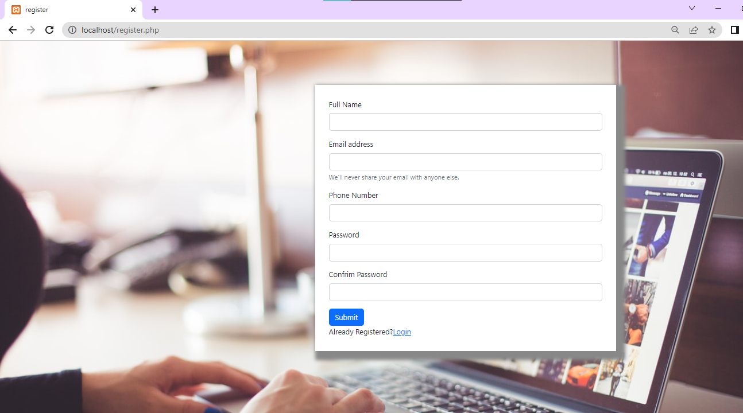

**2.register.php**

<!DOCTYPE html>

<html lang="en">

<head>

<meta charset="UTF-8">

<meta http-equiv="X-UA-Compatible" content="IE=edge">

<meta name="viewport" content="width=device-width, initial-scale=1.0">

<link href="https://cdn.jsdelivr.net/npm/bootstrap@5.2.2/dist/css/bootstrap.min.css" rel="stylesheet" integrity="sha384-Zenh87qX5JnK2Jl0vWa8Ck2rdkQ2Bzep5IDxbcnCeuOxjzrPF/et3URy9Bv1WTRi" crossorigin="anonymous">

<style>

body{

background-image: url('background.jpg');

background-size: cover;

}

form{

background-color: #fff;

margin-top: 6em;

margin-left: 30em;

margin-right: 10em;

padding: 30px;

box-shadow: 10px 10px 8px 10px #888888;

}

</style>

<title>register</title>

</head>

<body>

<div class="container">

<form action="">

<div class="mb-3">

<label for="exampleInputName" class="form-label">Full Name</label>

<input type="text" class="form-control" id="exampleInputName" name="name">

</div>

<div class="mb-3">

<label for="exampleInputEmail1" class="form-label">Email address</label>

<input type="email" class="form-control" id="exampleInputEmail1" aria-describedby="emailHelp" name="email">

<div id="emailHelp" class="form-text">We'll never share your email with anyone else.</div>

</div>

<div class="mb-3">

<label for="exampleInputNumber" class="form-label">Phone Number</label>

<input type="number" class="form-control" id="exampleInputNumber" name="phone_no">

</div>

<div class="mb-3">

<label for="exampleInputPassword1" class="form-label">Password</label>

<input type="password" class="form-control" id="exampleInputPassword1" name="password">

</div>

<div class="mb-3">

<label for="exampleInputPassword2" class="form-label">Confrim Password</label>

<input type="password" class="form-control" id="exampleInputPassword2">

</div>

<button type="submit" class="btn btn-primary">Submit</button>

<br>

Already Registered?<a href="Login.php">Login</a>

</form>

</div>

</body>

</html>

**OUTPUT:**

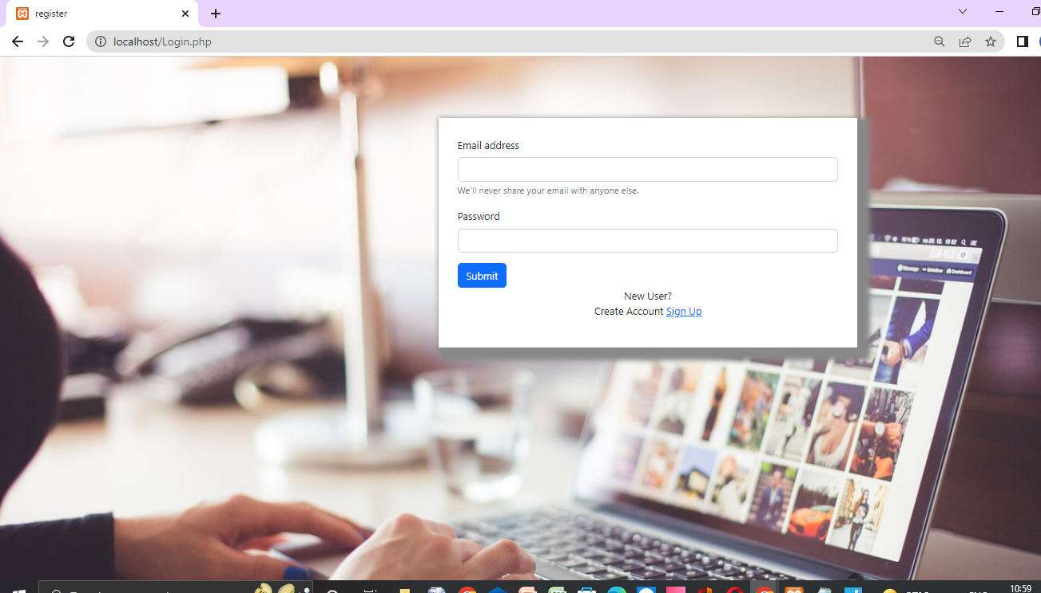

**3.index.php**

<!DOCTYPE html>

<html lang="en">

<head>

<title>Dashboard</title>

<meta charset="UTF-8">

<meta http-equiv="X-UA-Compatible" content="IE-edge">

<meta name="viewport" content="width=device-width, initial-scale=1.0">

<link href="https://cdn.jsdelivr.net/npm/bootstrap@5.0.2/dist/css/bootstrap.min.css" rel="stylesheet" integrity="sha384-EVSTQN3/azprG1Anm3QDgpJLIm9Nao0Yz1ztcQTwFspd3yD65VohhpuuCOmLASjC" crossorigin="anonymous">

<link href="style.css">

<script src="https://ajax.googleapis.com/ajax/libs/jquery/3.6.0/jquery.min.js"></script>

<script src="https://maxcdn.bootstrapcdn.com/bootstrap/3.4.1/js/bootstrap.min.js"></script>

<style>

/* The side navigation menu */

.sidebar {

margin: 0;

margin-top: 5px;

padding: 0;

width: 200px;

background-color: #f1f1f1;

position: fixed;

height: 100%;

overflow: auto;

}

/* Sidebar links */

.sidebar a {

display: block;

color: black;

padding: 16px;

text-decoration: none;

}

/* Active/current link */

.sidebar a.active {

background-color: #04AA6D;

color: white;

}

/* Links on mouse-over */

.sidebar a:hover:not(.active) {

background-color: #555;

color: white;

}

/* Page content. The value of the margin-left property should match the value of the sidebar's width property */

div.content {

margin-left: 200px;

padding: 1px 16px;

height: 1000px;

}

.navbar{

overflow:hidden;

background-color: #333;

position: fixed;

top:0;

width:100%;

}

/* On screens that are less than 700px wide, make the sidebar into a topbar */

@media screen and (max-width: 700px) {

.sidebar {

width: 100%;

height: auto;

position: relative;

}

.sidebar a {float: left;}

div.content {margin-left: 0;}

}

/* On screens that are less than 400px, display the bar vertically, instead of horizontally */

@media screen and (max-width: 400px) {

.sidebar a {

text-align: center;

float: none;

}

}

</style>

</head>

<body>

<div>

<nav class="navbar navbar-expand-lg navbar-light bg-light" style="position-fixed;">

<div class="container-fluid">

<a class="navbar-brand" href="#">Navbar</a>

<button class="navbar-toggler" type="button" data-bs-toggle="collapse" data-bs-target="#navbarNav" aria-controls="navbarNav" aria-expanded="false" aria-label="Toggle navigation">

<span class="navbar-toggler-icon"></span>

</button>

</div>

</nav>

<div class="sidebar">

<a class="active" href="#home">Jobs</a>

<a href="#news">News</a>

<a href="#contact">Contact</a>

<a href="#about">About</a>

</div>

<!-- Page content -->

<div class="content">

<p>

<a class="btn btn-primary" data-bs-toggle="collapse" href="#collapseExample" role="button" aria-expanded="false" aria-controls="collapseExample">

Link with href

</a>

</p>

<div class="container">

<a href="#demo" class="btn btn-primary" data-toggle="collapse">POST JOB</a>

<div class="collapse.in" id="demo">

<div class="card card-body">

<form>

<div class="mb-3">

<label for="Company Name" class="form-label">Company Name</label>

<input type="text" class="form-control" id="">

</div>

<div class="mb-3">

<label for="position" class="form-label">Position</label>

<input type="text" class="form-control" id="exampleInputPosition">

</div>

<div class="mb-3">

<label for="JobDesc" class="form-label">Job Description</label>

<input type="text" class="form-control" id="JobDesc">

</div>

<div class="mb-3">

<label for="CTC" class="form-label">CTC</label>

<input type="text" class="form-control" id="CTC">

</div>

<button type="submit" class="btn btn-primary">Submit</button>

</form>

</div>

</div>

</div>

<script src="https://cdn.jsdelivr.net/npm/bootstrap@5.0.2/dist/js/bootstrap.bundle.min.js" integrity="sha384-MrcW6ZMFYlzcLA8Nl+NtUVF0sA7MsXsP1UyJoMp4YLEuNSfAP+JcXn/tWtIaxVXM" crossorigin="anonymous"></script>

</body>

</html>

**OUTPUT:**

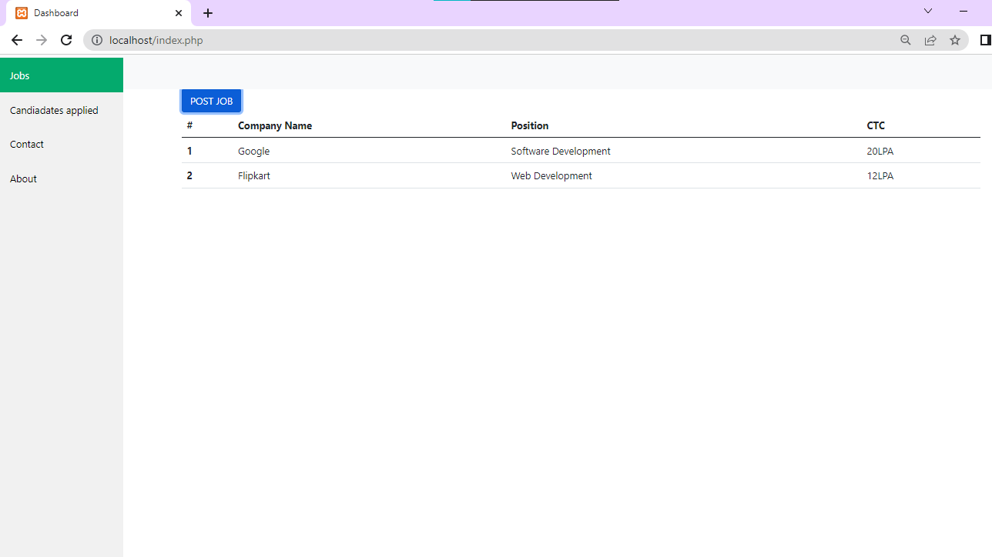

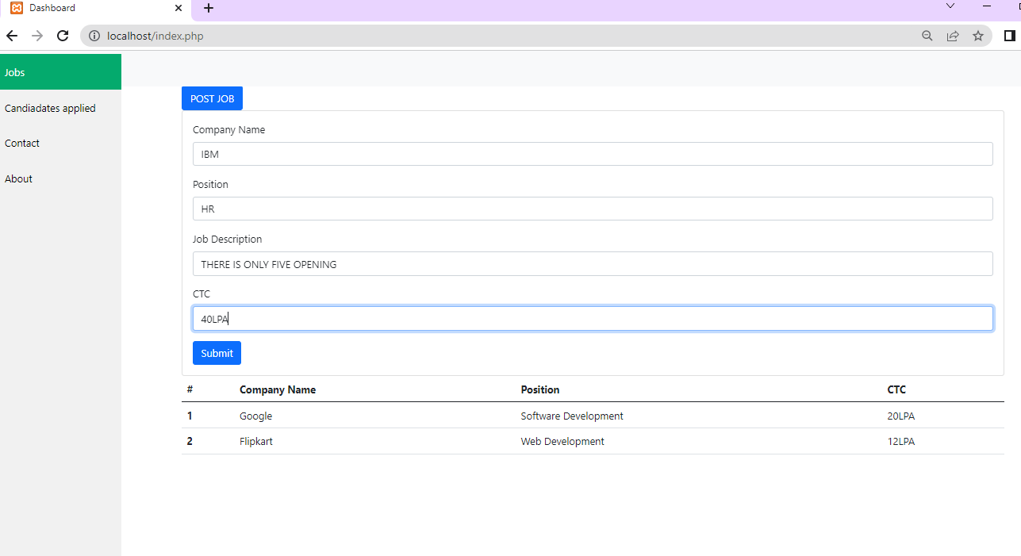

**4.header.php**

<!DOCTYPE html>

<html lang="en">

<head>

<meta charset="UTF-8">

<meta http-equiv="X-UA-Compatible" content="IE=edge">

<meta name="viewport" content="width=device-width, initial-scale=1.0">

<link href="https://cdn.jsdelivr.net/npm/bootstrap@5.2.2/dist/css/bootstrap.min.css" rel="stylesheet" integrity="sha384-Zenh87qX5JnK2Jl0vWa8Ck2rdkQ2Bzep5IDxbcnCeuOxjzrPF/et3URy9Bv1WTRi" crossorigin="anonymous">

<link href="https://cdnjs.cloudflare.com/ajax/libs/font-awesome/6.2.0/css/all.min.css" rel="stylesheet" integrity="sha512-iBBXm8fw90+nuLcSKlbmrPcLa0OT92xO1BIsZ+ywOWZCvqsWgccV3gFORBv0z+8dLJgуAHIhR35VZc2oM/gI1w==" crossorigin="anonymous">

<title>Dashboard</title>

<style>

.sidebar {

margin: 0;

margin-top: 2px;

padding: 0;

width: 200px;

background-color: #f1f1f1;

position: fixed;

height: 100%;

overflow: auto;

}

/* Sidebar links */

.sidebar a {

display: block;

color: black;

padding: 16px;

text-decoration: none;

}

/* Active/current link */

.sidebar a.active {

background-color: #04AA6D;

color: white;

}

/* Links on mouse-over */

.sidebar a:hover:not(.active) {

background-color: #555;

color: white;

}

/* Page content. The value of the margin-left property should match the value of the sidebar's width property */

div.content {

margin-left: 200px;

padding: 1px 16px;

height: 1000px;

}

/* On screens that are less than 700px wide, make the sidebar into a topbar */

@media screen and (max-width: 700px) {

.sidebar {

width: 100%;

height: auto;

position: relative;

}

.sidebar a {float: left;}

div.content {margin-left: 0;}

}

/* On screens that are less than 400px, display the bar vertically, instead of horizontally */

@media screen and (max-width: 400px) {

.sidebar a {

text-align: center;

float: none;

}

}

.navbar {

overflow: hidden;

background-color: #333;

position: fixed;

top: 0;

width: 100%;

}

</style>

</head>

<body>

<div>

<nav class="navbar navbar-expand-lg bg-light" style="position: fixed;">

<div class="container-fluid">

<a class="navbar-brand" href="#">Navbar</a>

<button class="navbar-toggler" type="button" data-bs-toggle="collapse" data-bs-target="#navbarNav" aria-controls="navbarNav" aria-expanded="false" aria-label="Toggle navigation">

<span class="navbar-toggler-icon"></span>

</button>

</div>

</nav>

<div class="sidebar">

<a class="active" href="#home">Jobs</a>

<a href="#jobs.php">Candidate Applied</a>

<a href="#contact">Contact</a>

<a href="#about">About</a>

</div>

**5.Jobs.php**

<?php include 'header.php'?>

<div class="content">

<table class="table">

<thead>

<tr>

<th scope="col">#</th>

<th scope="col">Candidate Name</th>

<th scope="col">Position</th>

<th scope="col">Resume</th>

</tr>

</thead>

<tbody>

<tr>

<th scope="row">1</th>

<td>Gilsey</td>

<td>PHP developer</td>

<td><a href=""><i class="fa fa-download" aria-hidden="true"></i></a></td>

</tr>

</tbody>

</table>

</div>

**OUTPUT:**

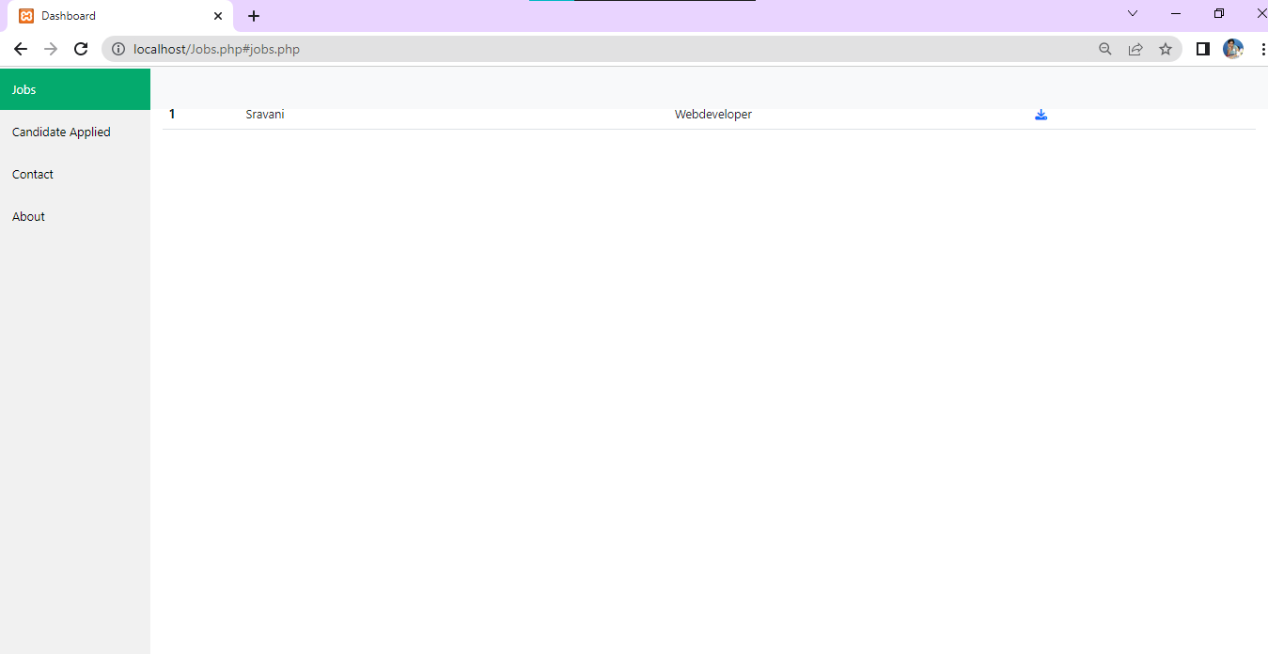

**6.Career.php**

<!DOCTYPE html>

<html lang="en">

<head>

<meta charset="UTF-8">

<meta http-equiv="X-UA-Compatible" content="IE=edge">

<meta name="viewport" content="width=device-width,initial-scale=1.0">

<style>

.navbar{

overflow: hidden;

background-color:#333;

position:fixed;

top:0;

width:100%;

}

</style>

<link href="https://cdn.jsdelivr.net/npm/bootstrap@5.0.0-beta3/dist/css/bootstrap.min.css" rel="stylesheet" integrity="sha384-eOJMYsd53i

<title>Document</title>

</head>

<body>

<div class="container-fluid">

<nav class="navbar navbar-expand-lg navbar-light bg-light navbar-fixed">

<div class="container-fluid">

<a class="navbar-toggler" type="#">Navbar</a>

<button class="navbar-toggler" type="button" data-bs-toggle="collapse" data-bs-target="#navbarNav" aria-controls="navbarNav" aria-expand

<span class="nav-toggler-icon"></span>

</button>

<div class="collapse navbar-collapse" id="navbarNav">

<ul class="navbar-nav">

<li class="nav-item">

<a class="nav-link active" aria-current="page" href="#">Home</a>

</li>

<li class="nav-item>

<a class="nav-link" href="#">Features</a>

</li>

<li class="nav-item">

<a class="nav-link" href="#">Pricing</a>

</li>

<li class="nav-item">

<a class="nav-link disabled" href="#" tabindex="-1" aria-disabled="true">Disabled</a>

</li>

</ul>

</div>

</div>

</nav>

<div class="jumbotron jumbotron-fluid">

<div class="container">

<h1>Bootstrap Tutorial</h1>

<p>Bootstrap is the most popular HTML,CSS...</p>

</div>

</div>

</div>

<script src="https://cdn.jsdelivr.net/npm/bootstrap@5.0.0-beta3/dist/js/bootstrap.bundle.min.js" integrity="sha384.JEW9xMcG8R+pH31 jmWH6WWP0W

</body>

</html>

**Output:**

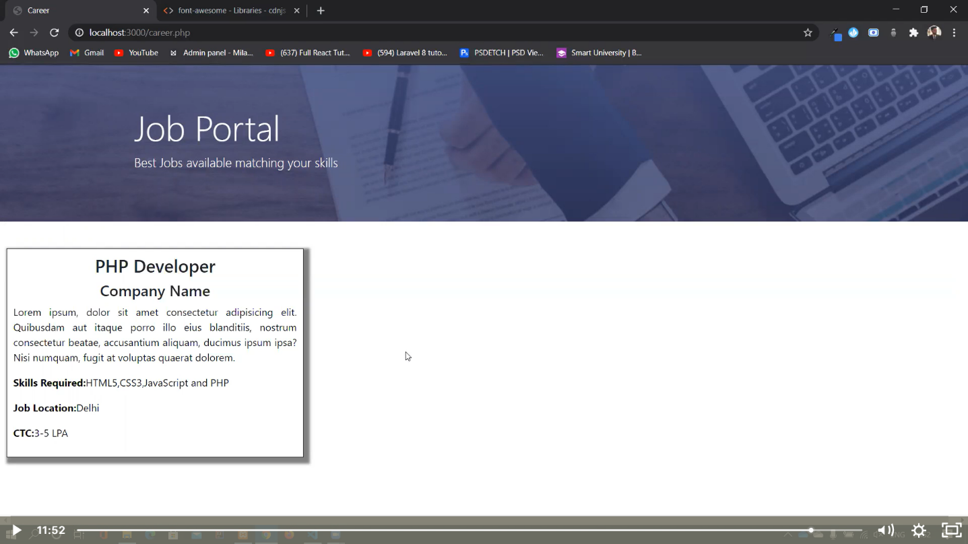

**Conclusion:**

The wider areas of job searching facilitate the quick and easy access to opportunities. The increasing job opportunities and changing scenario of the business environment today has made more people to search for better career and employers to search for better potential. This situation has prompted many to move to job portals to look for the ways that has been widely accepted and fully useful in job searching. In this sense the job portals assumes greater importance and we could develop such an efficient system which is used by lot many job hunters and employers.