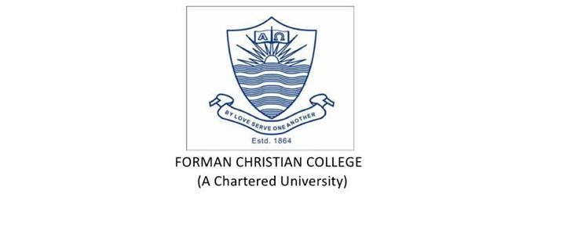

**Group Members:** Fazal dad Saleem(231459090)

Khuda Dad Saleem(231459091)

Huzaifa Khaliq(231459085)

**Course Name:** Technology Management

**Instructor Name:** Saad Bin Saleem

**Assignment 5**

Both the frameworks ITIL and COBIT are well known in the world for IT management. ITIL is the most famouse framework all around the globe for service management, whereas COBIT is known worldwide for service management and enterprise governance. Both of them are equally important and very successful when it comes to offering costum governance when delivering quality service management COBIT and ITIL have great ability, when paired together, to increase the value to large extent, for companies, it’s partners and also for the costumers.

In the latest updated versions, both the frameworks complement each other. Both of the framework concentrate on changing the stakeholder desires into value. They have been totally shaped for the organisation. They allow to use benificial parts when the organisations need them. ITIL 4 concentrates more than it’s previous version on the governance, having a ring within the SVS fully owned by it. Due to this companies are able to understand that how and where COBIT can fit into the strategy. Advice is also provided by ITIL 4 on how to carry out several processes of the COBIT. There are many examples of it from which one is change management. ITIL totally provides a structure and processes to carry out this practice properly.

The aim of both the framework is same. There main purpose is to increase the efficiency and stability of IT structure. Though they are different framework but they are identical and interlinked to each other. How the everyday processes should be managed by the IT employees is identified by the ITIL. Both of them have always complemented each other and this is been continually reinforced by their their new versions. When it comes to creating organizational governance and management objectives directly from stakeholders, COBIT is used, whereas ITIL 4 helps to guide those needs though it’s service value system turning inputs into outputs that deliver valuable outcomes for both internal and external costumers.

There are processes such as BA106 which means managing change processes in COBIT matches the ITIL change management process. Unlike ITIL, COBIT also have a process of risk management known as APO12 that manages risks.Both are equally important in ITSM, though they have unique goals but still are very much complementary to each other. COBIT takes care of the resources, risks and IT efficiency. While ITIL the decision making of the organisation.

IT can be situated in larger companies as a service oriented due to both of these frameworks. Due to this IT departments can can plan their own policies and practices. They also allow companies to create there own roadmaps with business directives having in mind and not pushing the department to bend to the whims of the rest of the company.

**Contribution**

Equal participation of every group member.